**Valhalla multi-fields**

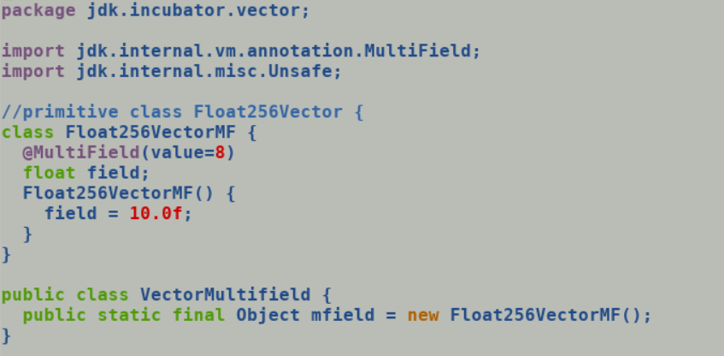

mfield references memory allocated over heap, following is the generated bytecode.

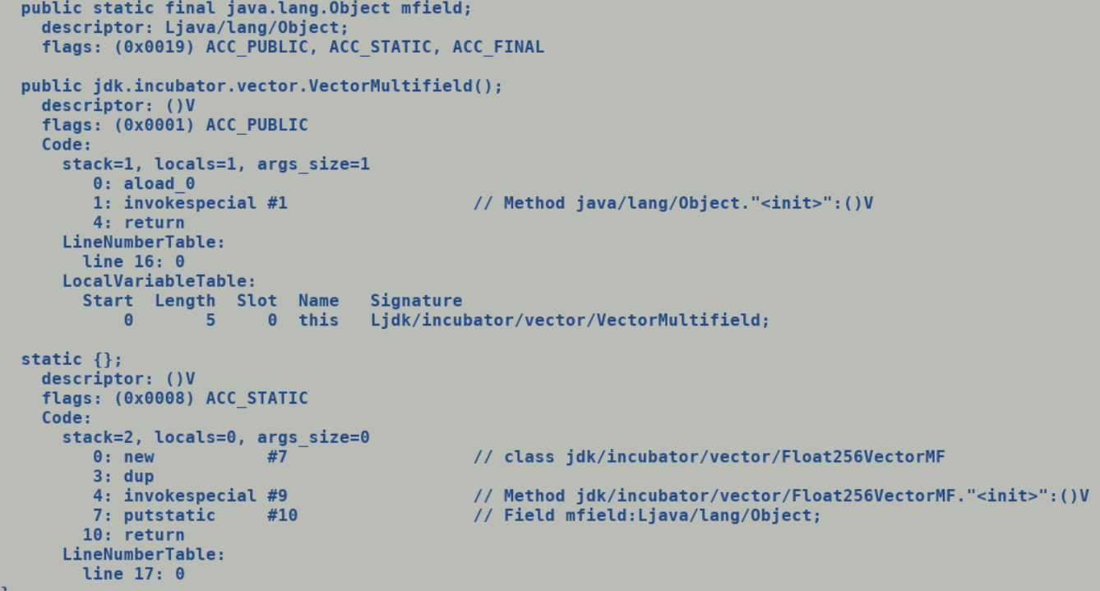

Bytecode after making Float256VectorMF a primitive class, no new allocation byte-code:-

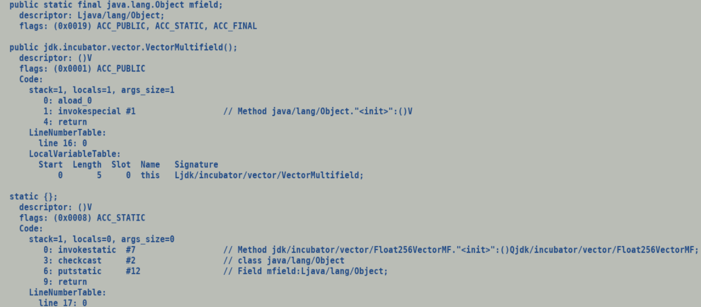

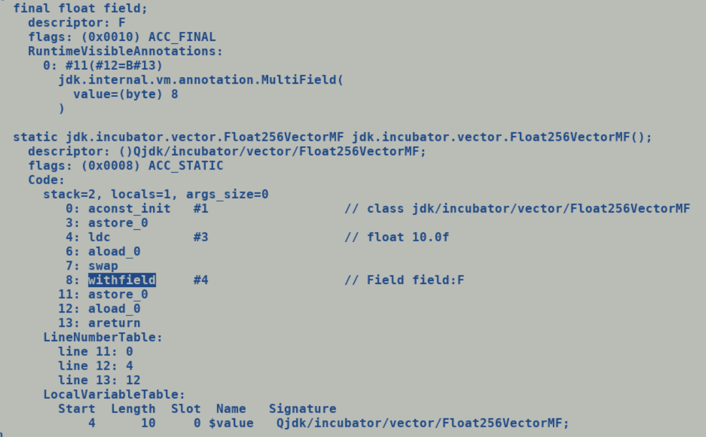

Actual oop allocation using InlineKlass::allocate_instance_buffer happen while processing aconst_init and withfield bytecode, allocated chunk is stored at default_value offset in klass mirror (usually holds static fields values). To honor immutability any update to primitive type object field results into new allocation (a true value semantics)

However, creation of multiple copies with each filed write in constructor looks sub-optimal, but in true spirit of immutability looks fine.

Descriptor of a multi field is still of scalar primitive type, any access to multi-field bundled instance to be done through varhandles.

Accessing fields using Var handles:-

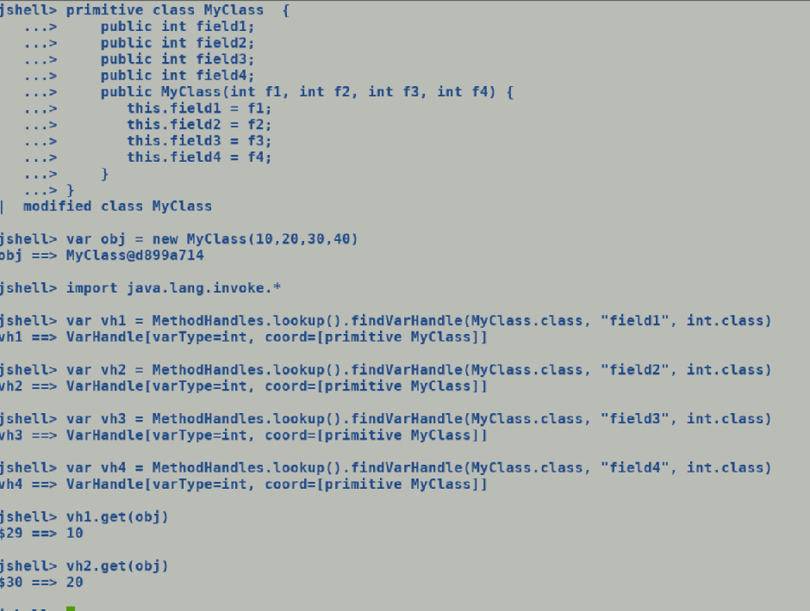

**Req1: Currently there are no var handle APIs to access the constituents of a multi-field, this is needed for field bundle initializations in fall back implementation.**

Req2: Any access to individual component of a multi-field on java side will be using varhandles, box expansion of vector will directly allocate the primitive type instance over buffer and store the contents of vector at the first field offset of the object.

Req3: Multi-fields are out of preview of scalarization.

Req4: Scalarization of vbox should be usable as it is since we bookkeep both the box and value over SafePointNodes, rematerialization may need some change to allocate instance buffer.

**Vector operation pipeline:**

var vec = FloatVector.fromArray(SPECIES_256, arr, idx); // Arg: opc, getClass(), float.class, length, base,

IR: LoadVector [TypeVect (float, 8)]

VectorBox Float256Vector

vec.lanewise(VectorOperator.ADD, 10.0f); // Arg: opc, length, float,class, vec1, vec2

IR: Unbox Float256Vector

AddVF vec1 vec2

vec.intoArray(dst, idx); //….

IR : StoreVector

VectorBox ->

Allocate backing_storage

StoreVector vec, backing_storage

Allocate Box

Store backing_storage , oop+offsetOf(Box.field)

With Primitive types multi-fields (just one allocation is sufficient.

Allocate buffer

StoreVector vec, oop+offsetOf(multi_field)

Scalarize_vbox_nodes:

Should be same (ideally no change)

Deoptimization: rematerialization

Reconstruct_object

StoreVector vec, object+offsetOf(multi_field)

Additional optimizations:

* Passing value across call though vector register interface.
* Primitive class objects are blasted into fields which are passed through GPRs and caller directly jumps to function_entry_point, there are inline_entry_point which does unpacking mainly used when callee is called from interpreter. Method I2C adaptors does not perform unpacking.
* Multi-field is a single bundle of fields hence by definition should not be disintegrated and passed through vector register, extracting individual element and passing them through GPR may be costly.

Vector Fields:

shell> vec.getClass().getFields()

$4 ==> Field[6] {

public static final jdk.incubator.vector.VectorSpecies jdk.incubator.vector.IntVector.SPECIES_64, public static final jdk.incubator.vector.VectorSpecies jdk.incubator.vector.IntVector.SPECIES_128, public static final jdk.incubator.vector.VectorSpecies jdk.incubator.vector.IntVector.SPECIES_256, public static final jdk.incubator.vector.VectorSpecies jdk.incubator.vector.IntVector.SPECIES_512, public static final jdk.incubator.vector.VectorSpecies jdk.incubator.vector.IntVector.SPECIES_MAX, public static final jdk.incubator.vector.VectorSpecies jdk.incubator.vector.IntVector.SPECIES_PREFERRED

}

**Example:**

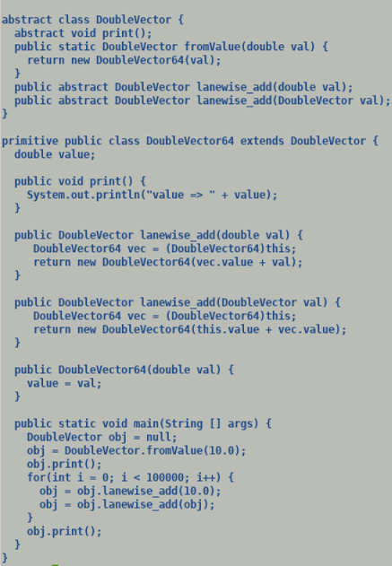

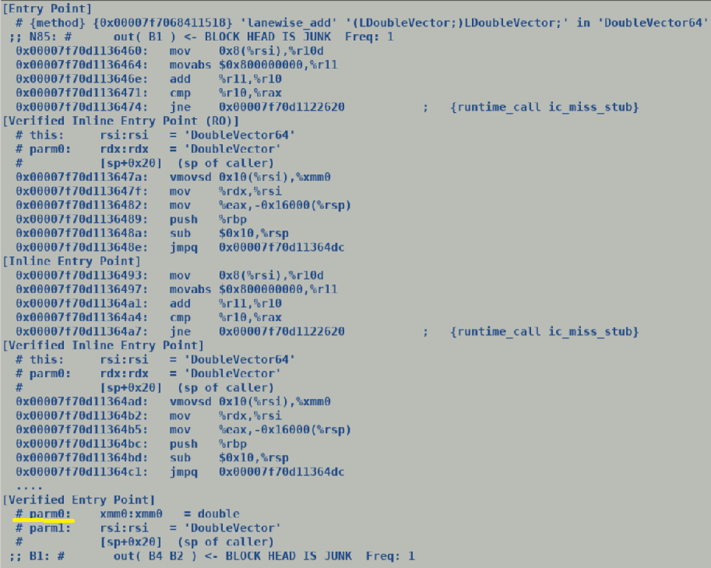

Exiting Vector Class Hierarchy

­­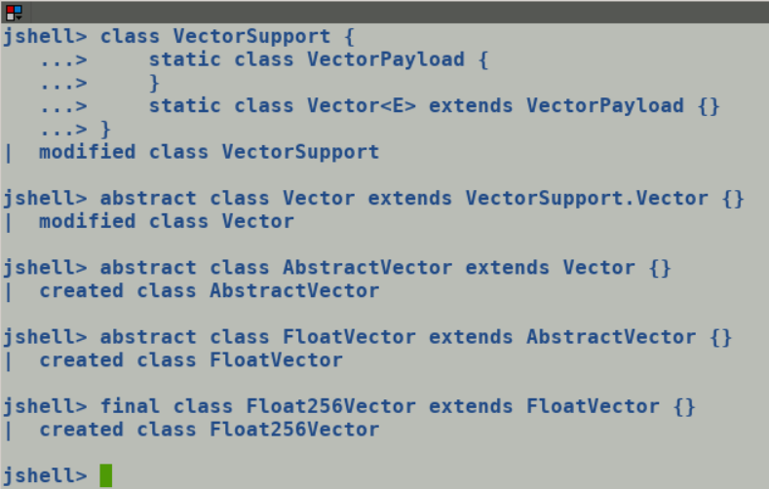

No use of sealed classes.

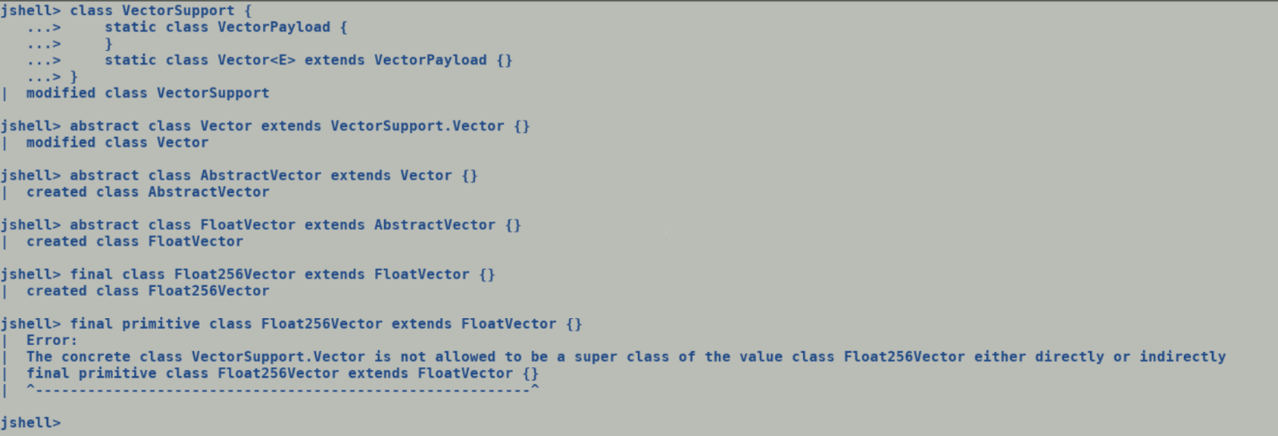

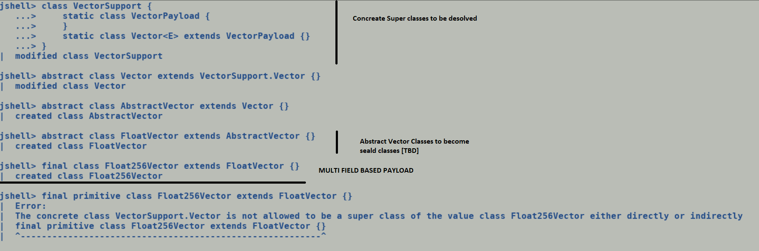

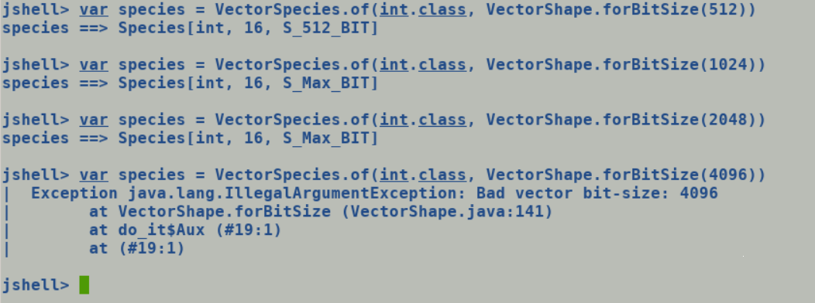

Abstract Vector Class: FloatVector

Concrete Vector Class: Float64Vector, Float128Vector, Float256Vector, Float512Vector

What about non-standard species? E.g., 1024, fallback implementation can handle any arbitrary sized arrays since lambda operate over individual array elements.

Passing vector across call.

Abstract class A {}

Primitive class B extends A {}

Caller {

A vec = new B();

obj.Callee(vec);

}

Int -> I2C -> Compile [Un]verified Inline Entry point (contents of receiver unpacked)

Compiler -> Compile [Un]verified entry point (primitive instance is passed as scalars from caller, no additional unpacking needed).

C2 -> C2 calls are always guaranteed to call the [un]verified entry points (not the inlined entry points)

Method JIT does make a receiver type check at unverified entry points and unpacks concrete primitive type arguments. To check if it also handled abstract class argument based on argument type profiles. But it may result into generation of multiple versions of method since its callee argument are call site specific.

Constraints imposed by class hierarchy on class hierarchy :-

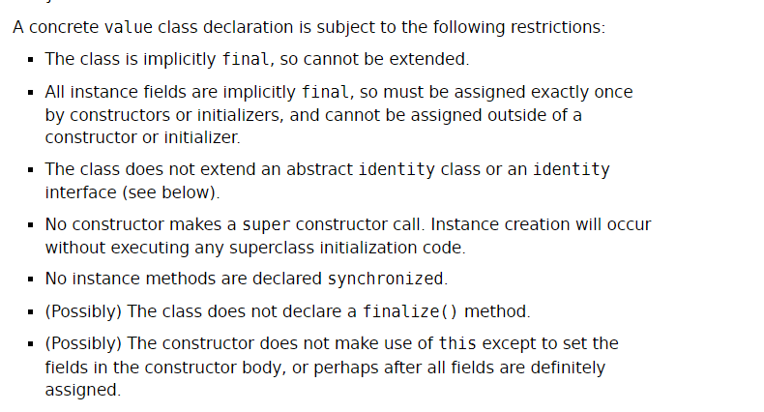

New hierarchy, all the parent classes to have class specific fields barring leaf level primitive class having multifield based backing storage



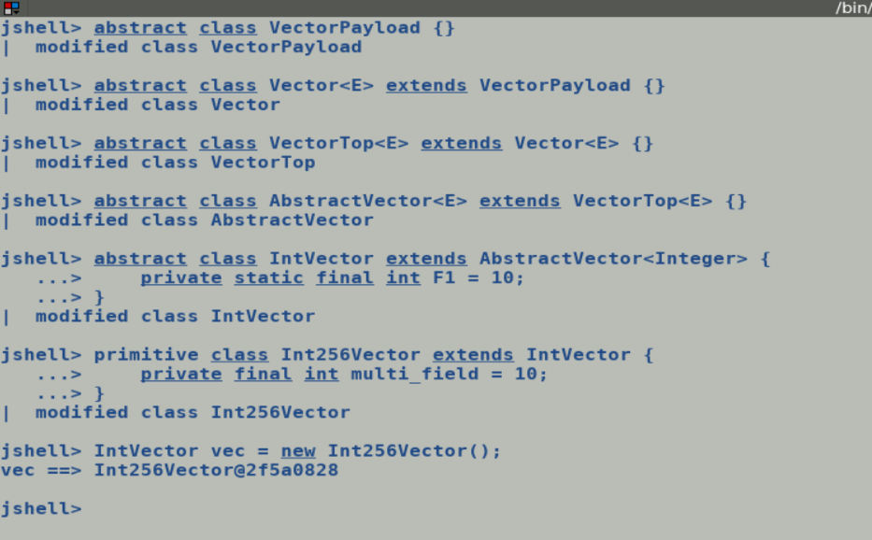

Number and type of fields in abstract vector class :-

jshell> IntVector.class.getDeclaredFields()[0]

$3 ==> static final int jdk.incubator.vector.IntVector.FORBID_OPCODE_KIND

jshell> IntVector.class.getDeclaredFields()[1]

$4 ==> static final java.lang.foreign.ValueLayout$OfInt jdk.incubator.vector.IntVector.ELEMENT_LAYOUT

jshell> IntVector.class.getDeclaredFields()[2]

$5 ==> private static final jdk.incubator.vector.VectorOperators$ImplCache jdk.incubator.vector.IntVector.UN_IMPL

jshell> IntVector.class.getDeclaredFields()[3]

$6 ==> private static final jdk.incubator.vector.VectorOperators$ImplCache jdk.incubator.vector.IntVector.BIN_IMPL

jshell> IntVector.class.getDeclaredFields()[4]

$7 ==> private static final jdk.incubator.vector.VectorOperators$ImplCache jdk.incubator.vector.IntVector.BIN_INT_IMPL

jshell> IntVector.class.getDeclaredFields()[5]

$8 ==> private static final int jdk.incubator.vector.IntVector.SHIFT_MASK

jshell> IntVector.class.getDeclaredFields()[6]

$9 ==> private static final int jdk.incubator.vector.IntVector.LSHR_SETUP_MASK

jshell> IntVector.class.getDeclaredFields()[7]

$10 ==> private static final jdk.incubator.vector.VectorOperators$ImplCache jdk.incubator.vector.IntVector.TERN_IMPL

jshell> IntVector.class.getDeclaredFields()[8]

$11 ==> private static final jdk.incubator.vector.VectorOperators$ImplCache jdk.incubator.vector.IntVector.REDUCE_IMPL

jshell> IntVector.class.getDeclaredFields()[9]

$12 ==> private static final int jdk.incubator.vector.IntVector.MIN_OR_INF

jshell> IntVector.class.getDeclaredFields()[10]

$13 ==> private static final int jdk.incubator.vector.IntVector.MAX_OR_INF

jshell> IntVector.class.getDeclaredFields()[11]

$14 ==> static final int jdk.incubator.vector.IntVector.ARRAY_SHIFT

jshell> IntVector.class.getDeclaredFields()[12]

$15 ==> static final long jdk.incubator.vector.IntVector.ARRAY_BASE

jshell> IntVector.class.getDeclaredFields()[13]

$16 ==> public static final jdk.incubator.vector.VectorSpecies jdk.incubator.vector.IntVector.SPECIES_64

jshell> IntVector.class.getDeclaredFields()[14]

$17 ==> public static final jdk.incubator.vector.VectorSpecies jdk.incubator.vector.IntVector.SPECIES_128

jshell> IntVector.class.getDeclaredFields()[15]

$18 ==> public static final jdk.incubator.vector.VectorSpecies jdk.incubator.vector.IntVector.SPECIES_256

jshell> IntVector.class.getDeclaredFields()[16]

$19 ==> public static final jdk.incubator.vector.VectorSpecies jdk.incubator.vector.IntVector.SPECIES_512

jshell> IntVector.class.getDeclaredFields()[17]

$20 ==> public static final jdk.incubator.vector.VectorSpecies jdk.incubator.vector.IntVector.SPECIES_MAX

jshell> IntVector.class.getDeclaredFields()[18]

$21 ==> public static final jdk.incubator.vector.VectorSpecies jdk.incubator.vector.IntVector.SPECIES_PREFERRED

jshell> IntVector.class.getDeclaredFields()[19]

$22 ==> static final boolean jdk.incubator.vector.IntVector.$assertionsDisabled

Advantage of multi-field-based backing storage over existing implementation.

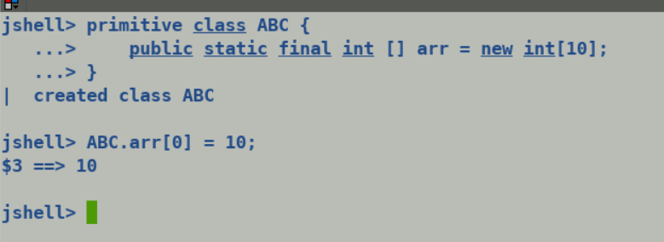

Final arrays are not immutable despite of being static final (frozen arrays guarantees immutability)

Static final multi-field will ensure immutability.

Loading vector.

Case A )

Existing Primitive type multi-field

Operation over arrays.

Case B )

Existing Primitive type multi-field

Storing arrays

Case C)

Existing Primitive type multi-field

Simple example usage of Primitive class.

primitive class Point {

int x;

int y;

}

VM Flags:

InlineTypePassFieldsAsArgs

InlineTypeReturnedAsFields

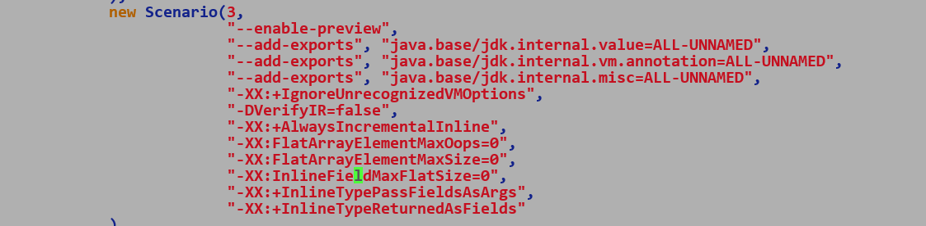

Important Code Pointers:-

Method::is_scalarized_arg , predicate : bt == T_PRIMITIVE_OBJECT

Method::has_scalarized_args only looks at method signatures to decide on scalarizability.

CompiledEntrySignature::has_scalarized_args() -> sets scalarized argument flags over Method during adapter creation.

BasicType inferencing of arguments is solely driven by argument signature (Q<CLASS>; -> T_PRIMITIVE_OBJECT, L<CLASS>; -> T_OBJECT) , checkout SignatureStream::next

KlassFactory::create_from_stream constructs InlineClasses during Class Loading and parsing if it encounters ACC_VALUE access flag.

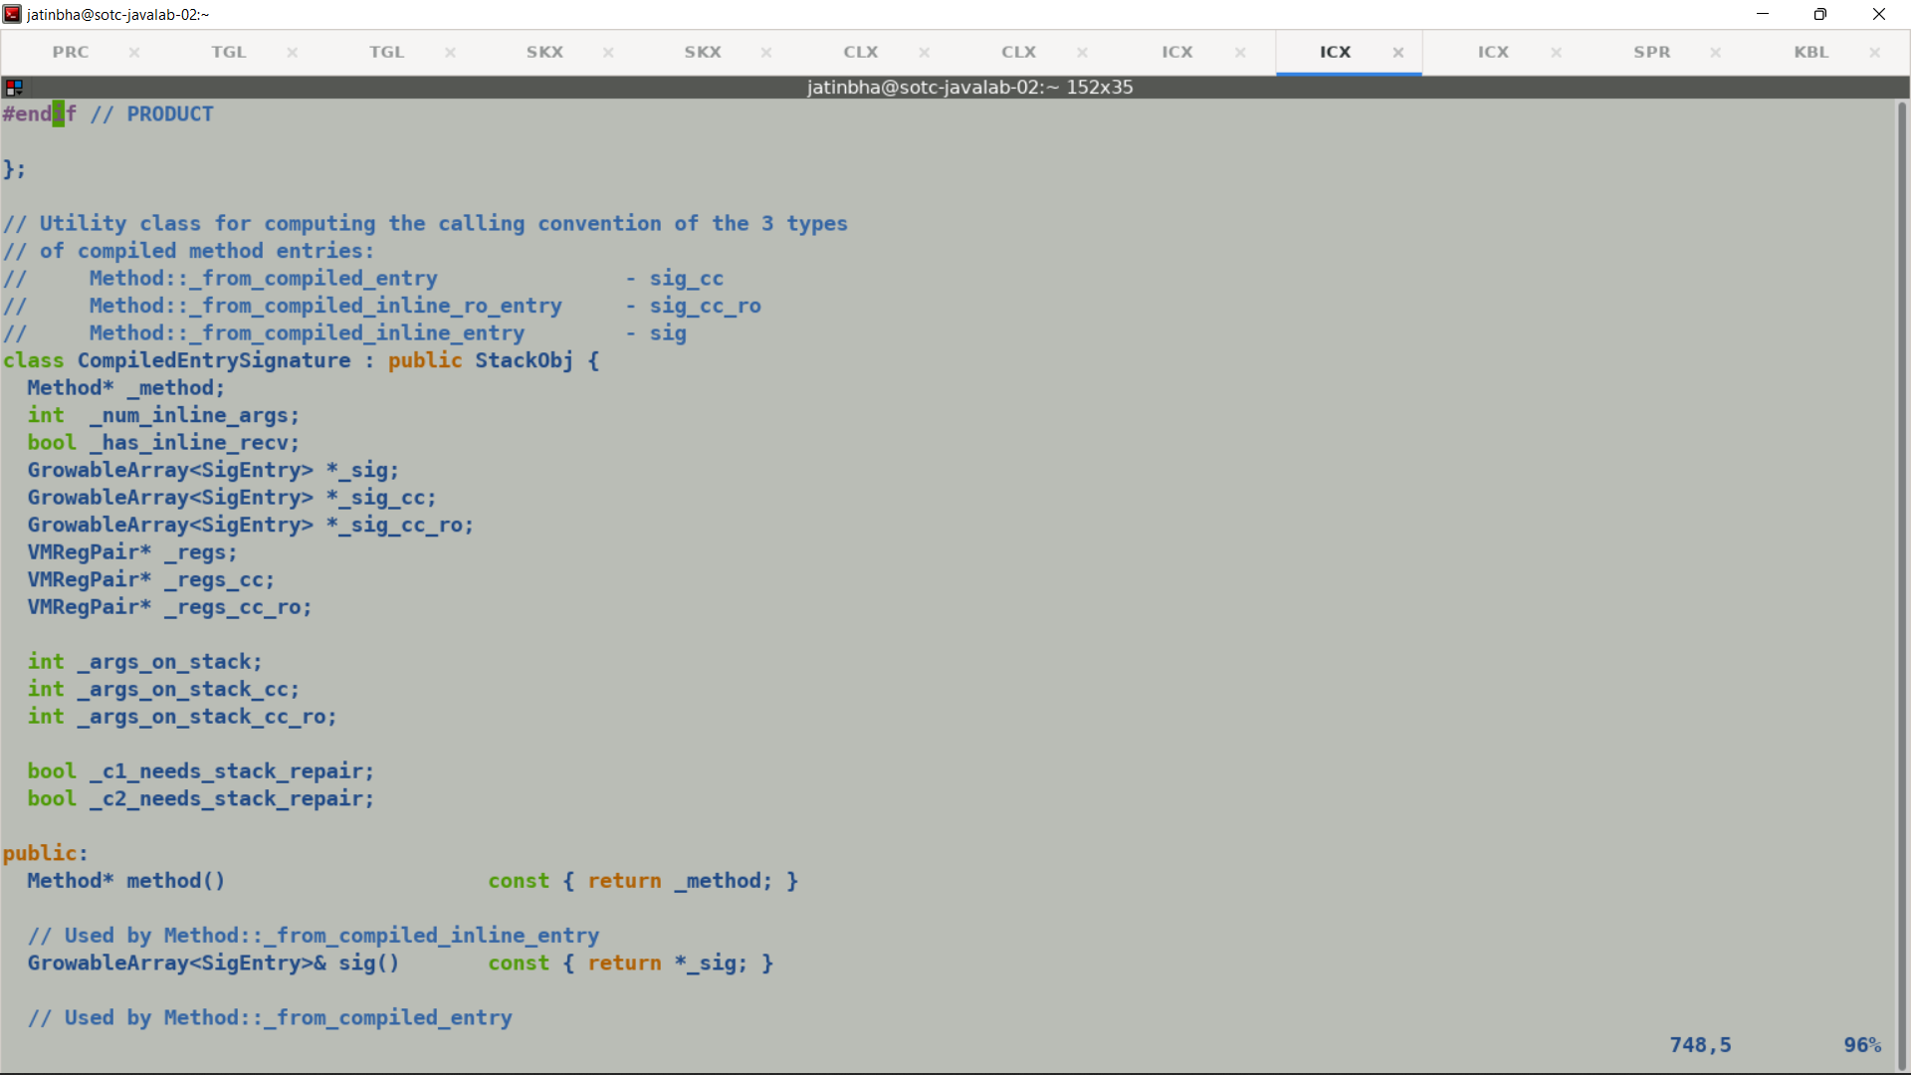

C2 IR:-

Two ways to handle box expansions, currently vectors are wrapped in boxes if they need to cross method boundary (a non-intrinsic API / regular java method).

1. VectorBoxNode (VectorNode) ->

VectorNode

_______________|_________________

|

VectorExtract VectorExtract …….

| | ………………

InlineTypeBaseNode (TypeInlineType : VectorPayloadMF64)

|

(AllocateNode)

May favor procedure in-lining

1. VectorBoxNode (VectorNode)

P1 = AllocateBuffer (Payload)

Copy VectoNode -> P1

B1 = AllocateBox (VectorType)

Assign B1.mfield = P1

**Incubator symbols are not resolvable by VM, it expects all the vmSymbols to be part of java.base module. Can be handled by name-based resolution for offset computation.**

Loose coupling b/w multi-field payload, generate on the fly when needed.

Life cycles of Valhalla:

Java Source:

primitive class Point {

int field1;

int field2;

Point (int x, int y) {

Field1 = x;

Field2 = y;

}

}

P1 = new Point(Param0, Param1);

P2 = new Point(Param2, Param3);

return new Point(p1.field1 + p2.field1, p1.field2 + p2.field2);

Byte codes:

Class Point:

Point.<init>

aconst_init

astore_2

iload_1

aload_2

swap

withfields

astore_2

iload_2

aload_2

swap

withfield

Compile handles inline type instances in a special way, it does not request any heap allocations for these instances, instead entire instance is fully represented in the IR as a new InlineTypeNode whose incoming edges are connected to scalar parameters. This promotes opportunity for its user to tier though the InlineTypeNode and directly get the scalar values using getfield and putfiled byte codes.

Bytecodes

1. aconst_init: Creates a default InlineTypeNode , inputs are tied to Params one for each scalar field of inline type.
2. withfiled: Updates one of the field of the InlineTypeNode, creates a new IR and copies all the inputs from original IR and replaced the edge corresponding to updated filed with new input.

Throughout the compilation flow a primitive type instance is represented using InlineTypeNodes with TypeInlineType as its IR type.

Vector as Values:

VectorPayload (abstract identity)

DoubleVector (abstract identity)

Double512Vector (Value) ACC_VALUE

mfield : VectorPayloadMF64 (primitive)

DoubleVector.fromArray (SPECIES, arr, index)

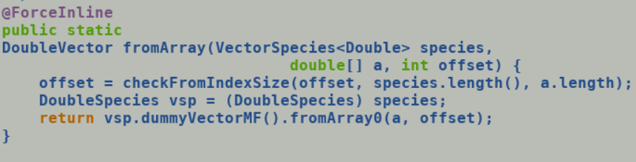

dummyVectorMF and all its callees carry forced Inline attribute, leaf level call allocates a

new VectorPayloadMF64/128/256/512() | C2 will create an InlineTypeNode for it.

But anyways dummyVectorMF are mainly used to pump concrete type information into IR which facilitates de-virtualization of accessors.

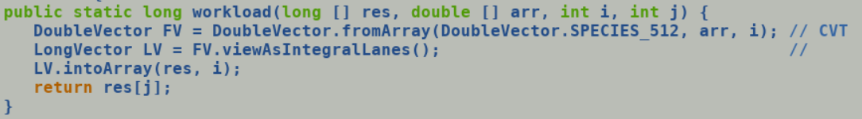

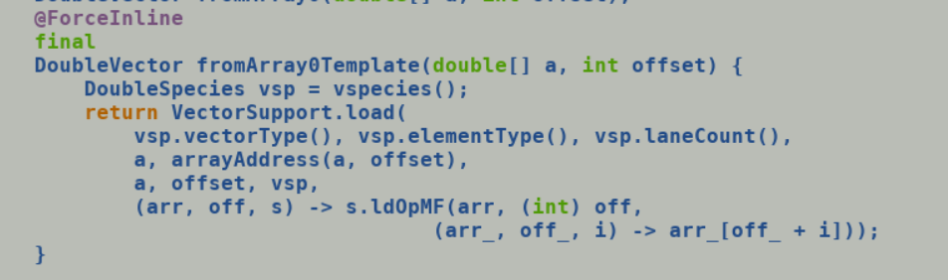

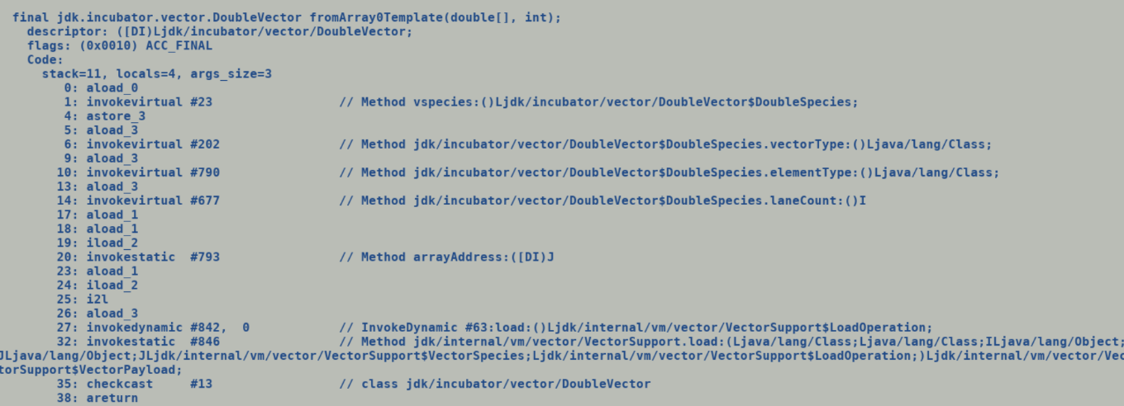

C2 follows lazy intrinsification for vector intrinsic, this gives the needed time for constants to seep in and thus promotes the chances of inline expansion.

During Parsing VectorSupport.load will be replaced by CallStaticNode, it type will be inferred using the descriptor defined intrinsification layer (vmIntrinsics).

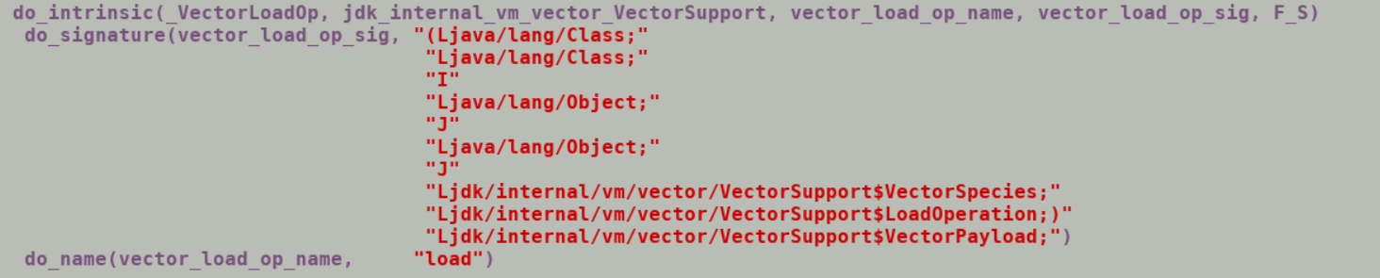

Immediately after intrinsic call there is a checkcast bytecode which tries to typecast the Call projection to DoubleVector type, C2 also consults profile information to get a granular target type, in this case it will discover Double512Vector (concrete type), since it’s a value type and input instance is still (we are in parsing) a reference type so compiler first generated a InlineTypeNode

CallStaticJavaNode (VectorPayload) [ 64 bytes) |

LoadVector VBoxNode (Double512)

(LoadB

InlineTypeNode (Double512)

|

Multi-field handling.

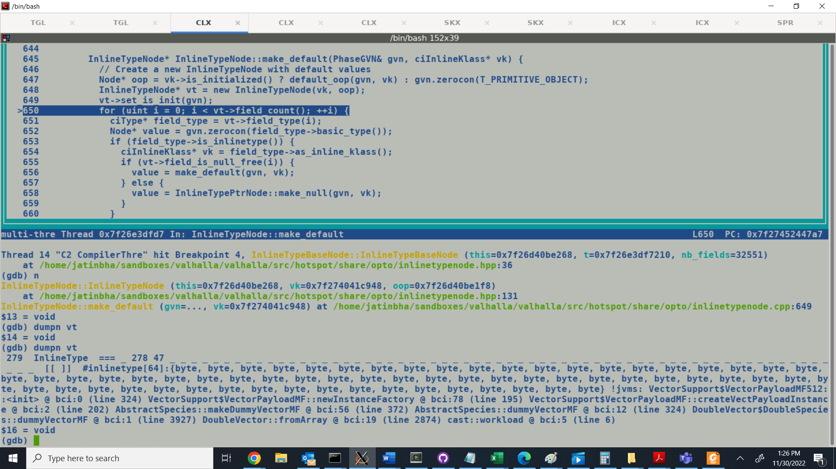

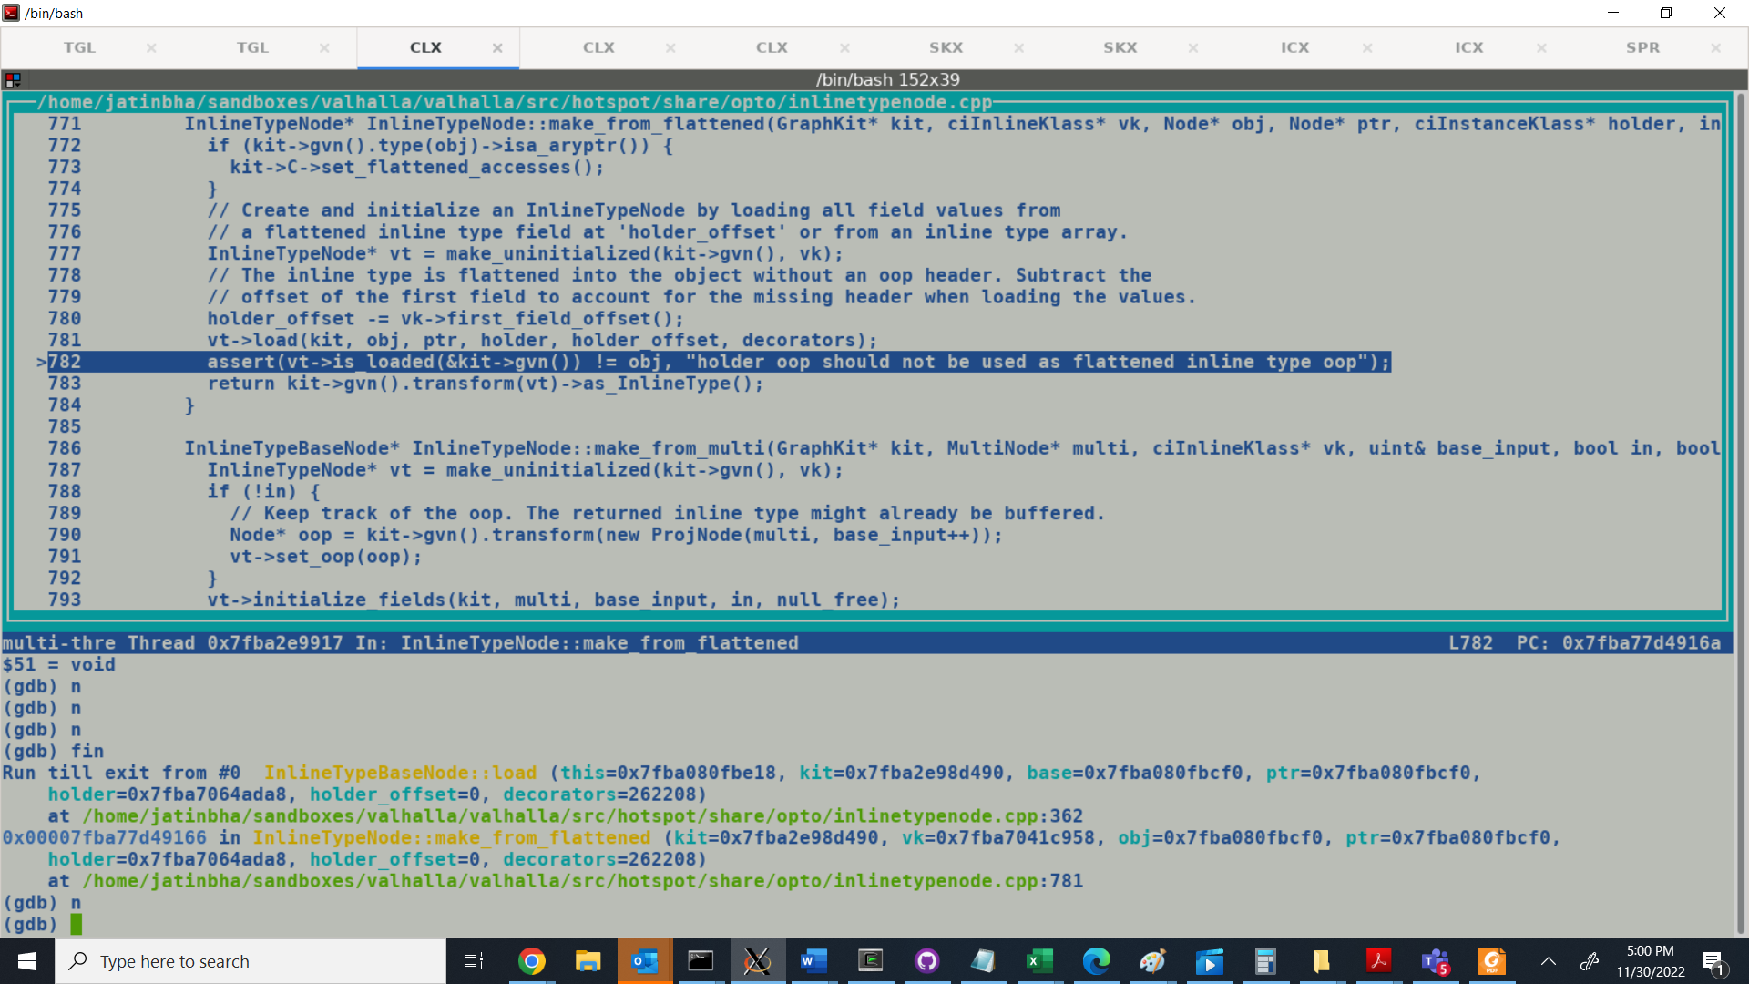

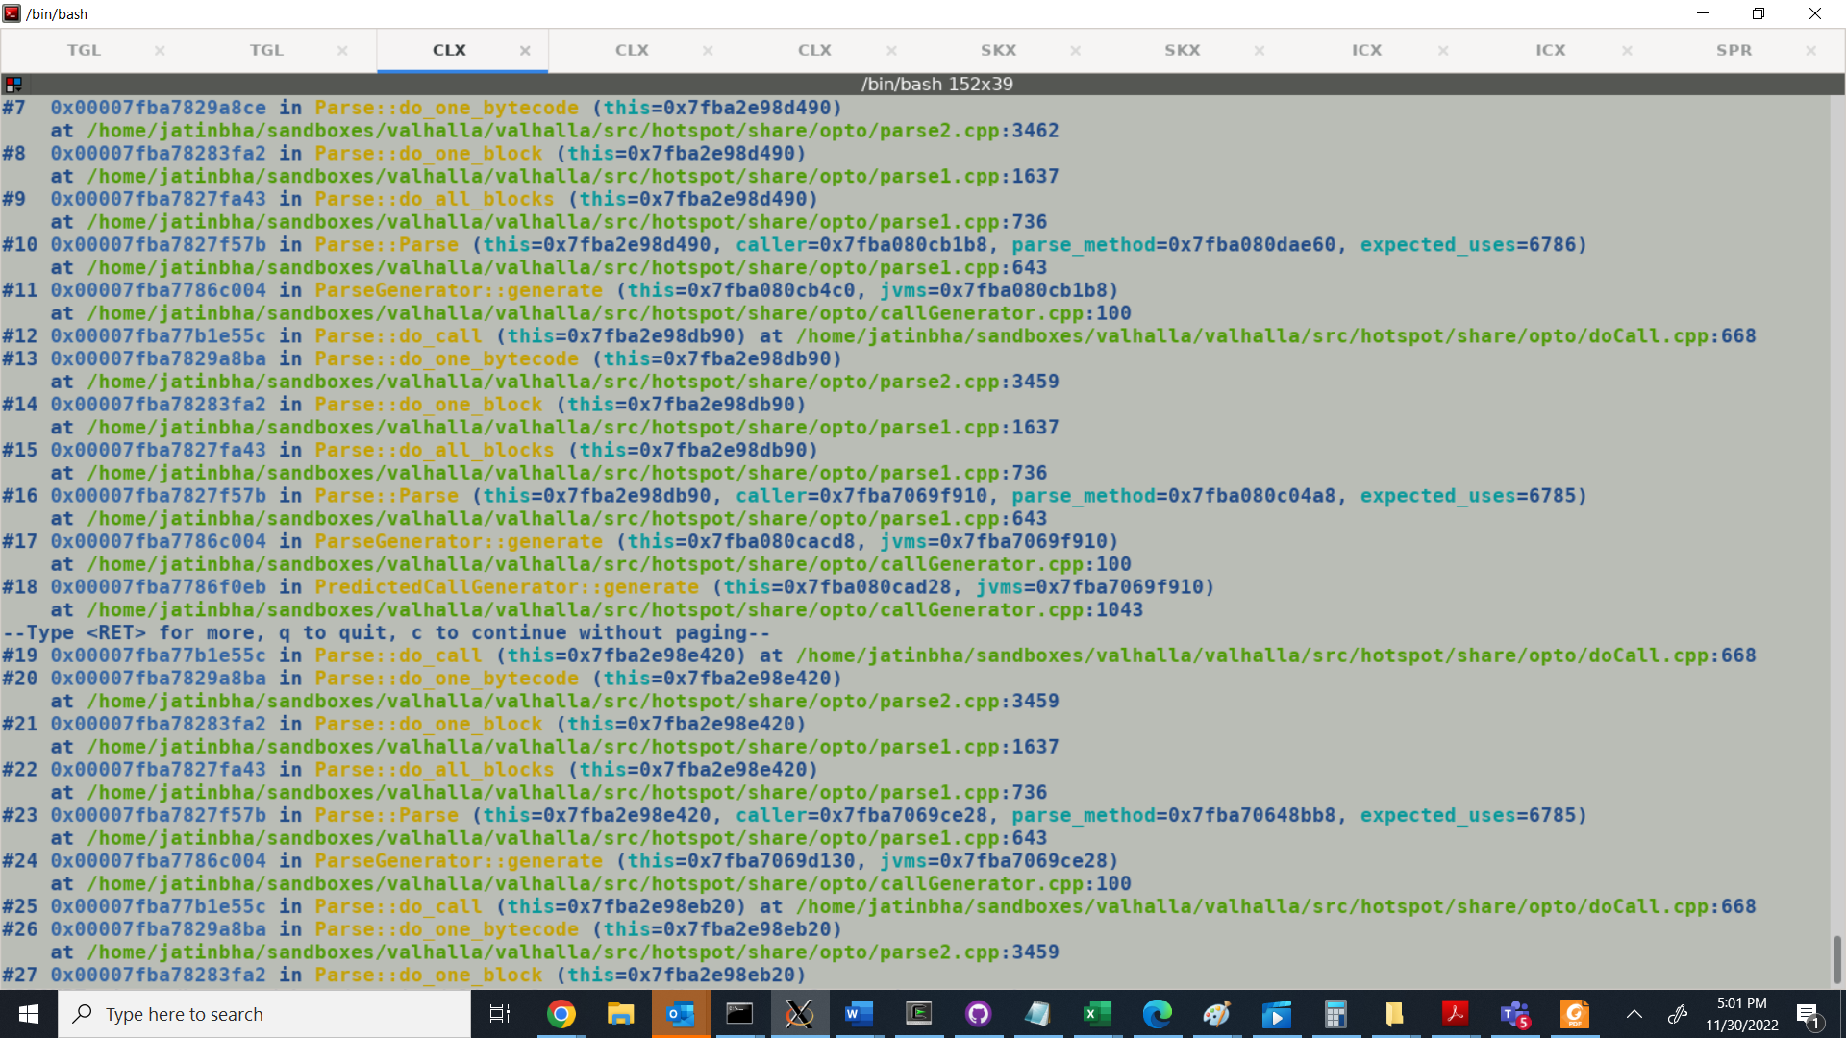

**Concrete value class layout: Double512Vector**

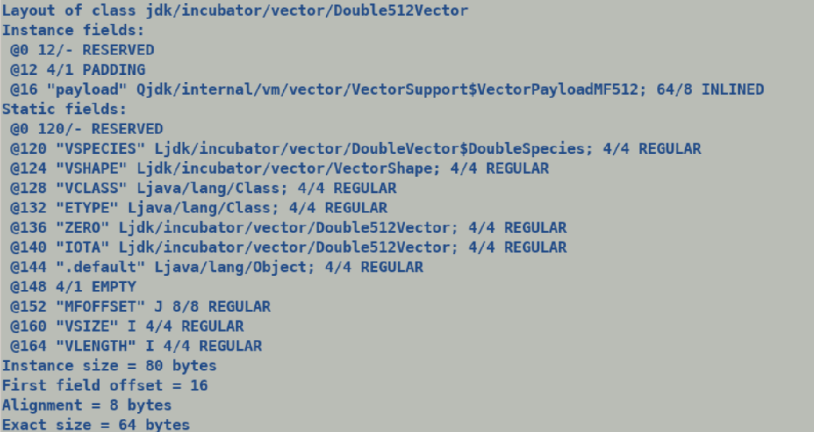

JVM Flags => PrintFieldLayout || (PrintInlineLayout && _has_flattening_information))

Java dynamic layout computation at runtime.

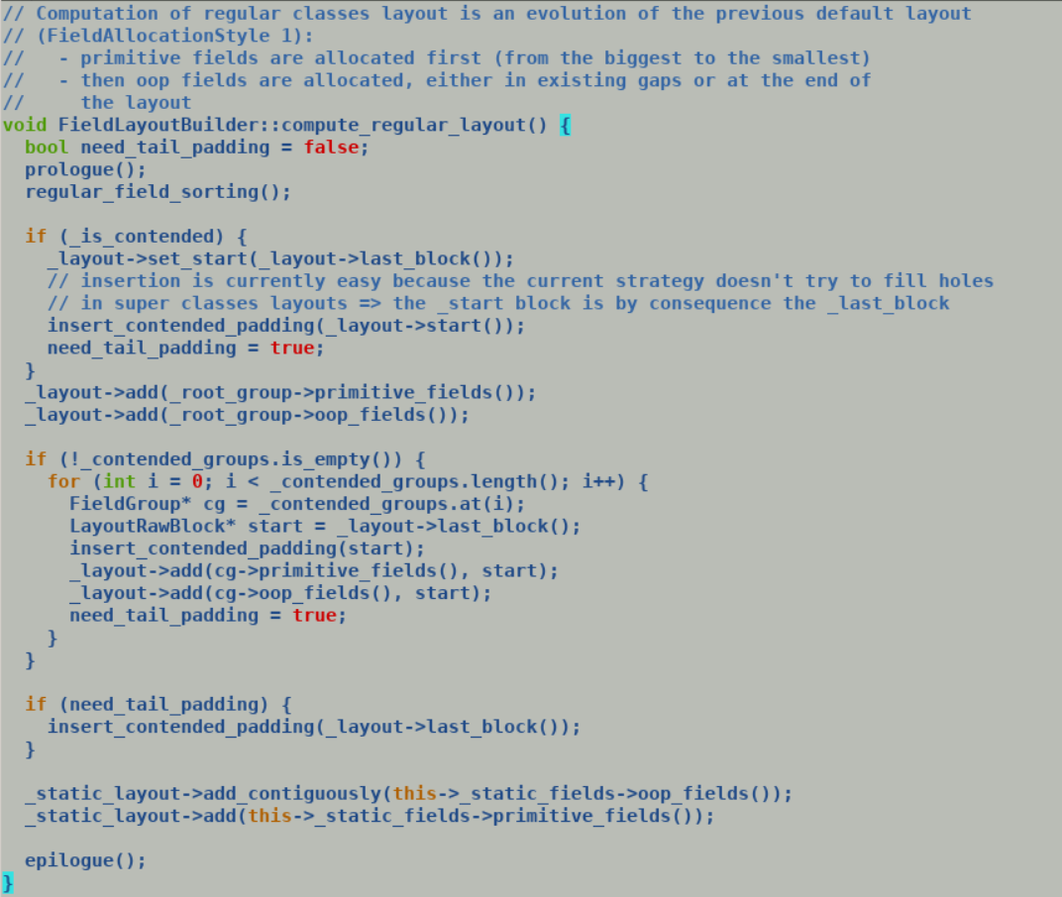

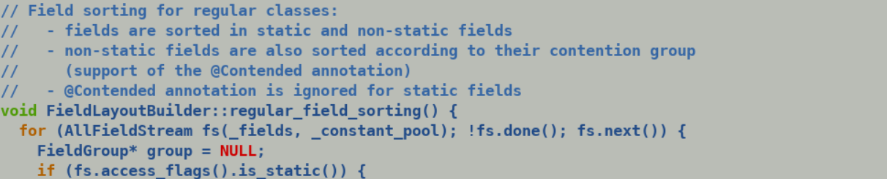

inline bool fieldDescriptor::is_inline_type() const { return Signature::basic_type(field()->signature(_cp())) == T_PRIMITIVE_OBJECT; }

inline bool fieldDescriptor::is_multifield() const { return field()->is_multifield(); };

inline u2 fieldDescriptor::multifield_base() const { return field_holder()->multifield_info(field()->secondary_index()).base_index(); }

Source:

DoubleVector vec = DoubleVector.fromArray(SPECIES, ARR, 0);

vec.convertShape(DSPECIES);

Few notes on Multifield handling in oops model:

* ClassFileParser create a separate fieldInfo for each static/non-static filed of a class.

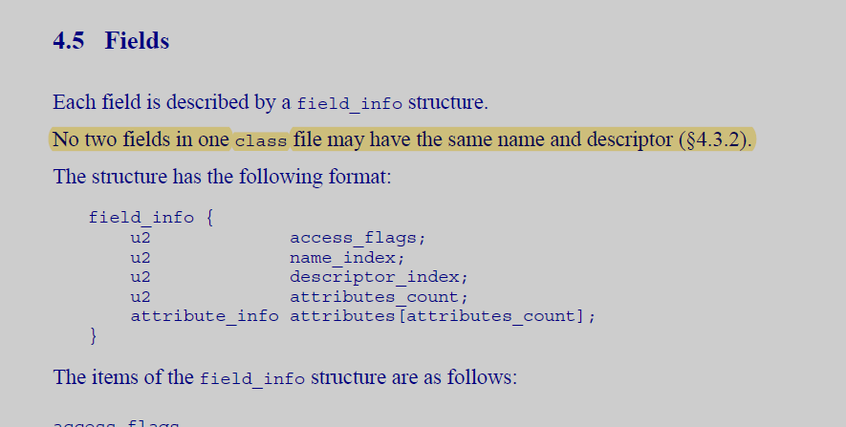

* When parser encounters a multi-field it first creates a multifield base field followed by secondary fields. Additional bookkeeping structure MultifieldInfo records the base field index and the secondary field index.
* Creating a separate fieldInfo for each multi-field simplifies the logic for layout computation.
* Compiler interface model sees each field as an independent scalar field, and thus out VectorPayloadMF payloads gets exposed to compiler as a bundle of scalar byte fields.

IR Stuff:

VectorSupport.load(elemType.class, vectorType.class, lanes, arr_base, index)

CALL = CallStaticDirectNode [ ] ( VectorSupport.VectorPayload)

Proj ()

CheckCast DoubleVector CALL -> With profile DoubleVector512.

(identity -> value conversion)

1. InlineTypeBaseNode : Default value node.
2. Initialize field[s] of value node by loading the contents of identity nodes.
   1. Since VectorPayloadMF64/128/256/512 are based on byte level multifeilds hence we end up generating lots of LoadB.
3. Instead we can skip any IR creation for synthetic multi-fields and treat the base level multifield as a vector. This will simplify the IR glue logic during identity to value conversions.

Thus, IR for VectorPayloadMF128 should look like following.

Param/LoadVector from IdentityObject from filed Address (TypeVect)

InlineTypeNode (TypeInlineType : VectorPayLoadMF128)

VectorUnboxNode -> may not be needed any more, we just need to in force the unboxing semantics, i.e. return the incoming edge of InlineTypeNode.

Thus, we may not need any explicit VectorUnbox (VectorBox X) => X transformation.

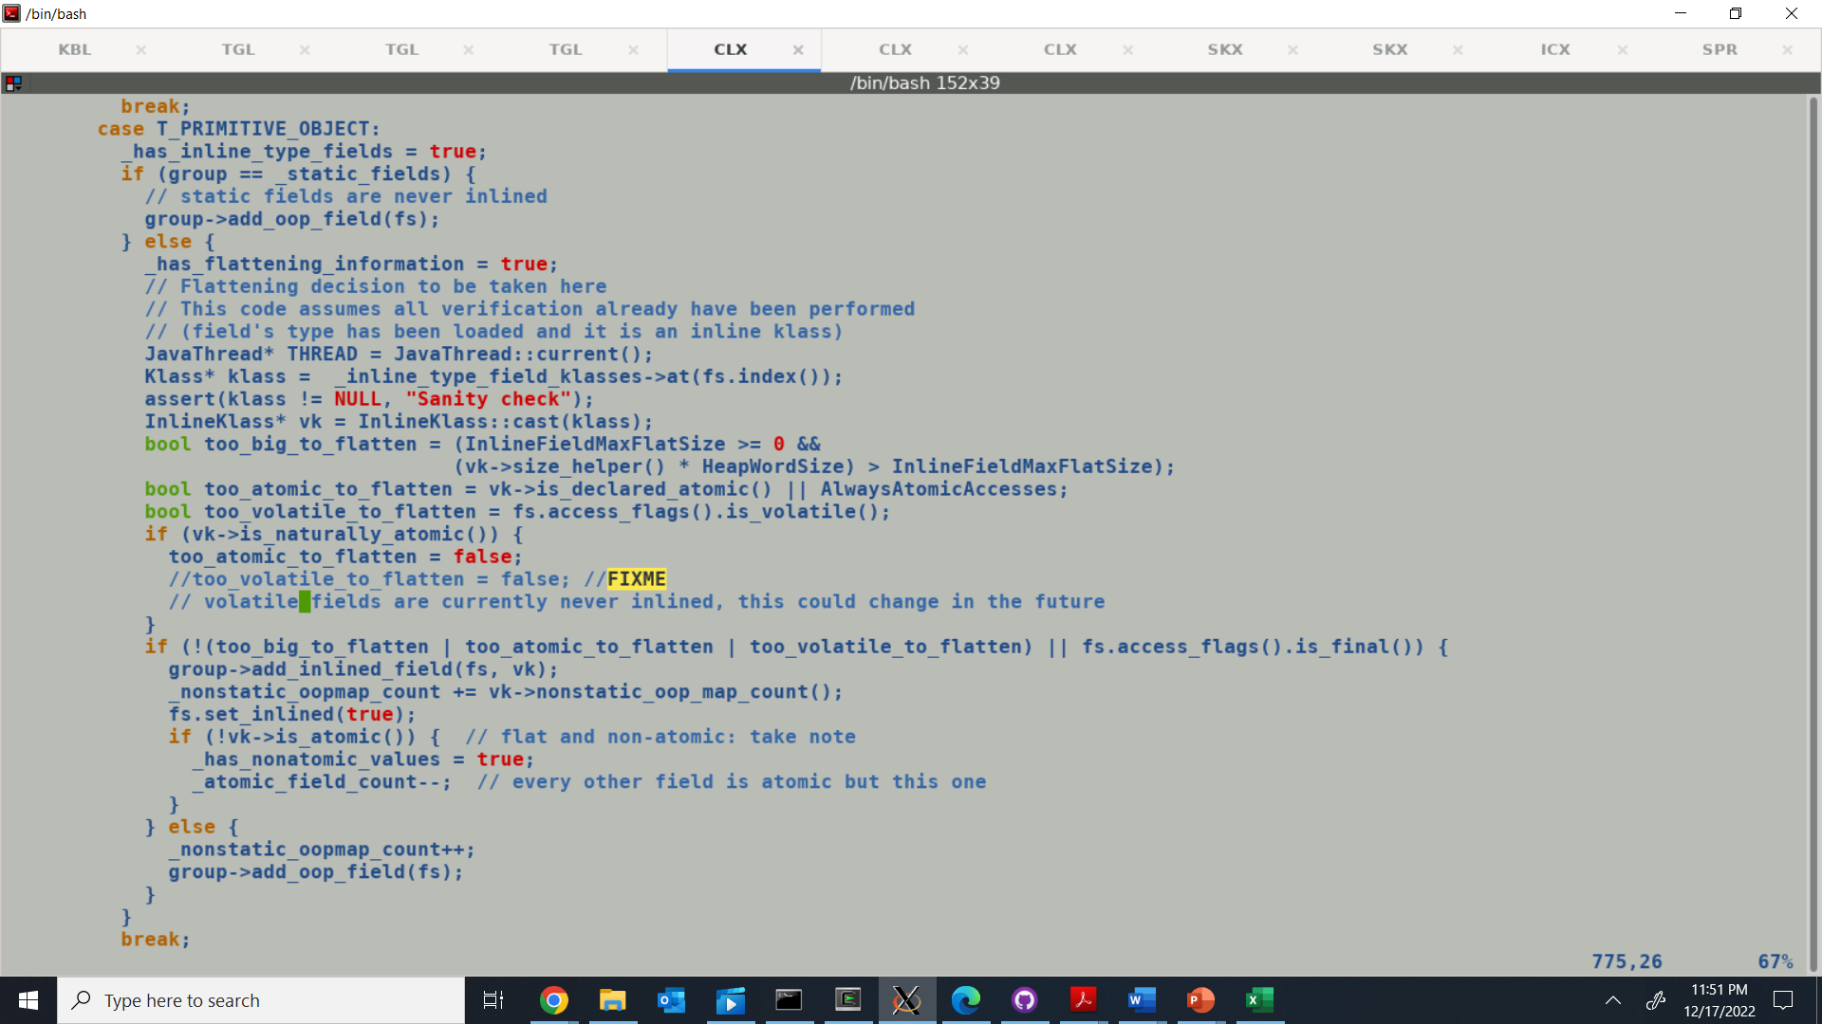



Optimal IR generation during identity to value conversions.

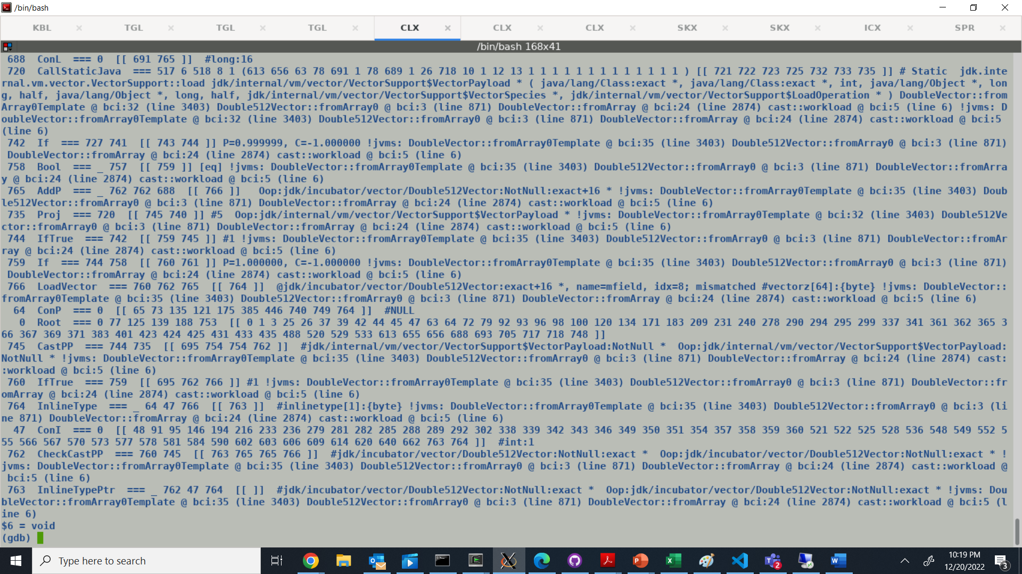

VM symbol initialization is followed by resolve_all to load the corresponding classes.

(gdb) i b

Num Type Disp Enb Address What

1 breakpoint keep y 0x00007f57b0cfdbca in vmSymbols::initialize()

at /home/intel/jatinbha/sandboxes/valhalla/valhalla/src/hotspot/share/classfile/vmSymbols.cpp:79

2 breakpoint keep y 0x00007f57b0cc6a04 in vmClasses::resolve_all(JavaThread*)

at /home/intel/jatinbha/sandboxes/valhalla/valhalla/src/hotspot/share/classfile/vmClasses.cpp:118

VectorPayload is part of java.base module. This loads the VectorPaylod at startup, creates a VM symbol to refer to it, and does necessary initializations for computing payload offsets.

Post inline expansion result.

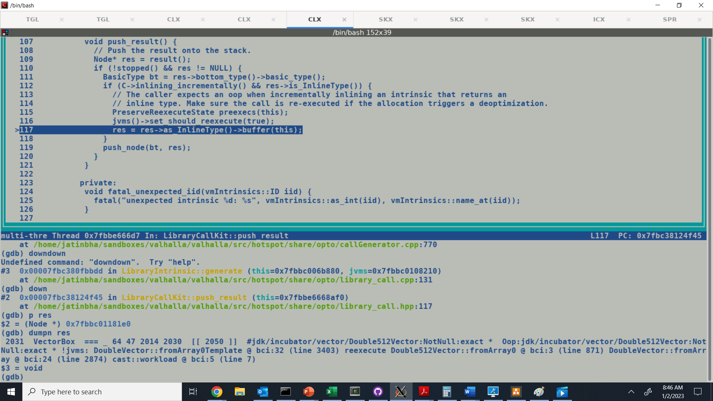

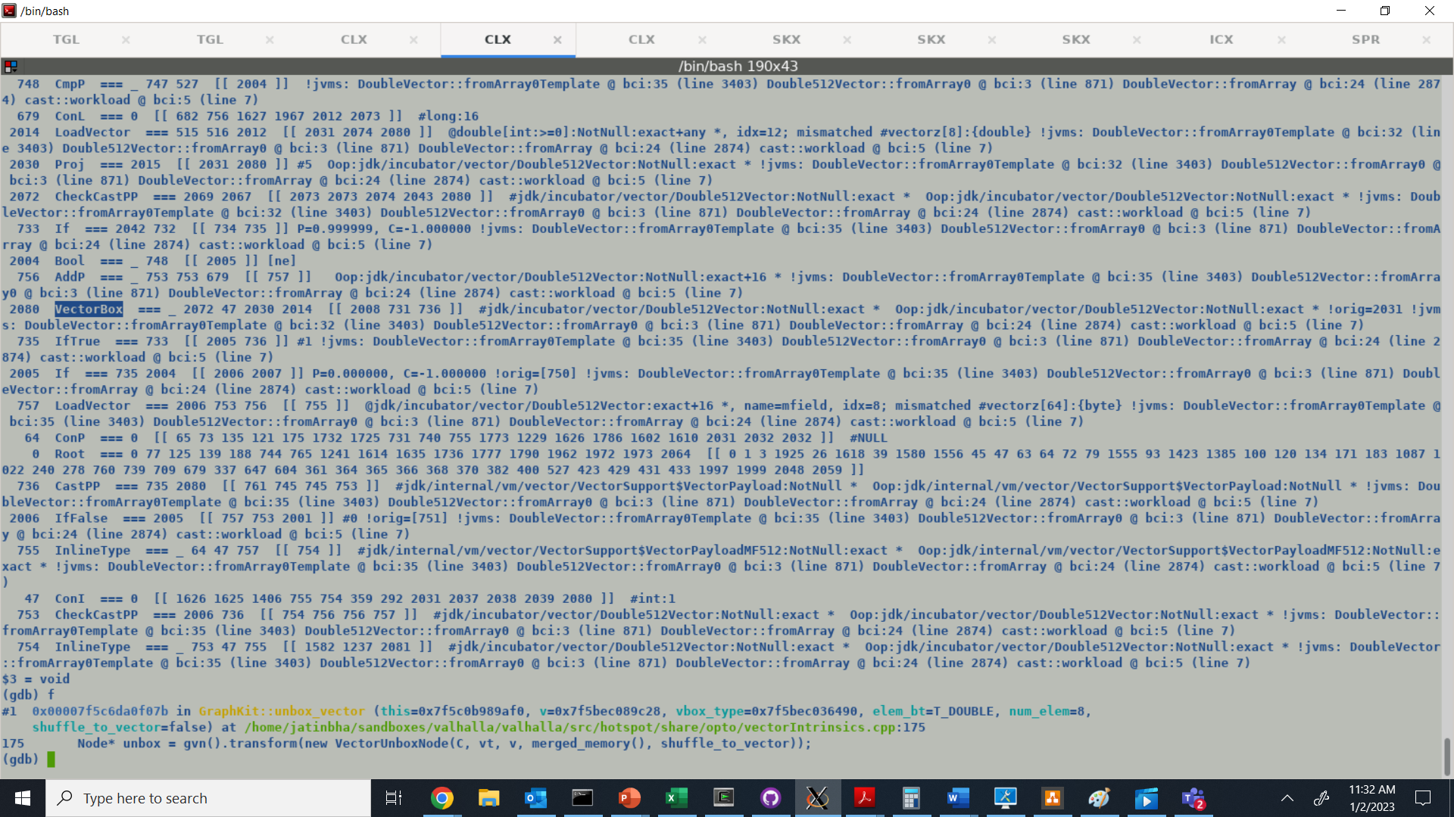

Post parsing IR dump: -

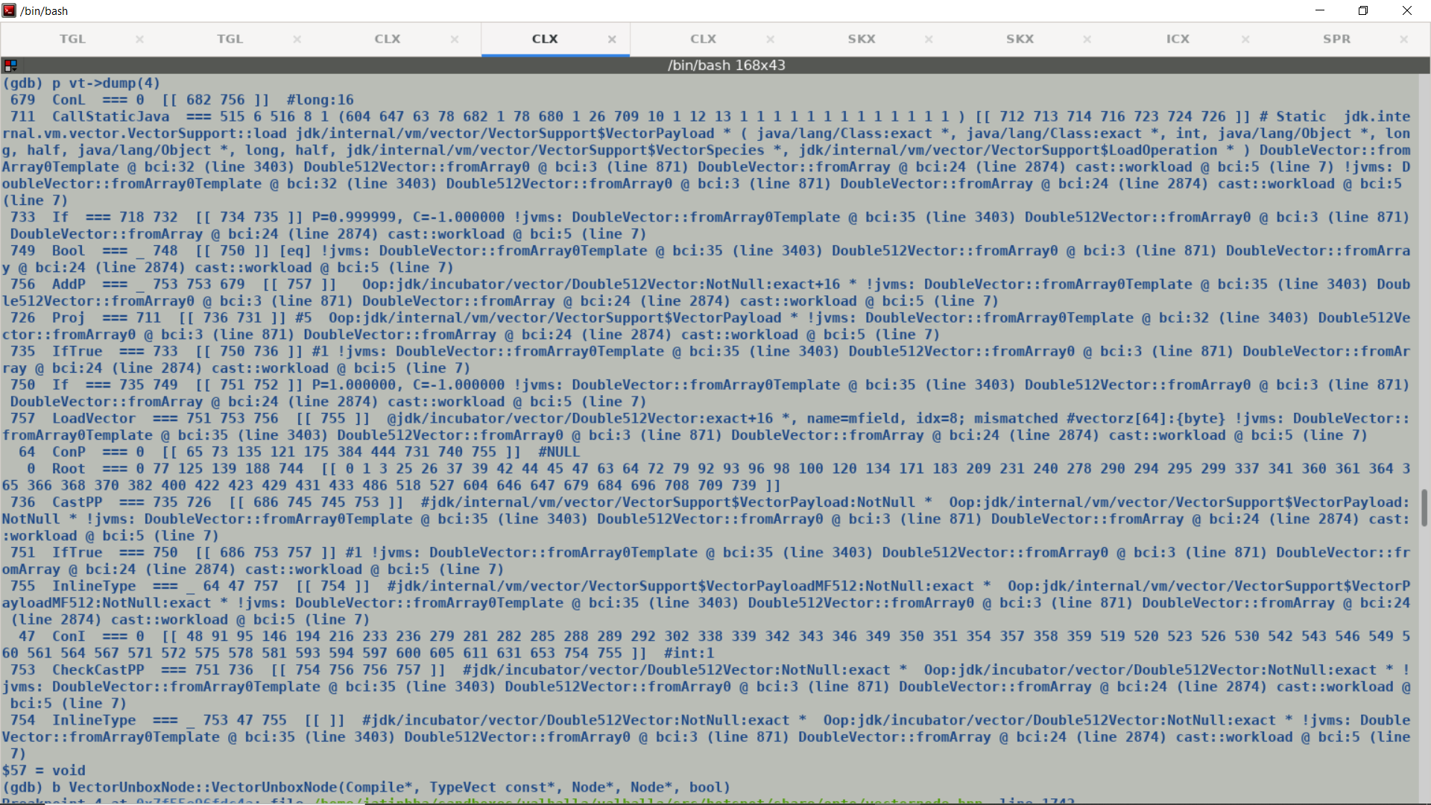

Post Inline Expansion, Call replaced by VectorBoxNode. We need to fold away rest of the IR nodes for Unboxing-Boxing sweeping. Call projection in above IR is of abstract identity type, whereas Boxes carry a concrete value types, this is sufficient to sweep away intermediate CheckPP (for null check) and subsequent CheckCastPP since incoming node type carries same type.

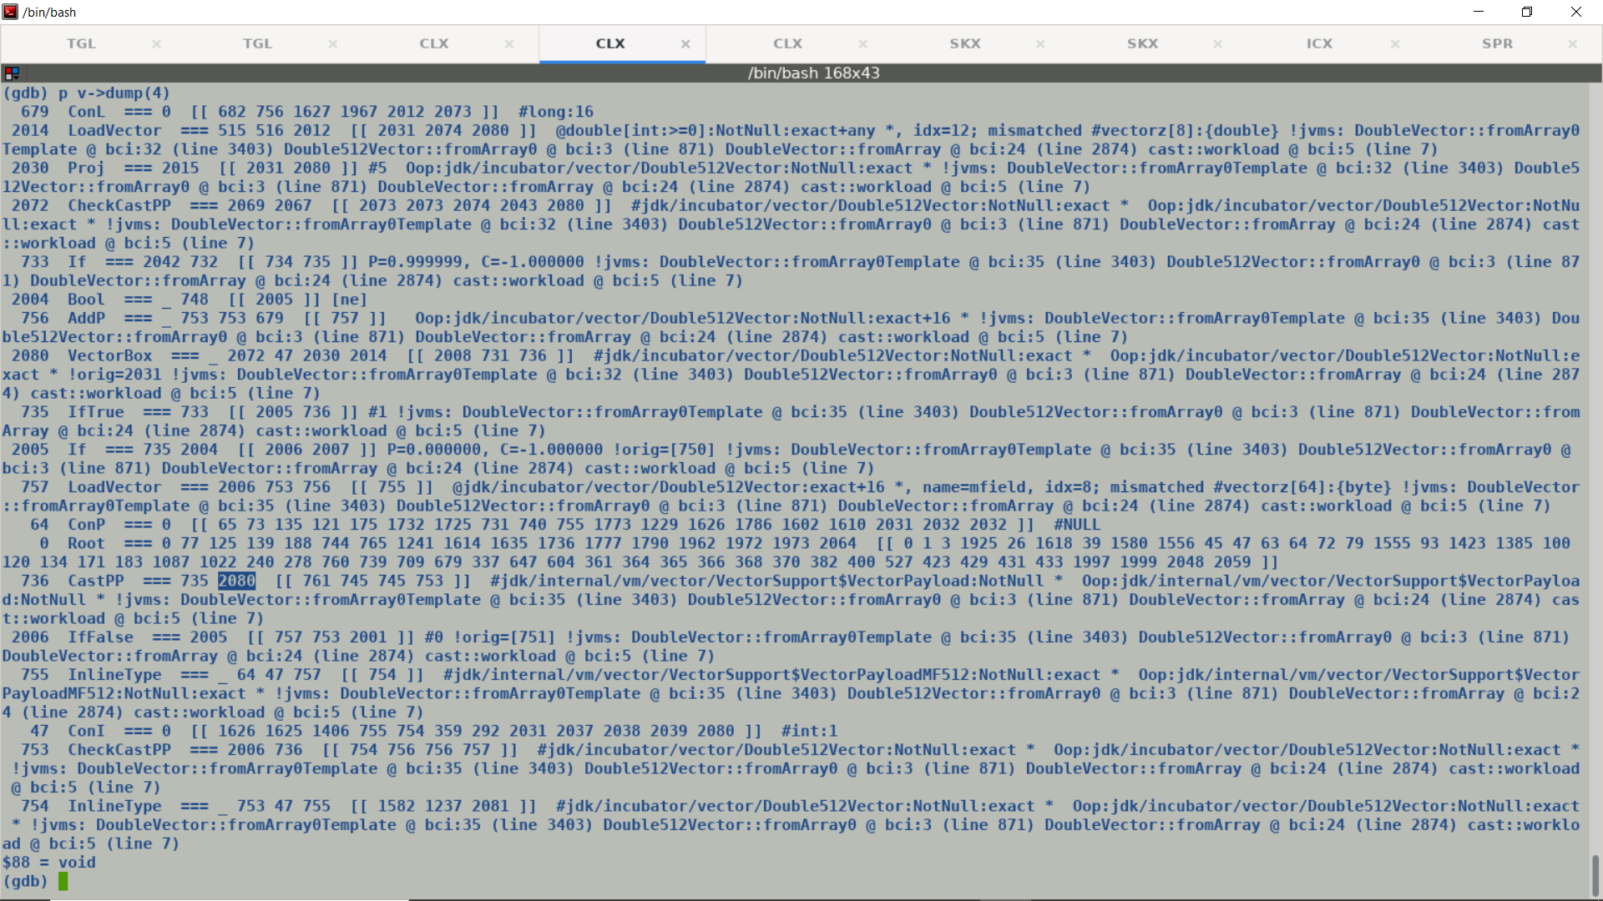

IR dump post lazy buffering for Vector Boxes

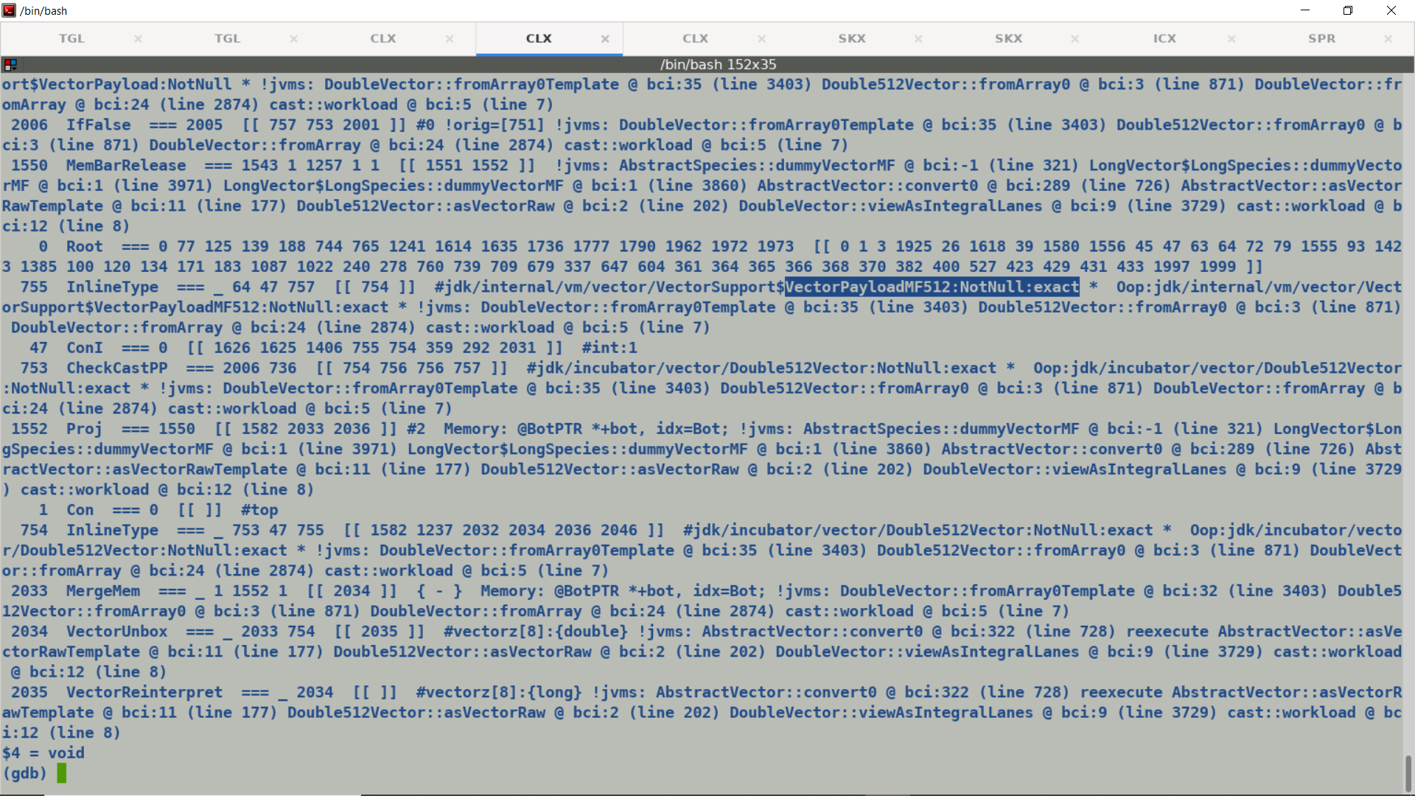

CPROMPT>javad -XX:CompileCommand=compileonly,inline_array::micro -XX:+PrintFieldLayout -cp . inline_array ; -XX:+PrintInlineLayout

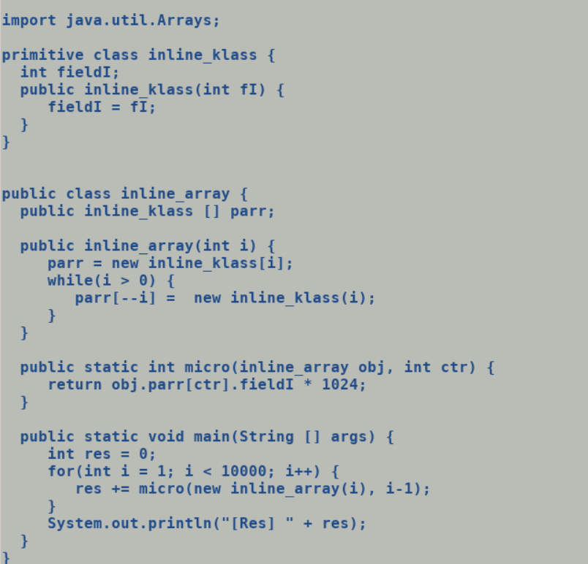

Layout of class inline_array

Instance fields:

@0 12/- RESERVED

@12 "parr" [Qinline_klass; 4/4 REGULAR

Static fields:

@0 120/- RESERVED

Instance size = 16 bytes

---

Layout of class inline_klass

Instance fields:

@0 12/- RESERVED

@12 "fieldI" I 4/4 REGULAR

Static fields:

@0 120/- RESERVED

@120 ".default" Ljava/lang/Object; 4/4 REGULAR

Instance size = 16 bytes

First field offset = 12

Alignment = 4 bytes

Exact size = 4 bytes

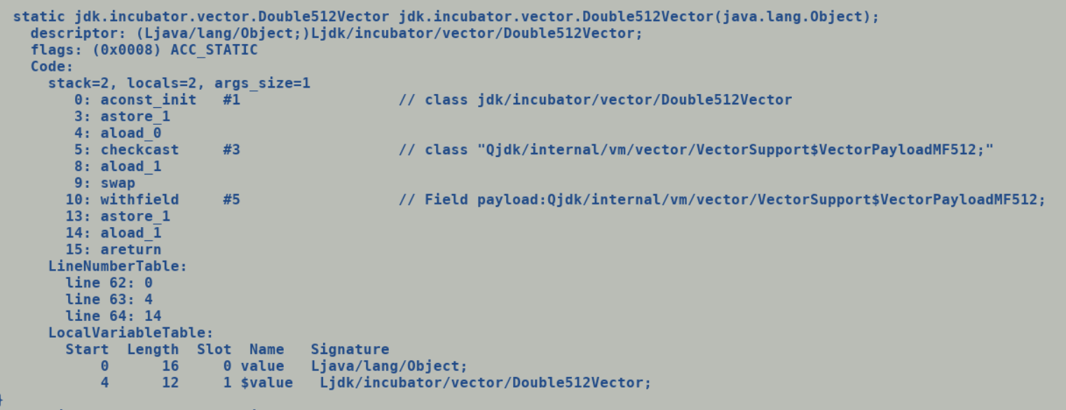

Source:

S1: dummyVectorMF().fromArray0(SPECIES, ARR, INDEX)

S2: dummyVectorMF() -> new Double512Vector ( new VectorPayload64MF())

S3:

if (dummyVectorMF != NULL)

return dummyVectorMF;

dummyVectorMF = makeDummyVectorMF();

C2 IR for S2:

**ReplicateB64**

**InlineTypeNode (VectorPayload64MF) : make_default**

|

InlineTypeNode (Double512Vector): make_uninitialized + field initialization

|

C2 IR for S3:

Bytecode for S3: getfield Double512Vector.dummyVectorMF

aconst_null

ifcmpeqa

Currently **dummyVector** is a stable field, its value can be used as constant after first initialization.

A comparison of a constant field with null reference gets folded out and we directly return dummyVector instead of generating the code for comparison followed by new allocation.

With dummyVectorMF comparison is not getting sweeped out since get field for a stable field is returning a NULL value. Holding class of dummyVectorMF / dummyVector is AbstractSpecies.

AbstractSpecies is the parent class for DoubleSpecies, since DoubleVector.SPECIES_* are all static final fields in DoubleVector thus post class loading during initialization new DoubleSpecies instances are allocated. In the stock implementation, first invocation of dummyVector method by interpreter results in allocation of new DoubleVector of size as per its holding species and this gets assigned (putfield) to stable field dummyVector. Subsequent access (getfield) of dummyVector field gets folded out since it’s a constant field instead of emitting a load access from its holder at field offset, this further folds out the comparison logic.

In new implementation, Double512Vector is a value object (unlike primitive objects it’s not null-free). During first invocation of dummyVectorMF method by interpreter DoubleVector gets allocated in buffer (part of heap).

Since all the fields of a value object are final values and

Its holder being a value class instance gets allocated in the buffer by interpreter (which is also a part of heap). In stock implementation, getfield bytecode for a constant/stable filed loads the value from the holding object at field offset and returns this value to compiler which creates a constant IR (Type for it).

Value class @stable field.

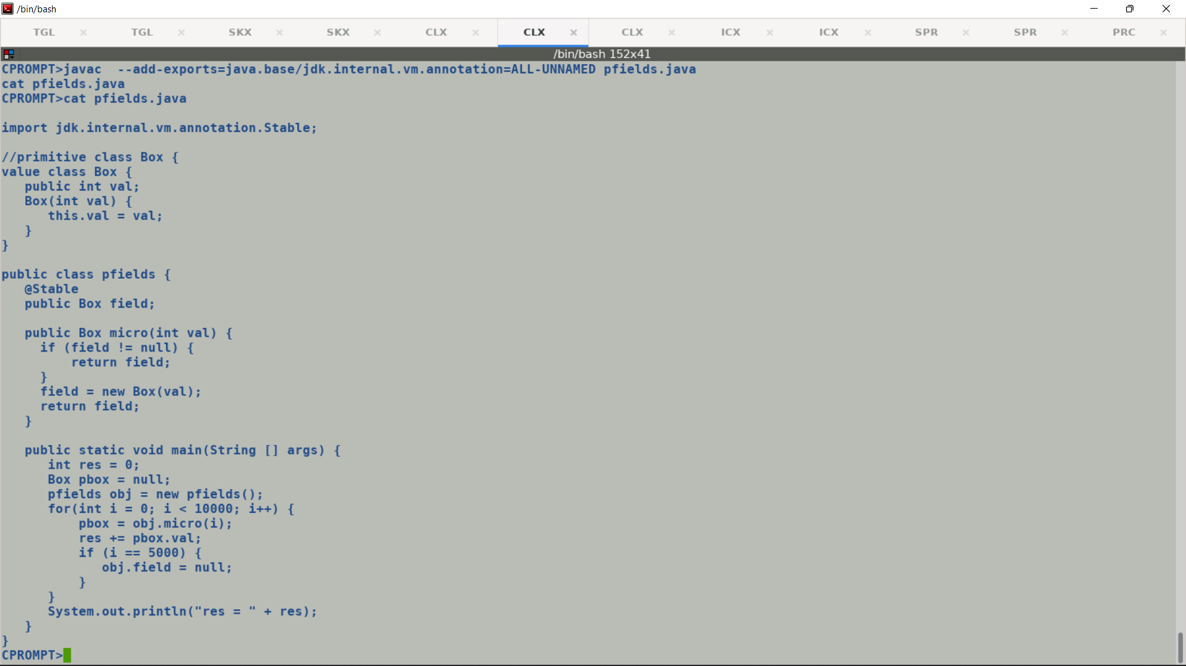

**Example to demonstrate primitive value conversion.**

CPROMPT>cat valueObjConv.java

abstract class Parent {

abstract int getIndex();

int printStr(Parent val) {

return val.getIndex();

}

}

primitive class Child extends Parent {

public int f1;

public int f2;

public int f3;

public int f4;

Child(int i1, int i2) {

this.f1 = i1;

this.f2 = i2;

this.f3 = i1 + 10;

this.f4 = i2 + 10;

}

int getIndex() {

return f1 << 16 | f2;

}

static int getIndexForChild(Parent val) {

return val.getIndex();

}

static int getIndexForChild(Child.ref val) {

//static int getIndexForChild(Child val) {

return val.f1 << 16 | val.f2;

}

}

public class valueObjConv {

//public final Child.ref pobj;

//public static final Child.ref pobj = new Child(10, 100);

public static final Parent pobj = new Child(10, 100); **// Emits same IR as above Primitive class ref. Loads the constant oop from holder and constructs InlineTypeNode using make_from_oop.**

static int micro(valueObjConv obj) {

int res = 0;

// Child obj = new Child(val, val + 10);

// primitve object to itentity reference conv.

res = pobj.printStr(obj.pobj);

// value obj conv

return res + Child.getIndexForChild(pobj) +

pobj.getIndex();

}

valueObjConv() {

}

public static void main(String [] args) {

int res = 0;

valueObjConv obj = new valueObjConv();

for(int i = 0; i < 10000; i++) {

res += micro(obj);

}

System.out.println("[Res] " + res);

}

}

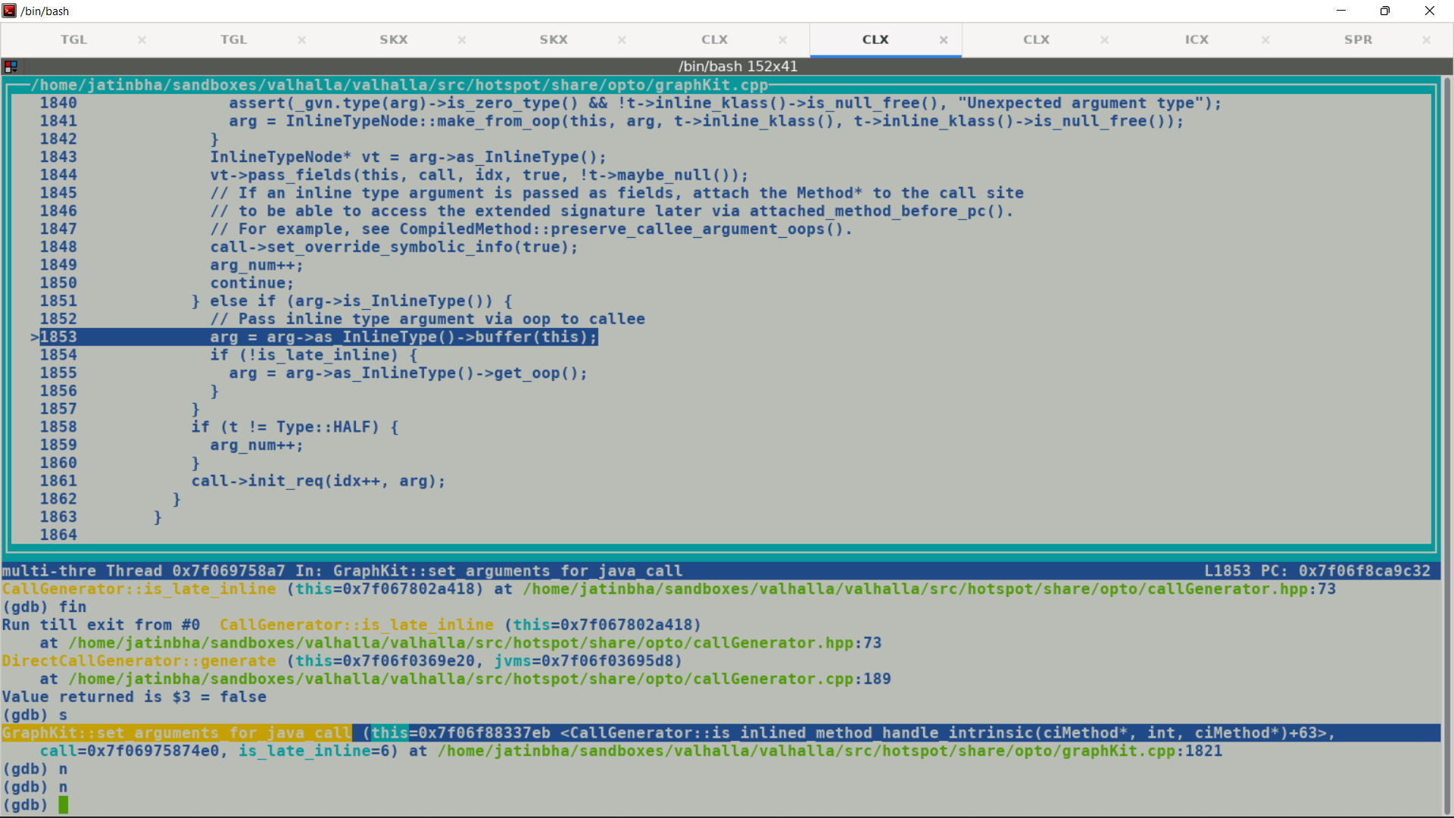

class Primitive { int f1; int f2; int [] farr; }

Buffer [ f1, f2, reference of farr]

Arrays upto are not flattened in the container value object.

Returning a vector value, in stock implementation scalarized fields are returned by loading individual components from oop. Since a vector holding a multifield payload represent a bundle of fields, thus vector result is tied to the return node, this causes a problem **unless there is a proper vector calling convention** defined to pass back vector field of an inline type instance like concrete vector classes.

There are two ways to address this problem: -

1. As per X86 ABI, XMM0 can be used to return a vector back to it caller. By explicitly bounding the register mask of a return value holding multi-field value, we can constrain the allocation set to just carry mask corresponding to one vector register i.e., XMM0. For VectorAPIs calling convention to be driven by functions signature, appearance of a vector descriptor in arguments or return type calls for passing the values though vectors, a mechanism on the lines of method specific Adaptors Handler. Since the position of vector argument may change b/w different methods hence **dynamic calling convention will be driven by function signatures**. e.g.

* lanewise (ILjdk.incubator.vector.Vector;)Ljdk.incubator.vector.Vector;
  + Few more points to be noted.
    - A concrete vector is not a null free instance; however, payload is always null free being a primitive type instance.
    - Need a way to encode null reference value in vector.
    - A user defined method receiving or returning a vector will be using abstract vector classes signatures.
      * Passing just vector value as argument may not be sufficient to re-construct the box in called (if need be), also the abstract class descriptor is not sufficient to provide the vector shape information. Thus a vector value instance when passed as argument must be accompanied by type and lane count information alternatively passing reference to static final species should be sufficient.
* Here first argument which is a VectorOperator is an integer and should be passed though GPR.
* Second argument is a vector; hence caller must pass it though one of the available XMMs (based on the allocation priority and established vector calling convention).
* Retrieval of arguments by callee will again be as per agreed upon calling convention b/w caller and caller, Callee will be able to retrieve the argument as passed from caller

1. In short team we can tier through LoadVector, scalarize the individual fields and connect them to return node.

Since most of the vector APIs are intrinsified hence we may seldom need to worry about passing vector across call boundaries. Problem seen in this case happens during dummyVector method compilations during warmup phase, since the return type signature is a reference hence compiler associates a GPR register mask with input machine operand, whereas actual incoming edge is a vector node , during gather live range ranges register masks are back propagated from use to it defs and hence bounded spill copy which is a vector type node get associated with a GPR register mask and results into a crash during allocation.

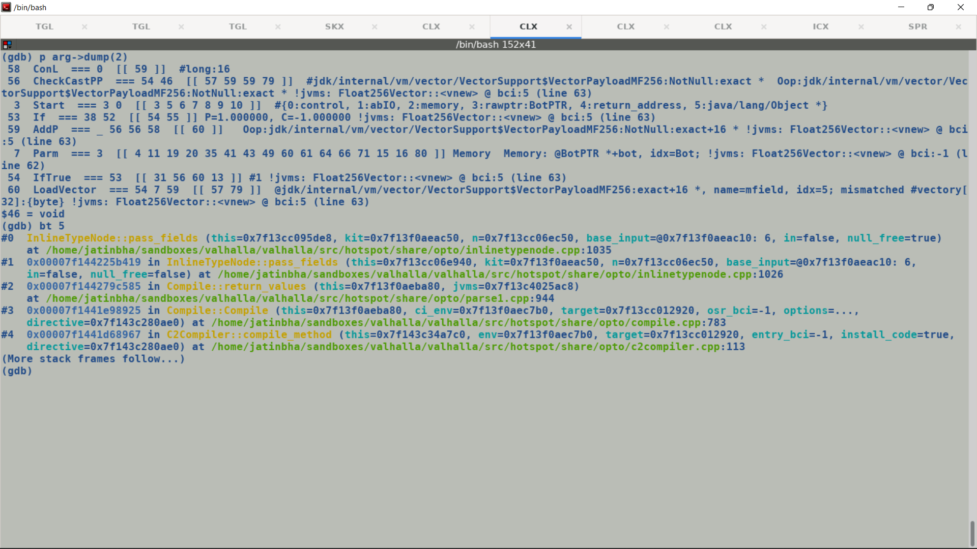

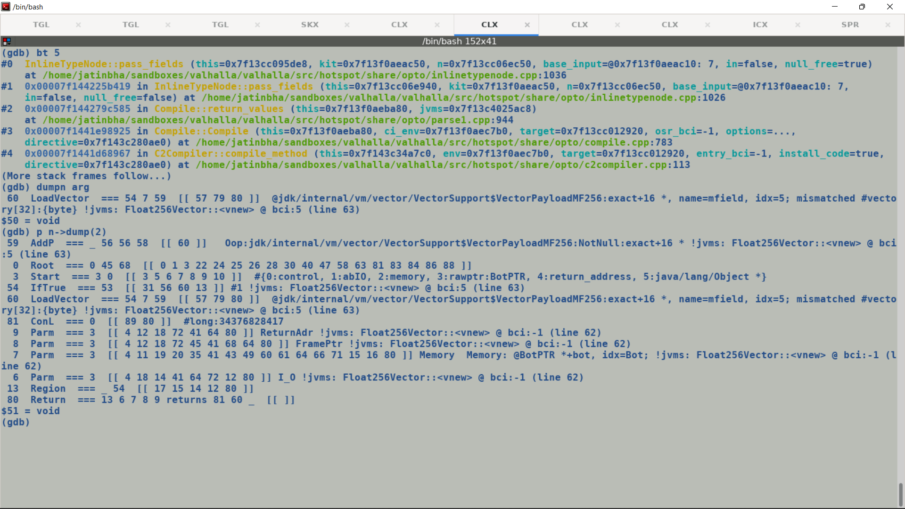

OSR compilation bug:



Batch compilation (blocking) leads to deterministic output, else interpreter may continue execution on issuing a compilation request to runtime.

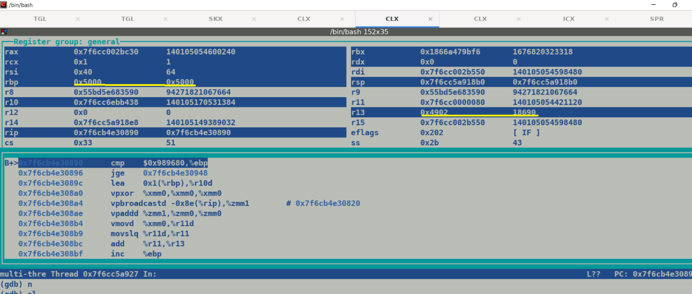

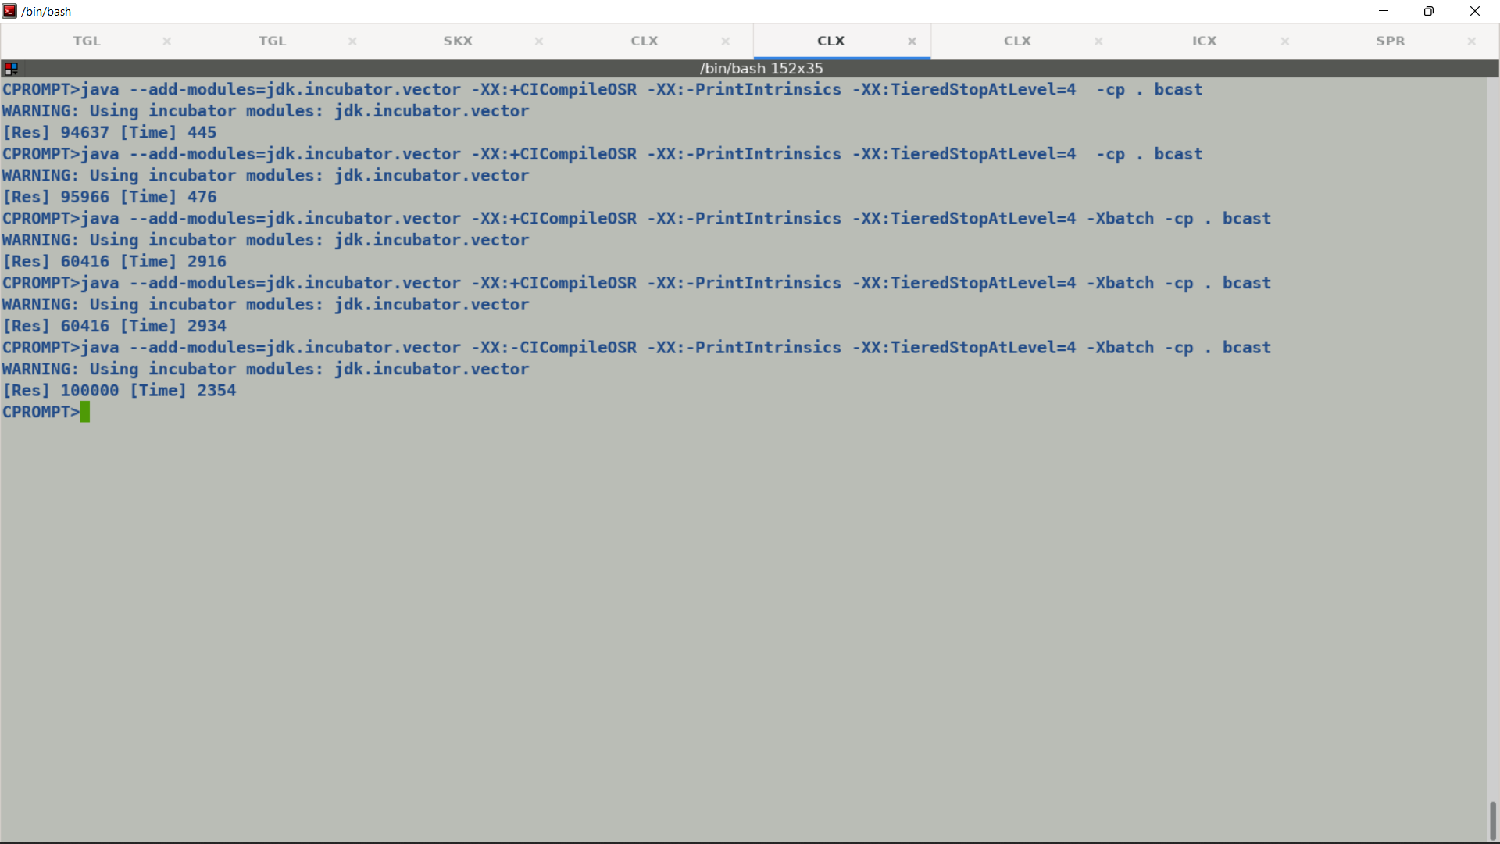

* Following issues were fixed to execute pure vector only tests :-
  + Stop idealization of InlineTypeNode when encapsulated oop is in larval state.
  + New boxing and unboxing ${\left(1+x\right)}^{n}=1+\frac{nx}{1!}+\frac{n\left(n-1\right)x^{2}}{2!}+…$ handling for InlineTypeNodes.
  + Fixed minor issues around StoreVector IR construction and corrected the type of PhiNode converging payload.
  + Existing calling conventions cannot handle vector as a return type, this IR shape appears in Value type class constructors.
    - This led to problems during register allocations since incoming mask of return value which is set according to the java calling convention (RAX) does not comply with vector return type.

**Source**                                                                                 **Bytecode**

Float512Vector(Object obj) {                                             aconst_init (Float512vector)              This.payload = (VectorPayloadMF512) obj;            aload_1

                                                          checkcast

                                                          withfields

                                                          areturn

}

**Relevant C2 IR (snippet)**

Obj

  |

  V

CheckCastPP

  |  (InlineTypeNode::make_from_oop)

  V

LoadVector

  |

  V

InlineTypeNode (VectorPayloadMF512)

  |

V

InlineTypeNode (Float512Vector)

  |

  V

ReturnNode

* Since InlineTypeNode are synthetic nodes thus intermediate IR chain folds away and LoadVector gets tied to the ReturnNode. Being a reference type object is returning using RAX register as per c-calling convention
* Interim solution to circumvent this problem is to directly return the oop encapsulated in the InlineTypeNode I.e. re-buffer the concrete box and return it back.
* If this method get inline-expanded then a new InlineTypeNode will get created which will load its fields from object reference.
* Root causing JIT code size increase: -
  + Newly create dummyVectorMF() methods access a @Stable annotated field.  In stock implementation null conditional check gets constant folded because stable field retain their values once initialized.

AbstractVector<E> dummyVectorMF() {

        If (dummyVectorMF != null) {            ---> getfield ; if_acmp

               return dummyVectorMF;

        }

        DummyVectorMF = makeDummyVector();

}

* + dummyVector[/MF] is a field in AbstractSpecies and predefined species of various shapes are static final constants. Thus a getfield operation over existing dummyVector field results into constant IR node creation, but dummyVectorMF is not seen as a constant field by compiler.
  + Created a small test case to mimic this functionality, in process of debugging the problem.

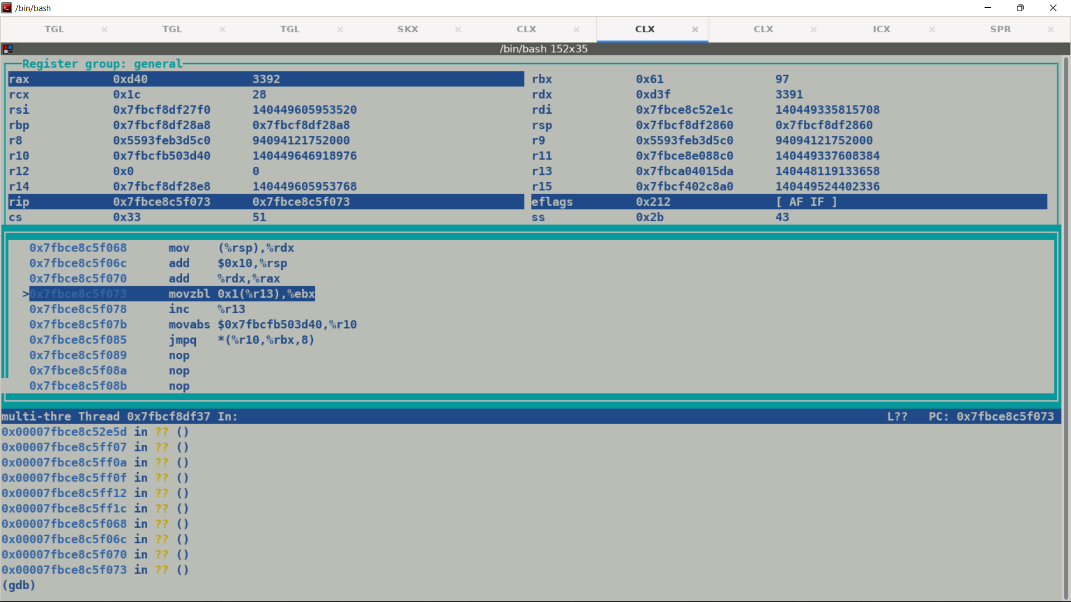

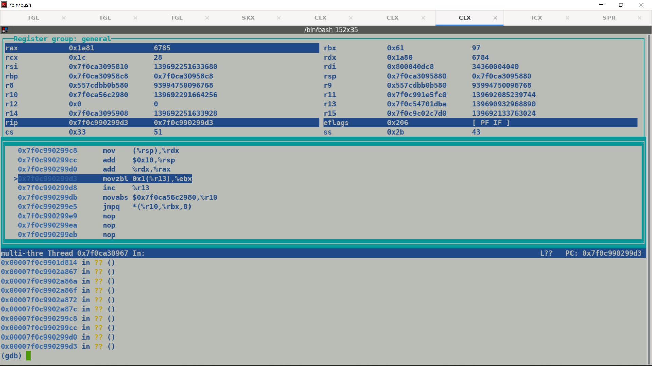

6785-3392

3393

100000 - 3393

96607

Java return convention for functions returning value instances as fields.

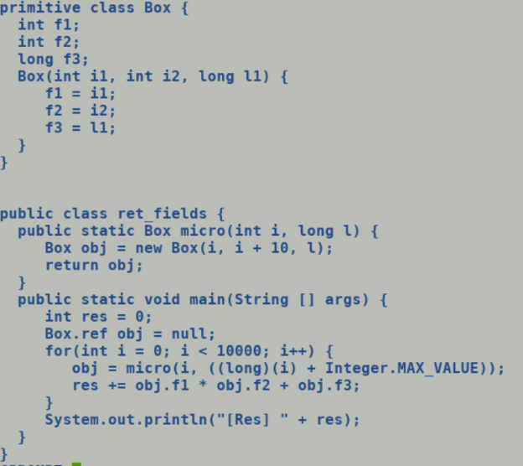



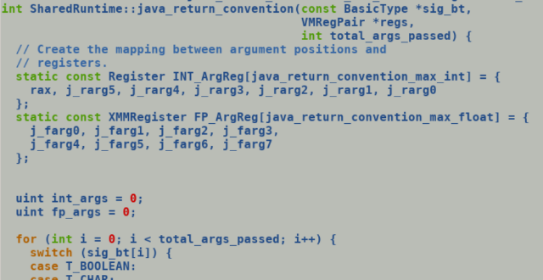

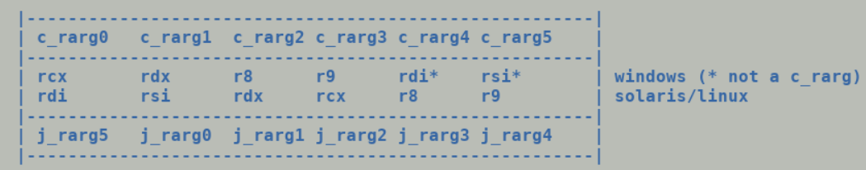

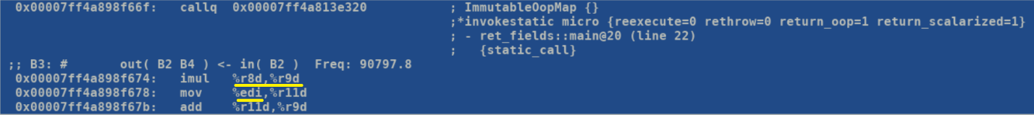

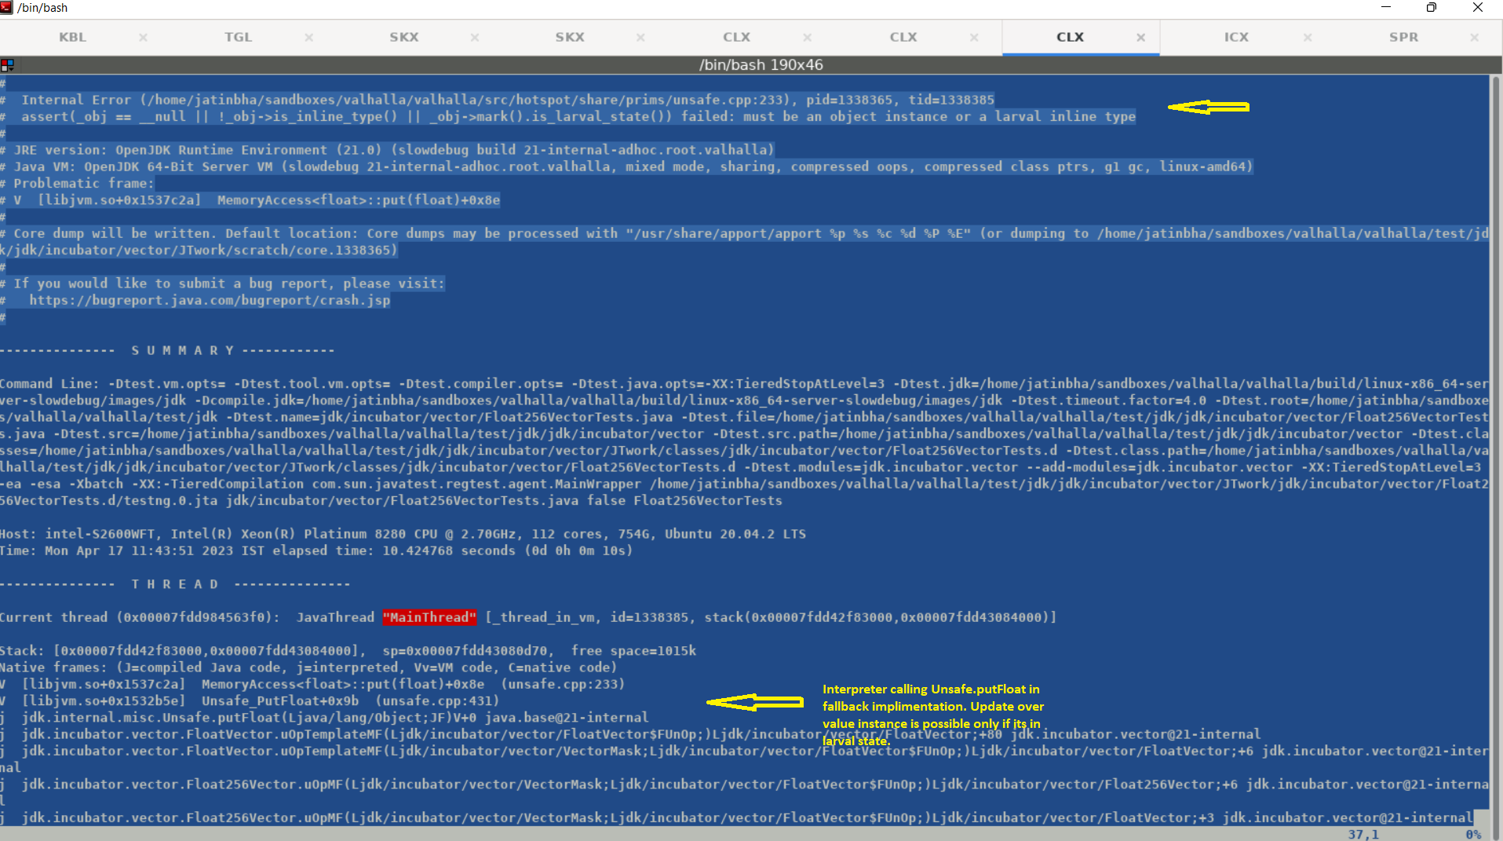

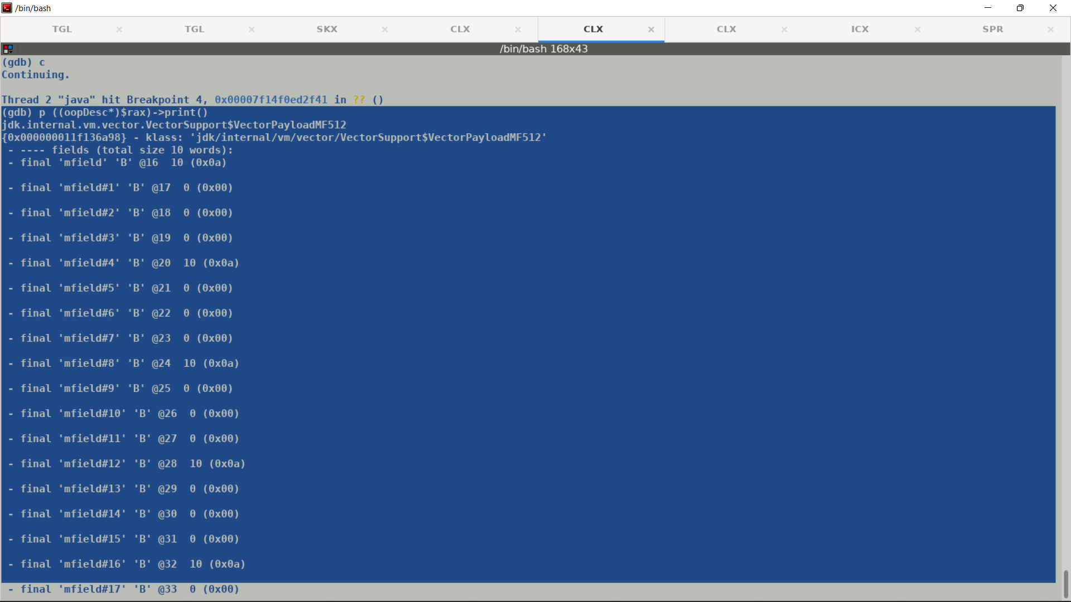

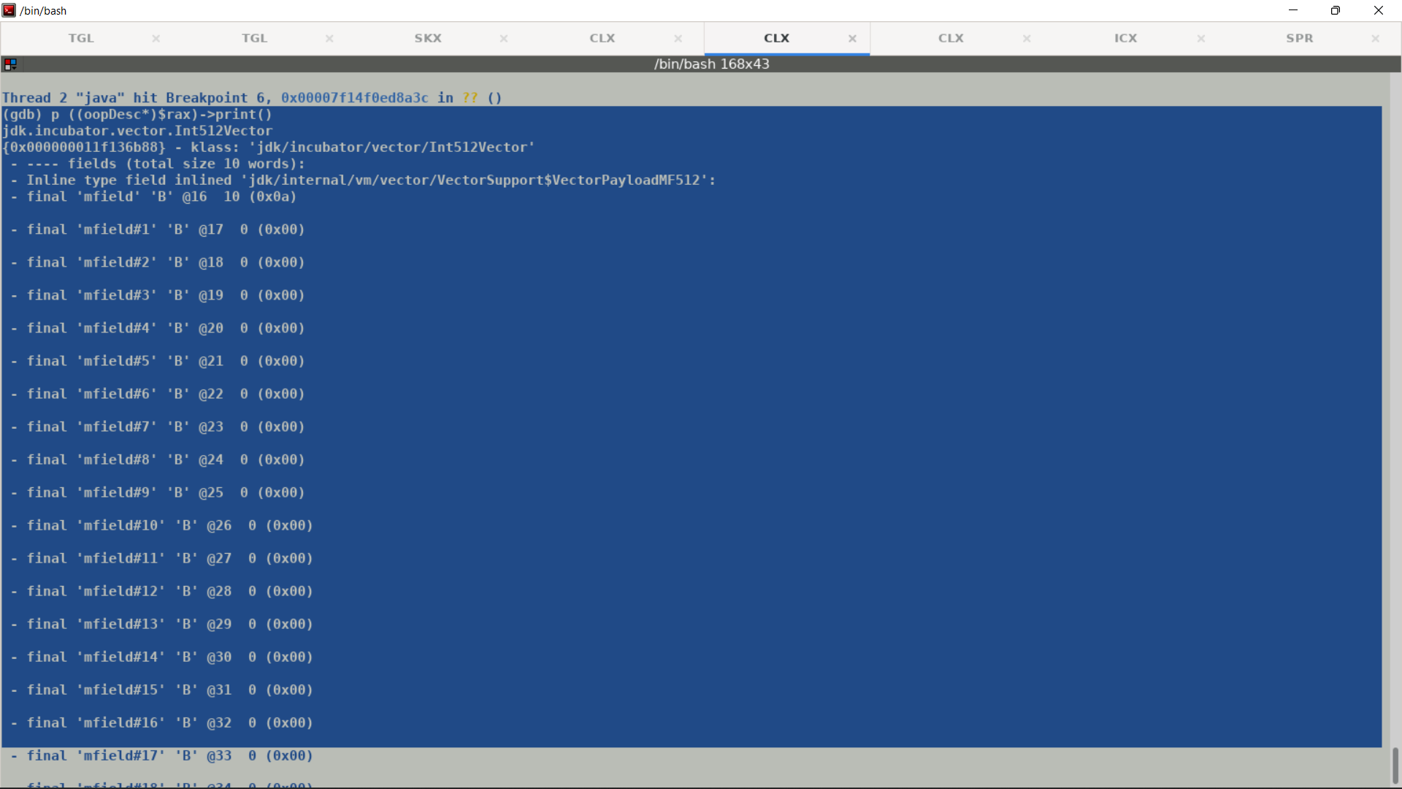

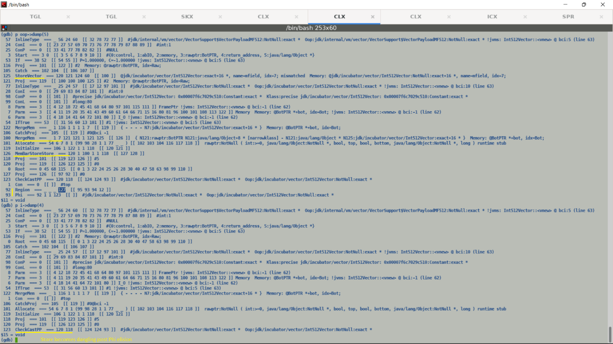

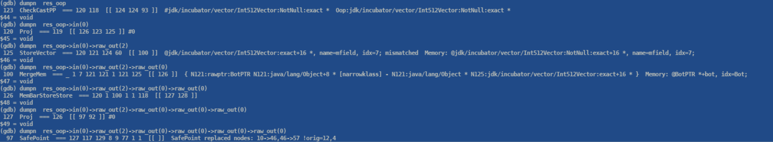

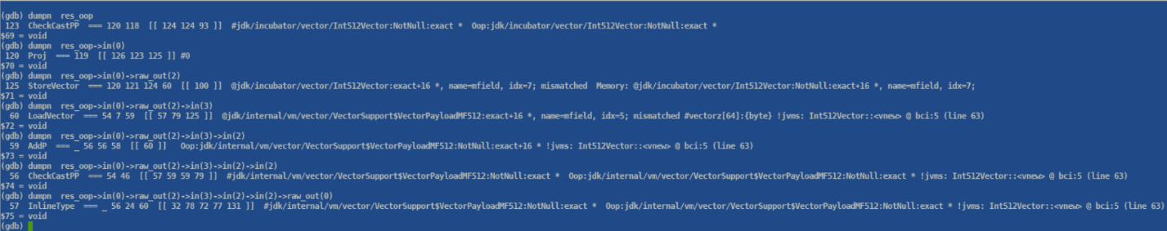

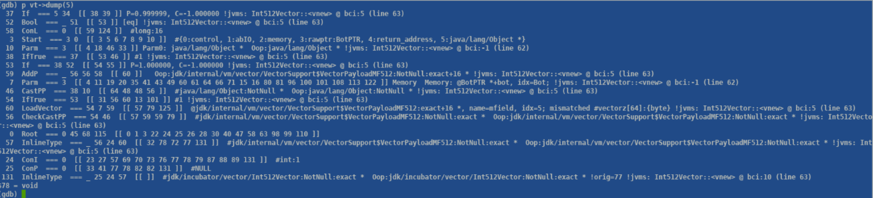

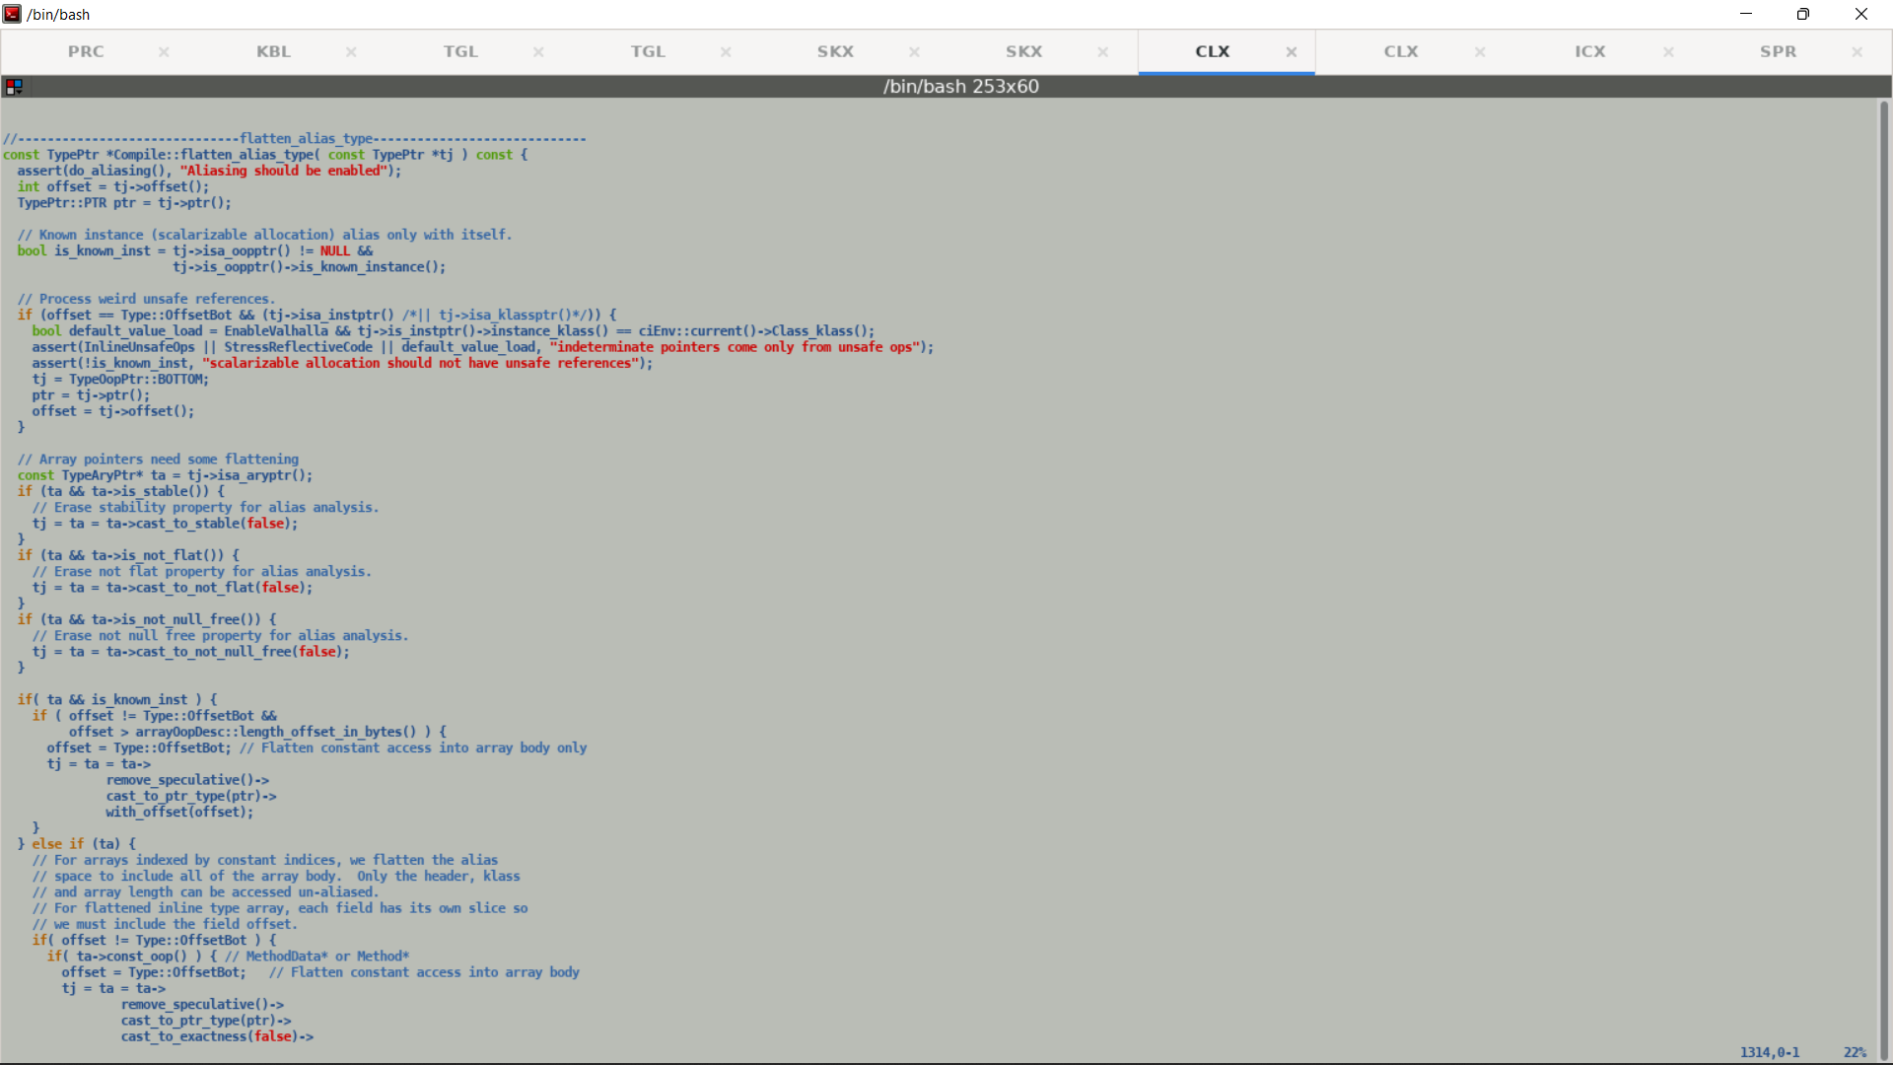

**Synthetic Multifield Tests and offsets.**

CPROMPT>cat myannot.java

import java.lang.annotation.ElementType;

import java.lang.annotation.Retention;

import java.lang.annotation.RetentionPolicy;

import java.lang.annotation.Target;

import jdk.internal.vm.annotation.*;

public class myannot {

@MultiField(value = 16)

public static final int fld1 = 10;

@MultiField(value = 16)

public static final int fld2 = 10;

public static void main (String [] args) {

System.out.println(fld1 + fld2);

}

}

javac --add-exports java.base/jdk.internal.vm.annotation=ALL-UNNAMED myannot.java

java --add-opens java.base/jdk.internal.vm.annotation=ALL-UNNAMED -Xbootclasspath/a:. -cp . myannot

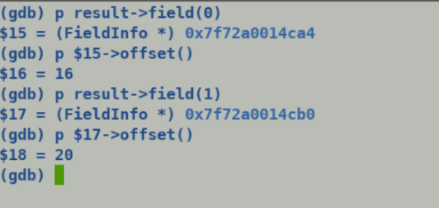

Uninitialized dummyVectorMF prevents folding conditional logic in dummyVectorMF() leading to increase in JIT code size.

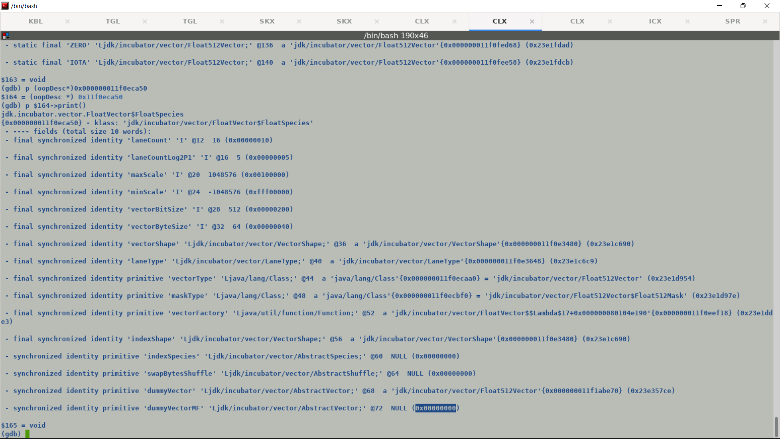

Initialization bug in java code fixed the problem, JIT code sequence matches the stock jdk now.

PhiNode::merge_through_phi reduces the number of boxing allocations by moving the boxes from converging scopes to point of converge.

PhiNode REGION VBOX1, VBOX2 => VBOX PhiNode1 PhiNode2

This optmizes the number of allocations during box expansions.

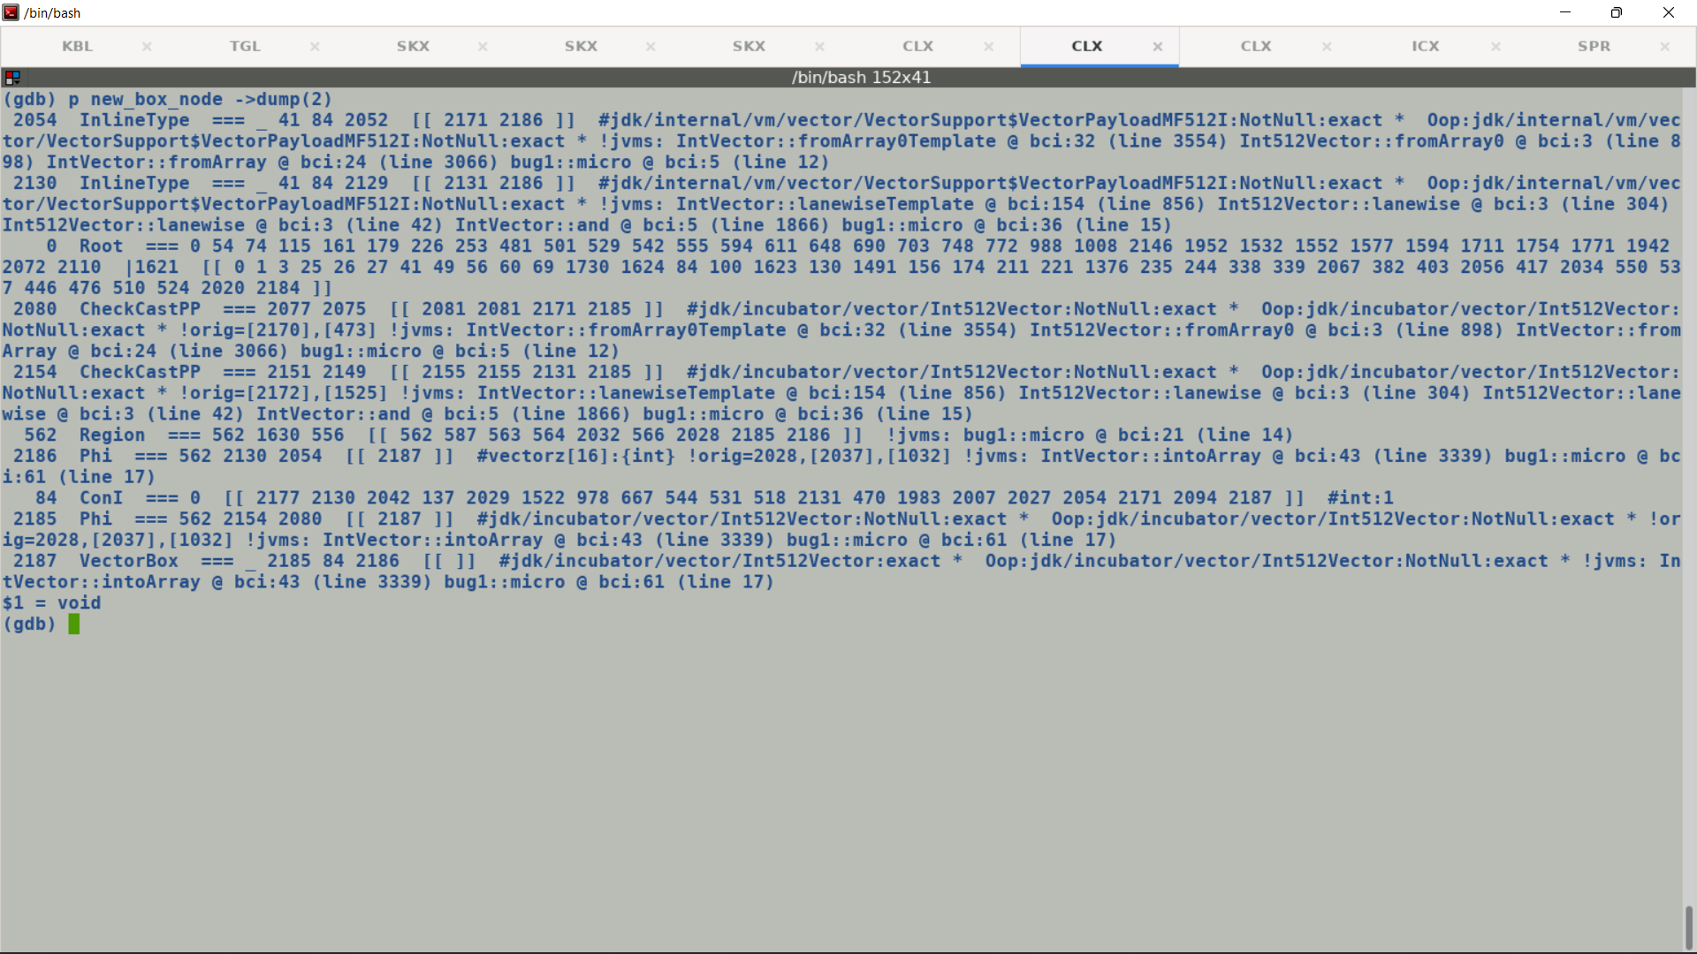

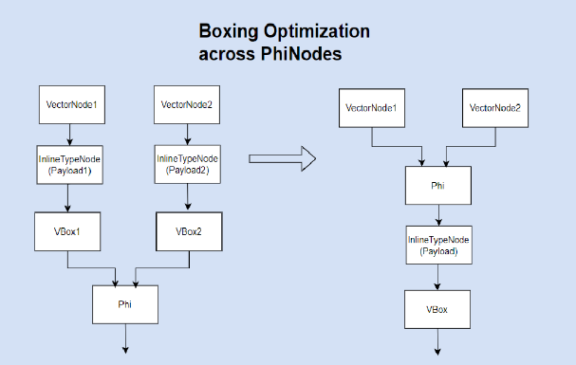

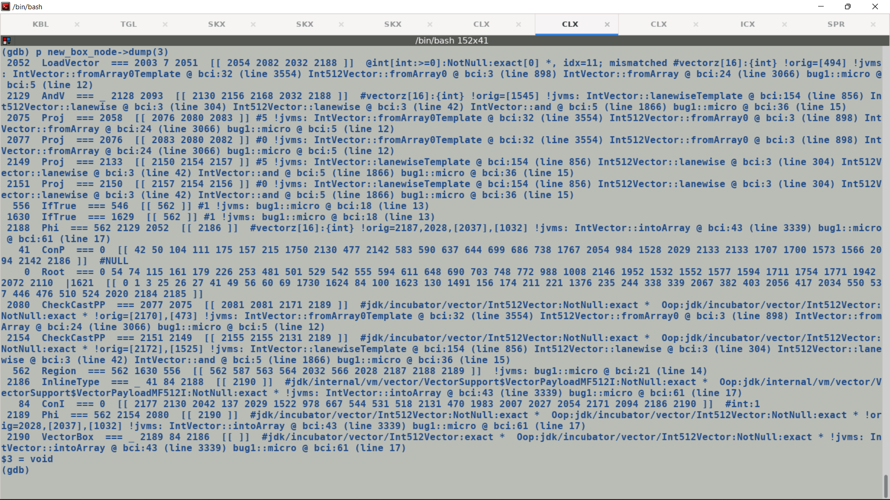

Lazy VectorBoxAllocate expansions: -

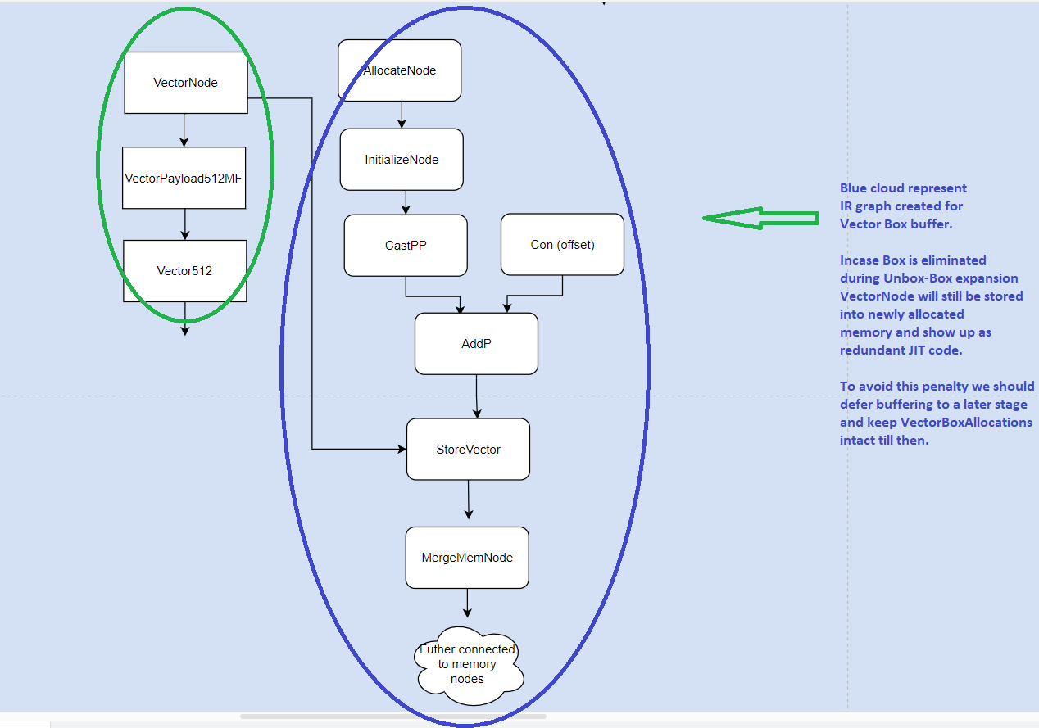

Q. Why do we need an explicit node VectorBoxAllocate along with VectorBox?

A. This is because we need memory and control edges to stitch the graph pallet created after buffering, VectorBoxAllocate is a Safepoint node carrying JVMstate and other relevant edges thus re-initializing GraphKit corresponding to a given JVM state is seamless.

One possible solution could be to associate memory and control edges with VectorBox nodes and treat them as special InlineType nodes OR bookkeep entire JVMState into VectorBox for a later use, but this will pose issues at convergence points where VectorBoxes coming from different control flow merge (and so does current VBAs and this is augmented by PhaseVector::expand_vbox_node_helper which processes each incoming VectorBoxAllocate separately by traversing backwards though PhiNode), but if we just preserve JVMState then we need to have a synthetic IR for bookkeeping which converge into PhiNode at control flow convergence points, so keeping VBA looks relevant and clean solution.

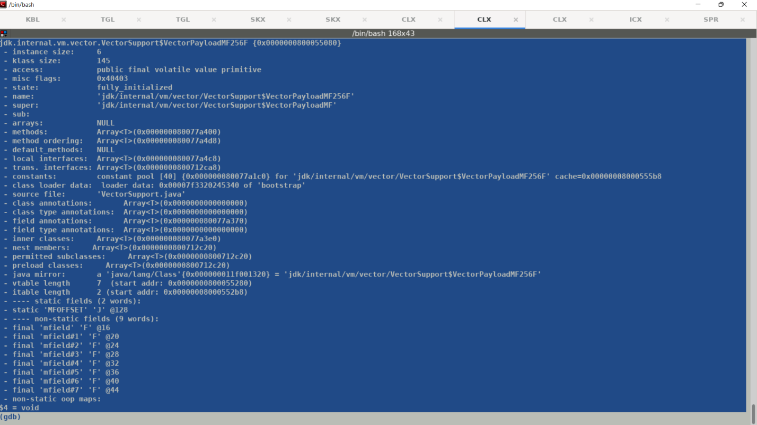

**Object re-materialization should preserve the larval state of newly allocated vector payload boxes so that subsequent field updates by interpreter do not cause assertion failures.**

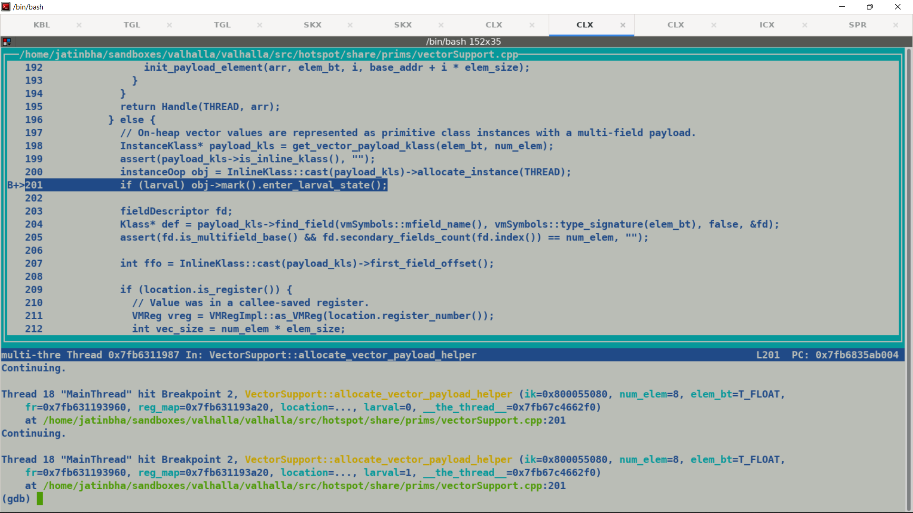

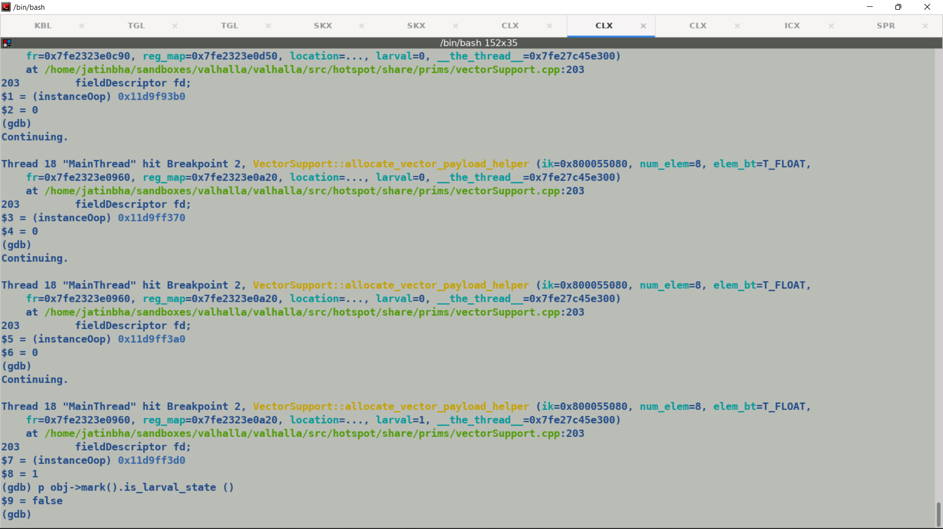

**Larval state propagation across function call.**

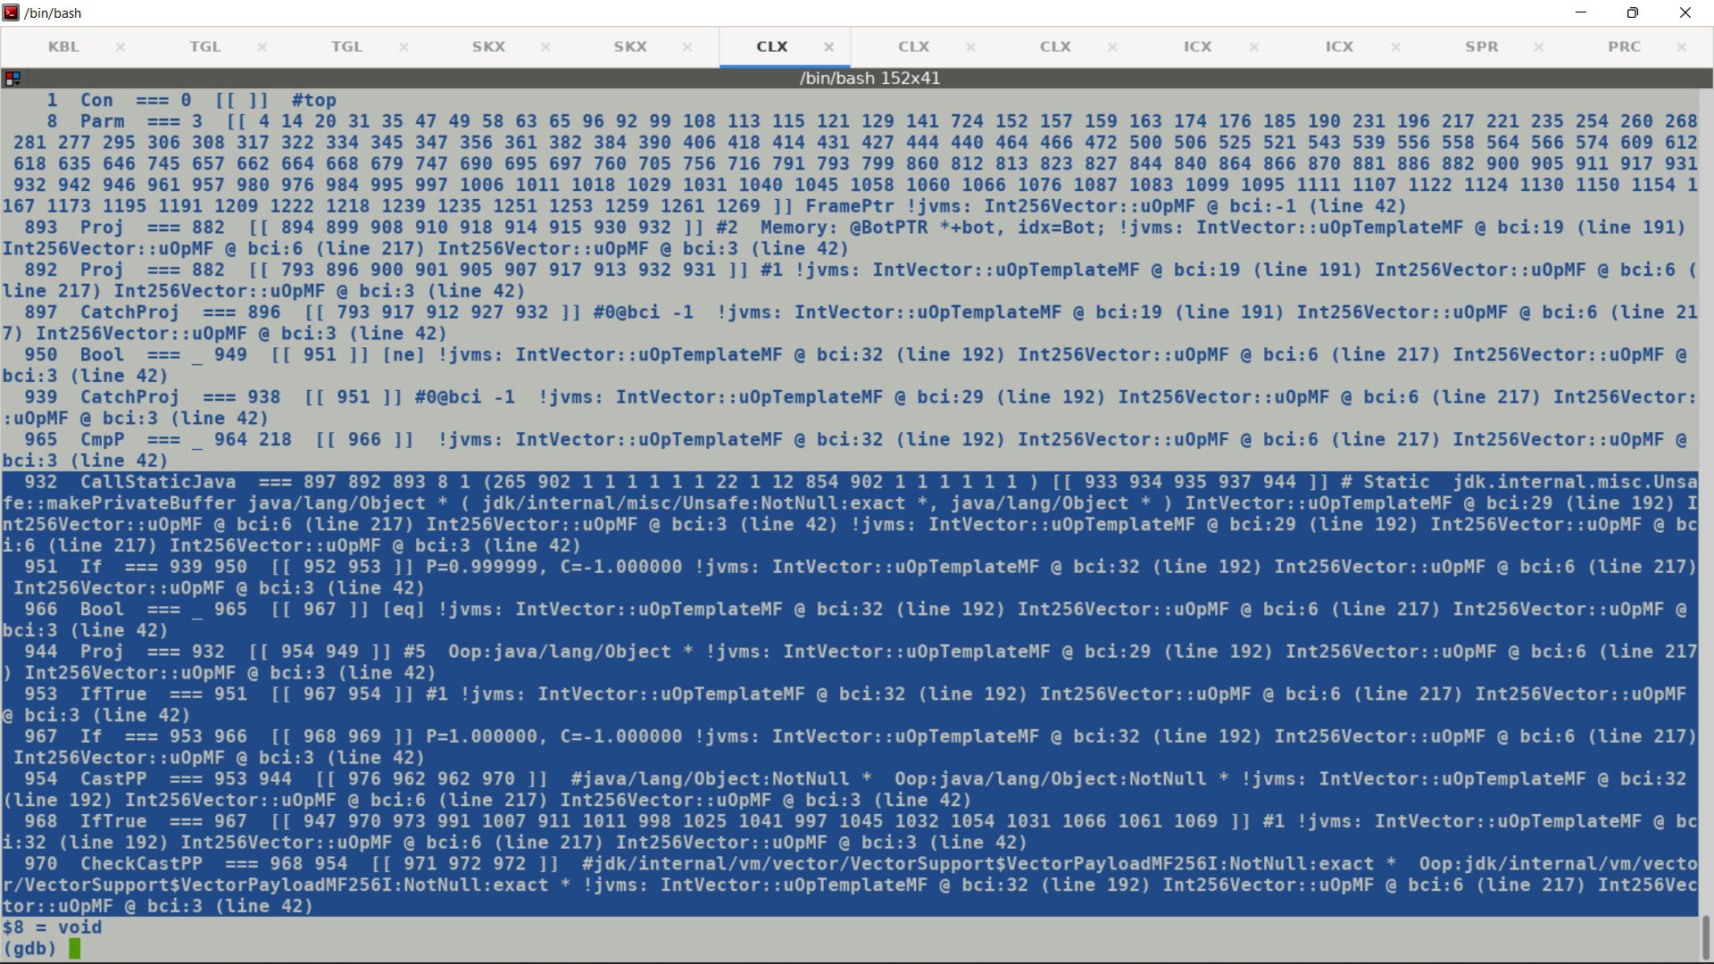

**Make private buffer allocates a new buffer and transitions it into larval state, but subsequent Unsafe.put in the callee expects allocation in larval state.**

Unsafe get should extract single lane from Multifield vector payload.

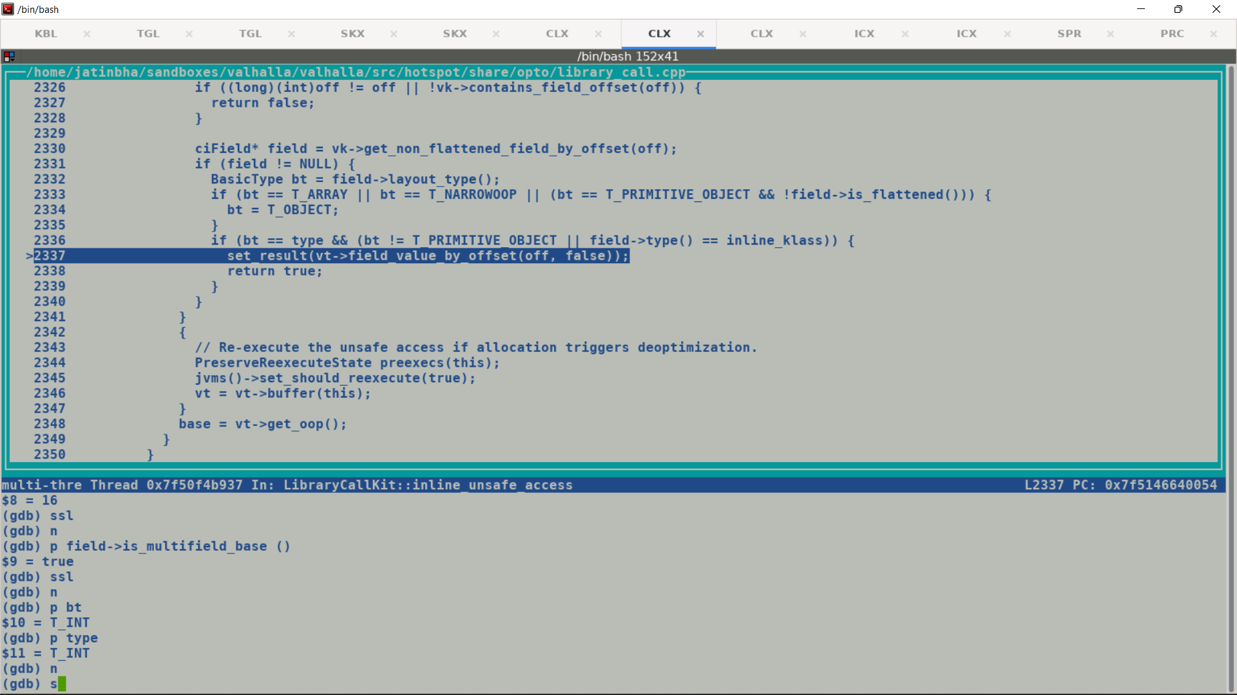

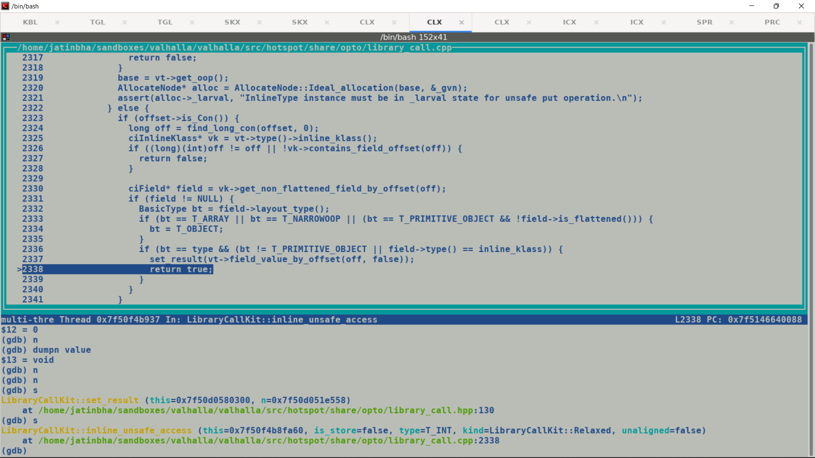

**Unsafe get/put are used in fall back implementation which gets executed only if intrinsification fails OR during warmup phase when only leaf level methods involving inline types are compiled, since C2 represent all the value objects as InlineType IR node hence , we have two solutions here:**

* **buffer the InlineType and load/store the required field from the buffer. (favored)**
* **Insert lane extraction IR to load needed field from multifield vector.**

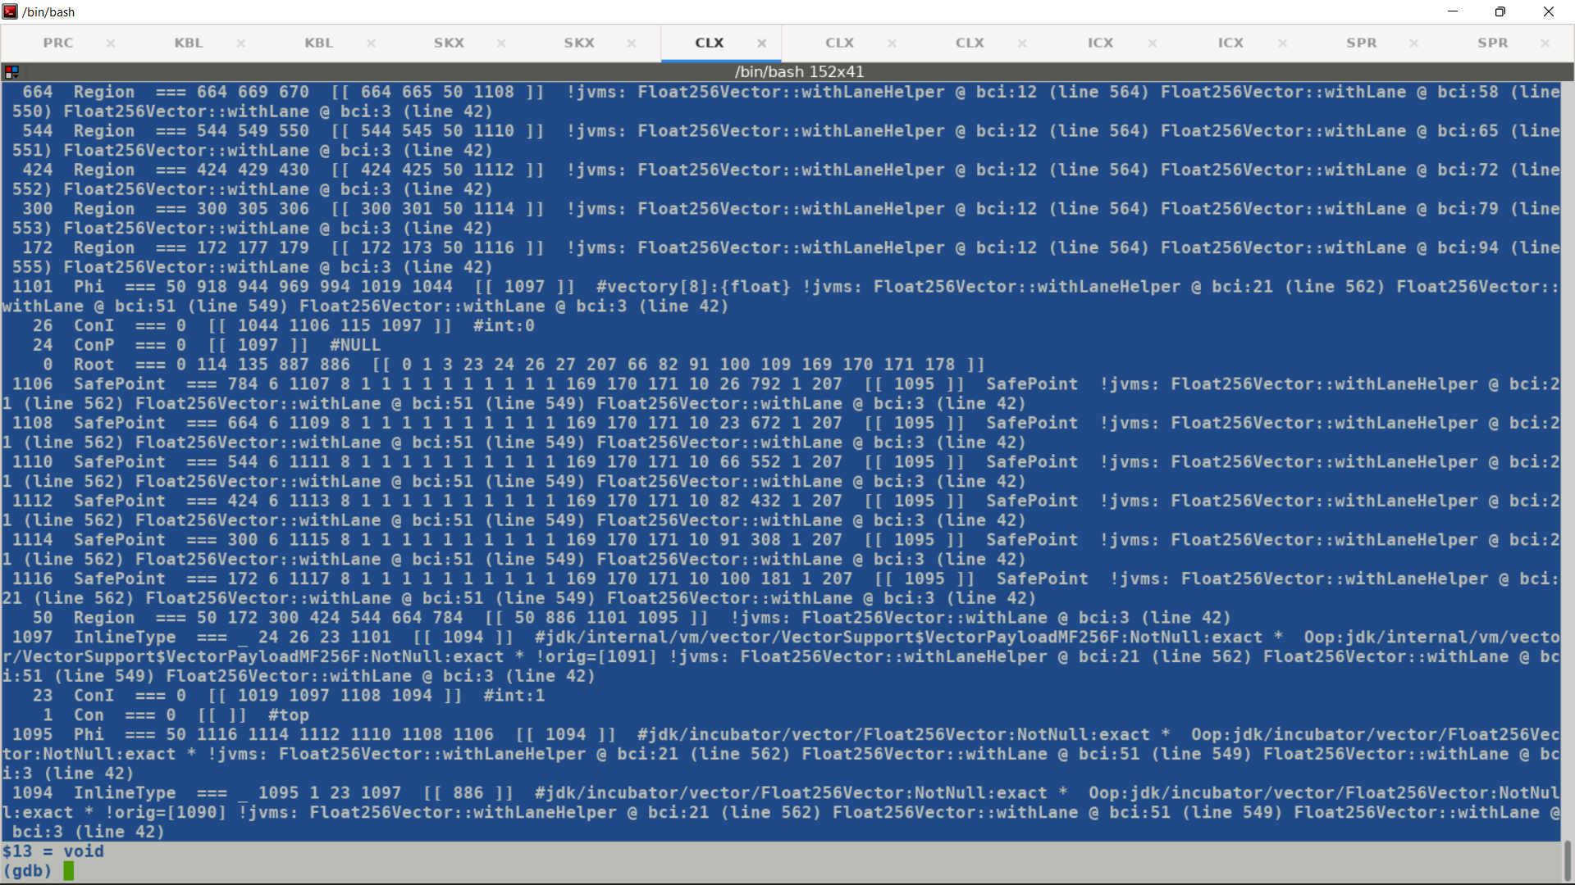

**InlineTypeNode is not a VectorBox, but vice-versa is not true, so box_elimination does not come into picture here.**

**Ideal Graph shape for Vector Box:-**

**VectorBox (VectorBoxAllocate, Vector)**

**Existing flow:-**

**=============**

**VectorBox Expansion :-**

**A1 = new_array (int)**

**StoreVector A1, Vector**

**T1 = new_instance(Box)**

**T1.payload = A1;**

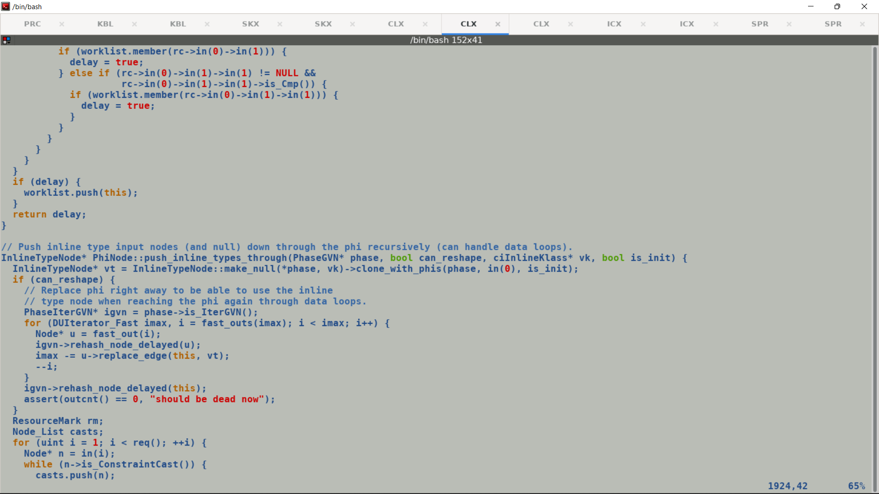

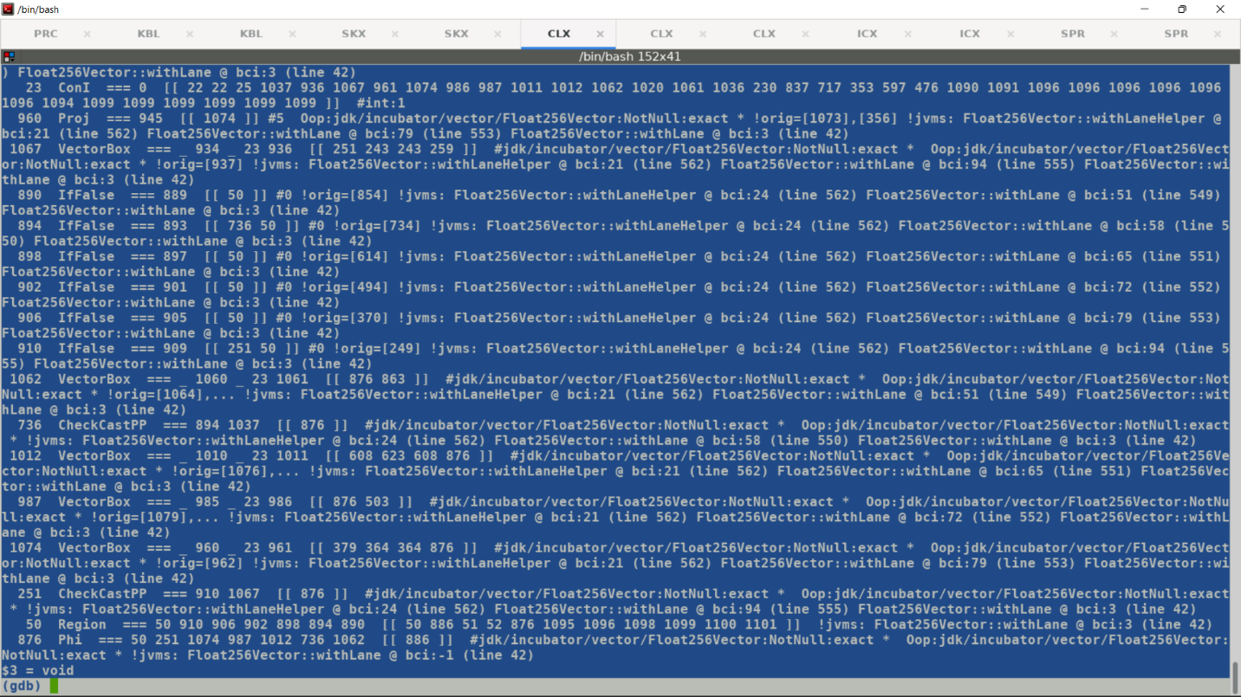

Larval State Propagation across non-inline function call. In this case makePrivateBuffer is not inline expanded. Causing issues in subsequent unsafe put operation which expect to operate over larval state allocation leading to assertion failures. Fixed by adding @ForceInline attribute over value objects creating routine vec_mf().

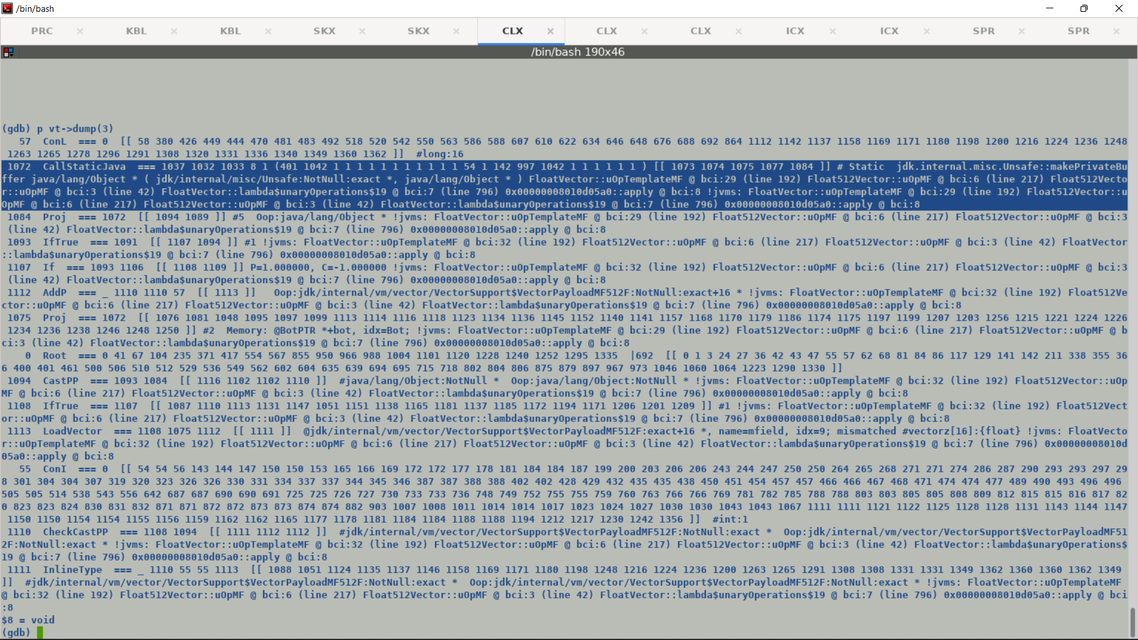

FieldInfo overhaul in JDK-21: Replaced 6 fixed width (16 bits) bit meta data fields which account for 96 bit with a variable sized encoding.

<https://bugs.openjdk.org/browse/JDK-8292818>

**Notes on Field Info:-**

* 1. Parse class file and bookkeep FieldInfo[1] into a temporary data structure (_temp_field_info) within ClassFileParser.
  2. A FieldInfo record is constructed for each real / injected / synthetic field.
  3. A multifield FieldInfo is augmented with an auxiliary data structure (MultifieldInfo) which is recorded in ClassFileParser.
  4. Once the parsing completes, create a new class runtime object (instance/inline/filatArrayKlass) and transfer the ownership of FieldInfo data from ClassFileParser to respective class object by compressing FieldInfo meta data fields using UNSIGNED5 encoding.
  5. Multifields are synthetic fields and its name / signature is not part of constant pool.
  6. Fully qualified names for multifields are generated using base multifield names and multifield indices.

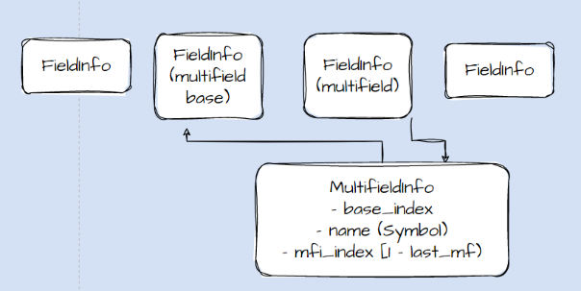

[1]

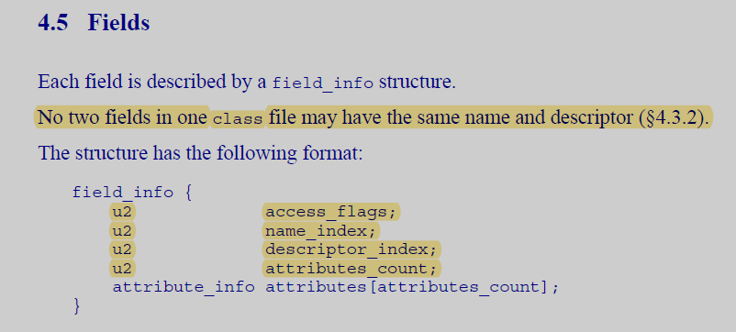

All 16 bit indices (u2) are with respect to Constant Pool of a class fiele.

To Check:

Other Injected Fields handling for name_index().

Base Mutifield on the same lines.

Basically Multifield name_indices are not part of constant pools since they are synthetic fields (injected by JVM based on encountering @multifield annotation), only the base multifield name and signature are part of constantpool.

If a fieldInfo is multifield then its name is part of MultifieldInfo structure.

Having special checks for multifield at all the places where FieldInfo.name_index is queried looks messy.

Changes:

~~Commenting out guarantee in fieldInfo.inline.hpp.~~

Replaced _temp_field_info with temp_field_info

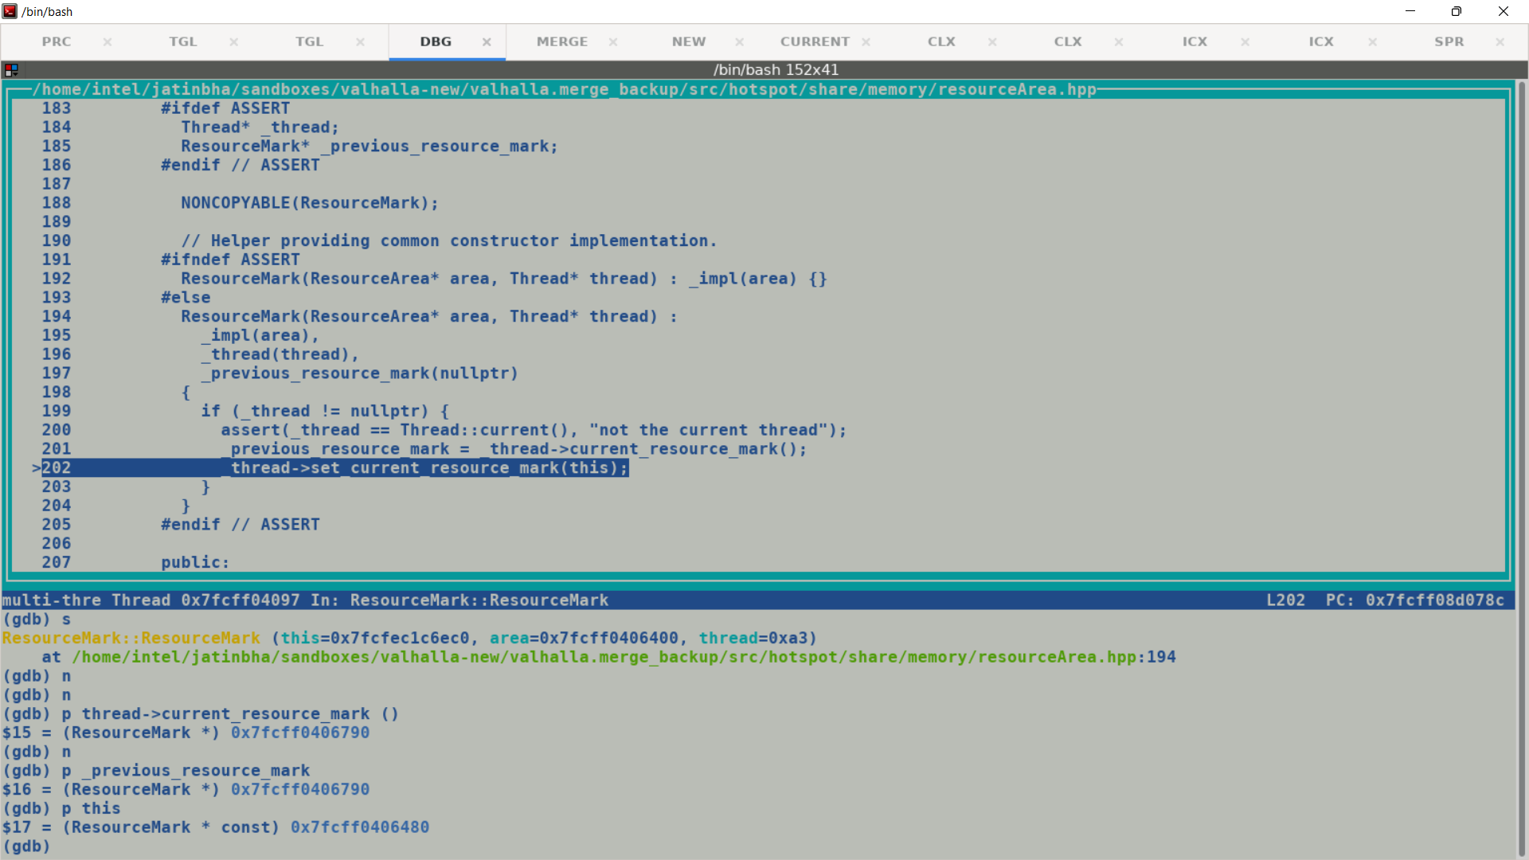

Re-allocations should be done at same ResourceMark nesting level, original allocation done at lower Resource mark nesting level should not be re-allocated at a higher nesting level as incremental memory may be sweeped out by destructor of immediate resource mark. ResourceMarks are based on RAII mechanism , this facilitate scoped memory allocation and freeing

Since GA<FiledInfo>_temp_field_info is contained in ClassFileParser hence mark installed in KlassFactory::create_from_stream applies to it. . Given that multi-field bundle size depends on attribute hence we may need to dynamically grow the temp_field_info to accommodate FieldInfo objects corresponding to synthetic multifield (injected)

_temp_field_info should also outlive the scope of immediate ResourceMark since its being used for generating compressed fields streams encapsulated into newly create InstanceKlasses.

All the VectorSupport classes are part of classes.jsa (shared serialized class file), VM maps same physical memory frames holding shared classes to virtual address space of different JVMs, this saves allocating explicit RAM frames for each Page mapping, similar to .so files 1:N mapping.

To print contents of shared class archive using -XX:+PrintSharedArchiveAtExit.

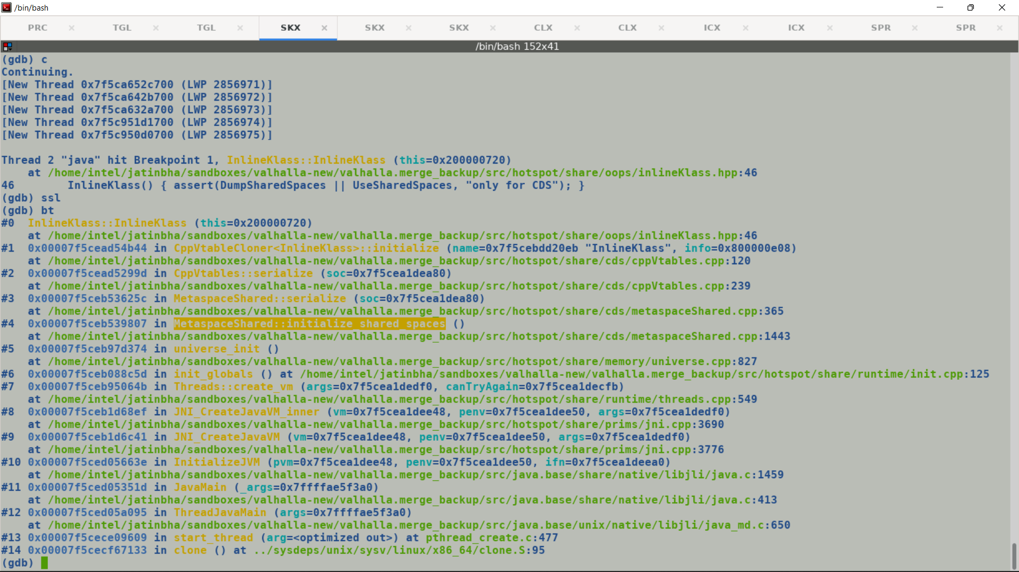

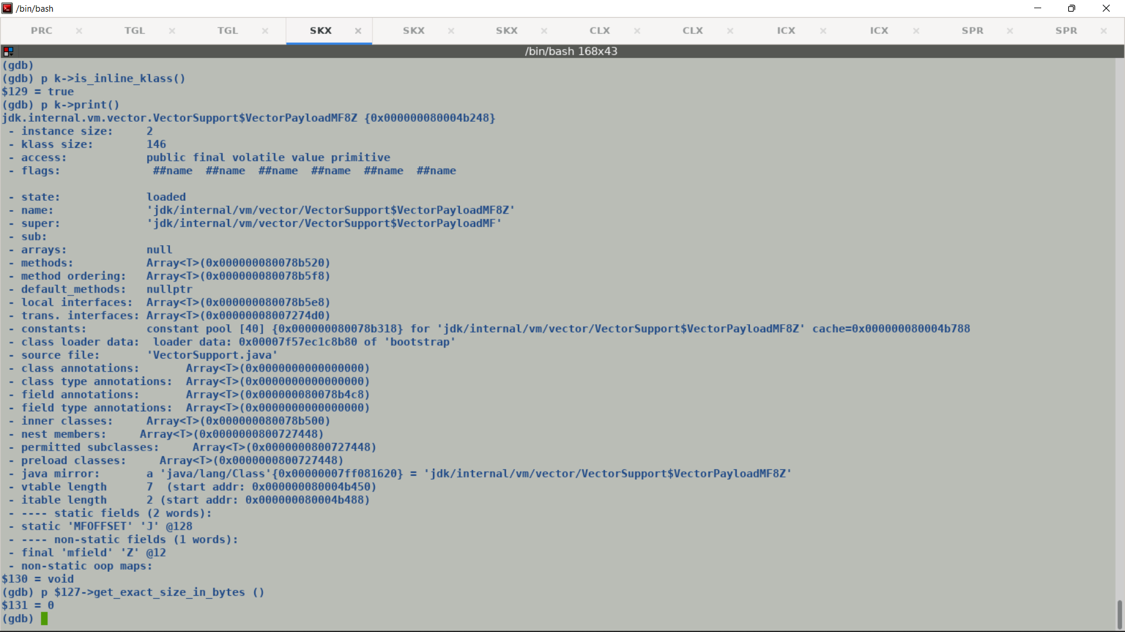

Two problems in de-serialized InlineKlass types:-

* ~~Offset of mfield#1 should be 20~~
* Exact size in bytes is 0, this indicates problem while de-serializing Fixed Inline Klass blocks.

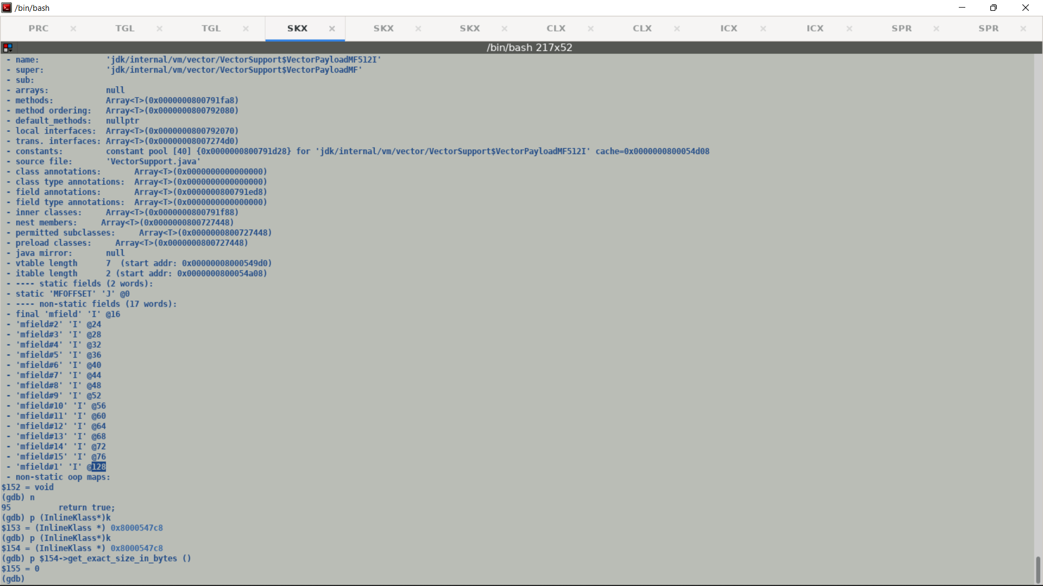

Dump with existing Valhalla :-

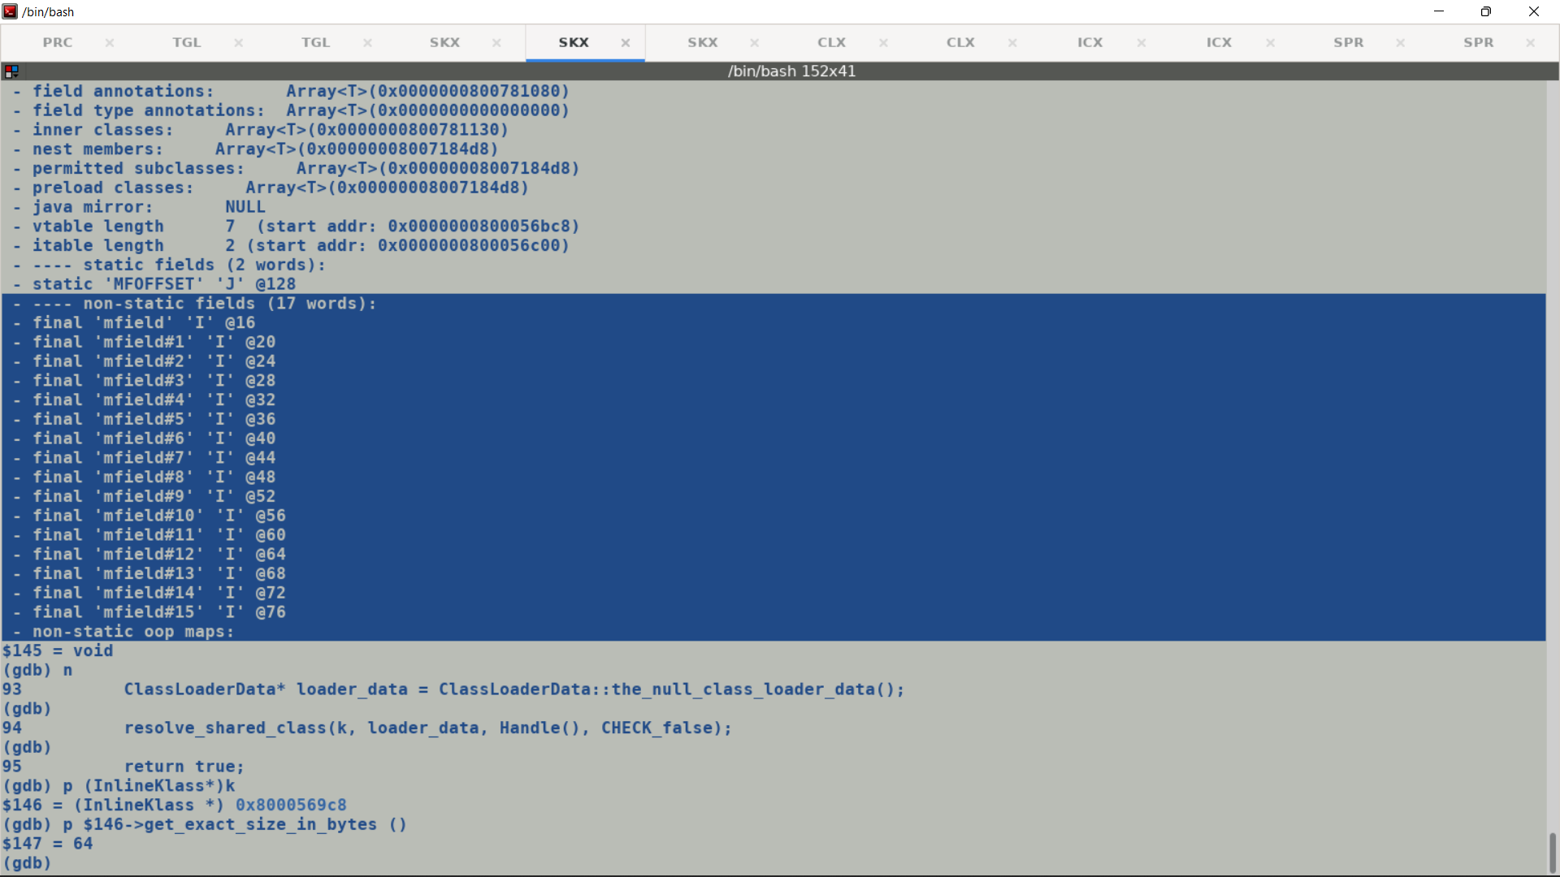

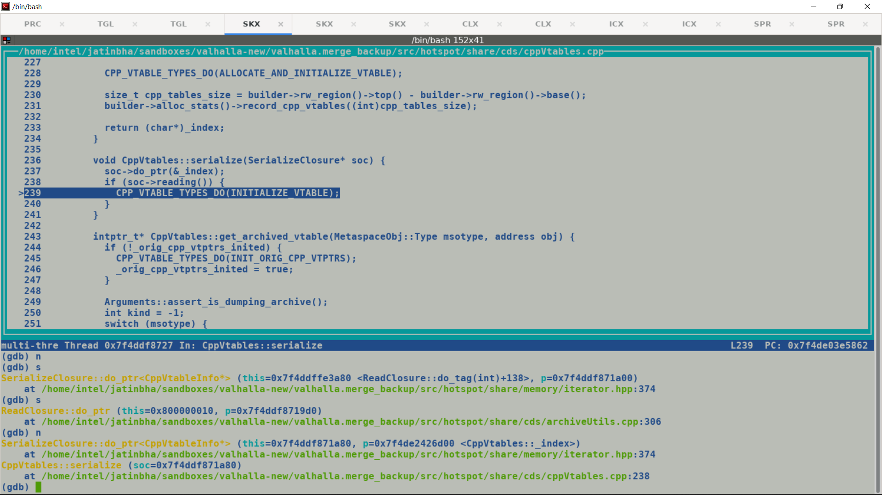

Build time command generating shared class archives.

SPROMPT>java -Xlog:cds,nmt,class -XX:+PauseAtStartup -Xshare:dump -XX:SharedArchiveFile=classes.jsa &

# We can also use jlink with --generate-cds-archive

# Dumping the contents of shared archive (classes.jsa)

# /home/jatinbha/sandboxes/valhalla/valhalla/build/linux-x86_64-server-slowdebug/images/jdk/bin/java -XX:+PrintSharedArchiveAndExit | grep "VectorSupport"

# For archiving/serialization we use following interfaces:

# ArchiveBuilder (Static / Dynamic) -> Static used for generating classes.jsa.

# For unarchiving/de-serialization use

# ArchiveHeapLoader interface.

# InlineKlass fixed block carries object size and calling convention adapters, we do remove adapter before archiving the runtime representation of an InlineKlass.

# De-serialization

# 

Static field MFOFFSET shares its index with first multifield#1, earlier we were not having ‘index’ fields in FieldInfo.

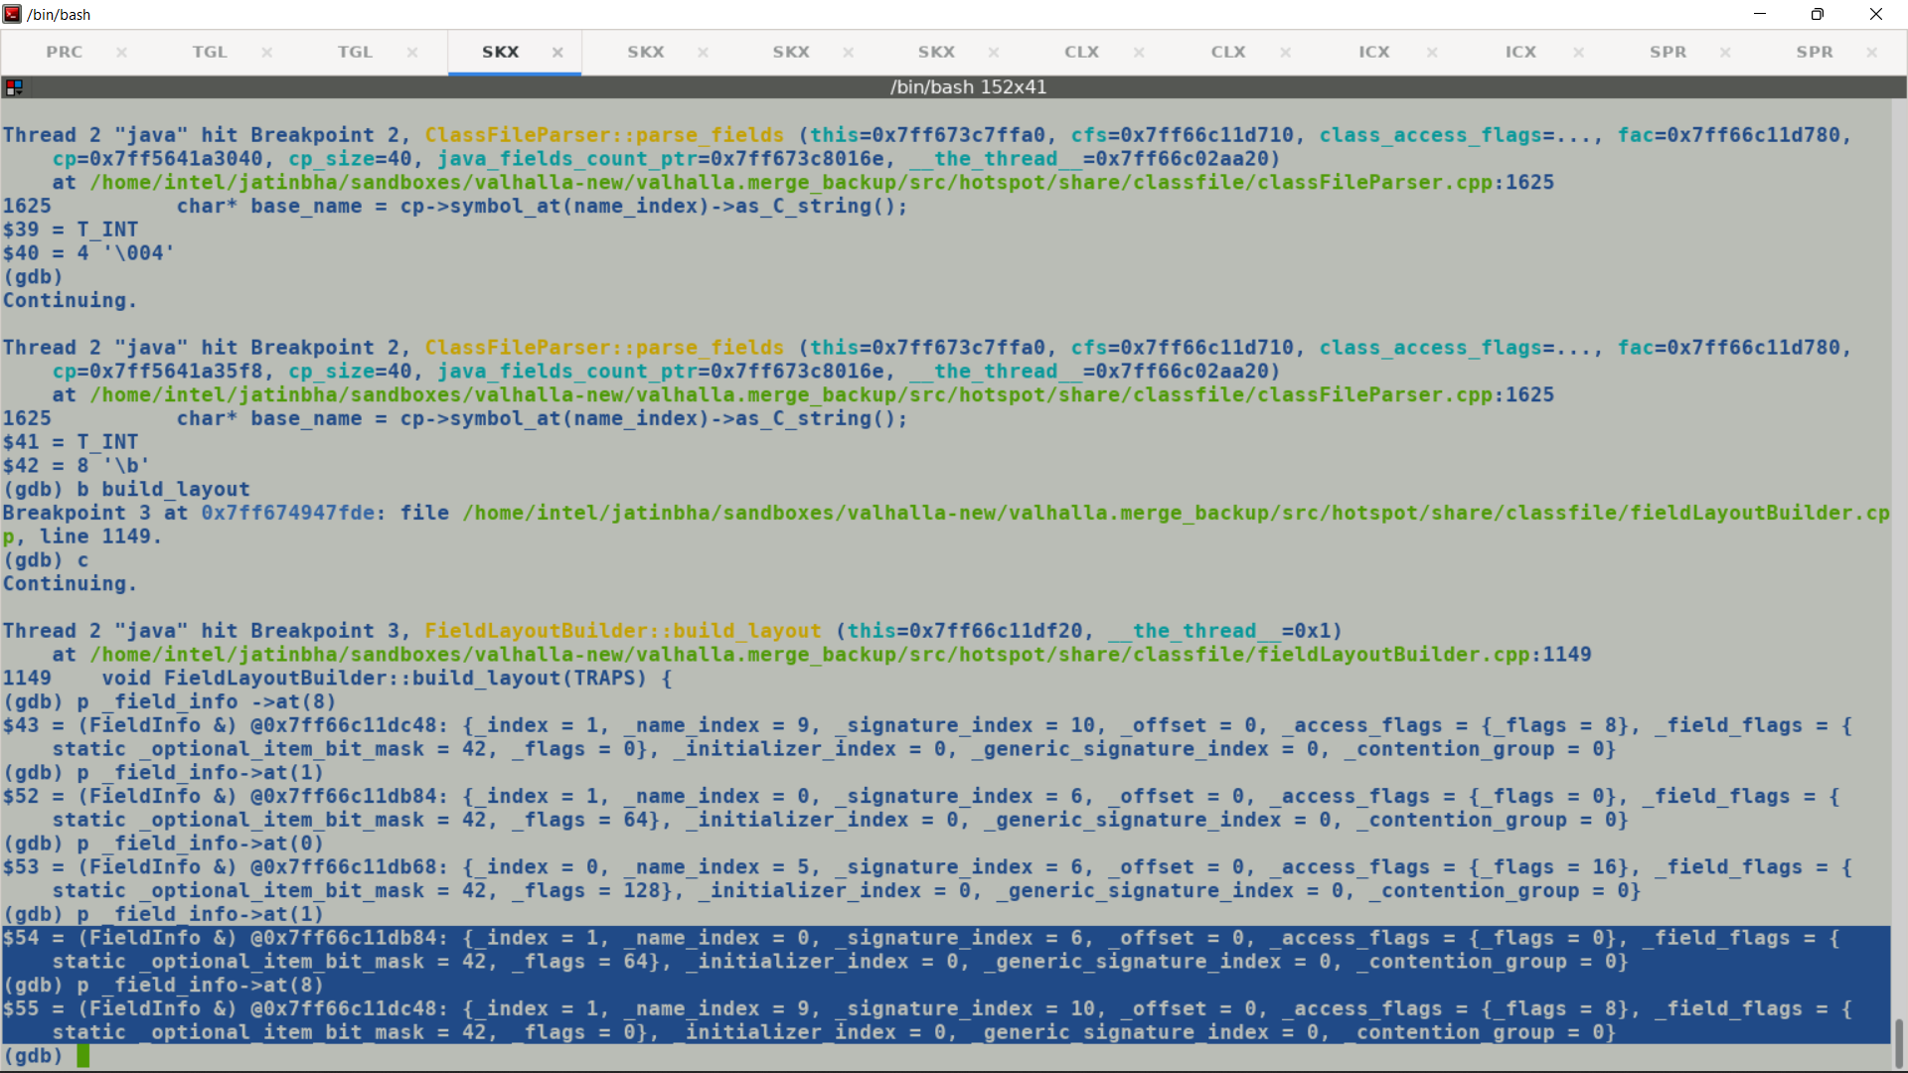

_static_fields->big_primitive_fields records the _field_index = 1 for static field which aliases with field index of mfield#1.

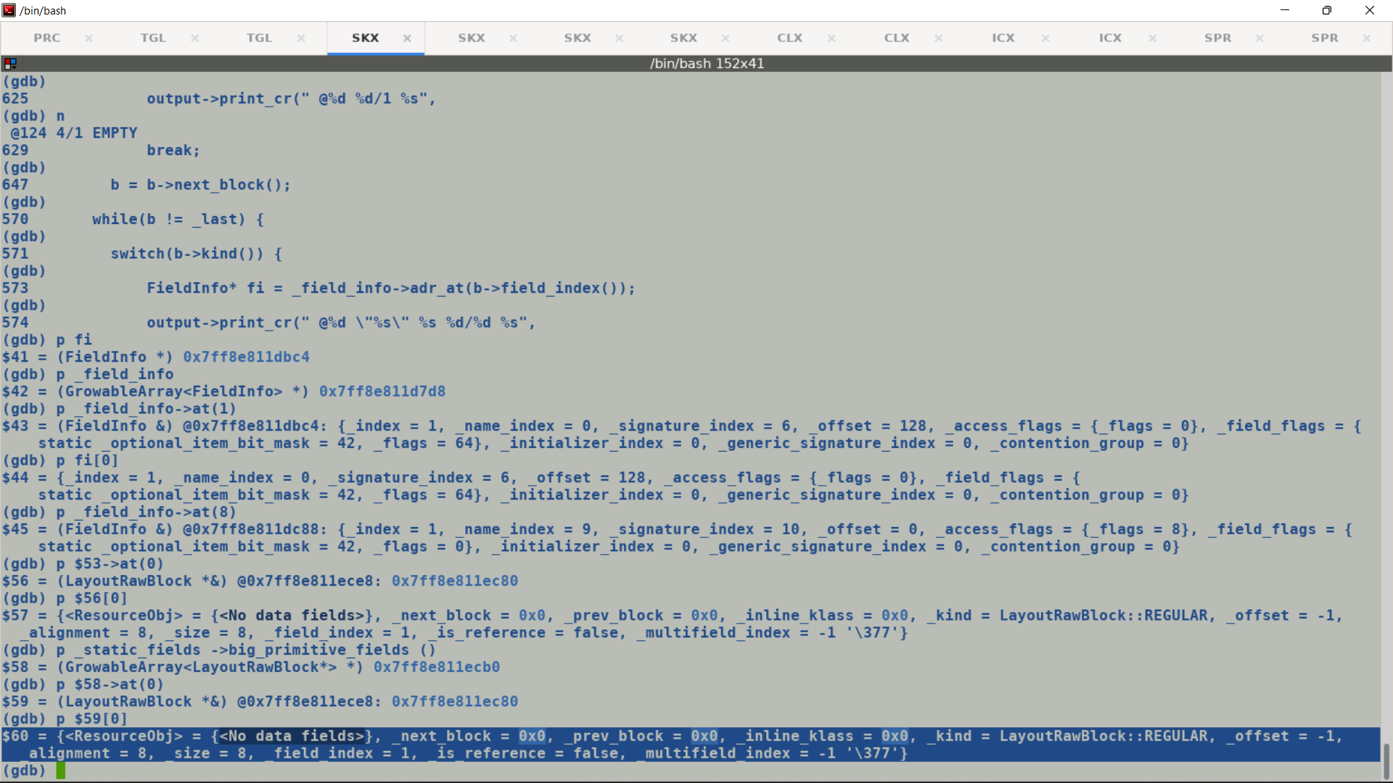

Call stack of Restore / de-serialization of VM classes during startup:-

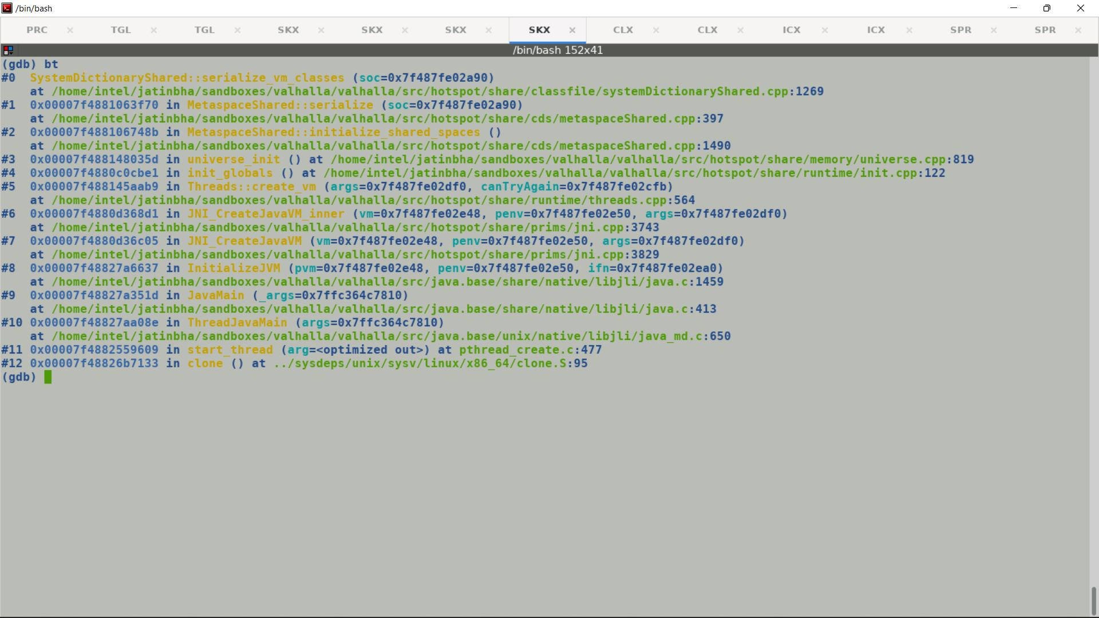

Existing Valhalla de-serialization dump shows correct exact_class size for VectorPayloads.

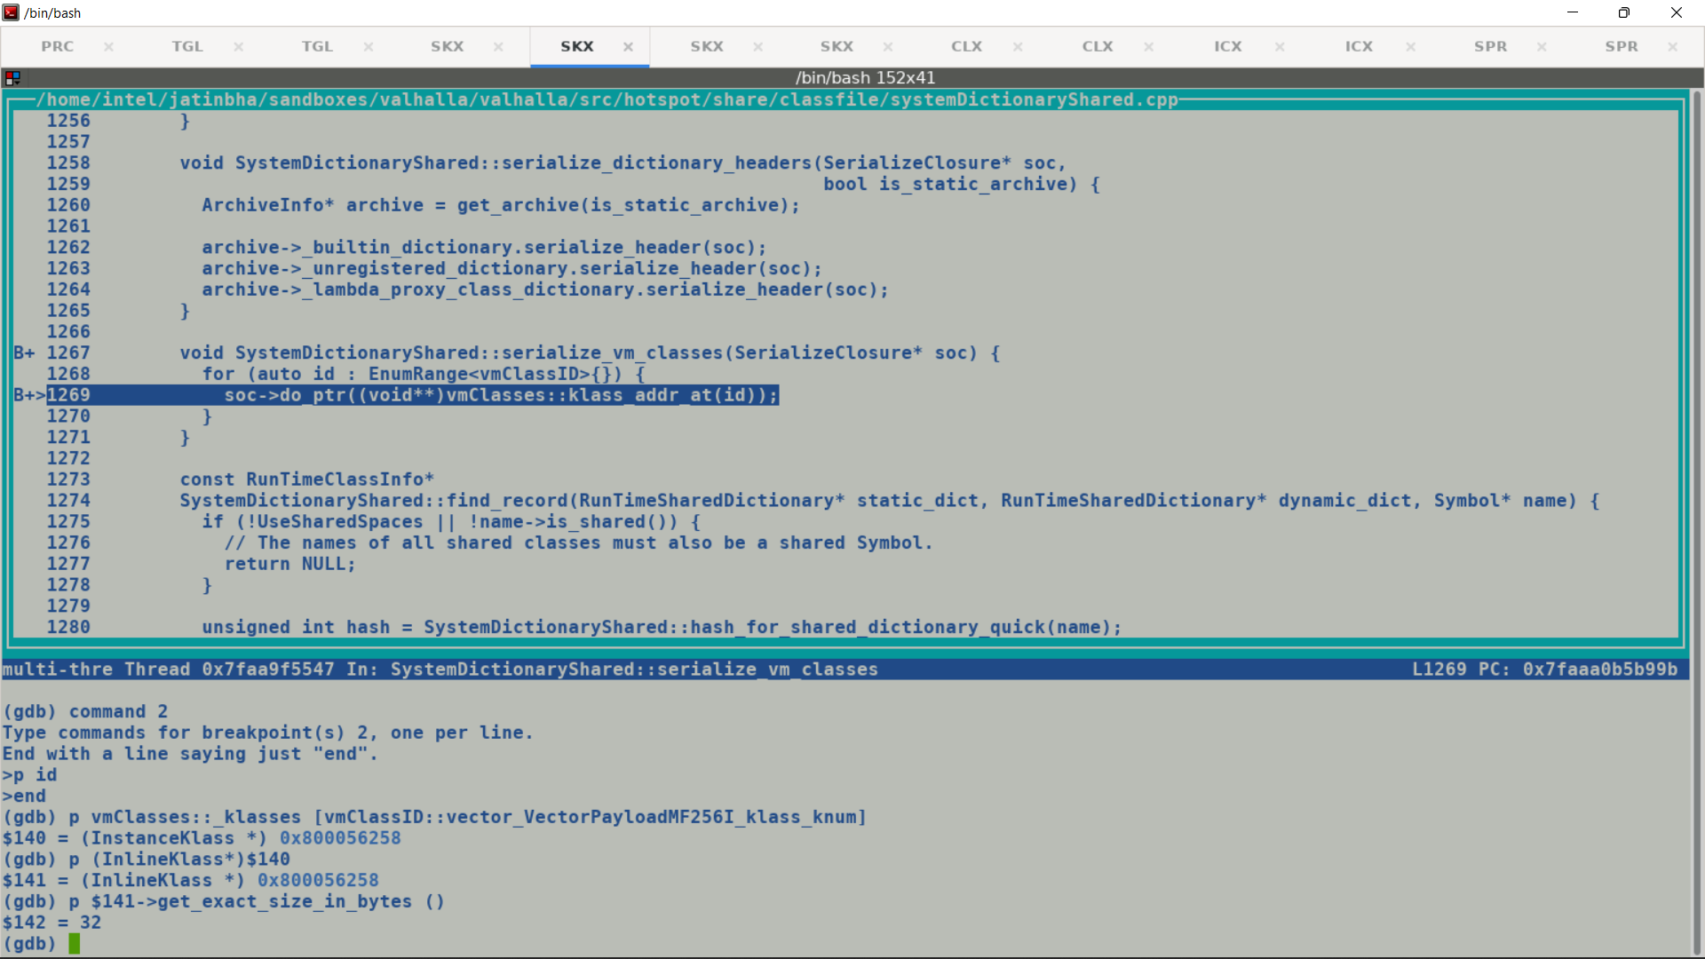

**Problem with merged branch, looks like an issue during serialization itself.**

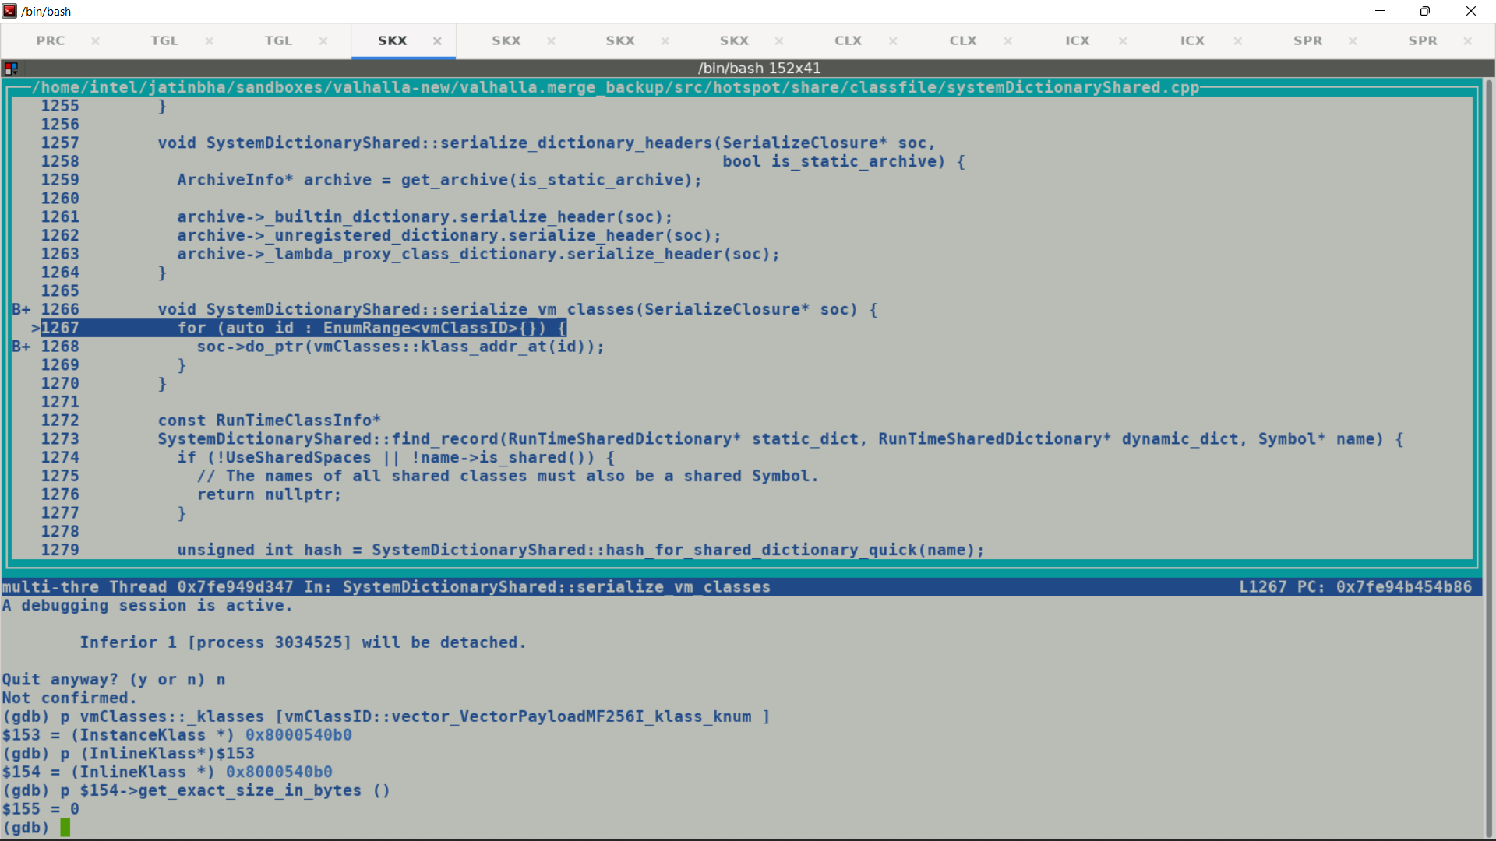

java -Xlog:cds=trace -XX:-PauseAtStartup -Xshare:dump -XX:+PrintInlineLayout -XX:SharedArchiveFile=classes.jsa > log.txt

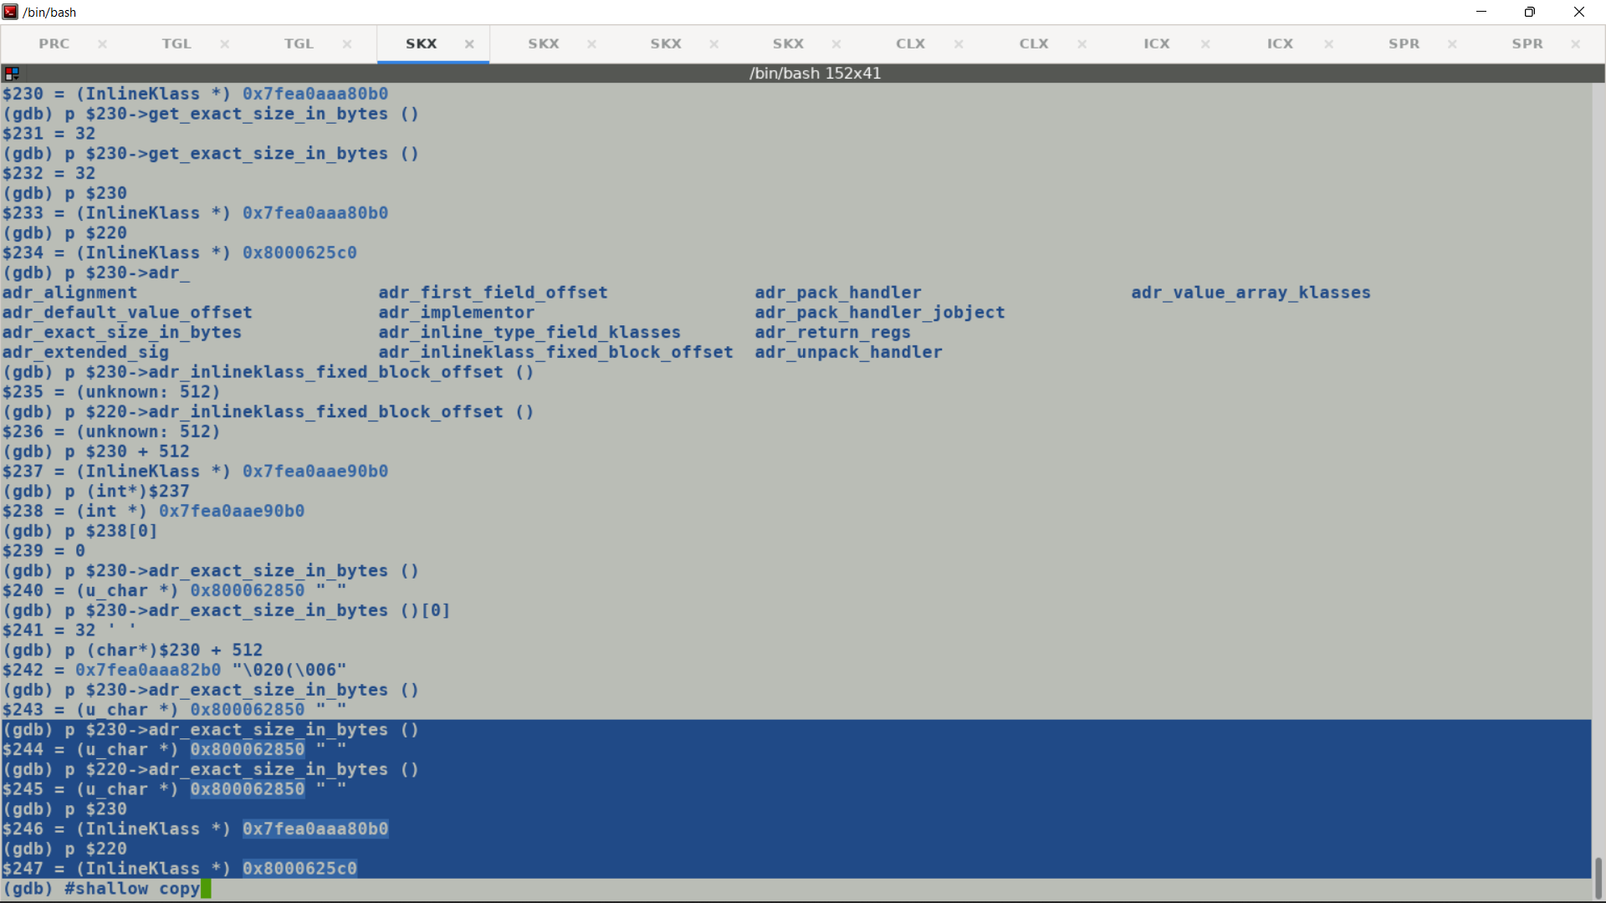

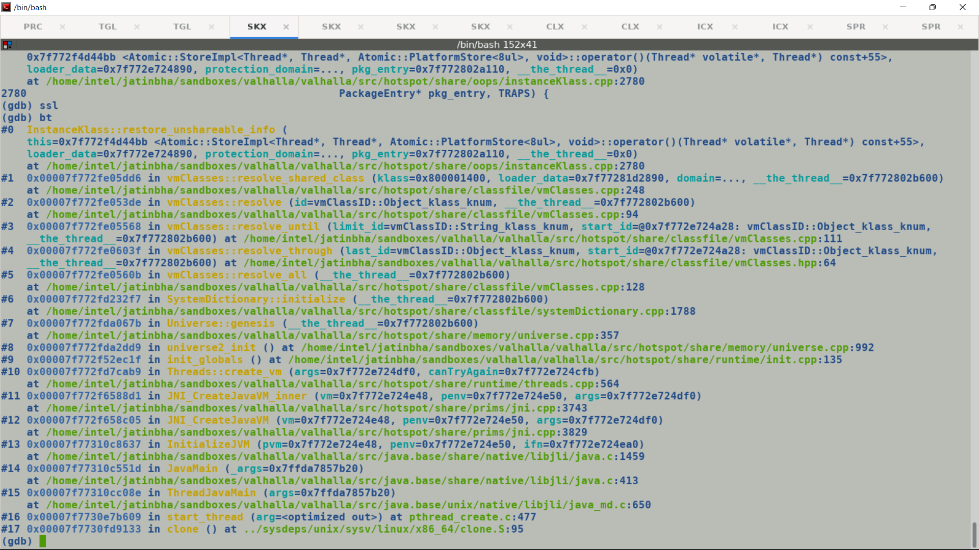

Debug dump sowing incorrect _adr_inlinkelass_fixed_block address with merged build.

Stock Valhalla + Vector

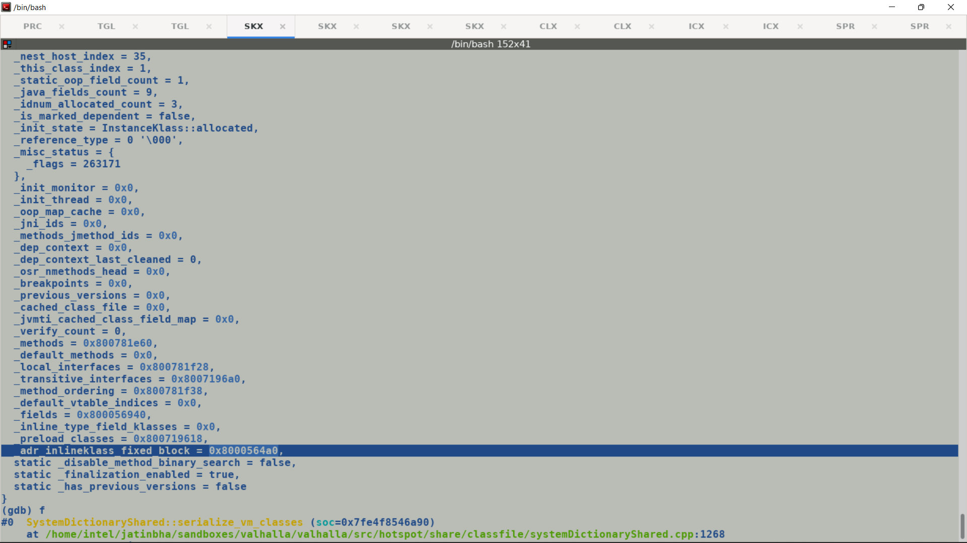

Merge Build

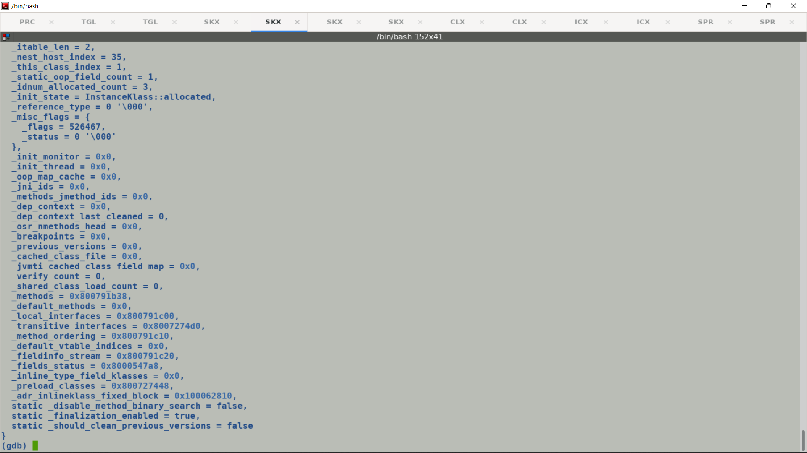

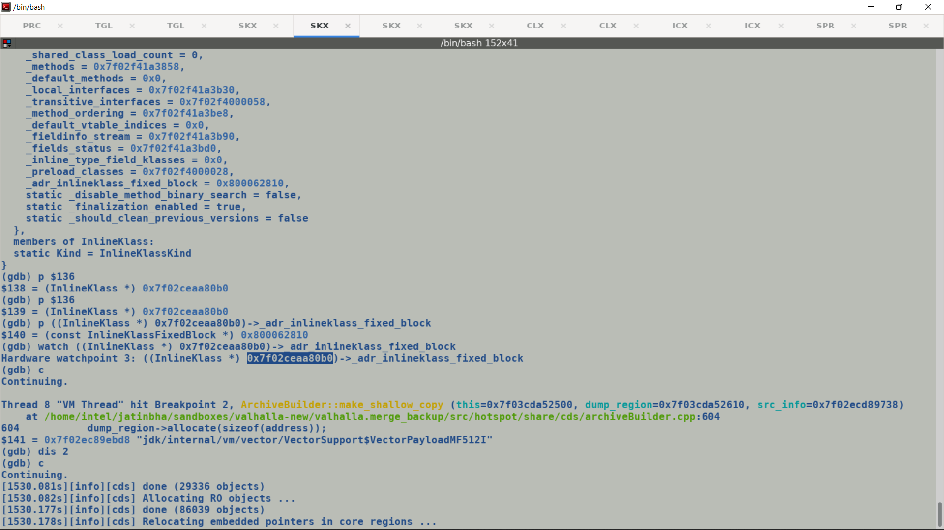

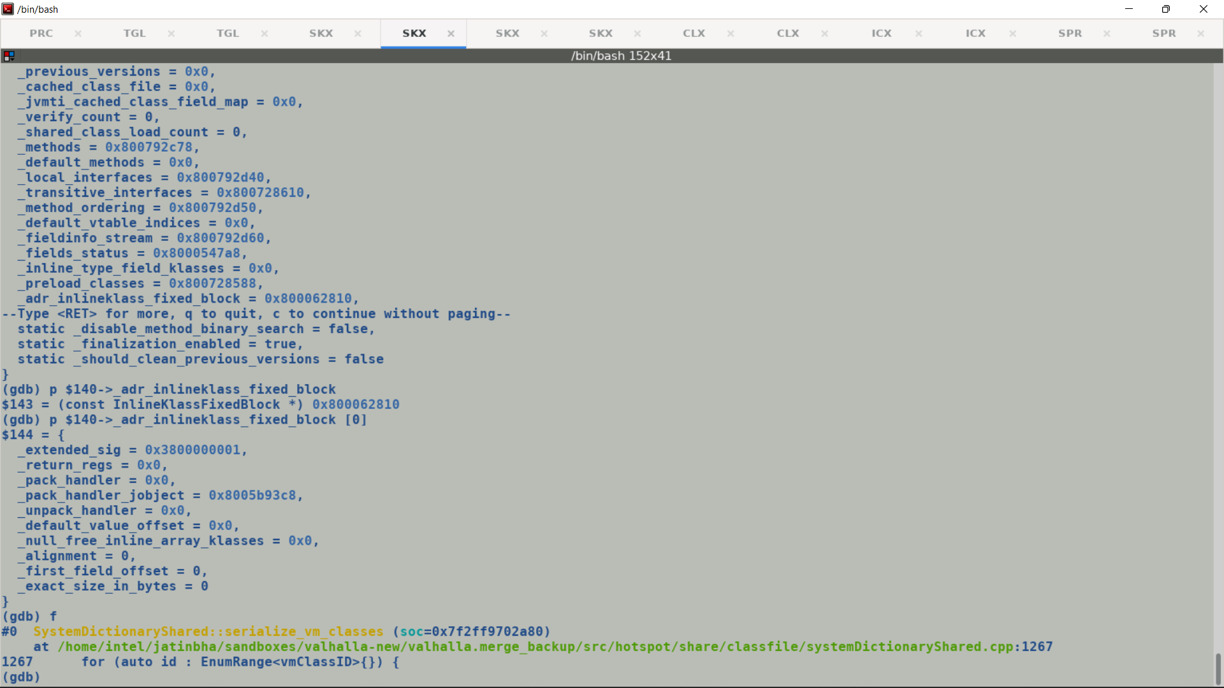

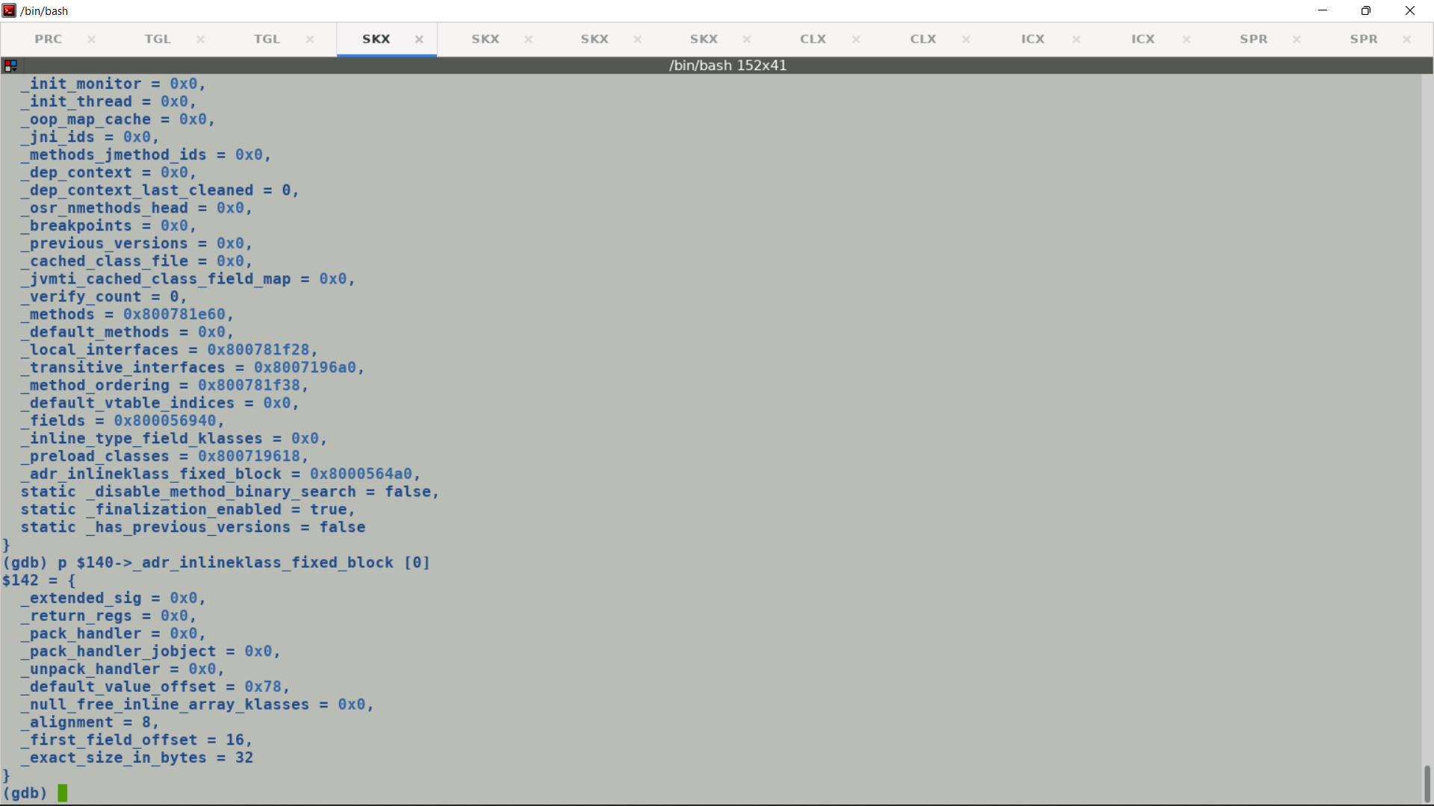

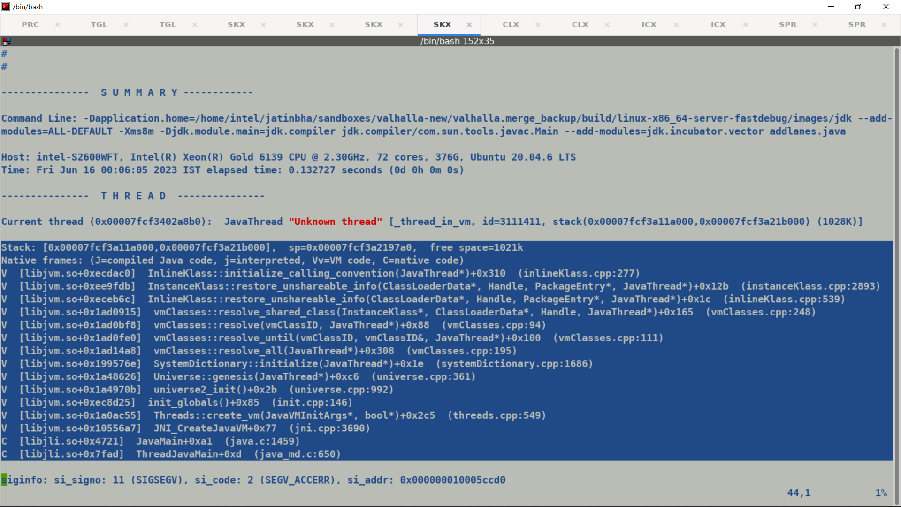

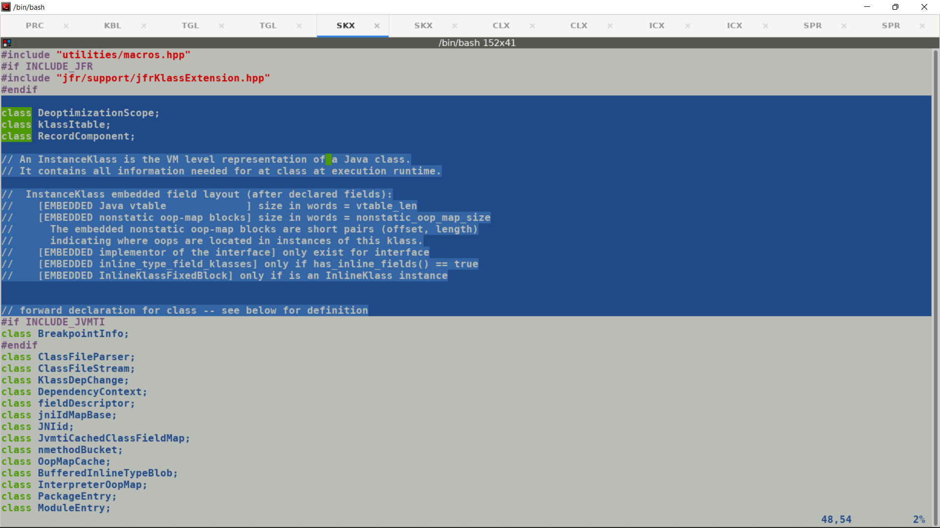

<https://openjdk.org/projects/valhalla/design-notes/state-of-valhalla/02-object-model>

<https://openjdk.org/projects/valhalla/design-notes/state-of-valhalla/03-vm-model>

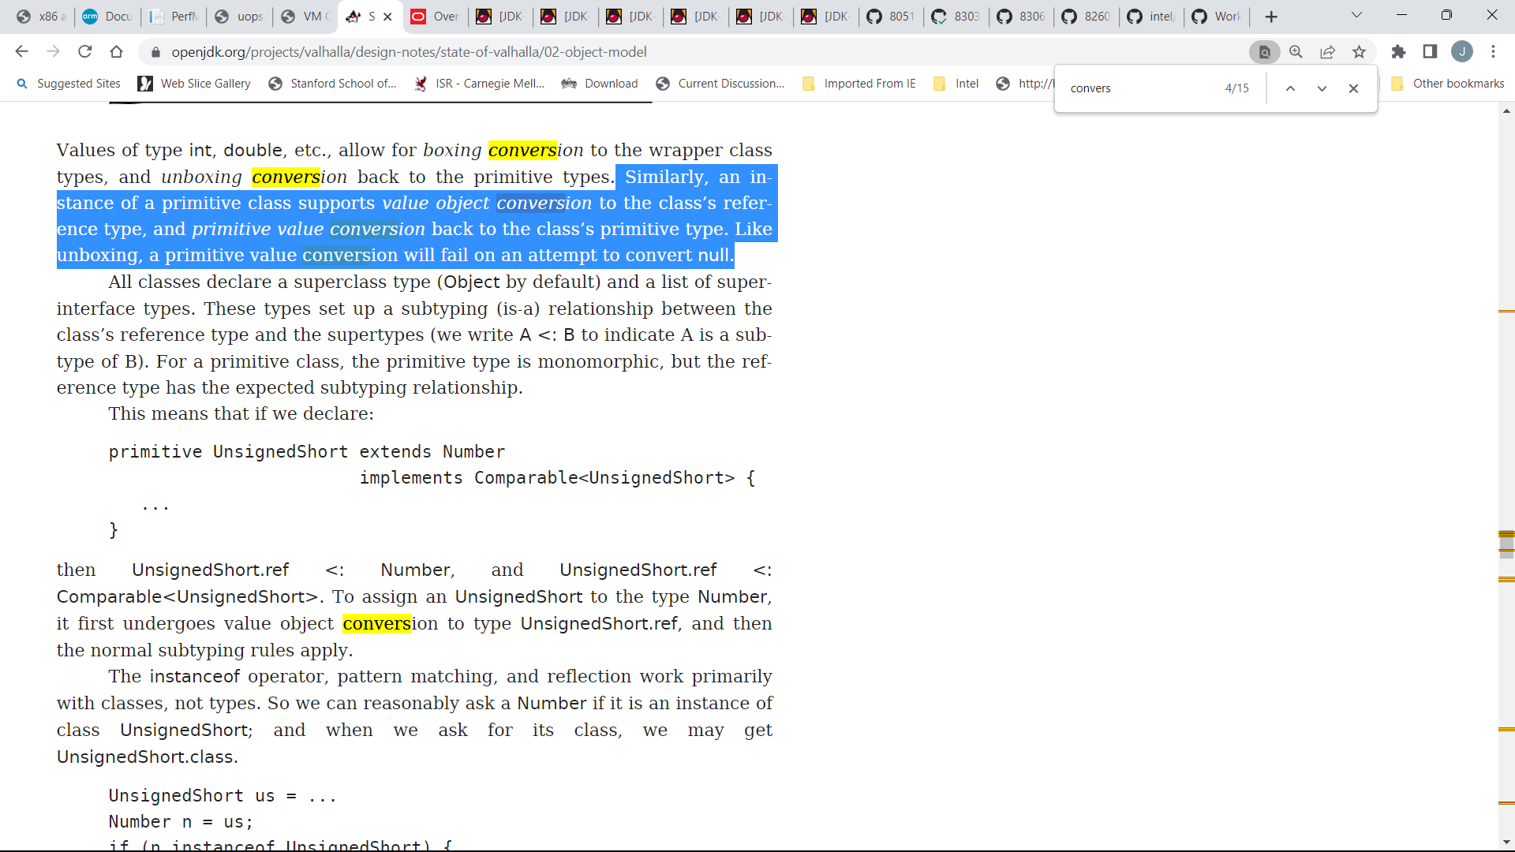

<https://openjdk.org/jeps/8277163>

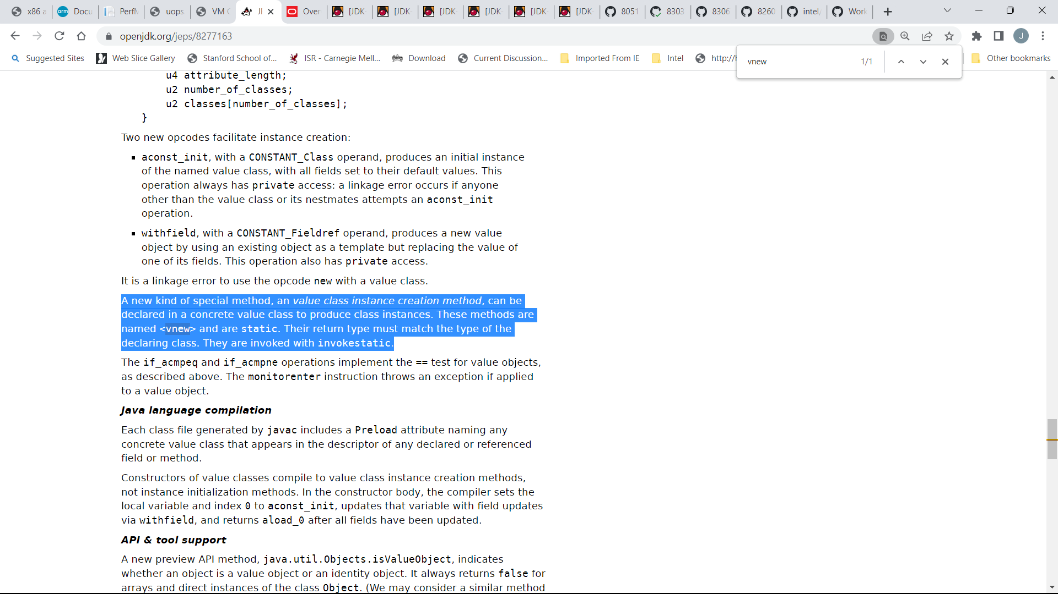

**With Stock build:**

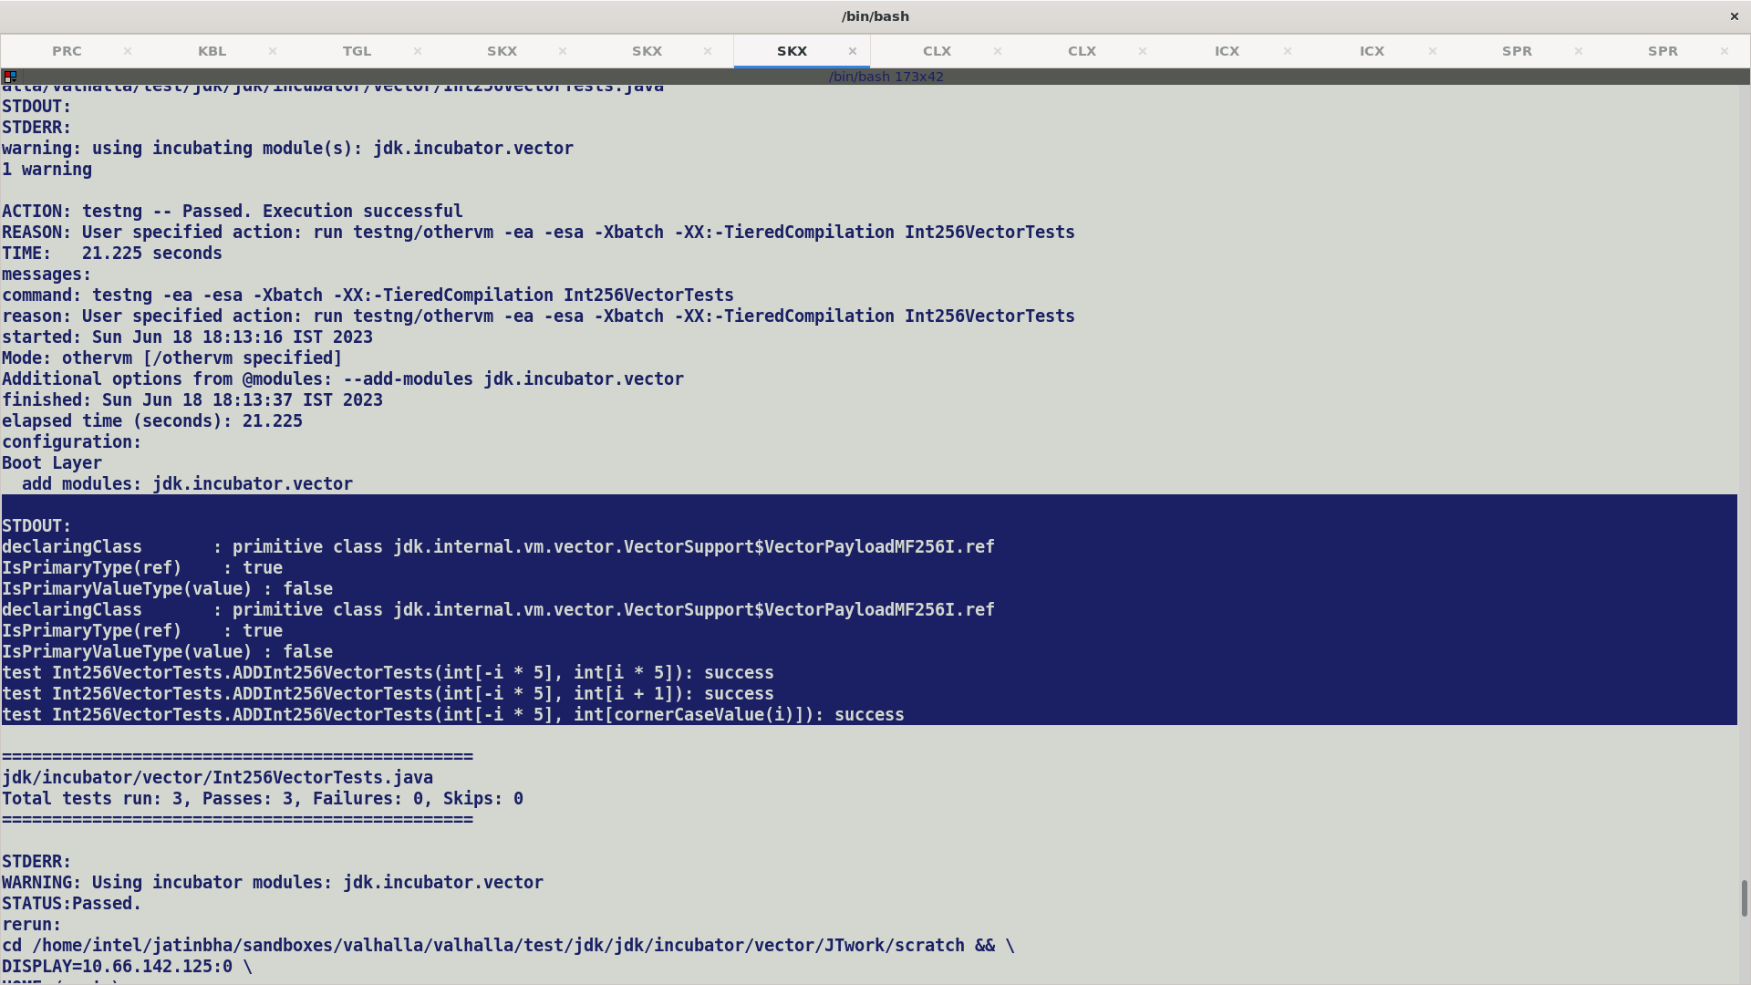

**With merged build:**

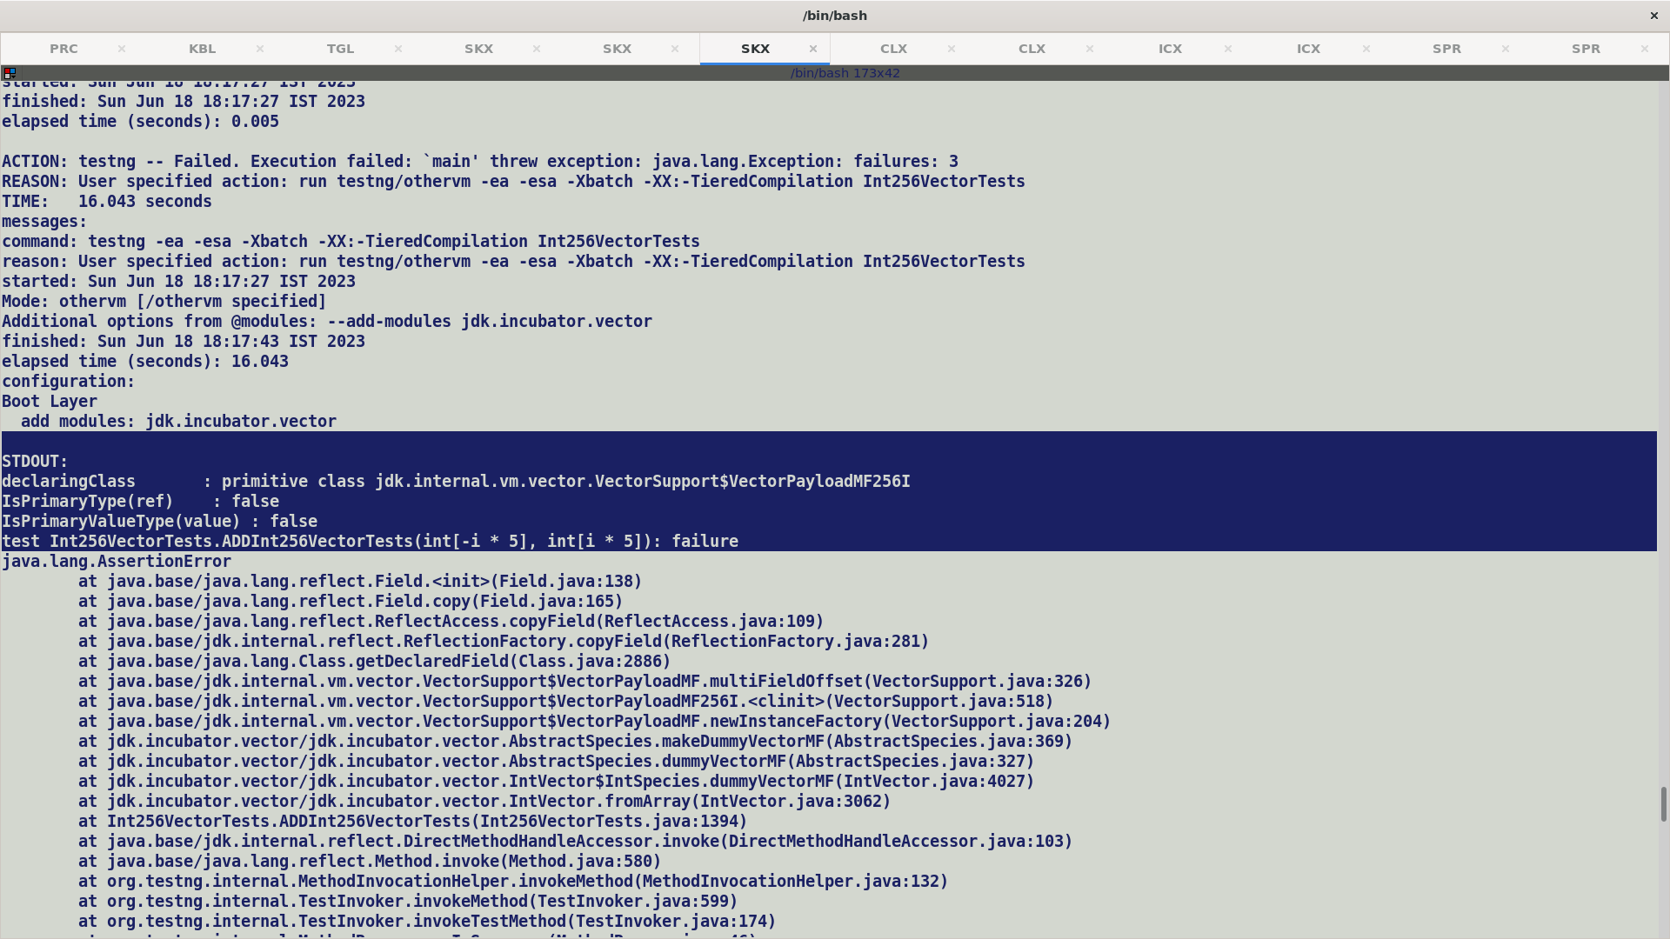

CDS serialization issue: -

* Mirrors are stripped off shared archive and are re-installed during vm startup, for vector payload (primitive class instances) primaryType (primitive class type i.e. .ref) and secondaryType (primitive value type) which should point to java and value mirrors are not initialized during startup.
* During VM startup all the non-archive classes goes through mirror fixups, but since VectorPayload* is part of the archive they are skipped over.
* As a workaround We can add VectorPayload* classes for fixup_list, or use -Xshare:off and do a proper fix in CDS flow.

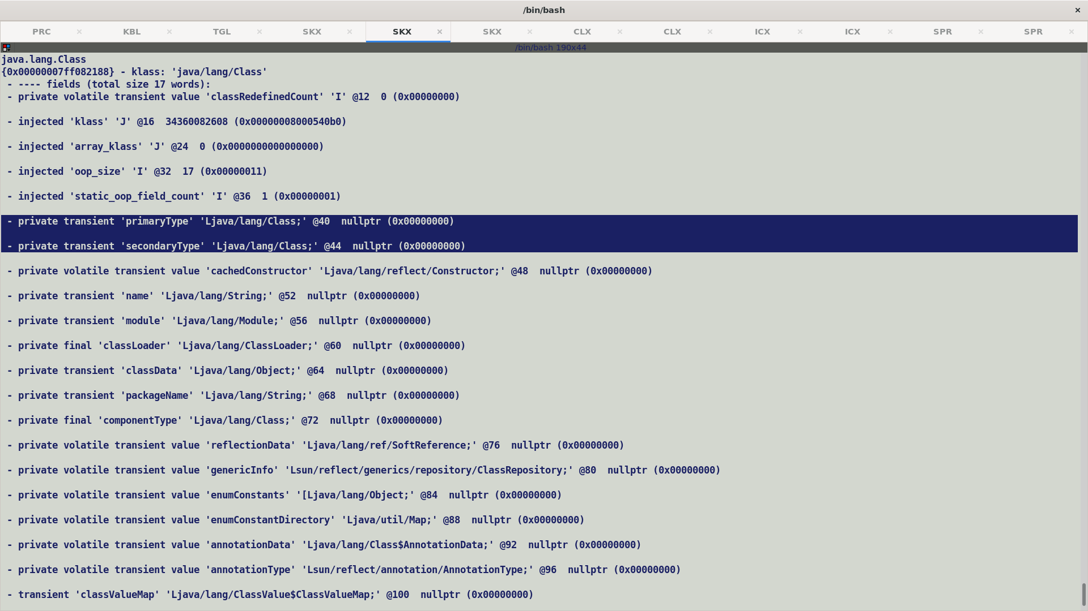

Fix for crash during vbox creation :-

Create InlineTypeNode prior to payload access, this will ensure that nof_non_static_fields initialize _declared_non_static_fields array.

Masking related:- Float64Mask bundle size should be 2. ( fixed it, this was a multifield and not multifield_base, during inline type node creation we take scalarization decision and reserve the space for incoming edge vector appropriately) , first field may still be multifield base with bundle size followed by rest of synthetic multifields, but compiler has appropriate checks in place based on match_rule_supported_vector at all the places where vector IR related (load/store/broadcast) multifield is being created.

Also once InlineTypeNode is created number of input is determined by InlineTypeNode::field_count() and not num_of_non_static fields.

Get_field_for_index is appropriately extended to return a multifield for index > 1

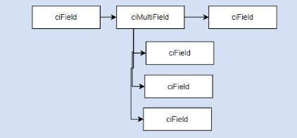

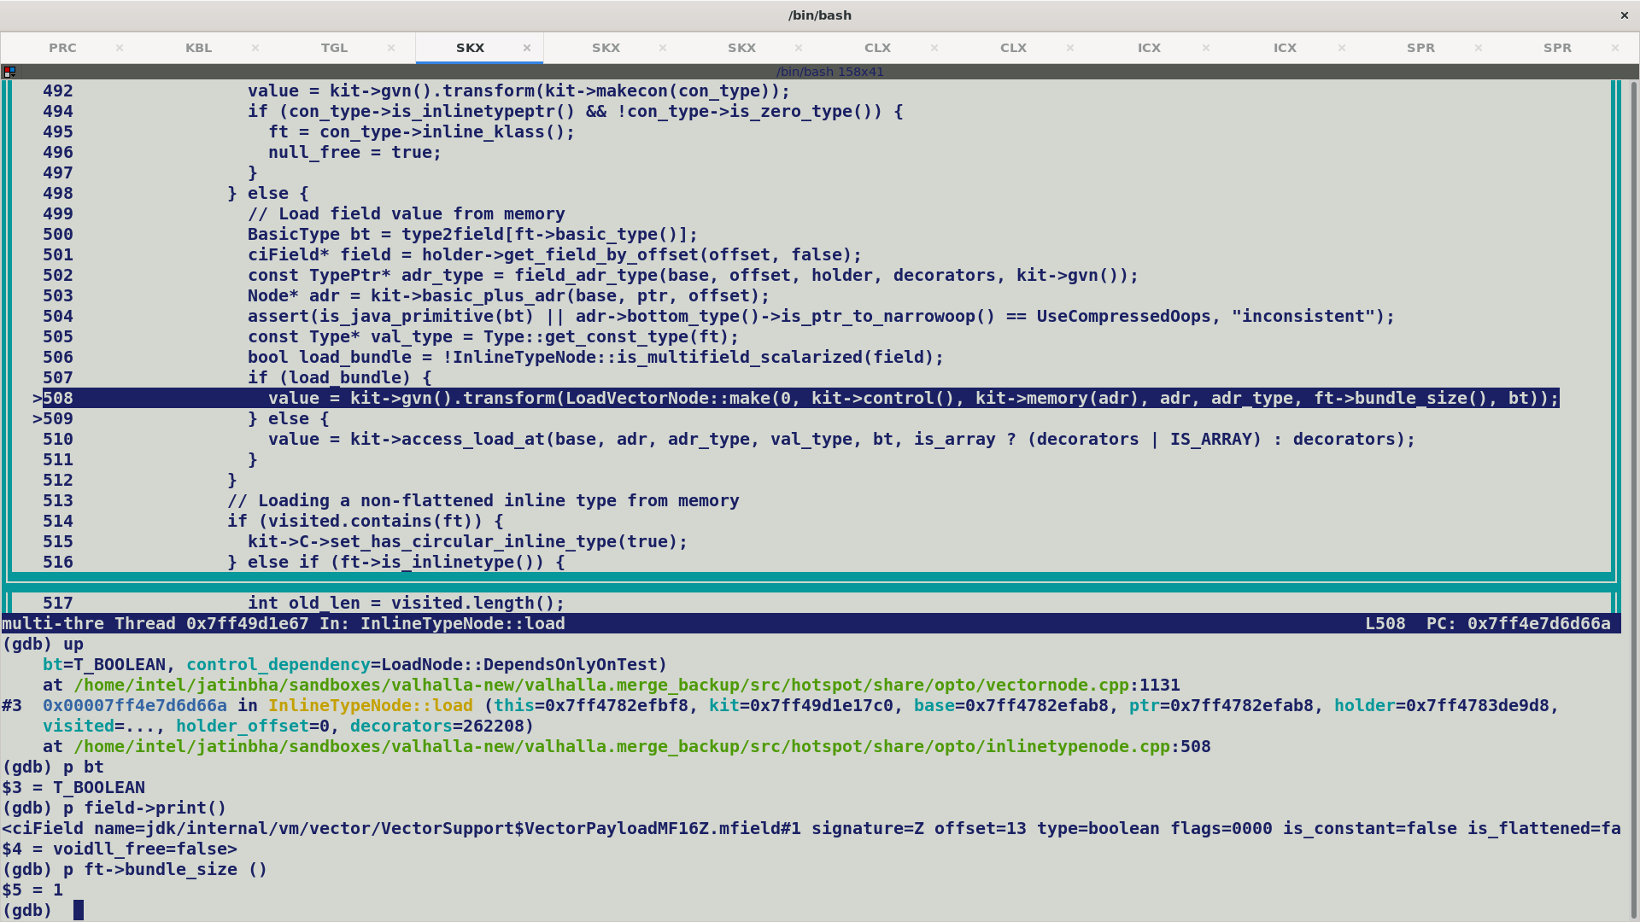

VectorAPI’s operating on Less than equal to 32 bit mask are not intrinsified i.e. not box creations, but compiler will still create InlineTypeNode since they are primitive / value klass instances, thus it may still enter regular deoptimization flow though fall back implementation .

Handling for Double/Long 64 vectors is in place, for masking we need to do similar handling. (Try Xiaohong’s patch for masking deoptimization)

TODO:

Shared CDS not preserving primaryType and secondaryType (infrastructure issue, to be done on lworld)

[Last issue in merge: Deop Incorrectness

Updating values:-

C1 does in-place update / put operations using Unsafe primitives, it does expect value object to be in larval state but it does not create a new value object with each update.

However, since C2 has a special IR representation of value / primitive objects i.e., an InlineTypeNode, hence with each update C2 create a new InlineTypeNode.

Fallback implementation make heavy use of unsafe put operations to update each individual lanes in a lanewise vector operation.

Thus the use of withfield byte code is mainly concentrated around value initialization methods (vnew) e.g. Float256Vector (VectorPayloadMF256F)

aconst_init -> create default initialized value object

astore_1

aload_0 -> loads incoming payload into operand stack.

aload_1

swap -> swaps top two operands over stack.

withfield <mfield> -> replaces mfield with payload argument and creates a new inline type.

-> Clones a new value object and replaces the specified field with the incoming argument.

-> Since payloads are primitive class instances they are fully flattened in its parent object context.

-> Therefore we have special handling in place for multifield annotated fields for all the execution engines (c1/c2 and interpreter).

Deoptimization Related Changes: -

De-optimization related changes, currently box / payload allocation and re-assignments are tightly coupled in single routine, but an InlineTypeNode created during fall back implementation for payloads may have constants / scalar registers (single element mask, shuffle, vectors) or vectors input values, thus it’s good to de-couple allocation and use existing re-assignment routines which already handle loading values from stack locations corresponding to GPRs and constant inputs. (Xiaohong shared a partial patch on this with her shuffle/mask handling).

In case of scalarization SafePointScalarObjectNode should bookkeep the locations of all the scalar nodes corresponding to a multifield bundle.

Double256Mask occupies 16 bit storage to hold mask corresponding to two mask lanes, we do not support 16 bit vectors and scalarize them into individual scalar node, during deoptimization in order to re-materialize the box we need to record the stack location for each scalarized field.

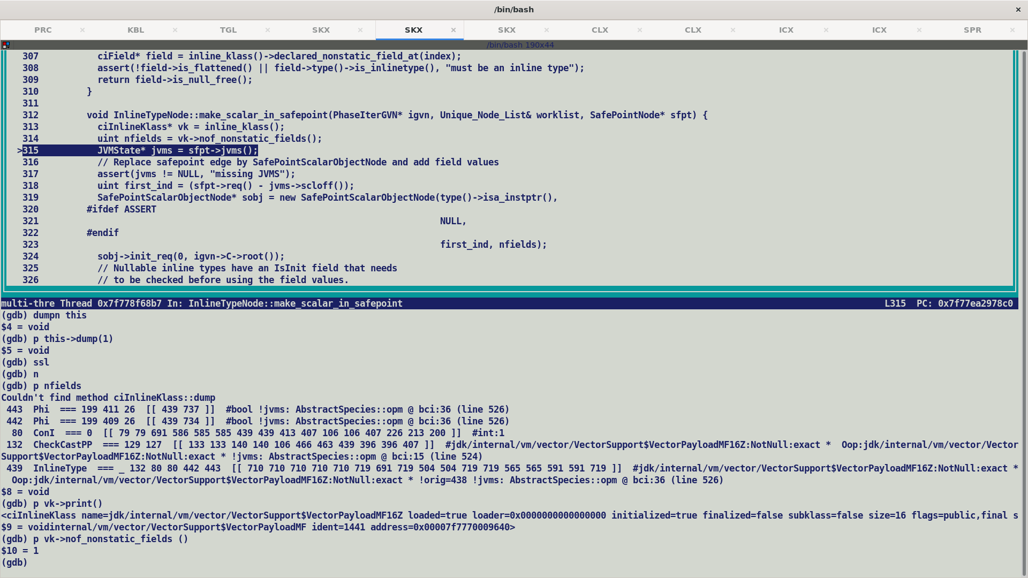

SafepointScalarObjectNode records the number of fields, starting field index of SafePointNode holding the field values and instance type information. This is then appended to debug information and is used while constructing Scope Descriptor used by deoptimization.

There is a discrepancy between ciField population and c2 IR construction*, compute_nonstatic_fields_impl* should recurse on seeing a flattened field which may also have inline fields, unless we do a bottom-up traversal in which case we are guaranteed to have gathered only leaf level fields but this looks like a remote possibility.

On the other hand, C2 InlineTypeNode is constructed in a hierarchical fashion where we create a different InlineTypeNode for a flattened field, all the load / store routines are also written recursively to adhere to this graph shape.

This may result in problems while bookkeeping scalarized fields at SafePoint in *process_inline_types* routine.

ObjectValue encapsulate field values which are used during field re-assignments for newly allocated boxes during de-optimization.

Since now we have decoupled allocation and re-assignments hence we no longer have to check to payload kinds during allocation which is a dump operations and legality related to payload locations should be done during re-assignments.

Add a new function interface which query compiles for supported vector sizes, This will enable ci* model to accurately return field counts for multifield bundle.

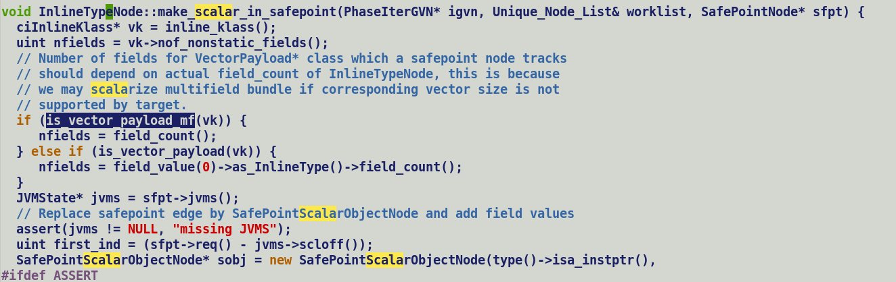

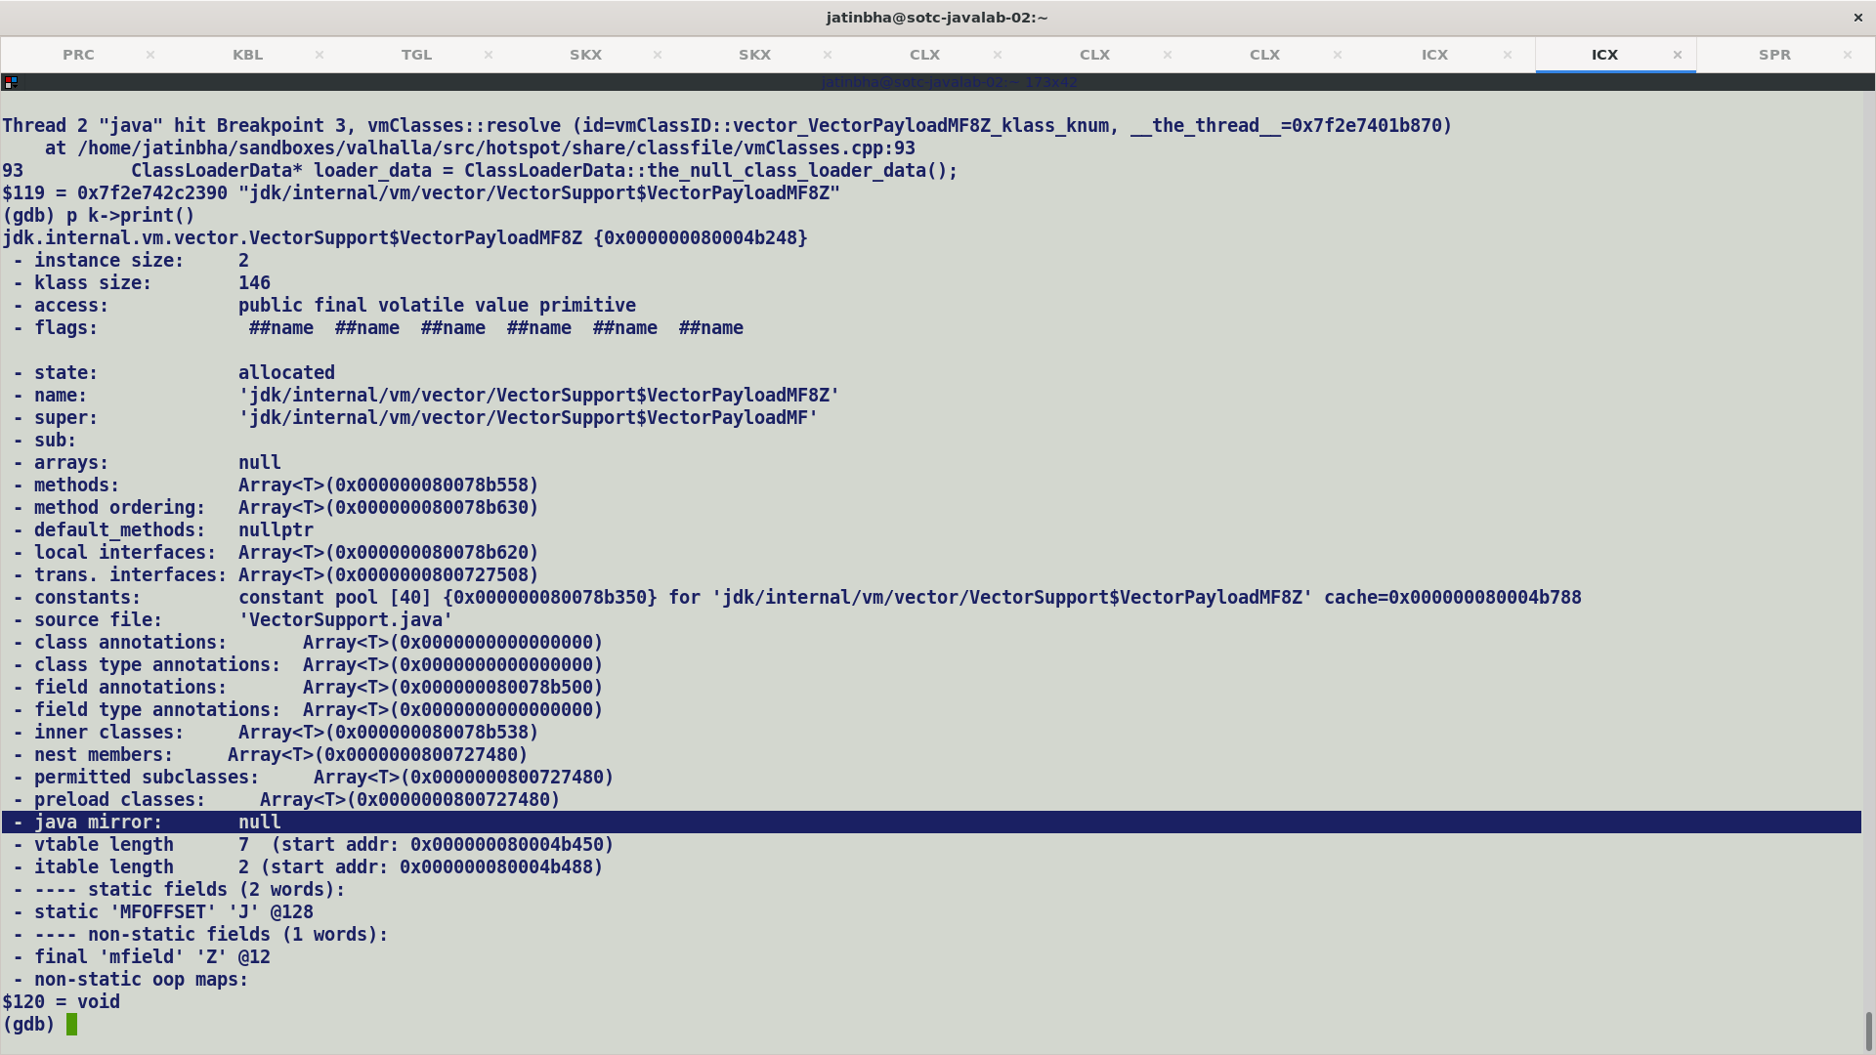

Since VectorPayload* classes are part of java.base module hence they make their way to classes.jsa shared archive, hence mirror should either be part of shared archive or it should be re-created during archive reading.

Concrete vector classes are anyways explicitly loaded and hence parsed as an when a reference is seen in constant pool during linking stage.

Earlier has_archived_mirror_index was not being set for archived VectorPayload* classes, thus mirrors were being re-created during startup and primaryType and secondaryTypes were initialized.

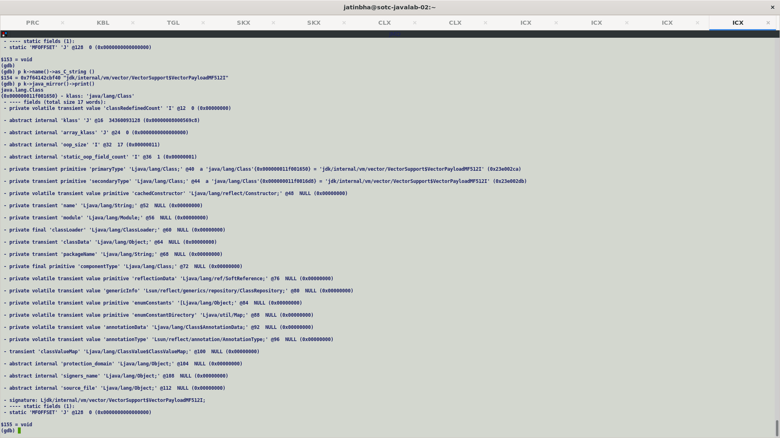

Post-merge, mirrors for VectorPayload* classes are archived and has_archived_mirror_Index flag set for them. But, restored java mirror points to an incorrect mirror object of a non-primitve class (java/lang/String).

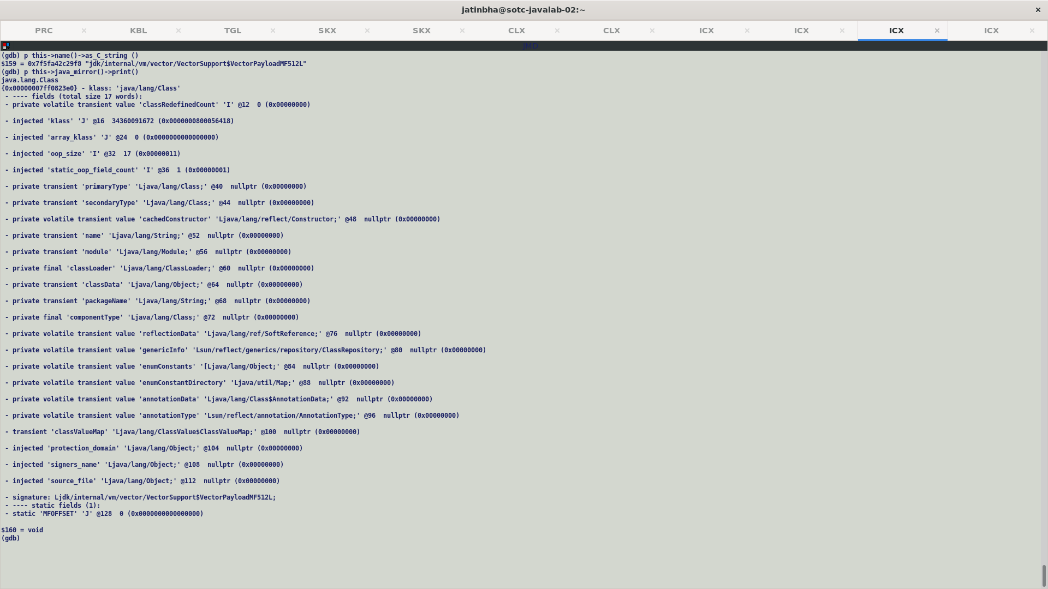

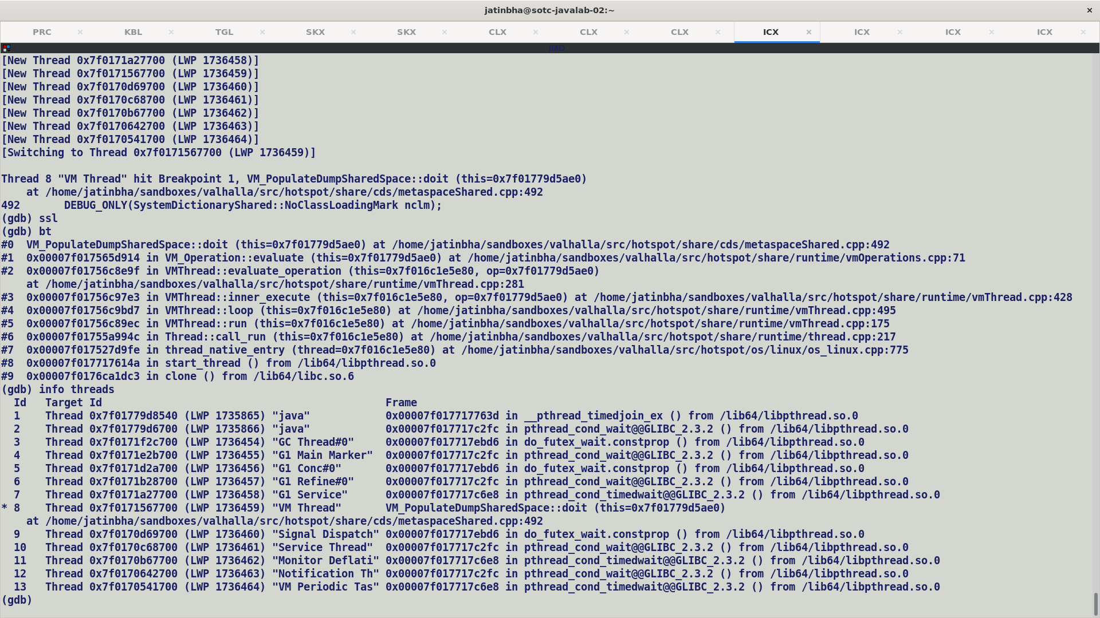

CDS Stuff:-

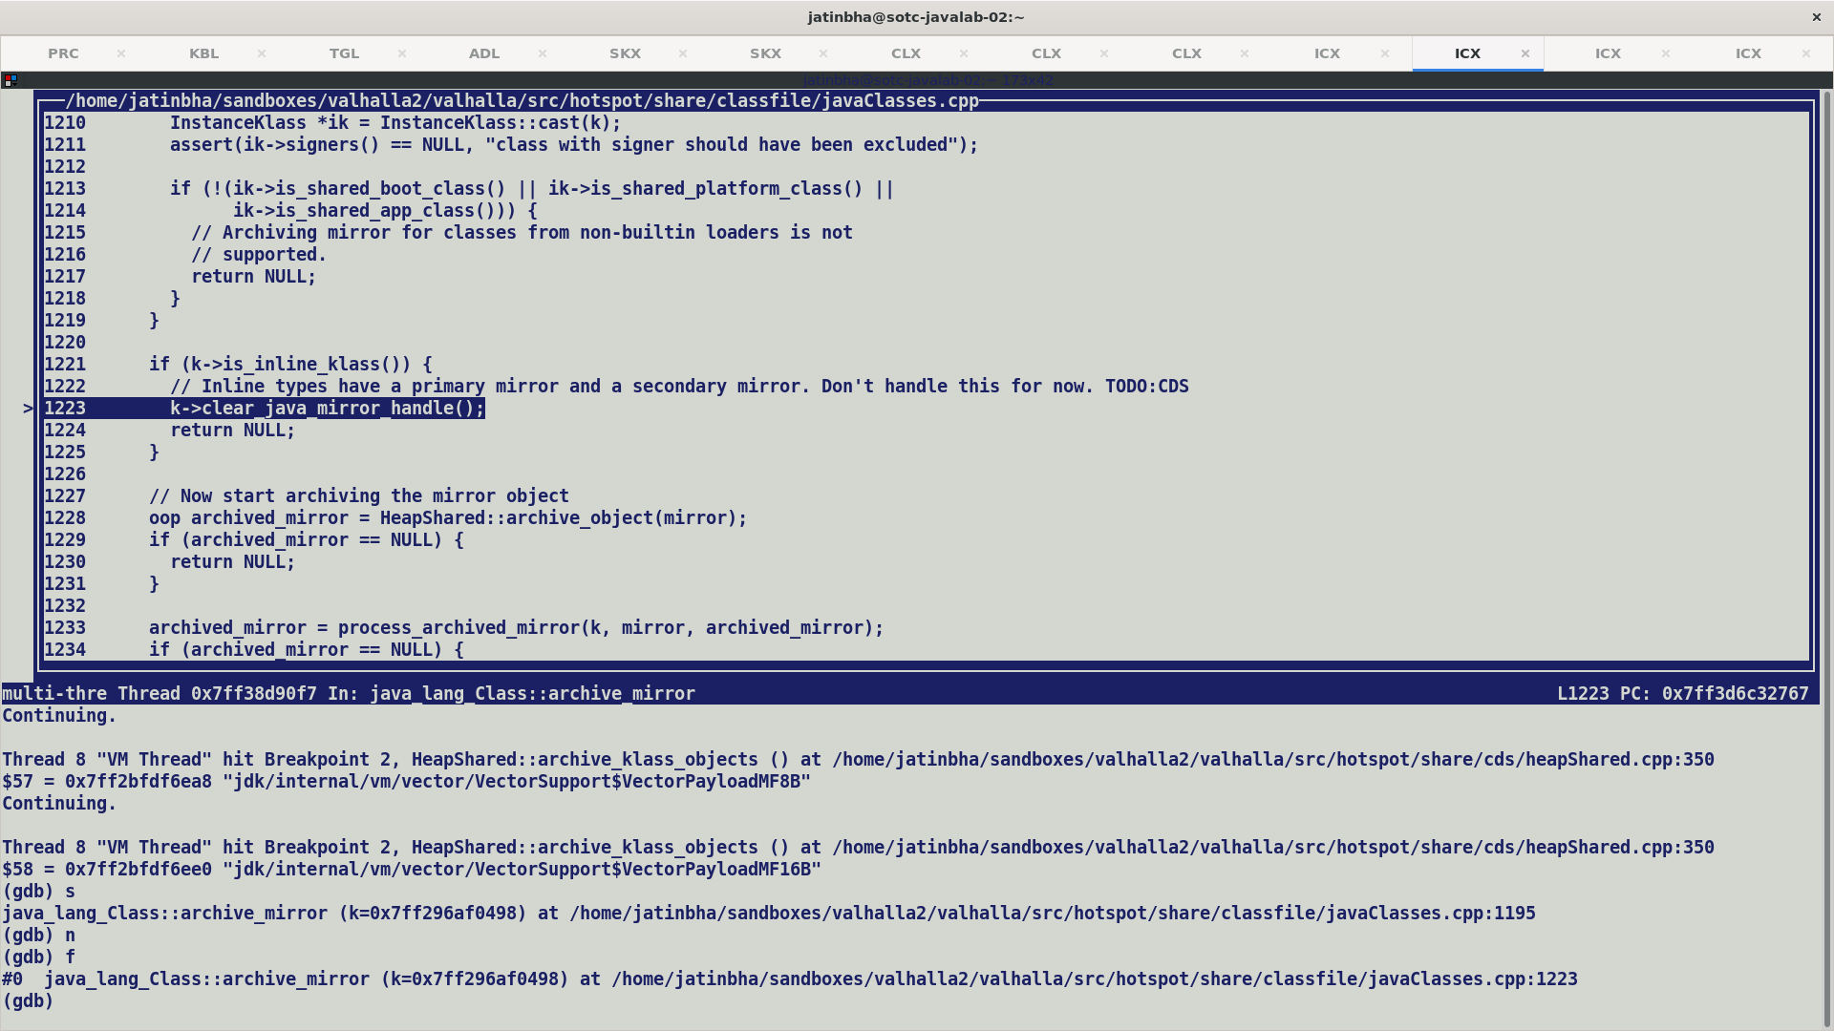

commit 6501f7fbcfa7a81ee6fce61660fdbd2414ed5754

Author: Ioi Lam <iklam@openjdk.org>

Date: Mon Dec 16 22:20:28 2019 -0800

8225638: [lworld] Store inline classes in CDS archive

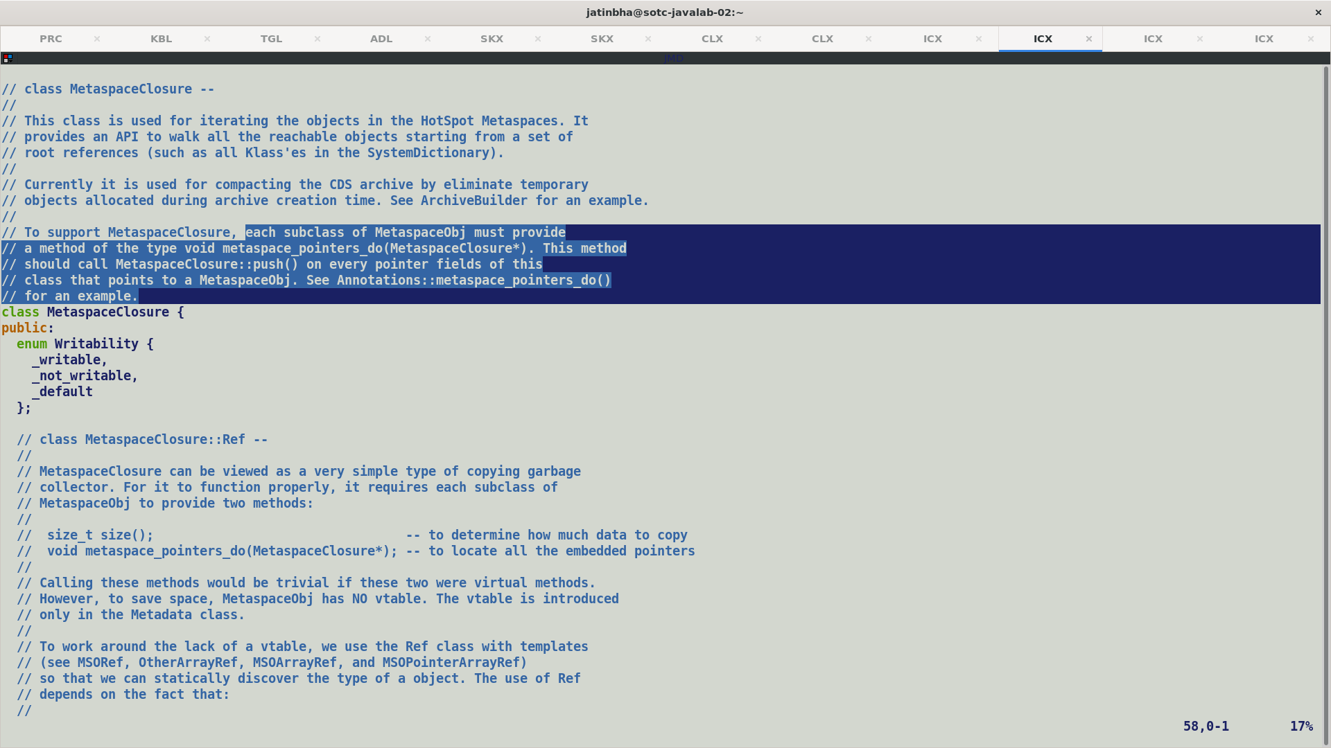

---------- Payload as Identity -------------

Layout of class payload

Instance fields:

@0 12/- RESERVED

@12 4/1 EMPTY

@16 "f1" J 8/8 REGULAR

@24 "f2" J 8/8 REGULAR

Static fields:

@0 120/- RESERVED

Instance size = 32 bytes

--------- Payload as Value -----------------

Layout of class payload

Instance fields:

@0 12/- RESERVED

@12 4/1 PADDING

@16 "f1" J 8/8 REGULAR

@24 "f2" J 8/8 REGULAR

Static fields:

@0 120/- RESERVED

@120 ".default" Ljava/lang/Object; 4/4 REGULAR

Instance size = 32 bytes

First field offset = 16

Alignment = 8 bytes

Exact size = 16 bytes

> -----Original Message-----

> From: valhalla-dev <valhalla-dev-retn@openjdk.org> On Behalf Of John Rose

> Sent: Wednesday, July 12, 2023 12:01 AM

> To: Frederic Parain <frederic.parain@oracle.com>

> Cc: Xiaohong Gong <Xiaohong.Gong@arm.com>; valhalla-dev@openjdk.org;

> nd <nd@arm.com>

> Subject: Re: [External] : RE: Question on the inline type flattening decision

>

> On 10 Jul 2023, at 8:09, Frederic Parain wrote:

>

> > Hi Xiaohong,

> >

> >

> > Field flattening has two major side effects: atomicity and size.

>

> Yes! Well put.

>

> Here’s some more fine print:

>

> Atomicity of a value class will be something that its class declaration can opt

> out of. For a class that is non-atomic, then (I think) both final and non-final

> instance fields of its flattenable type (the null-excluding type, aka the “val

> type” or Q-type) can use the same policy.

>

> For a value class which is atomic (and that is the default), it will not be

> possible (until the day we have efficient HTM) to flatten fields of that type, if

> they are mutable.

So that layout does not tier them apart.

>

> (There’s even more fine print for nullable reference types from value classes,

> if the VM ever tries to inline nullable types, but that’s way in the future and

> will not be user visible.)

>

> >

> > Final fields are not subject to atomicity issues because they are immutable

> after their initialization.

>

> So the current policy treats non-final instance fields as flattenable, which

> means it treats them as immutable. This is 99.99% correct.

>

> There is a technical debt here concerning what sorts of indeterminate

> behavior are allowed in the 0.01% case, where (a) the constructor for the

> object containing the flattenable field allows “this” to escape and another

> thread picks it up, and (b) the other thread makes a racing read of the

> flattenable field at just the wrong moment. Here’s the debt: Either we do

> not flatten the field (at least when we know, statically, that this bad thing

> can happen) or else we somehow delay the racing read until a safe moment

> (by means of a mutex protocol of some sort), or (yet again) we somehow

> detune the JVMS to allow atomic value classes to race, if their containers

> are so rude as to allow concurrent reads through escaped “this” pointers. I

> think the most practical option is the first, which means, sadly, the 99.99%

> correct policy for final fields needs reconsideration. But maybe I’ve missed

> some fortunate aspect in the current policy, that allows it to avoid the

> 0.01% error.

>

> (It’s corner cases like this that make JVM design exceedingly difficult. Most

> language specs. and runtimes don’t bother to track all the details to this

> level, but Java does.)

>

> >

> > Both final and non-final fields have an impact on the object size, and

> potentially on cache behavior.

>

> This is true for instance fields, because there are an indefinite number of

> instances of them. It is not really true for static fields, and that’s a

> distinction that can have an effect on flattening policy.

> The existing policy never flattens static fields; all the code quoted in this

> thread is for non-static fields.

>

> <digression topic=“flattening static fields”>

Flattening of static field into mirrors.

>

> There would be zero benefit, and some harm, to flattening static final fields.

> The harm is to startup time, when that is dominated by interpreter

> performance. The JIT doesn’t care either way; it’s a compile-time constant.

>

> Non-final statics are also very different from non-final instance fields, so it is

> reasonable to use a different policy for them as well. Since statics are

> inherently shared across threads, maybe the atomicity issue is more

> strongly felt; maybe. Or maybe that’s why we have “volatile”, to mark fields

> where we really care about that. The current policy makes all static reads

> and writes fully race-free, at the cost of heap-buffering each stored value.

>

> In any case, it is good that the flattening policy code in the Valhalla VM has

> separate branches for static and non-static fields.

>

> But, I have sometimes wondered if it would be a good idea to have the VM

> buffer flattened static non-finals secretly in length-one arrays, and tell the

> getstatic and putstatic opcodes to go look there for their payloads. It would

> be a little wasteful, but not much. The array references would be rooted

> immutably in the class mirror object, just as if the fields were plain

> references. Unlike other heap buffers, a length-one array creates a mutable

> variable for a value. But it would make such non-final statics be much more

> racy. Maybe its better to tilt to the side of non-raciness, which is what the

> current policy does.

>

> None of these musing should be taken as a call to consider flattening statics

> directly in the normal container for static fields, which is the Class mirror

> object for the class declaring the statics. This is a wild and tricky tactic,

> which would probably become unmanageable (for several reasons) if we

> tried to wedge flattened fields into the poor Class mirror. Class mirrors are

> weird enough already.

>

> </digression>

>

> > Bigger objects are less likely to fit in data caches, and bigger

> > distances between fields would require more cache lines and more cache

> > misses to read them. This issue is not significant when accessing fields of a

> single object, but it can become dominant when accessing fields of objects

> stored in a flat array.

>

> It’s an interesting tradeoff: Indirections almost certainly depart to new

> cache lines, while if you pile up enough size in flattened variables, then you

> start departing the cache line just to get to the other side of a single object.

> (HW prefetchers often favor contiguous block accesses, which make it

> favorable longer.)

>

> Also, and semi-independently, memory traffic correlates with cache line

> traffic. So if your workload is very flat and cache-line-local, but it loads a

> bunch of useless bits in every flat object, those useless bits will have a

> similar effect to (prefetchable) cache line departures.

> This can happen even if all the objects fit in one cache line, if the alternative

> was to have two objects fit in each cache line, in a different organization of

> the data. The enabling condition there is that an object might have “hot”

> and “cold” fields, in which case flattening the “cold”

> fields will incur a tax (in data case traffic) on access to the “hot”

> fields. Because loading a cold field you don’t need into a full data cache will

> displace some other object’s hot field which you do need.

>

> The way I like to think about this latter effect is to envision, on the one

> hand, everything flattened as much as possible, with no pointers or headers

> loaded into the cache, but maybe with some “garbage” bits mixed into the

> flat data. (“Garbage” bits are, for example, bits which are zero 99% of the

> time.) And on the other hand, everything indirected through pointers,

> which means every non-garbage data reference has to thread through a

> pointer and jump past a header (loading those items into the cache, AND

> making a non-prefetchable load), but also enjoying the freedom from

> loading flattened garbage data. You can flatten too much, if what’s flattened

> into your containers has low entropy, and eventually it can cause enough

> data cache traffic that you wish for your pointers back, so you can refrain

> from loading cold garbage at the other end of some of those pointers.

>

> >

> > So, in theory, the flattening test should be:

> >

> >   if (!((!fieldinfo.access_flags().is_final() &&

> > (too_atomic_to_flatten || too_volatile_to_flatten))

> >         || too_big_to_flatten)) {

> >

> > Atomicity constraints are considered only for non-final fields, and

> > size constraints are considered for all fields.

> >

> >

> > That being said, we have always been more aggressive in the flattening

> > of final fields because it was beneficial to C2.

>

> Yes. There’s a debt to pay here, though. It might be that we end up

> rethinking this policy, regarding non-static final fields, for the two cases of

> declared-atomic (the default) and declared-non-atomic (the racy power-user

> option).

>

* **Protection from tearing.** We may want to use the reference type when we are concerned about tearing. We can use P.ref as a field or array component type to request reference semantics; because loads and stores of references are atomic, P.ref is immune to the tearing under race that P might be subject to. (The volatile modifier offers an alternative solution for fields, but comes with some additional, possibly unwanted performance implications. Some race-accepting multithread algorithms might work better with safely buffered P.ref values than with bare P.)

Here are some quick rules of thumb:

* Use identity classes when we need mutability, layout extension, or locking.
* Consider value classes when we don’t need identity, but need nullity or have cross-field invariants.
* Consider primitives when we don’t need identity, nullity, or cross-field invariants (no two fields point to same value) and can tolerate the zero default and tearability that comes with primitives.
* Remember that the P.ref reference type for a primitive recovers the benefits of a value class.

Regarding performance we can observe some complementary rules of thumb:

* Identity objects usually live in the heap, except on a very good day with JIT inlining and escape analysis.
* Value objects should tend to stay above the heap as arguments and returns, but buffer in the heap when their references are stored there.
* Bare primitive values should appear in the heap less as separately buffered objects and more as flattened values in their containers.
* While reads and writes of references are still atomic, meaning that we will not see tearing for L-carried values, the same forces push us to allowing tearing on larger bare values. Thus, a thread can witness an “impossible” combination of fields in a bare value, given the right (or wrong!) race condition. Since primitive classes may want to carefully control their internal invariants, structure tearing can cause new kinds of failures if it violates those invariants; this is often a cue to use value classes rather than primitive classes.
* Structure tearing may not appear on some platforms. On other platforms it may be rare, although mischievous code might force it to happen on command. In any case, tearing cannot be ruled out absolutely. Java provides several means of ensuring tear-freedom; declare the field volatile, or use a reference rather than a bare value. (The former is only available for fields; array elements must choose the latter.) The JVM then excludes tearing by any means it chooses: Software transactions, hardware locking, hidden synchronization, extra buffering, or some combination of the above.

In all paths through the reflective APIs which classically (before Valhalla) yield class mirrors, the JVM will continue to return ref mirrors.

<https://openjdk.org/projects/valhalla/design-notes/state-of-valhalla/03-vm-model#flattenable-contexts>

Final fields containing value objects, under both L and Q descriptors, can be routinely flattened. Mutable fields containing value objects under Q descriptors can be routinely flattened; mutable fields containing value objects under L descriptors must provide atomic loads and stores, which requires either atomic instructions or an indirection. Atomicity for single-word classes like java.util.Optional (after migration to a value class) is probably easier to manage than multi-word classes.

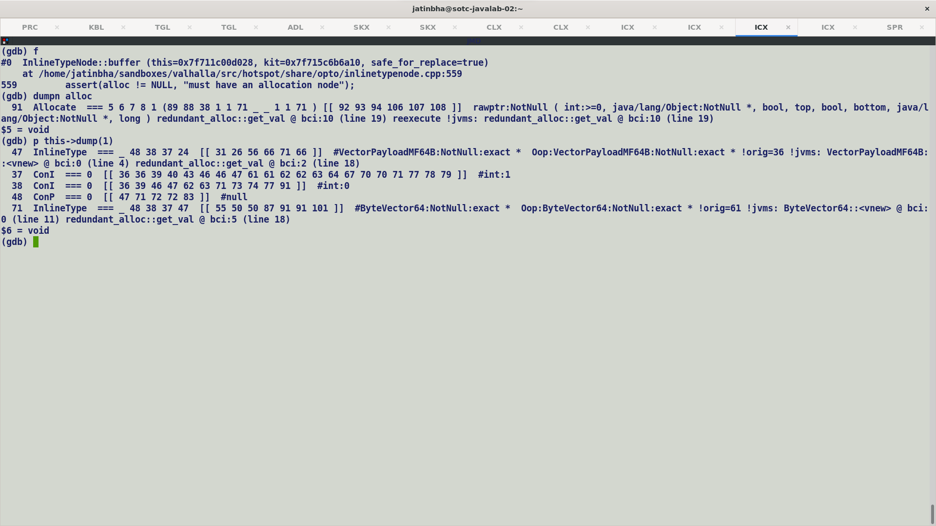

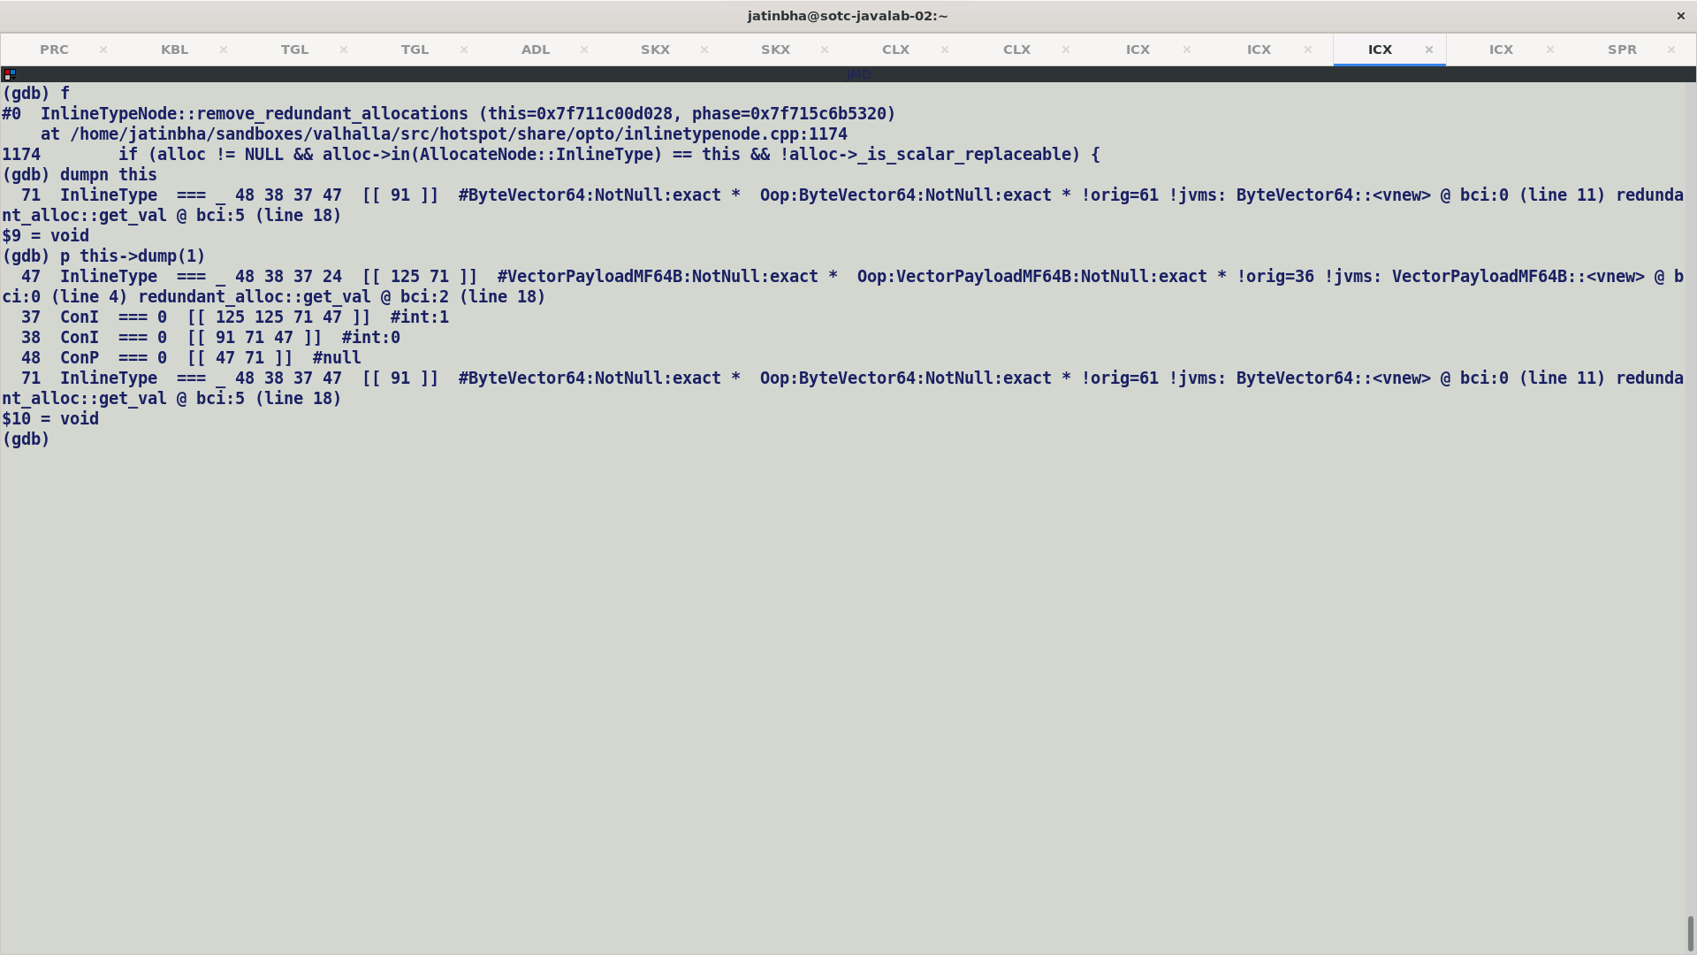

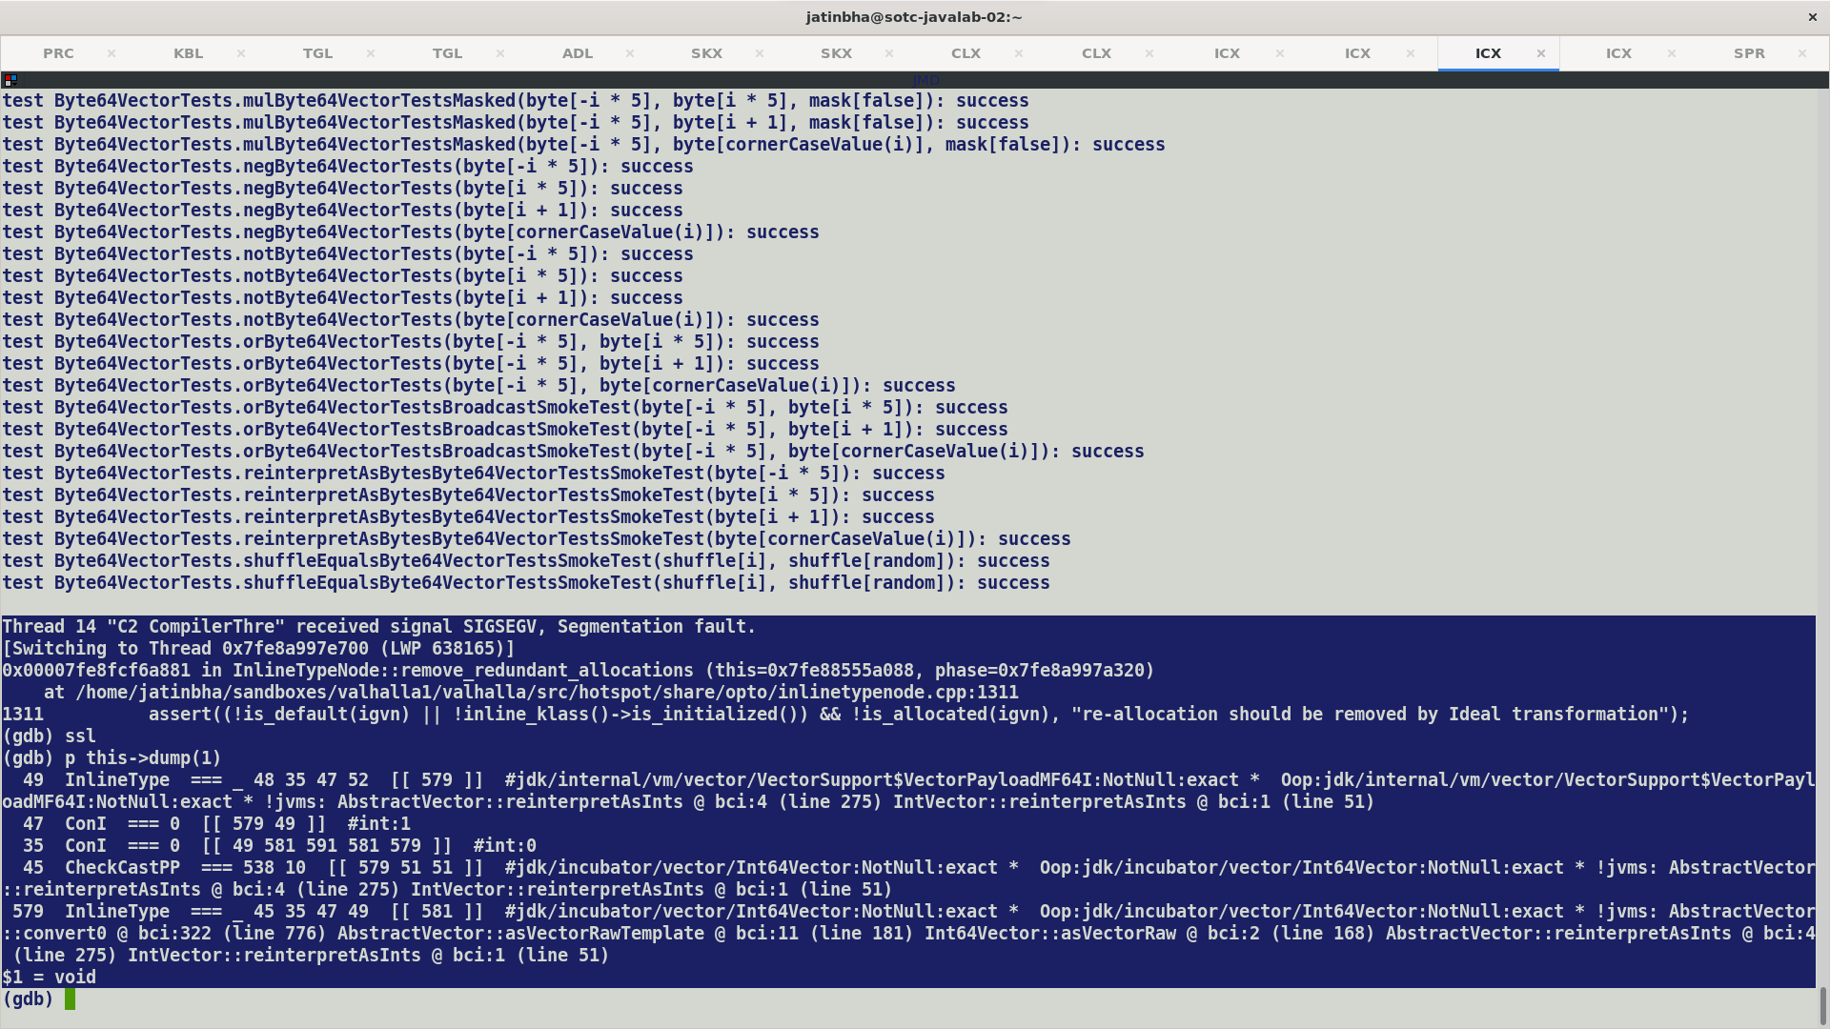

Speculative type promotion of Param0(receiver) from abstract vector to concreate vector type by way of introducing explicit CheckCastPP, while InlineTypeNode is not buffered.

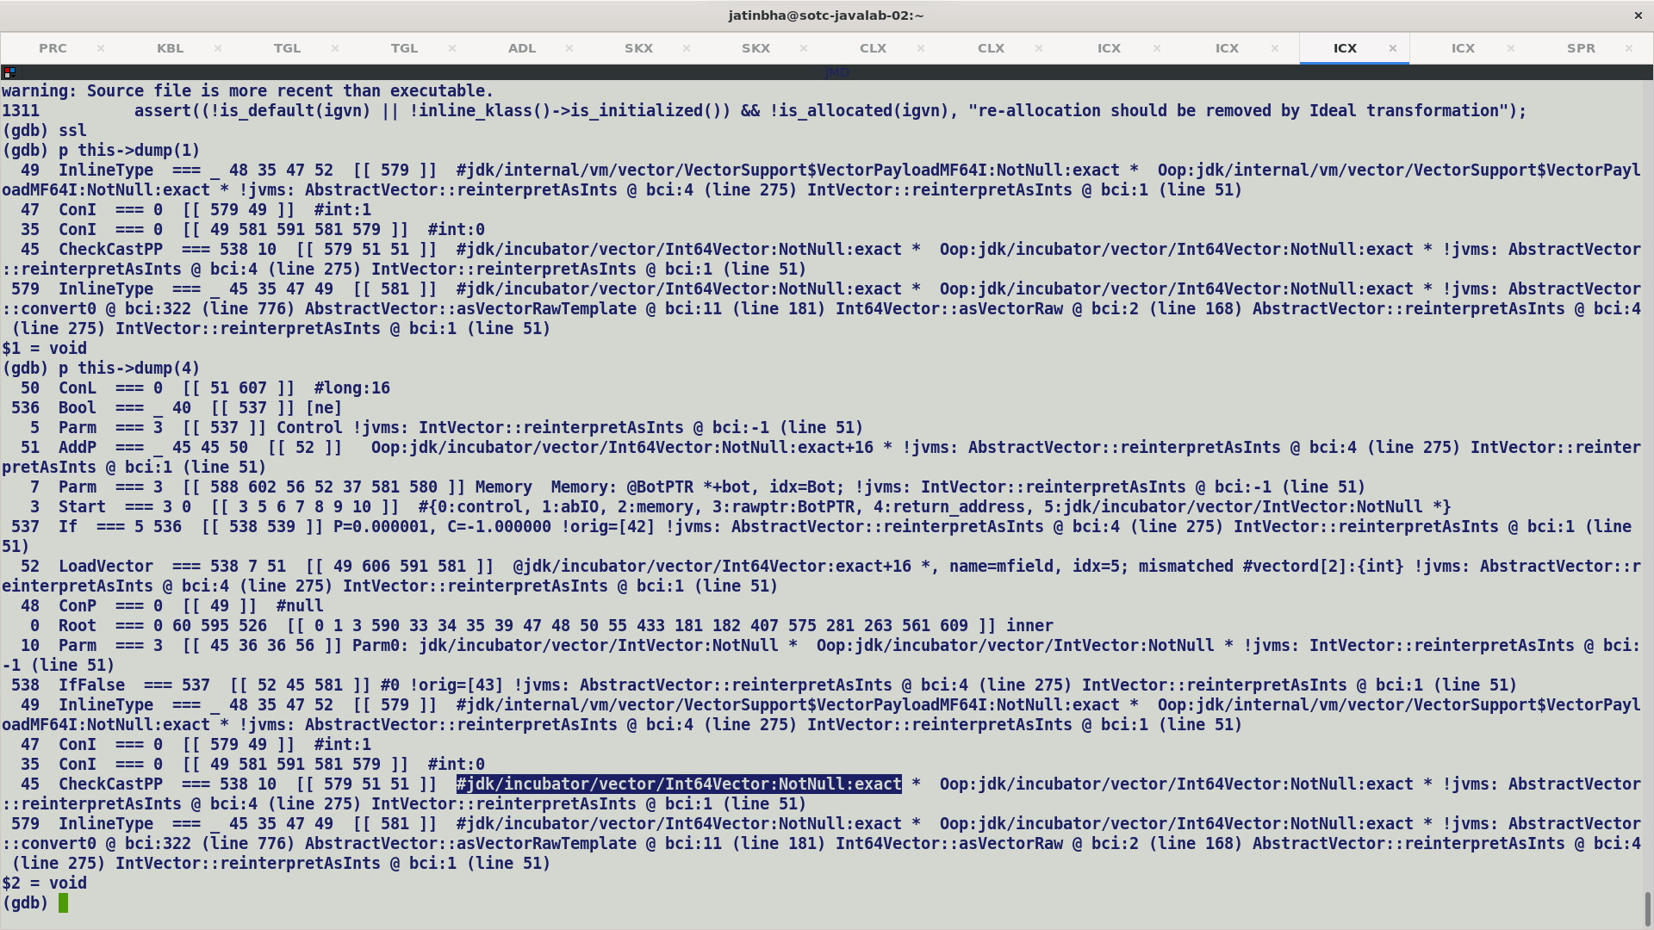

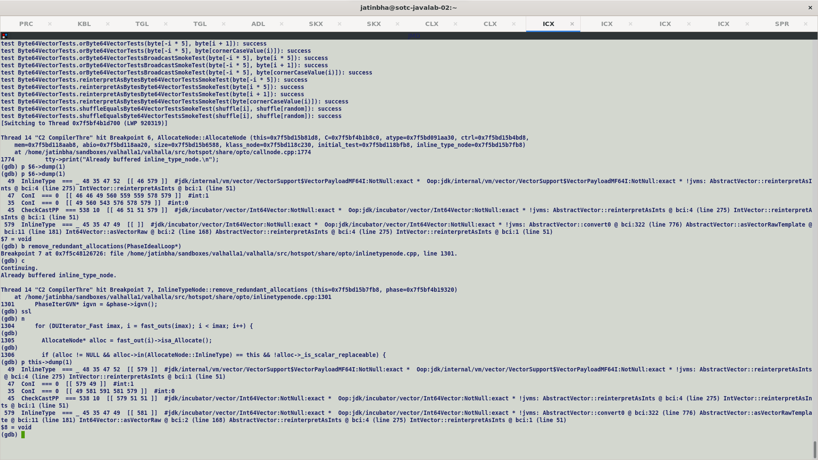

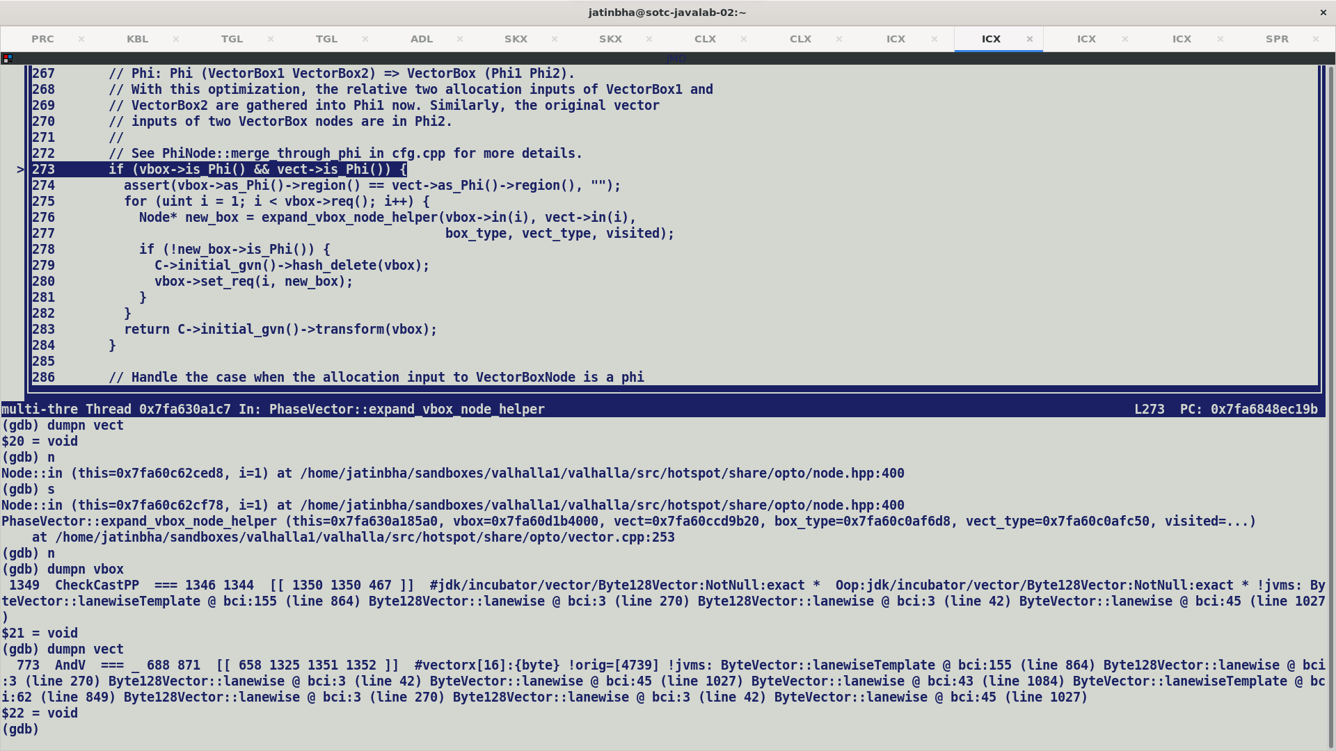

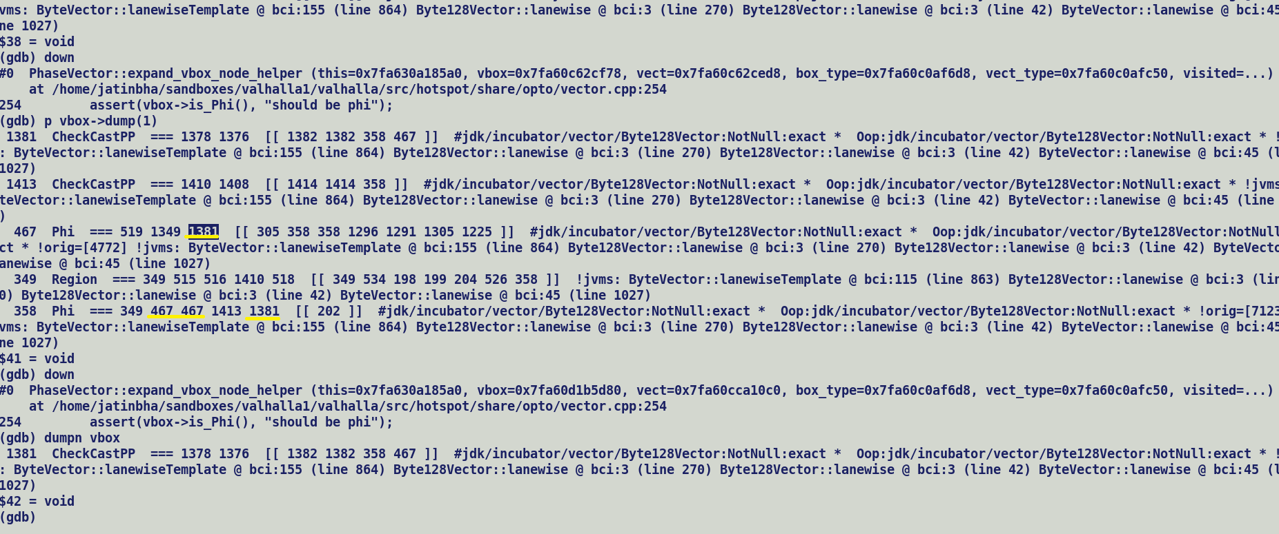

Cyclic Phi pattern:-

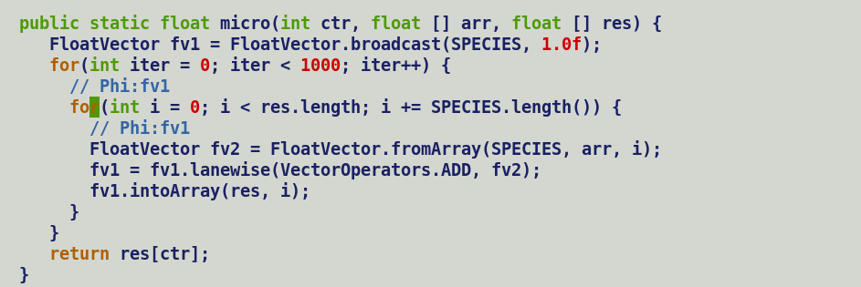

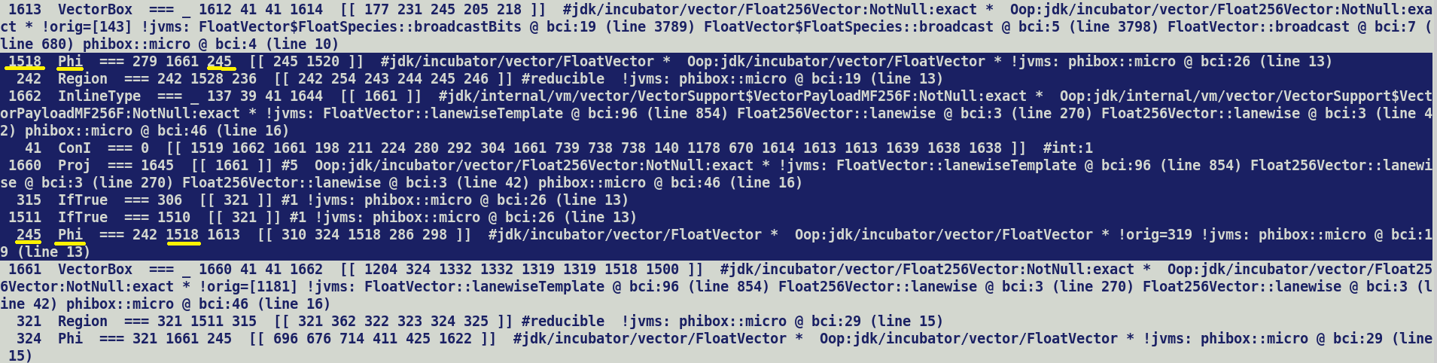

Aliasing:-

Since multi-fields are accessed using unsafe APIs, which first compute an unsafe address and then computes an alias index corresponding to it. Thus each lane will have a different alias index and no two lanes will be seen as aliases. Effectively in terms of aliasing behaviour a multifield is seen as a bundle of scalars rather than one unified field. This has an advantage while access individual field values, since each field update will be a different memory slice in MemoryMergeNode.

It is different from arrays where all the element are considered as aliases, this is because alias index is computed using TypeAry.

C1 HIR and LIR corresponding to Double128Mask constructor (vnew), showing incorrect address displacement (16) for multifield store.

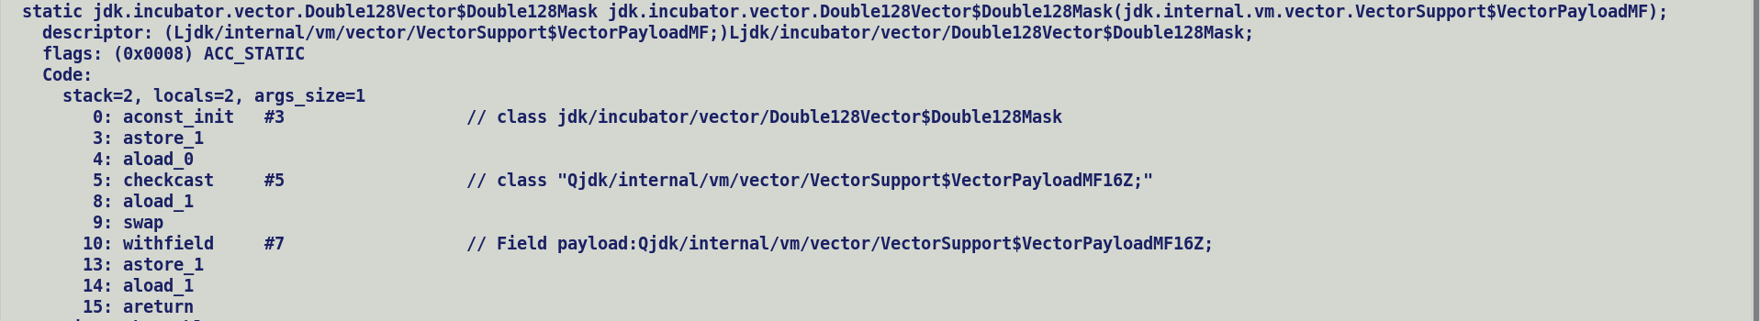



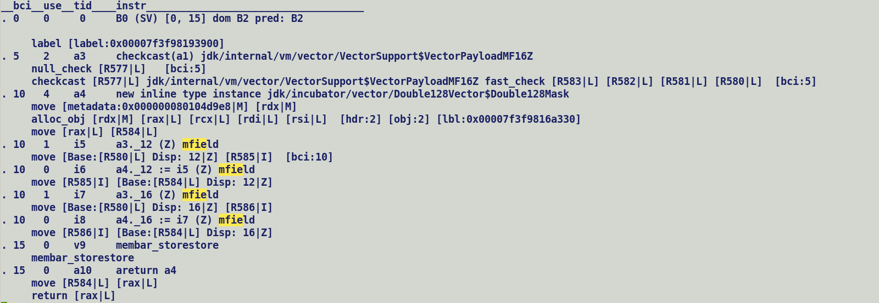

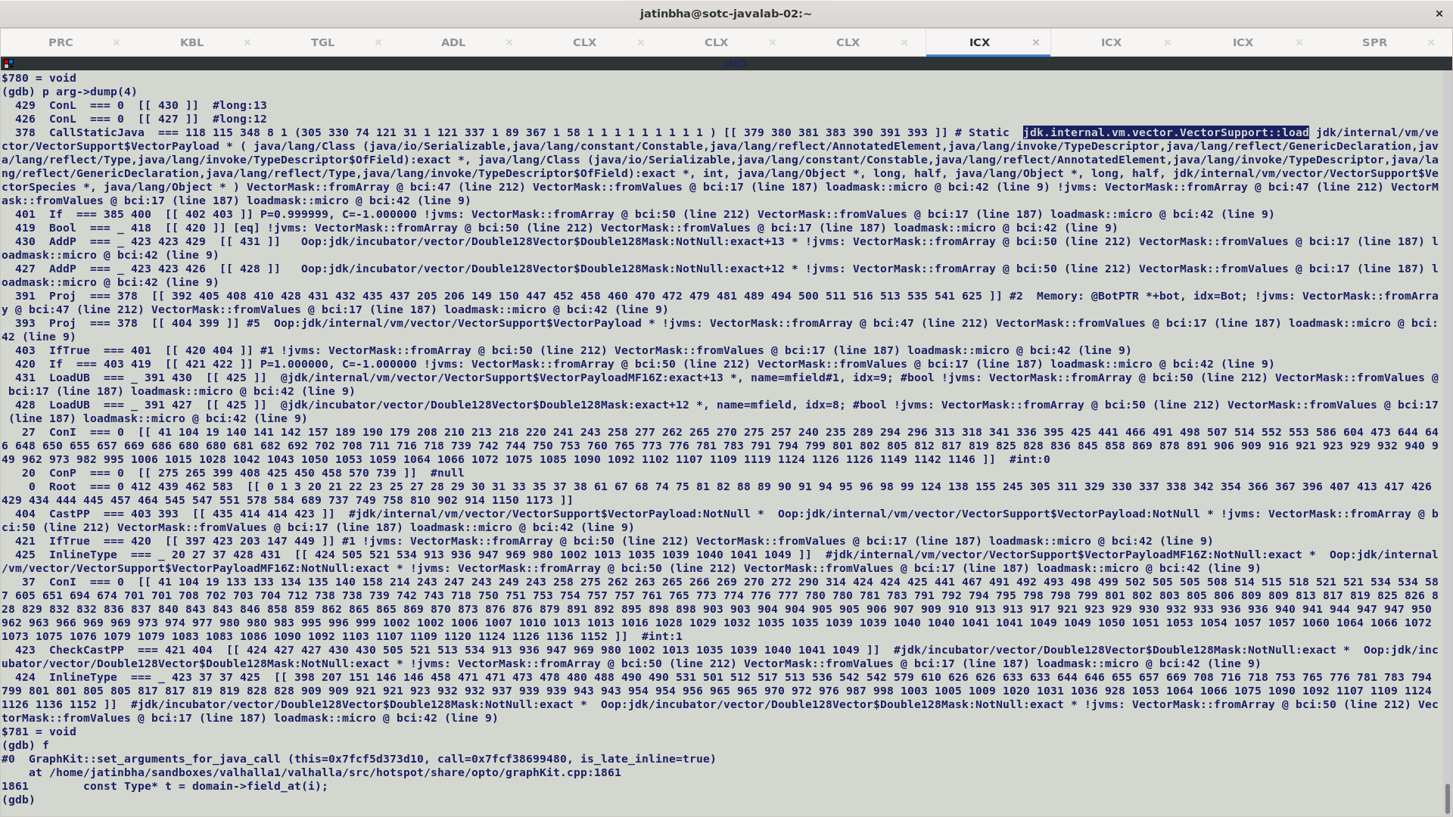

Masking payloads are backed by boolean multifield. Thus, both C1 and C2 (in-case payload does not fit in target vector) will update boolean fields as integral fields.

Easiest way to circumvent this problem is to treat these store access as array indexed writes. As per JVM specification boolean [] are stored in a packed representation as byte [] arrays.

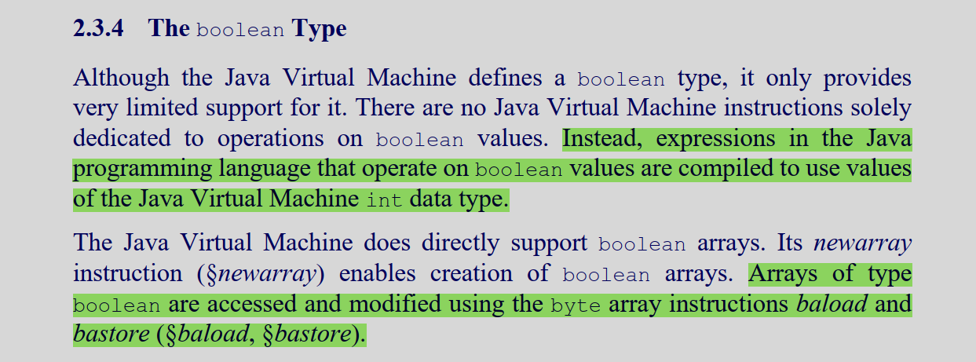

FP16 naturally Atomic Inline Type:-

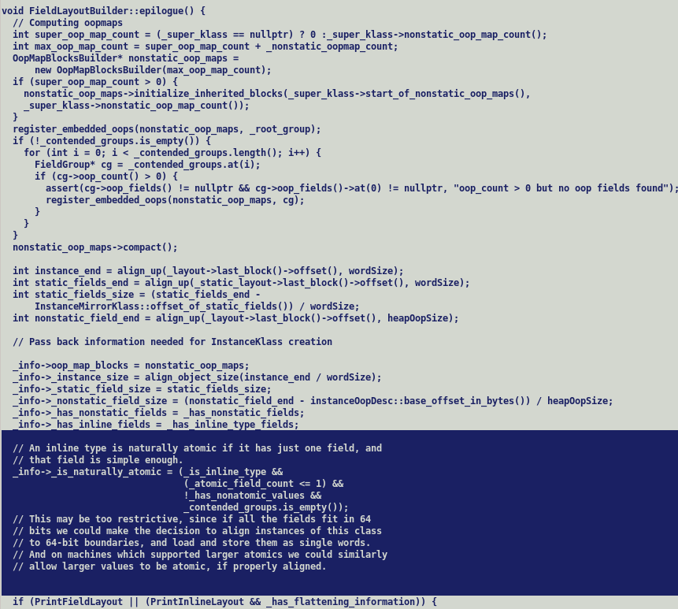

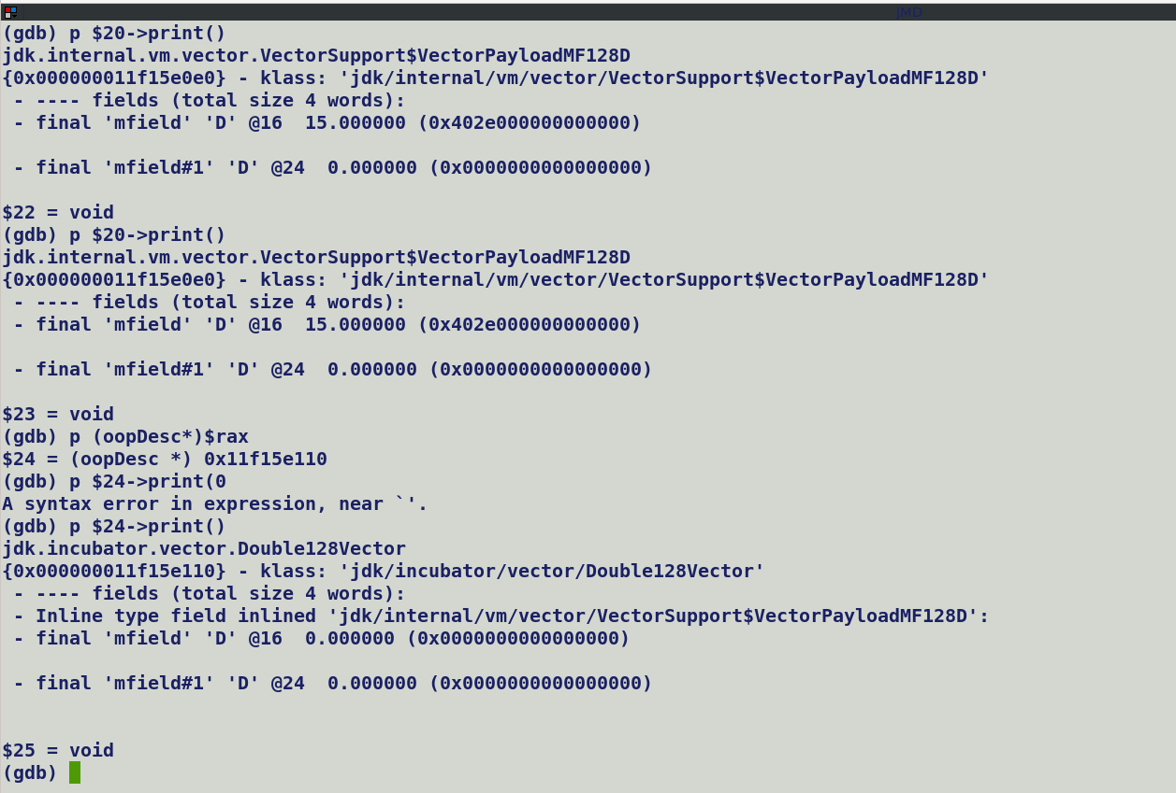

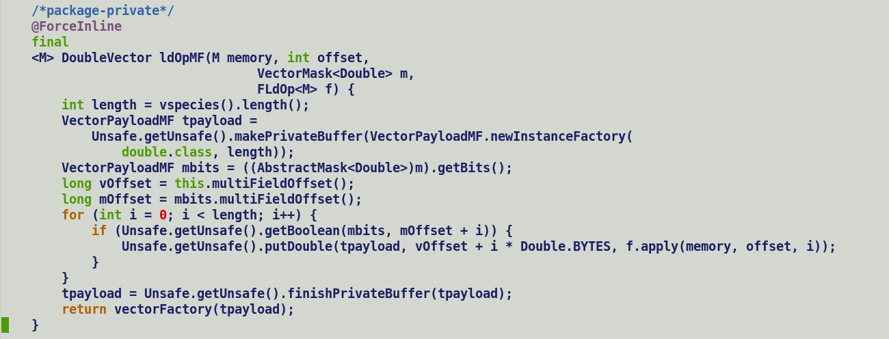

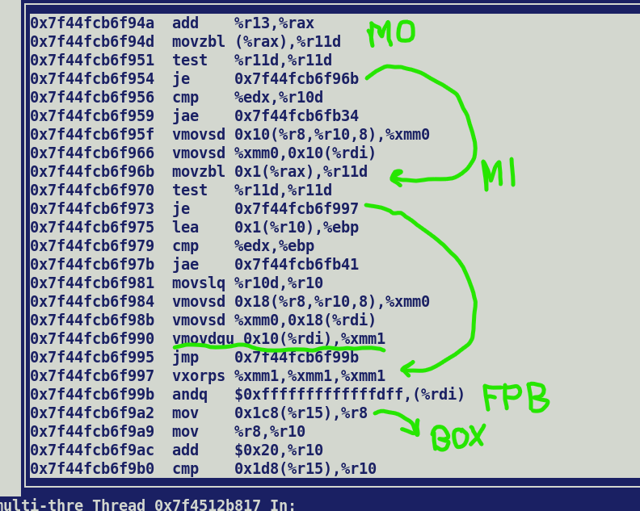



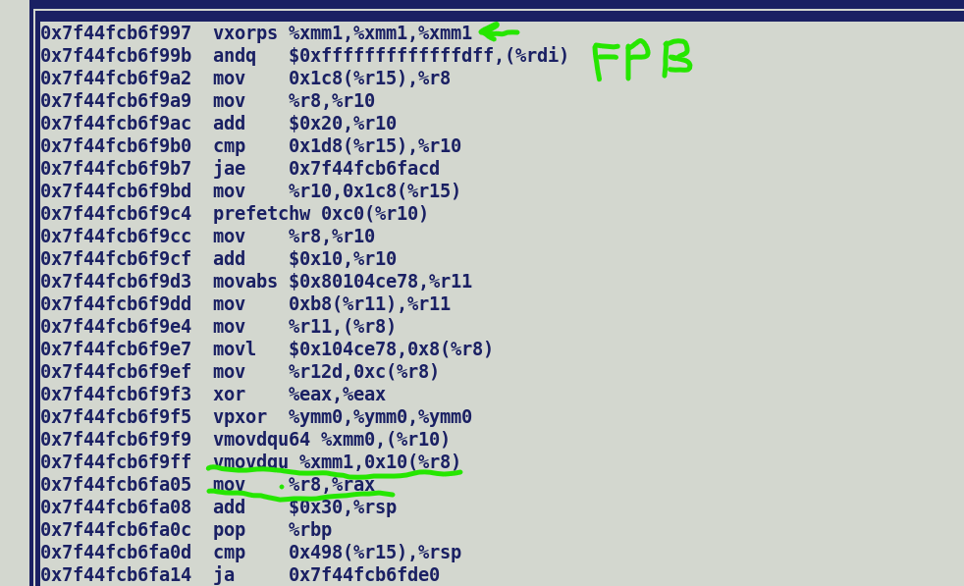

With -XX:DisableIntrinsic=_finishPrivateBuffer problem is masked out, since rdx implicitly passed as second argument contains updated values.

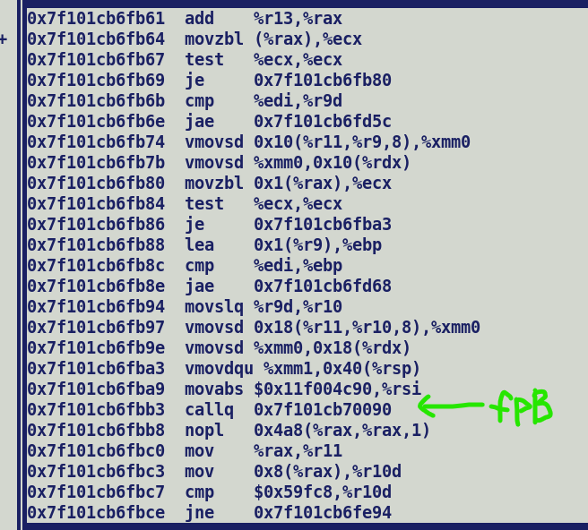

Analysis:-

Unsafe.putDouble:-

Computes unsafe address, update the contents using StoreD, re-materialize InlineTypeNode from updated memory location using InlineTypeNode::make_from_oop. This will load updated payload contents using LoadVector IR.

We can see in below post optimized IR snippet two StoreD nodes but just one LoadVector.

Fall-back implementation contains a scalar unsafe loop :-

if (Unsafe.getBoolean(i)) {

Unsafe.putDouble(value_objet, offset + I , readArray(i));

=> StoreD + LoadVector-> InlineTypeNode.

}

Missing LoadVector IR in first conditional block cause incorrect result. This could be a problem in unrolling.

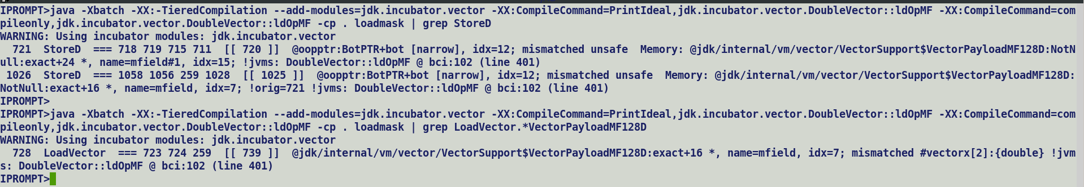

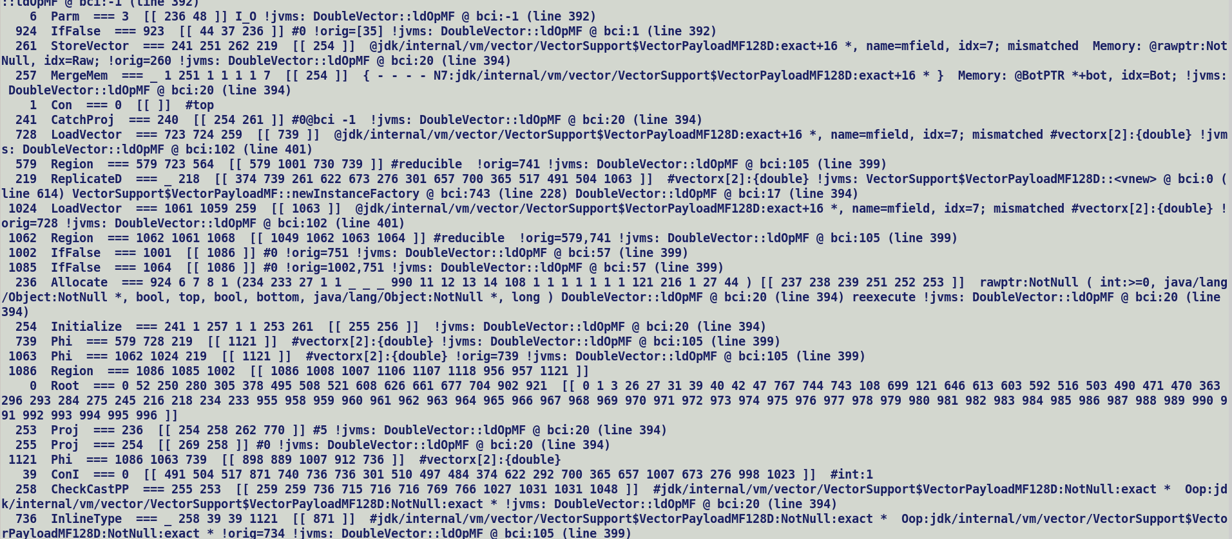



Root cause: -

original graph (before unrolling)

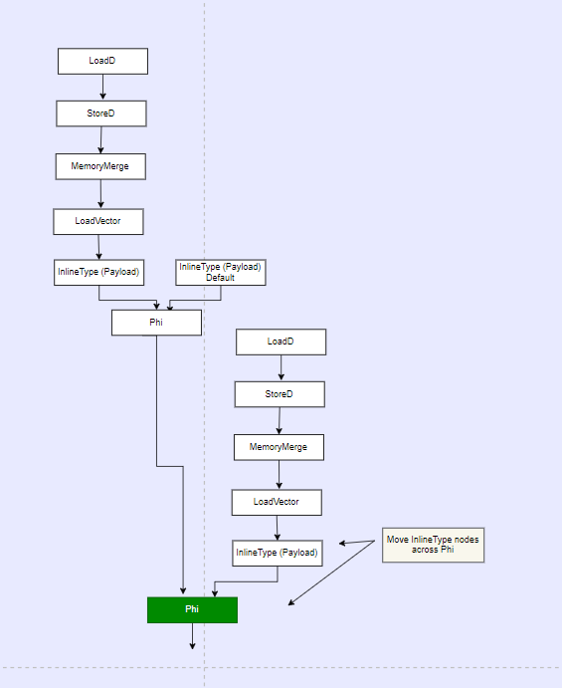

Phi -> Loop Variant

Process_inline_type_across_phi ():- Moves InlineTypeNode across phi node, thus pushing it out of loop.

Loop gets unrolled :- body is cloned and phi adjustment and fall-in edge adjustments automatically facilitates correct induction variable to each cloned body.

Original body :- TC = 1

Clone body = TC = 0

After unrolling during region idealization one of the incoming branch becomes dead and associated LoadVector is sweeped out.

Apparently branch which is sweeped out was guarded by first mask element, thus its load vector never gets executed and the one which remains was guarded by all false mask element.

Thus, result is not updated and gets default value.

-----------------------------------------------------------------

Phi fall-in edge adjustment during unrolling

Orig: Phi B1:v1, B2:v2

Post cloning + adjustment:

Phi B1:v1, B2:v2

Phi:B2:v2, B3:v3

If a loop, then adjustment in original Phi

Phi B1:v1, B4:v3

B4: v4 = Phi B2: v2, B3:v3

VectorMask.fromValues (false, true, false, true)

* Incoming values are passes as boolean []
* Boolean [] LoadVector -> VectorLoadMask -> InlineTypeNode

Even though API directly accept values but since they are passed through an array and all the elements of an array share same alias index (type-based computation) hence we cannot directly get (load) the constant feeding (stored) into an array index. Small primitive arrays once treated as flat arrays will facilitate passing indexed stores to users, by design all the fields of a value type objects have different alias indices, and this definition should also be applicable for flattened arrays.

Source: -

mask = fromValues(true, false)

For (int I = 0; I < 2; i++) {

If (mask.getBoolean(i)) {

vt.putDouble(arr[i]);

}

}

BYTE CODE (C2 consumable ciTypeFlow) :-

C2 Parse stage maintains Safepoint holding JVM state per Block, during parsing blocks are processed in RPOT order and block state of converging block is computed by merging incoming block states, thus same local variable which is at exactly same input index in SafePoints of incoming blocks is converged to form a Phi node at target block to maintain SSA semantics of Ideal graph.

Since JVM is a stack machine hence each push and pop operations injects/removes a new IR node into operand stack maintained in SafePoint.

Block1: P(TOP), S(Block2)

I = 0;

Block2: P (Block1, Block5), S (Block3, Exit)

I < 2

Goto Exit

Block3: P (Block2), S (Block4, Block5)

M1 = mask.getBoolean(i)

If m1 != true goto Block5

Block4: P (Block3), S (Block5)

T = arr[i]

Vt = putDouble(T)

Block5: P (Block3, Block4), S (Block2)

I = I + 1

Goto Block2

Exit: P (Block2, Block5), S (NULL)

Loop:- EntryControl (loop guards) , ExitControl (conditions)

Unrolling:- Loop body cloning + adjust convergence nodes (Phi) inputs.

__Loop:

Phi [s]

Loop_Body

Unrolled Loop:

__Loop: [ Adjust the exit condition and make it half original value]

Phi [s] (set 1) [ Edge connected to loopback index should be connected to outgoing edges of corresponding cloned phi nodes]

Loop_Body [orig]

Phi [s] (cloned) [ Tie the incoming edge of cloned Phi to outgoing edge of corresponding original Phi node , all the other edges of cloned Phi should be tied to TOP]

Loop_Body [cloned]

Similar modification should be done on Region nodes holding the modified Phi. Just making the changes in Region may also suffice since Idealization can then automatically prune the Phi nodes accordingly.

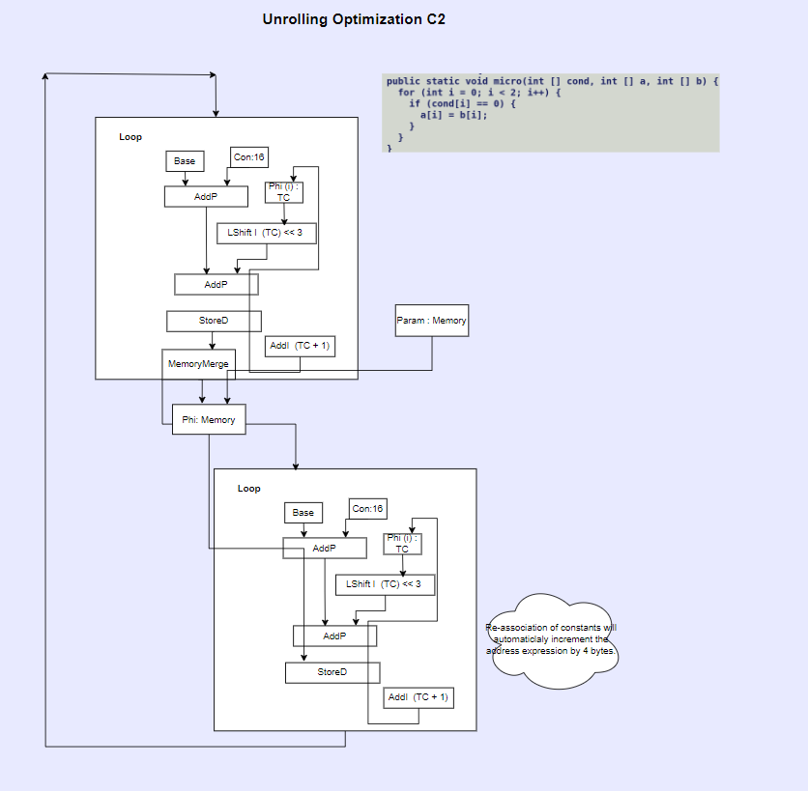



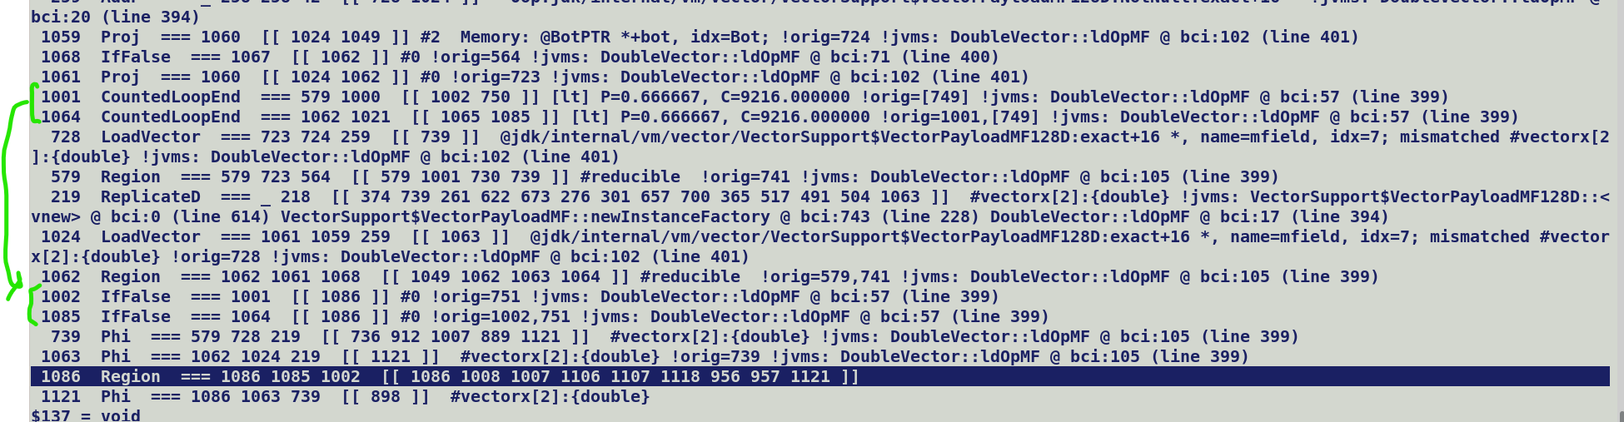



Region at the intersection of original and cloned loop body.

* 1001 and 1064 are fall out edges from two loop bodies, true edges take us into loop bodies.
* InlineTypeNode are always pushed outside loop by idealizing transformations.

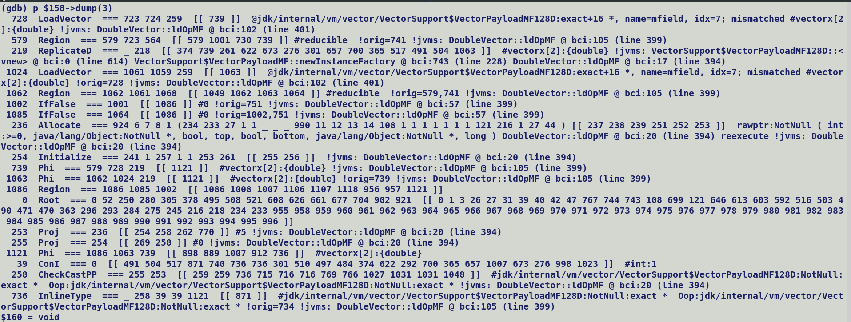

728 -> LoadVector (Updated Value from first putDouble())

1024 -> LoadVector (Updated Value from second putDouble())

736 -> Chooses the value from first / second conditional blocks or initial default value based on the control flow taken during execution.

Observations:

1/ Unrolling cost does not take into account branch probabilities of conditional blocks within loop, it being a dumb transformation replicates the loop bodies, may result into lots of dead blocks which will only bloat the loop bodies.

2/ policy_maximally_unroll do not take into account explicit sizes of bulky operations (floating point to integral conversions, reverse etc..)

3/ MOFFSET should be static final to avoid redundant getstatic which translates into LoadL.



Graph for region corresponding to if condition in cloned loop body.

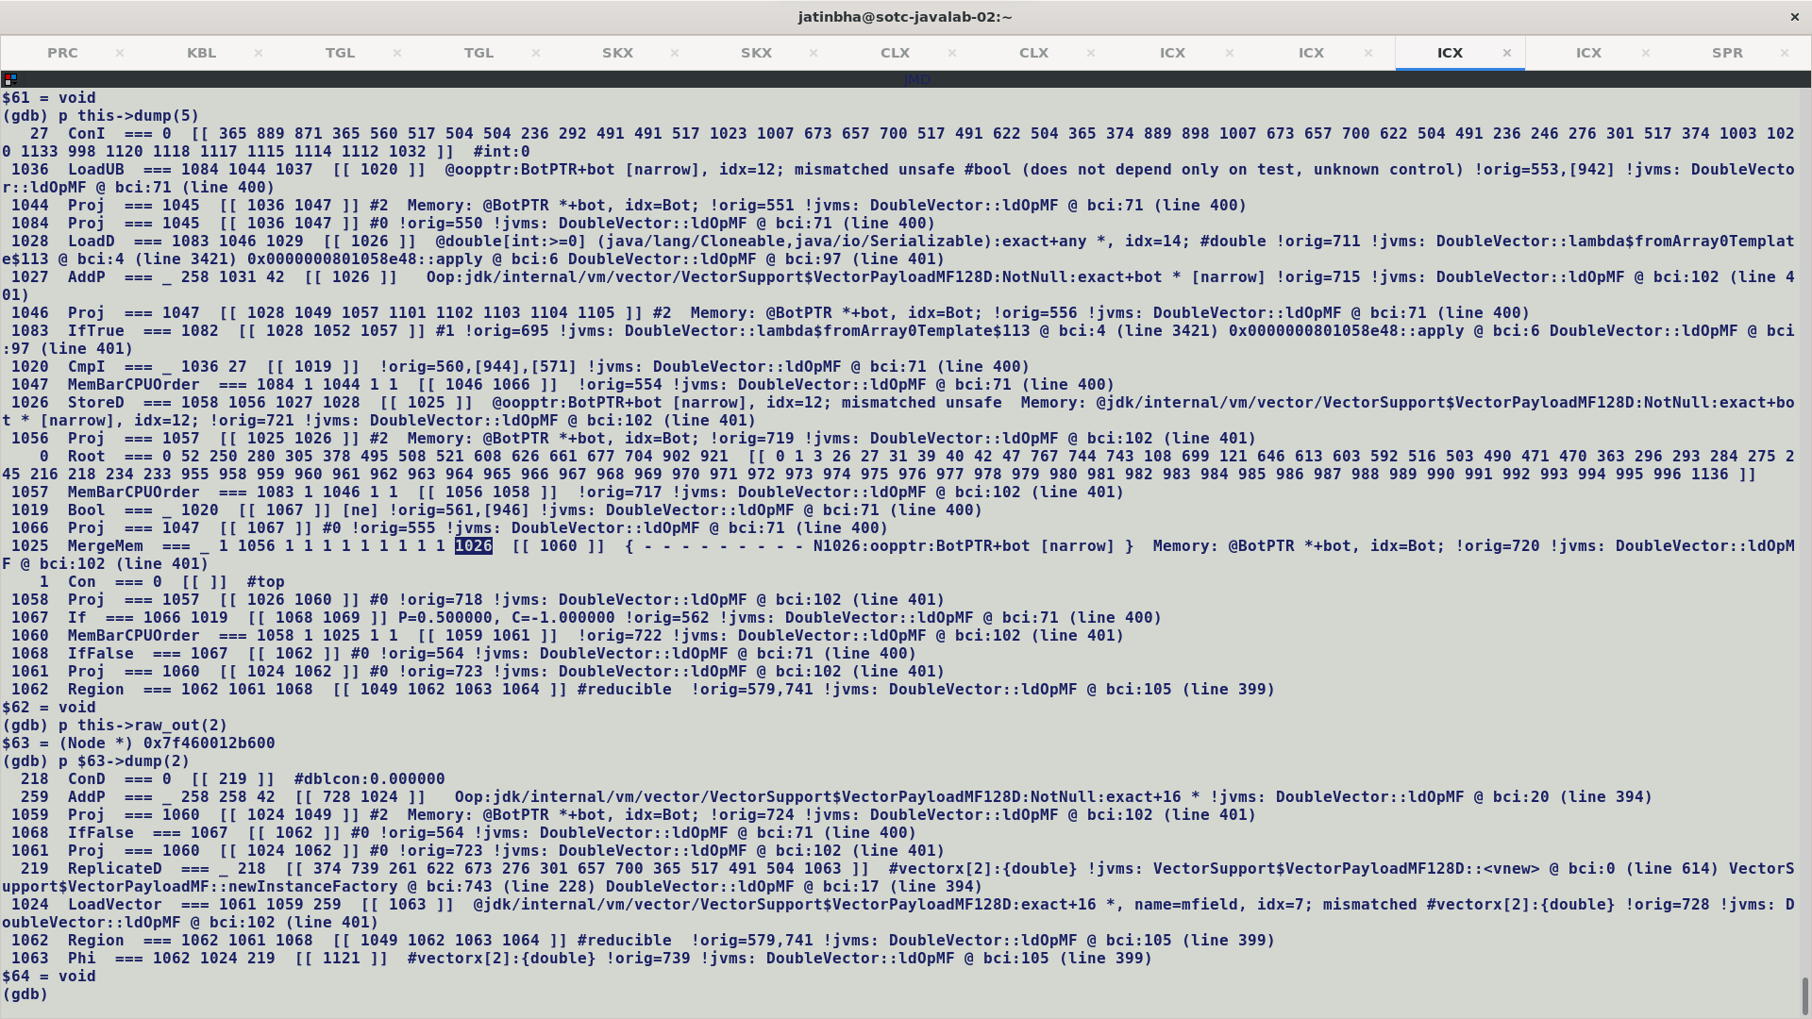







739, 1063 : Converging values from each if () { } block in loop and its cloned body.

579, 1062 : Converging regions



1121: Converged vector value from loop bodies (original and cloned).



1085, 1002: landings for false projections from original and cloned loop bodies.

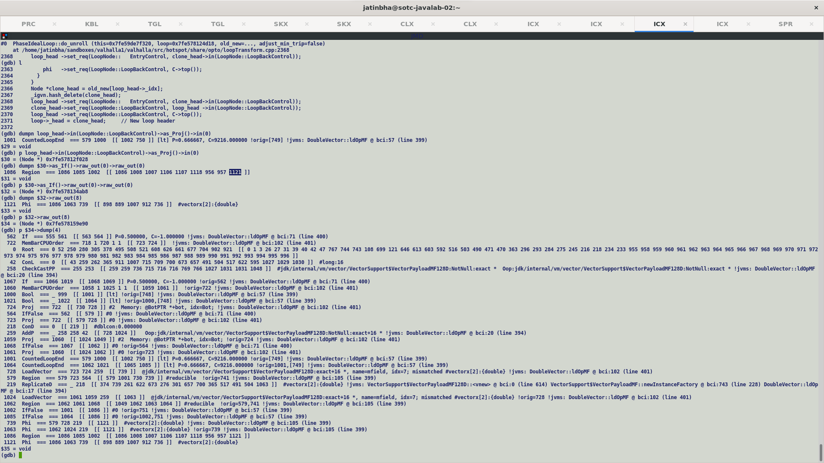

Since unrolled body must always be on a fallback path, hence its loop back control is set to TOP and Entry control is set to exit control of preceding loop body.

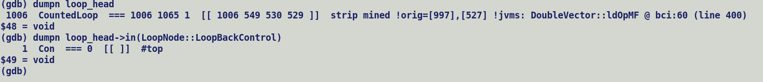

During unrolling, original loop’s loop back control is tied to TOP and entry control with loop back control of predecessor cloned loop. Loop/CountedLoop/OuterStripMinedLoop are Region nodes and CountedLoopEnd/OuterStringMinedLoopEnd are derivatives of IfNode and fan’s out true/false control projections. In this case since one of the inputs of Loop is tied to TOP value, hence GVN sweep out phi nodes input at corresponding edge index. Which seems correct since these are unrolled loop bodies and loop variant phi nodes can be replaced with their unique inputs.

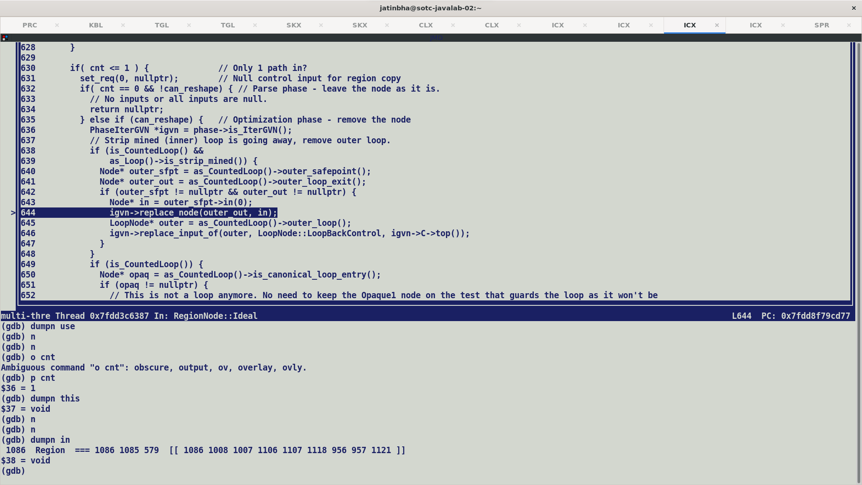

Single input regions control forwarding to users.

Cloned loop (first unroll block)

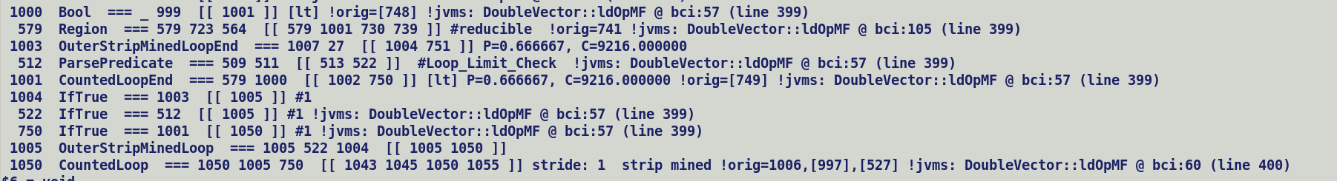



Loop head (second unroll block)

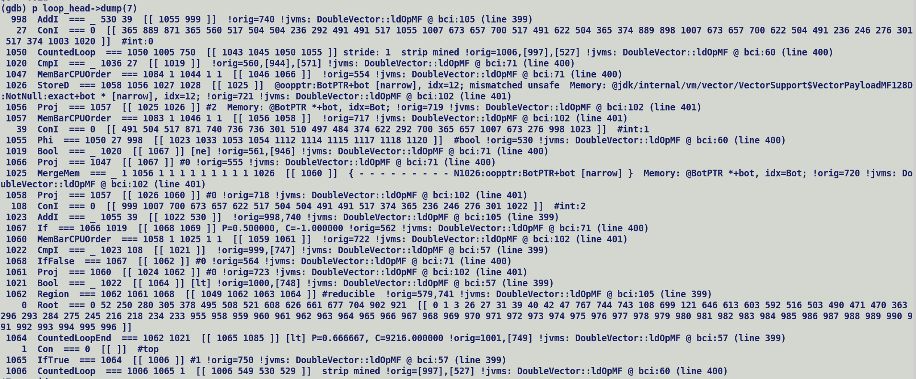



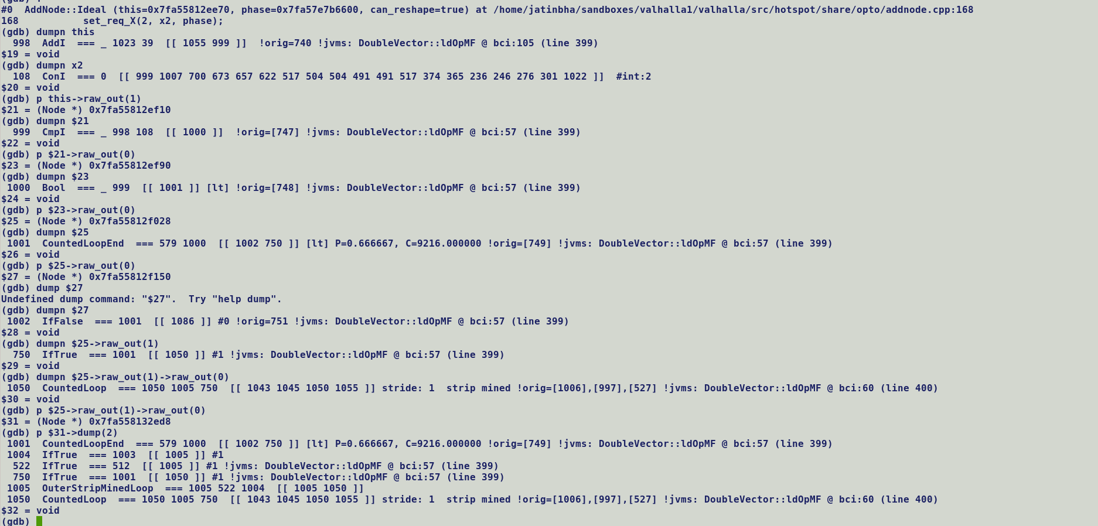



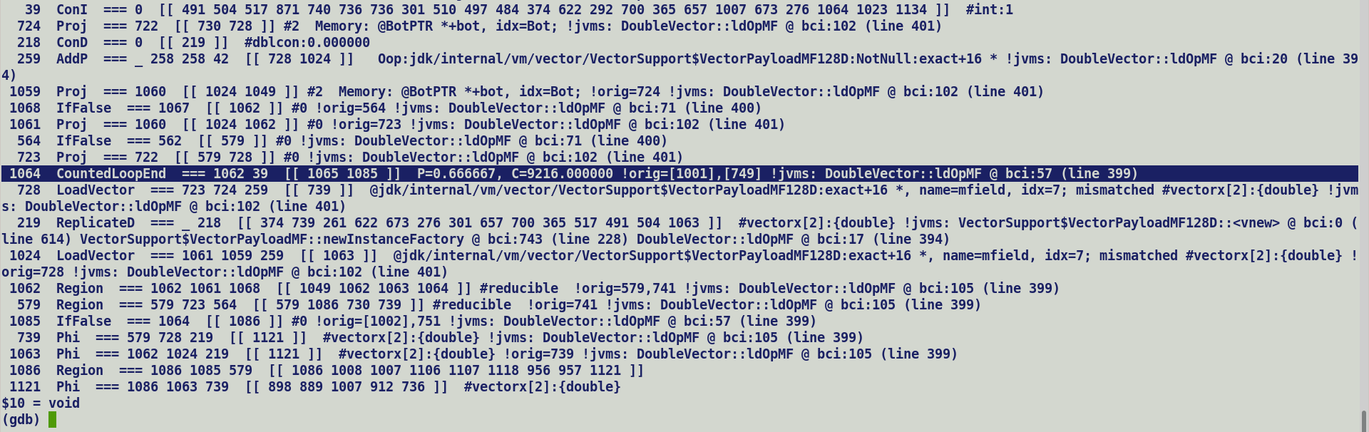



**Source:**

Vt = makePrivateBuffer(VectorPayload.newInstance());

mask = fromValues(true, false)

For (int I = 0; I < 2; i++) {

If (mask.getBoolean(i)) {

vt.putDouble(arr[i]);

}

}

**Pseudo IR:**

Entry:

Vector1 = makePrivateBuffer(VectorPayload.newInstance());

mask = fromValues(true, false);

OuterStripMinedLoopEnd

OuterStripMinedLoop: {

CountedLoopEnd1 = false : RegionCLE1F true : RegionCLE1T

CountedLoop1: **RegionCLE1T**

B1: If (mask.getBoolean(i)) {

vt.putDouble(arr[i]);

}

Region1 = Region Region1

Vector1 = Phi:Region1 LoadVector(0):B1, ReplicateD:entry

CountedLoopEnd2 = false : RegionCLE2F true:

CountedLoop2: **RegionCLE2T** (clone of CountedLoop1) RegionCLE2T [Each cloned loop entry points to loopback edge of preceding loop body]

Existing case

B2: If (mask.getBoolean(i)) {



vt.putDouble(arr[i]);

}

Region2 = Region Region2

Vector2 = Phi:Region2 LoadVector(1):B2, ReplicateD:entry 🡨 (A)

}

LoopExit: [converge landings from loop exits of original and cloned loop bodies]

Region3 = Region Region3 **RegionCLE1F RegionCLE2F**

Vector3 = Phi:Region3 Vector1:Region1 Vector2:Region2}

W.R.T to above pseudo-IR, removal of Vector1:Region1 on account of constant control of CL1 which always takes false projection should still preserve the semantics since either vector loaded with newly updated contents or default value shall reach the Loop Exit.

CountedLoop (Region): EntryControl {ExitControl of predecessor loop body} , LoopBackControl {1}

With LoopUnrollLimit set to 1,

for (I = 0; I < 2; I++) {

if (getBoolean(i)) {

vt.putDouble (array[i]); // LoadD -> StoreD -> LoadVector -> InlineTypeNode \

\

\___ push_inline_type_nodes ( move InlineType nodes

/ across Phi, outside loop, thus only stored will feed

/ into MergeMemoryNode)

/

ReplicateD -> InlineTypeNode /

}

}

**Phi (Entry: ReplicateD , Post_If : Vector (Phi:LoadVector:IfTrue, ReplicateD: IfFlase))**

**Unsafe.putDouble returns a void, but with Valhalla, inline expander re-materializes InlineTypeNode with updated memory contents and silently replaces original value object in SafePoint map. Because of void return type parser does not create an explicit loop variant phi (like trip count) while merging the state of entry and loop back (latch) block. This will cause an issue with multiple loop iterations where conditional block within loop body containing unsafe put is not executed on every iteration, since value coming from true and false projections are overwritten on same location.**

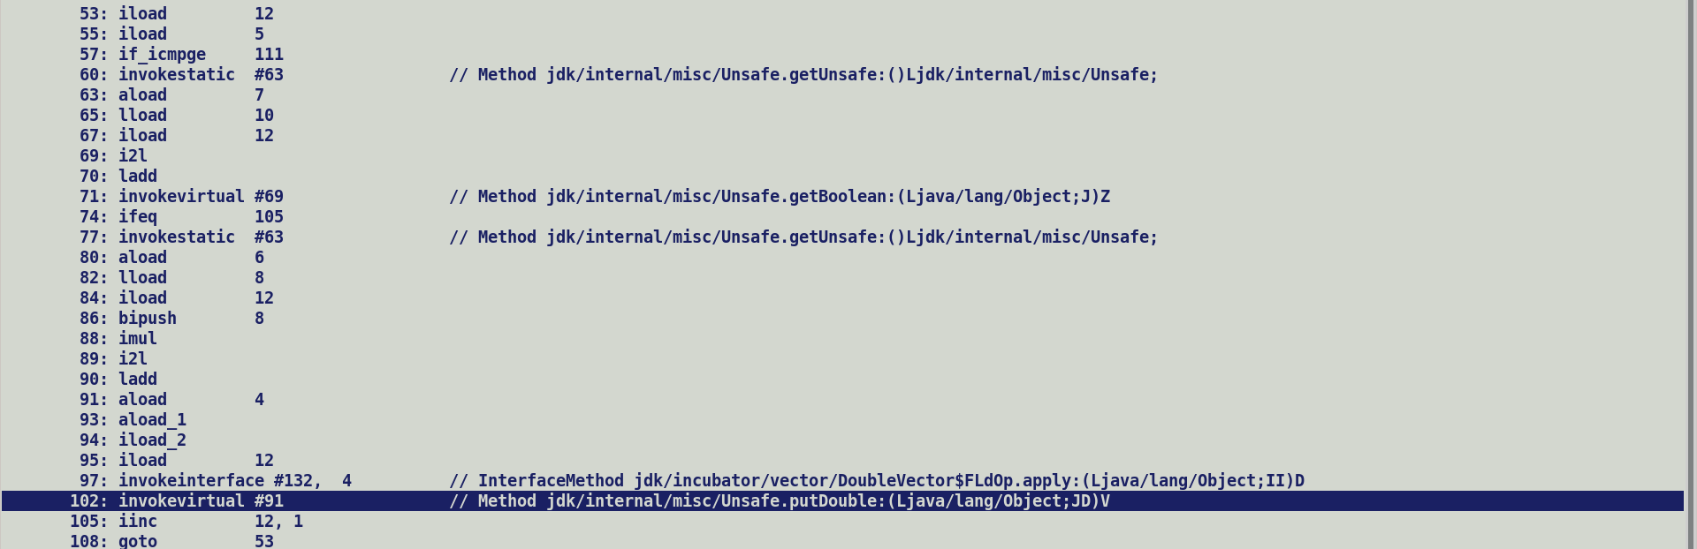

**Generally, if a value is updated with in a loop with each iterations i.e., it is either a primary or secondary induction variable then parser creates an explicit Phi in the loop starting block through merge_common routine which converges the JVM state of loopback and entry blocks. In this case since the return value of putDouble is void hence we do not emit an explicit astore to save back updated value object into JVM state, rather expander silently updates the JVM state to point to update InlineTypeNode.**

**Strip mining: -**

Original Loop

For (I = 0 ; I < N ; I += SLICE) { // outer strip mined (introduced only for counted loops)

For (J = I; J < SLICE; j++) {

}

Polling_Checks;

}

Unrolled loop

For (I = 0 ; I < N ; I += SLICE * UNROLL_FACTOR) { // outer strip mined (introduced only for counted loops)

For (J = I; J < SLICE; j++) {

TC = Phi {0}, ADD {TC + 1}

}

Polling_checks

For (J = I; J < SLICE; j++) {

TC = Phi {TC}, ADD {TC + 1}

}

Polling_checks

For (J = I; J < SLICE; j++) {

TC = Phi {TC}, ADD {TC + 1}

}

Polling_Checks

}

Loop Unswitching: -

For (I = 0; I < N; i++) {

If (Loop_Invariant_Condition) { Cmp -> Bool -> If -> {IfTrue , IfFalse}

True_Block

} else {

False_Block

}

}

Transformation:-

If (Loop_Invariant_Condition) { // Move condition out of loop, clone loop bodies in both true and false paths.

For (I = 0; I < N ; i++) {

If (Loop_Invariant_Condition) { Bool {1} -> If -> {IfTrue , IfFalse} // Replace outgoing edge of Cmp with Constant 1

True_Block

} else {

False_Block

}

}

} else {

If (Loop_Invariant_Condition) { Bool {0} -> If -> {IfTrue , IfFalse} // Replaced Ougoing Edge of Cmp with Constant 0

True_Block

} else {

False_Block

}

}

**Inductive Phi accepts the initialization value set in pre loop block :-**

Entry:

XMM0:= ReplicateD // Initialization outside the loop.

Loop:

XMM1 = Phi Loop: XMM1, Entry: XMM0 // Generated to converge updated values of same variable.

// coming out of different blocks. C2 IR generation (bytecode parser) automatically

// generate inductive Phi in loop to converge values of a variable from entry and latch block.

….

….

Updates to XMM1 in Loop.

….

**Non-Inductive Phi :-**

Entry:

newInstanceNode(); // Creates ReplicateD IR but CFG **early** scheduler places it close to its actual use.

// We do not have an explicit controlling edge on ReplicateD node hence they are not

// pinned to block generating them.

Loop:

If () {

V1 = LoadVector

}

Phi TrueIF: V1, FalseIF: ReplicateD

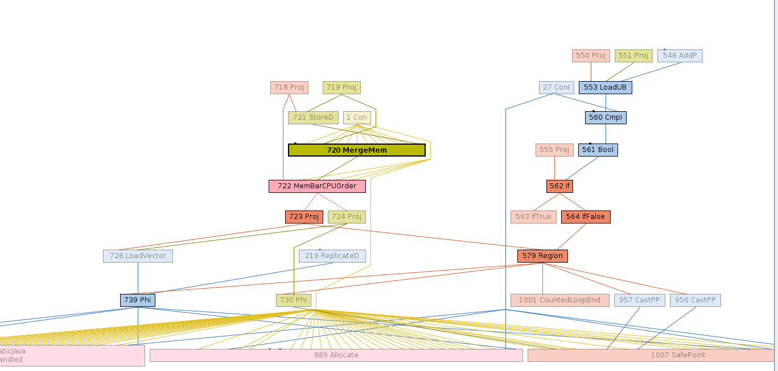

Deoptimization fixes and cleanups (Xiaohong Gong / ARM): -

* Incorrect offset computation during reassign_fields
* Removal of special handling for box / payload allocations.

**Remaining Items**: -

Unrolled small putDouble loop issue (FIXED):-

* putDouble returns void and only updated memory state associated with a JVM State.
* Masked operations do partial updates to value objects, re-materialized node does update the JVM state to mimic the effect of bytecode driven state updation.
* *Loop:*

*If (mask(i)) {*

*putDouble(vt, arr[i]);*

*}*

***[ Phi <InlineTypeNode<-LoadVector , ifTrue]> < InlineTypeNode <-ReplicateD, ifFalse> ] 🡪 Goes through push_through_phi***

*finishPrivateBuffer.*

* PutDouble only updates memory state of value object corresponding to true mask bits.
* By disabling intrinsification of finishPrivateBuffer we will enforce explicit boxing and buffering of payload argument.
* It will be sub-optimal but functionally correct, part of fallback implementation so will not affect performance.

Max Species Support: -

* Parse time identification of multifield bundle size, since it determines number of FieldInfo objects and layout of Payloads.
* Disable CDS for Vector Payload Classes due to max vector size difference b/w CDS creation and reading.
* Existing limitation in MaxVector size computation, c1 returns -1. Entire VectorAPI support is added to C2 so it should be fine to pass -1 as multifield annotation value for max species payload.

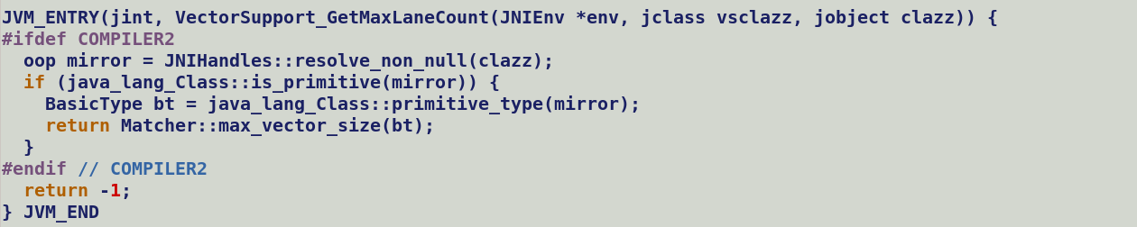

Incorrect Graph Shape: - During cyclic vector box expansion (we see a CheckCastPP in place of Phi).

======================= ./LOGS_VECTOR_sselevel0/test-results/jtreg_test_hotspot_jtreg_hotspot_vector_1/text/newfailures.txt ======================

# newfailures.txt

compiler/vectorapi/TestLongVectorNeg.java [Fixed]

compiler/vectorapi/TestMaskedMacroLogicVector.java [Fixed] : Problem was also in stock lworld in ***sharpen_type_after_if***

***Crash during late inline expansion of laneWise API which was asserting while trying to unbox incoming object, unboxing IR always expect to receive an InlineType node as its input, but in this case if_acmp processing was creating CheckCastPP without materializing InlineTypeNode.***

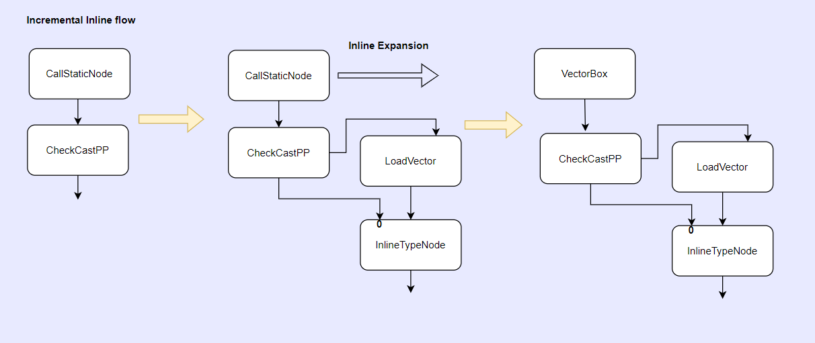

compiler/vectorapi/TestNoInline.java [Fixed]

* Incremental-inlining issue when VectorBoxes are returned. With parse time inline expansion of such methods, uninitialized VBA gets tied to return nodes and boxes are swept during dead node elimination.
* With lazy intrinsification, “call -> return” graph fragment is replaced by “VectorBox -> return” pattern, thus properly initialized and expanded VBA are returned. Expansion replaces Box with an expanded VBA.

PhaseVector :-

* Expand_vunbox (light weight)
* Expand_vbox (Uses existing InlineTypeNode::store)
* Scalarize Vbox nodes
  + All functionality is moved to process_inline_types
  + Remaining transform to replace Phi (VBA, VBA) -> new VBA when passed as call argument saves costly VBA expansions to allocate and store IR.
    - This can be removed after calling convention changes when we pass scalarized vector box arguments i.e. directly passing a vector payload vectors.
    - As of now we buffer the vector value when passed across the calls, thus its good to save redundant VBA expansions in incoming phi blocks.
    - **Stock inline objects are always guaranteed to be scalarized** when passed as argument, also they do not have a vector fields, java does not have an explicit vector type from language perspective, all the fields of value objects are either of primitive types or reference type or value types. Which is why *process_inline_types* do not have a special handling in place for passing buffered arguments to calls.
* Inline vector re-boxing calls, not used any more, could not find any occurrence of “mayBeRebox” in java code.

Valhalla extensions to if_acmpeq:

* In regular flow, non-value object reference comparison is lowered to pointer comparison i.e. VM compares the heap address pointed by references being compared.
  + We do an optimization during escape analysis to remove an expensive pointer comparison CmpP for non-escaping allocations.
* For Valhalla reference comparison boils down to deep field level comparison.

Merge with latest lworld (there has been a recent jdk mainline merge)

Platforms: Linux x86_64, Windows x86_64;

32 bit-builds

Minimal build (C1 -> fix in lworld first, get through merge)

Zero-build

Functional Validation Options: -

Generic:-

-XX:-Inline

* lworld infra issue to propagate larval state across calls.

-XX:+DeoptimizeALot

* Failing tests in shuffle related tests.

-Xbatch

-XX:CompileThresholdScaling = 0.3 (low)

-Xcomp

-UseAVX = 0,1,2,3,KNL

-TieredCompilation :- ON / OFF

-TieredStopAtLevel=0,1,2,3

-IncrementalInline : - Parse time intrinsification + Lazy Inline Expansion.

-Djdk.incubator.vector.VECTOR_ACCESS_OOB_CHECK=0,1,2

-XX:- DoEscapeAnalysis

* Valhalla options (flattening sizes).

Valhalla:-

InlineMaxField

Performance Validation:-

* All existing Vector API operations JMH micros.
* Large Kernel micro benchmarks.

nomenclature and language and JVM model changes in primitive classes to non-nullable value types , semantics are still the same.

Having an implicit constructor is a necessary but not sufficient

condition for

heap flattening.  The other required condition is that variable that holds a

`Complex` needs to be non-nullable.

Value classes that declare an implicit constructor are subject to additional restrictions:

* The class must not be an inner class with an enclosing instance.
* The initial instance of the class must not contain itself. That is, no instance field of the class may have a null-restricted type (discussed below) that directly or indirectly depends on the declaring class.
* (Possibly) To avoid confusion, no instance field of the class may have an initializer expression, and the class may not declare instance initializers.

<https://mail.openjdk.org/pipermail/valhalla-spec-observers/2023-May/002243.html>

### Flattening

Flattening in the heap is an emergent property, which is achieved when

we give up the degrees of freedom that would prevent flattening:

 - Identity prevents flattening entirely;

 - Nullability prevents flattening in the absence of heroics involving

exotic

   representations for null;

 - The inability to use a class without initialization requires

nullability at

   the VM representation level, undermining flattening;

 - Atomicity prevents flattening for larger value objects.

Putting this together, the null-exclusion type of implicitly constructible value classes is flattenable in the heap when the class is non-atomic or the layout is suitably small.  For ordinary value classes, we can still get flattening in the calling convention: all identity-free types can be flattened on the stack, regardless of layout size or nullability.

Max Species Support design spec: -

* Exclude dumping VectorPayload classes, these hold multifield whose lanecount is determined at runtime based on max vector size supported by target platform.

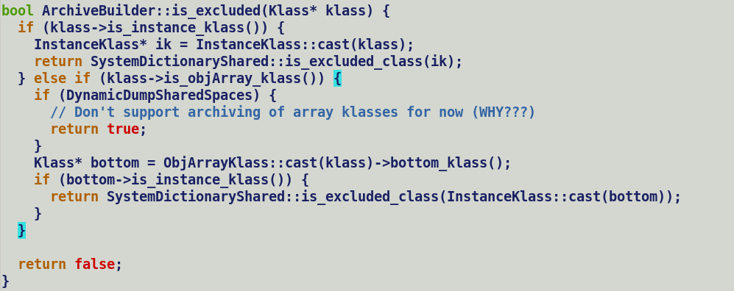

* Symbols based multifiled payload size estimation, VM is exposed to payload symbols, parser to estimate bundle size of max species by querying max vector size and class symbol name. Symbols are initialized at VM startup.
* All the known VM classes should be part of java.base modules, thus VectorPayload* classes should be defined in java.base/jdk/internal/vm/vector/VectorSupport.java
* Payload class name for max species mask to encode bundle type and vector type.
  + VectorPayloadMFMaxZL -> For LongMaxVector mask.
* Shuffles lane size and type match with corresponding vector type.
* Gen source template modifications (VectorPayloadMF{species:Max}{bundle_type[0]}{vector_type[0]}

Max species reported lane count with client compiler build.

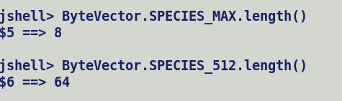

putstatic updates the class mirror which encapsulates both class and instance specific field. But mainly mirror updates static fields.

Default value object of an inline class are immutable.

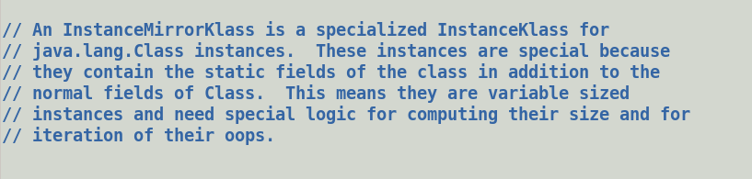

C1’s flat Array Access Optimization: -

primitive class ABC {

int field;

}

ABC [] farr = new ABC [ 1024];

farr[i].field = 10; // non-flat array => aaload + putfield -> slow path (allocated ABC) -> update field of ABC.

Fast patch -> flat-array -> LoadIndexed + DelayIndexedLoad (for getfield) -> address computation over flat array -> LoadI

* Generic Payload -> VectorPayloadMaxB -> Cannot handle both the cases, we need a different bundle size for backing storage, i.e. different multifield attribution, which will trigger class specialization i.e. VectorPayloadMFMaxFB and VectorPayloadMFMaxIB.
* ARM’s proposal to pass additional lane type within the attribute i.e. @multifield (-1, ‘float’), @multifield(-1, ‘int will also translate into class specialization. Thus, extending the multifield attribute definition will not reap much benefit.
* Q. Why do we need to share same payload b/w MaxFloat and MaxDouble concrete vectors?

A. Value object semantic prohibits casting a value object to another value object, this is semantically incorrect as values are immutable data objects. Problem occurs during max species mask casting operation b/w lane types float-int, double-long and vice-versa as participating payloads are different value class objects. This problem will not occur while casting mask belonging to concrete species, because source and destination both belongs to same concrete value class e.g., VectorPayloadMF256Z etc.

***java.lang.ClassCastException: class jdk.internal.vm.vector.VectorSupport$VectorPayloadMFMaxDZ cannot be cast to class Qjdk.internal.vm.vector.VectorSupport$VectorPayloadMFMaxLZ; (jdk.internal.vm.vector.VectorSupport$VectorPayloadMFMaxDZ is in module java.base of loader 'bootstrap')***

***Using accurate float vector size of 32 byte on AVX=1 will pose problems with re-interpretation APIs since max integral vector size is 16 bytes, thus a lane count mismatch will pose problems with lanewise cast and re-interpret operation.***

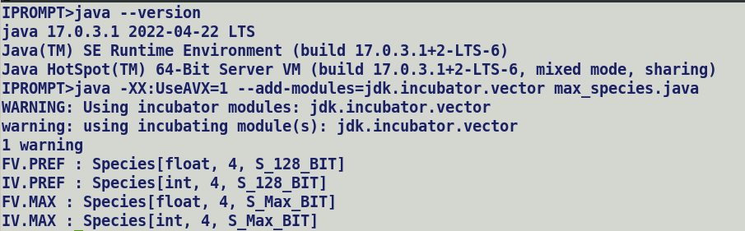

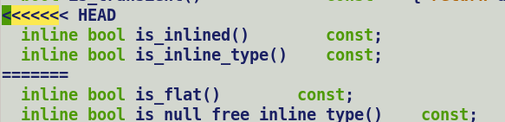

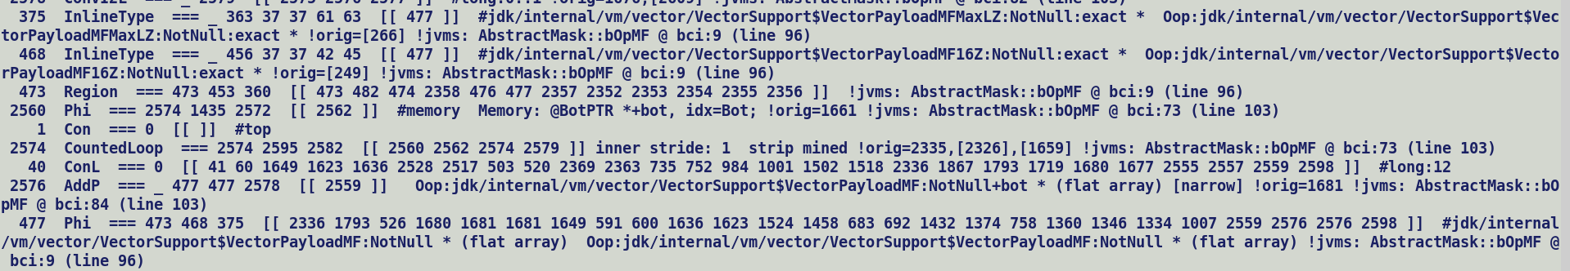



Q1. Why do we need a separate VectorPayloadMaxMF class?

A. To ascertain the payload bundle size during parsing since its needed for field layout computation. Static VLENGH is only initialized during initialization phase, which is the third phase in class preparation (loading – linking – initialization).

Q2. Do we pass VectorPayload class along with BoxType class to inline expanders?

A. No, we only pass box type since IR corresponding to payload is implicitly created by C2 compiler.

Q3. Can we declare a generic VectorPayloadMF field in the concrete box which can later on point to a concrete payload?

A. We can, but then it will pose problems while assigning concrete payloads to generic payload field, as per specification value object cannot be type casted by other value types. These are immutable objects. As cast operations will translate into explicit buffer allocation, copy in source value object, and rematerialize destination value object from buffer. This will result into emitting additional JIT code. This is possible today through value-ref conversions, but then generic field may not be flattened into its container. Thus, its best to have explicit VectorPayloadMF classes one for each max species payload.

* Ci Model Sweeping
* Ci field cache – ciConstantPoolCache
* When GC frees up meta data region holding oop model data it also triggers cleanup in compiled code caches and ci model (verify)
  + A klass which is not referenced by any oop in heap is a candidate for sweeping. A Klass removal also flushes method and field level information.
  + Removing a method also removes its corresponding MDO holding profiling counters for method innovations and back edge taken counts.
  + Thus, a re-compilation of a freed method should begin with a lower tier compiler and gradually move to top tier.



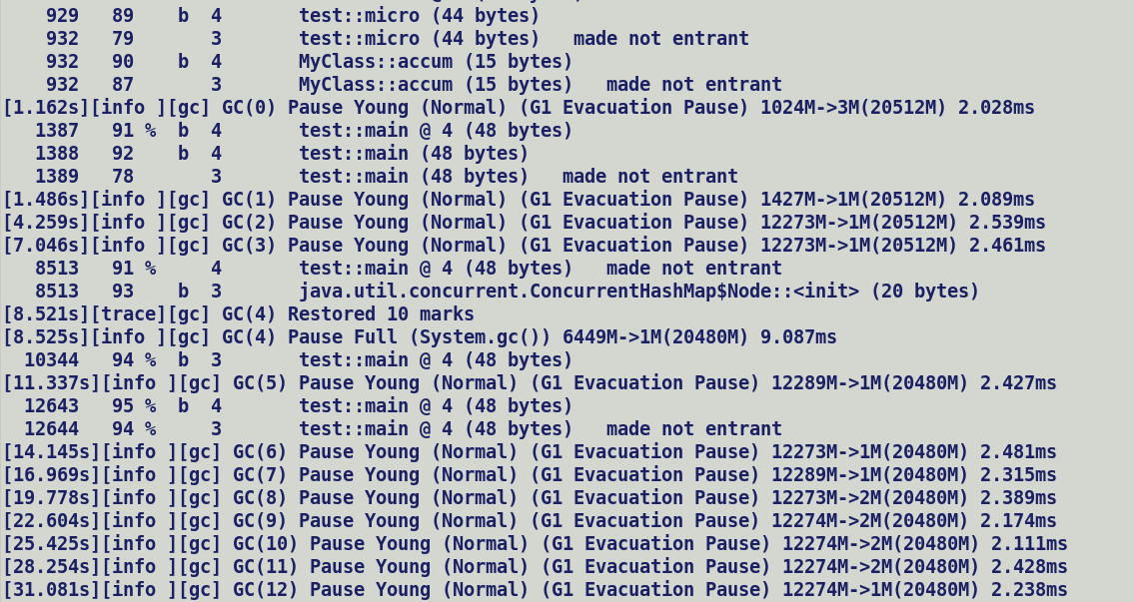



b -> bytecode compilation, 3 level (C1), % (OSR compilation) @4 (bci) (48 bytes of bytecode)

Removed VectorPayloadClassesMF from known vmClass structure, this will prevent their runtime image construction during startup. Also, it will automatically prevent archiving these classes into CDS shared archive (max species support).

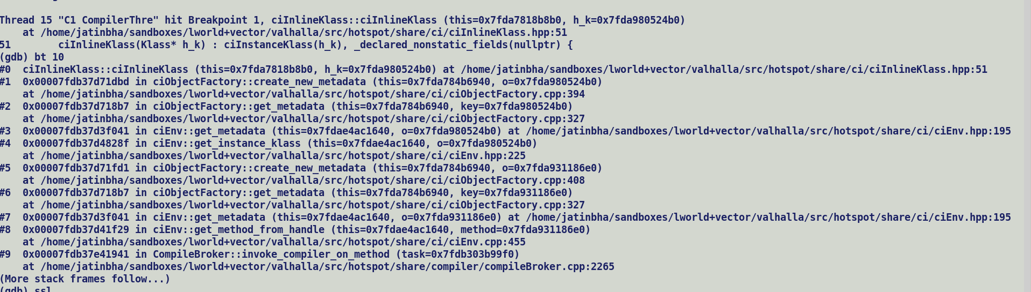

CI model caches:-

* _ci_metadata
* ciConstantPoolCache -> per class file

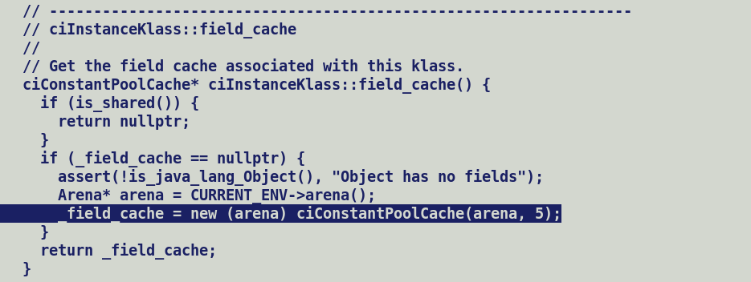

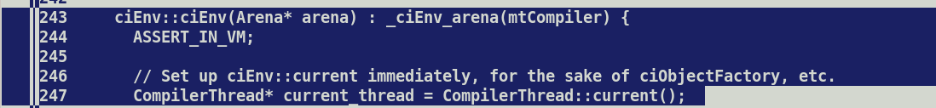

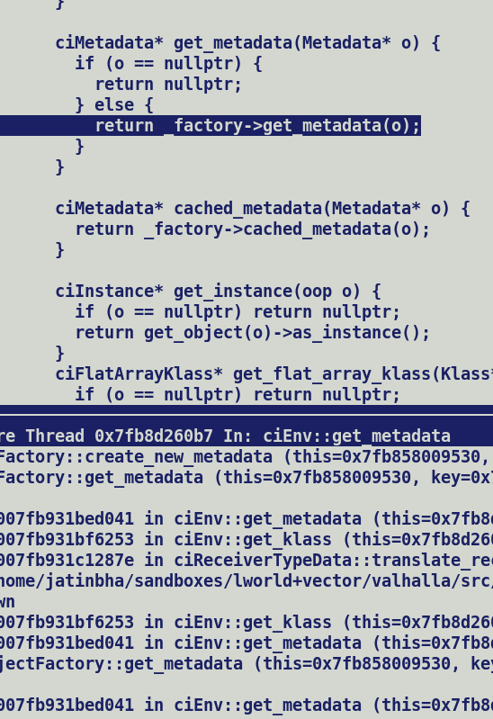

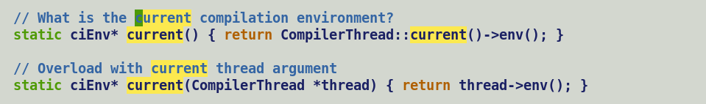

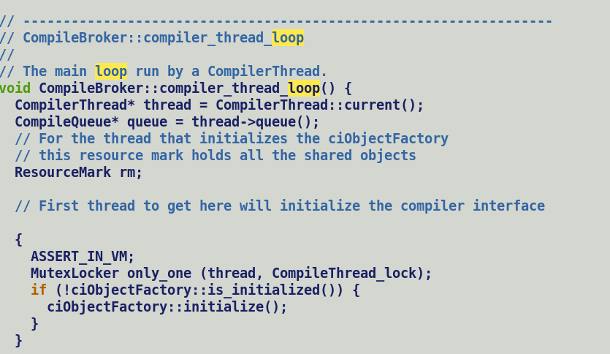

Initial object factory initialization for known vm classes is racy and protected by lock, VMPayloadClasses* classes are removed from known VM class set, only corresponding symbol are known to vm.

No locks around ciObjectFactory::get_Metadata() , which create a new metadata (ciInlineKlass etc..) if it does not exist.

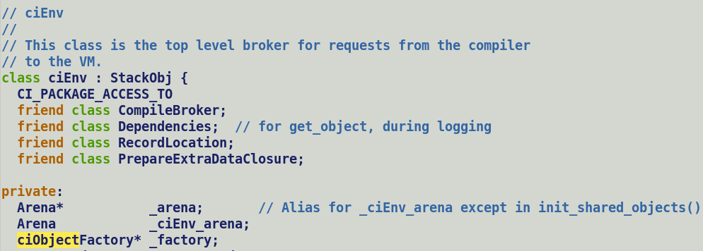

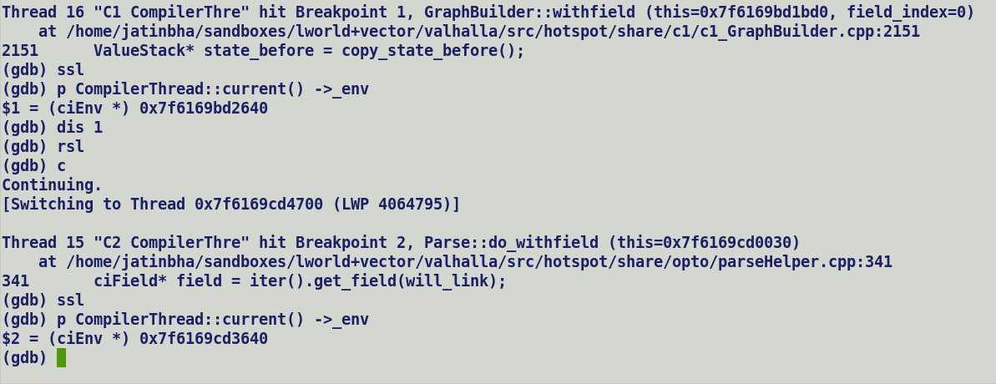

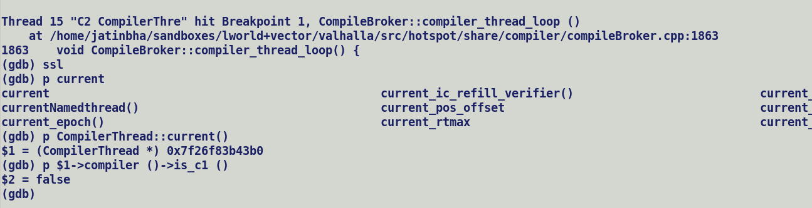

ciEnv is created per compilation task level check *CompileBroker::invoke_compiler_for_method*.

InlineKlass and FileInfo caching in ciObjectFactory.

ciObjectFactory

_shared_ci_metadata

ciInstanceKlass

_field_cache

Lookup is based on field index (fixed, part of FieldInfo) and holder (ciInlineKlass).

* Remove VectorPayloadClasses from VM_CLASSEES_DO, this will ensure these Payload Classes are not part of CDS archive, this is important for functional correctness with MaxSpecies, archive lock field layouts which are dependent on maximum vector size supported by target which may be different from JVM execution target.

Also, payload classes will not take part in shared object initialization of ciObjectFactory.

* ~~Limit caching for handful of VectorPayloadMF classes. If it ever becomes a problem, we can extend caching hash function to take CompileThread IDX into account.~~
  + ~~It will also avoid complexities in field lookup routines.~~
* ~~TODO: Disable ci_metadata cache to measure the impact of caching on a large micro.~~

CompilerThread specific cache to hold

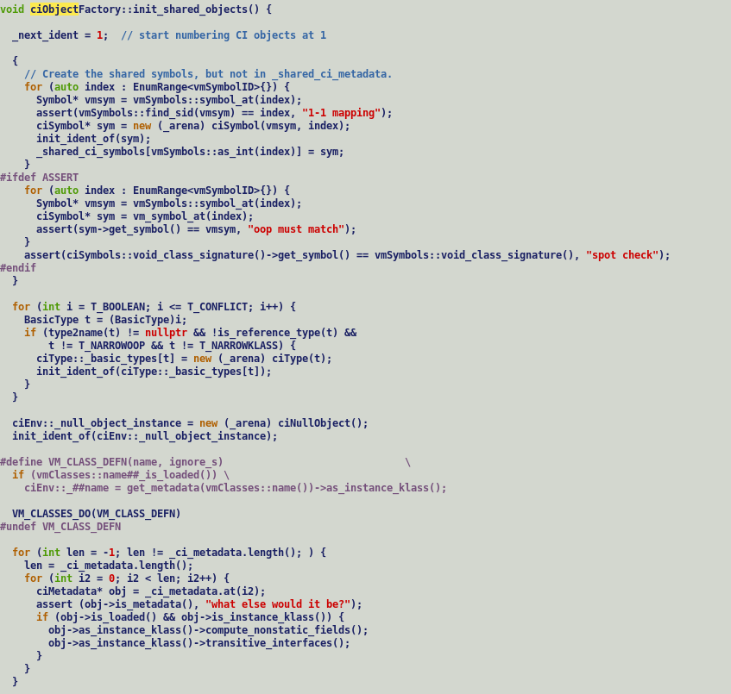



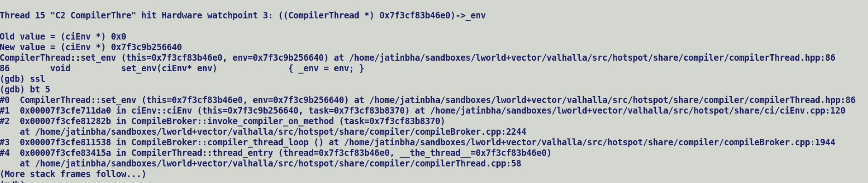

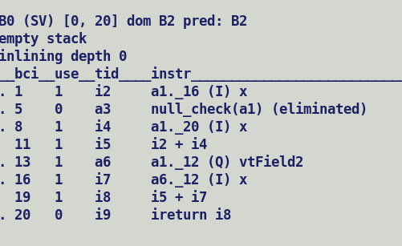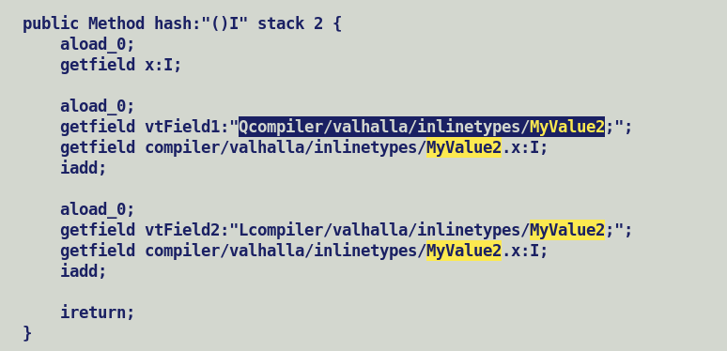

Valhalla – Mixed calling convention extension for vectors.

* Method specialization based on vector sizes (stretch)
* Argument type profiles (calling context specific).
* Parameter creation in caller context (*GraphKit::build_start_state*) is purely based on method signatures.
* Vector API exposes abstract vector type to users, vector arguments signatures will always have Ldescriptor;

Nomenclature: -

Arguments: - Which a callee method receives and operates over. Also called as formal parameters.

Parameter: - Actual values passed to call instance in caller context.

Example class hierarchy for illustration:-

Abstract Class: -

* Concrete Value Class1 – Field count n
* Concrete Value Class2 – Field count m

Method call descriptor:

***ReturnType Method (AbstractClass arg1, AbstractClass arg2)***

🡪 Method signature is composed of **Ldesctiptor;** arguments.

🡪 Thus, method will not be decorated with *has_scalar_argument* flags which is set while creating method specific AdapterHandles.

🡪 However, argument type profiling can associate concrete value types with arguments, and this will result into creation of additional CheckCastPP node which type cast the abstract typed argument into concrete value type node. It should also ensure creation of a new InlineTypeNode which rematerializes the fields from casted parameter. Casted Parameter will get tied to oop field of new InlineTypeNode.

🡪 *GraphKit::record_profiled_arguments_for_speculation* records the types of parameters for method specialization.

🡪 Value parameters will always undergo value to reference conversion i.e., buffering if method is not in-lined, this is purely driven by argument signatures which in this case are L descriptor references. Had it been a Q descriptor reference, compiler would have scalarized the parameters before passing it to callee.

🡪 Argument speculative type profiles are relevant in calling context i.e., mainly for inline expanders which needs to meet closed world assumptions.

🡪 We do record parameter types in ParametersTypeData but Valhalla unpack entry point currently do not handle those cases, as discussed we can defer mixed calling convention changes for the time being.

Reproducer shows inlined code generation of Paren::genHash() varies in specialized_calling::micro argument type profiles, C2 does perform bi-morphic inlining with multiple speculative types.

abstract class Parent {

public abstract int genHash();

}

value class Child1 extends Parent {

int field1;

int field2;

public Child1 (int f1, int f2) {

this.field1 = f1;

this.field2 = f2;

}

public int genHash() { return field1 >> field2; }

}

value class Child2 extends Parent {

int field1;

int field2;

int field3;

int field4;

public Child2 (int f1, int f2, int f3, int f4) {

this.field1 = f1;

this.field2 = f2;

this.field3 = f3;

this.field4 = f4;

}

public int genHash() { return (field1 + field2 >> field3) * field4; }

}

public class specialized_calling {

public int micro(Parent obj) {

return obj.genHash();

}

public static void main(String [] args) {

int nesting_topology = Integer.parseInt(args[0]);

specialized_calling obj = new specialized_calling();

int res = 0;

if (nesting_topology == 0) {

for (int i = 0; i < 100000; i++) {

if ((i & 1) == 0) {

res += obj.micro(new Child1(i, i + 10));

} else {

res += obj.micro(new Child2(i, i + 10, i + 20, i + 30));

}

}

} else if (nesting_topology == 1) {

for (int i = 0; i < 100000; i++) {

res += obj.micro(new Child1(i, i + 10));

}

} else {

for (int i = 0; i < 100000; i++) {

res += obj.micro(new Child2(i, i + 10, i + 20, i + 30));

}

}

System.out.println("[res] " + res);

}

}

Following is the type profiling information when nesting_topology = 0

@ 1 Child2::genHash (20 bytes) inline (hot)

@ 1 Child1::genHash (10 bytes) inline (hot)

\-> TypeProfile (2581/5163 counts) = Child1

\-> TypeProfile (2582/5163 counts) = Child2

@ 31 Child1::<vnew> (20 bytes) inline (hot)

@ 34 specialized_calling::micro (5 bytes) disallowed by CompileCommand

@ 57 Child2::<vnew> (44 bytes) inline (hot)

@ 60 specialized_calling::micro (5 bytes) disallowed by CompileCommand

# {method} {0x00007fe54f400458} 'micro' '(LParent;)I' in 'specialized_calling'

;; N64: # out( B1 ) <- BLOCK HEAD IS JUNK Freq: 1

0x00007fe5ecdcf360: mov 0x8(%rsi),%r10d

0x00007fe5ecdcf364: movabs $0x7fe553000000,%r11

0x00007fe5ecdcf36e: add %r11,%r10

0x00007fe5ecdcf371: cmp %r10,%rax

0x00007fe5ecdcf374: jne 0x00007fe5ecdabaa0 ; {runtime_call ic_miss_stub}

0x00007fe5ecdcf37a: nop

0x00007fe5ecdcf37b: nop

0x00007fe5ecdcf37c: nop

0x00007fe5ecdcf37d: nop

0x00007fe5ecdcf37e: nop

0x00007fe5ecdcf37f: nop

[Verified Entry Point]

[Verified Inline Entry Point]

[Verified Inline Entry Point (RO)]

# this: rsi:rsi = 'specialized_calling'

# parm0: rdx:rdx = 'Parent'

# [sp+0x20] (sp of caller)

;; B1: # out( B8 B2 ) <- BLOCK HEAD IS JUNK Freq: 1

0x00007fe5ecdcf380: mov %eax,-0x18000(%rsp)

0x00007fe5ecdcf387: push %rbp

0x00007fe5ecdcf388: sub $0x10,%rsp

0x00007fe5ecdcf38c: cmpl $0x1,0x20(%r15)

0x00007fe5ecdcf394: jne 0x00007fe5ecdcf44e ;*synchronization entry

; - specialized_calling::micro@-1 (line 32)

0x00007fe5ecdcf39a: mov 0x8(%rdx),%r11d ; implicit exception: dispatches to 0x00007fe5ecdcf410

;; B2: # out( B5 B3 ) <- in( B1 ) Freq: 0.999999

0x00007fe5ecdcf39e: nop

0x00007fe5ecdcf39f: nop

0x00007fe5ecdcf3a0: cmp $0x1001488,%r11d ; {metadata('Child2')}

0x00007fe5ecdcf3a7: je 0x00007fe5ecdcf3be

;; B3: # out( B7 B4 ) <- in( B2 ) Freq: 0.499999

0x00007fe5ecdcf3a9: cmp $0x1001000,%r11d ; {metadata('Child1')}

0x00007fe5ecdcf3b0: jne 0x00007fe5ecdcf3e6 ;*invokevirtual genHash {reexecute=0 rethrow=0 return_oop=0 return_scalarized=0}

; - specialized_calling::micro@1 (line 32)

;; B4: # out( B6 ) <- in( B3 ) Freq: 0.499999

0x00007fe5ecdcf3b2: mov 0x10(%rdx),%r10d

0x00007fe5ecdcf3b6: sarx %r10d,0xc(%rdx),%eax ;*ishr {reexecute=0 rethrow=0 return_oop=0 return_scalarized=0}

; - Child1::genHash@8 (line 13)

; - specialized_calling::micro@1 (line 32)

0x00007fe5ecdcf3bc: jmp 0x00007fe5ecdcf3d3 ;*invokevirtual genHash {reexecute=0 rethrow=0 return_oop=0 return_scalarized=0}

; - specialized_calling::micro@1 (line 32)

;; B5: # out( B6 ) <- in( B2 ) Freq: 0.499999

0x00007fe5ecdcf3be: mov 0x10(%rdx),%r11d

0x00007fe5ecdcf3c2: add 0xc(%rdx),%r11d

0x00007fe5ecdcf3c6: mov 0x14(%rdx),%r8d

0x00007fe5ecdcf3ca: sarx %r8d,%r11d,%eax

0x00007fe5ecdcf3cf: imul 0x18(%rdx),%eax

;; B6: # out( N64 ) <- in( B5 B4 ) Freq: 0.999998

0x00007fe5ecdcf3d3: add $0x10,%rsp

0x00007fe5ecdcf3d7: pop %rbp

0x00007fe5ecdcf3d8: cmp 0x498(%r15),%rsp ; {poll_return}

0x00007fe5ecdcf3df: ja 0x00007fe5ecdcf438

0x00007fe5ecdcf3e5: retq

Phi Node assertion failure during vector box expansion: -

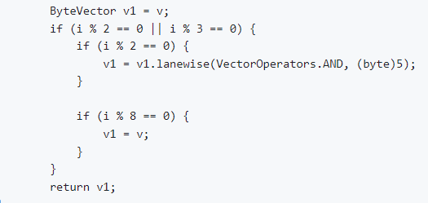



Backward traversal from root (P3) will visit V twice leading to assertion failure.

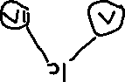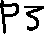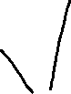

Type profile driver Bi-morphic inlining of payload query method, will inject a PhiNode are convergence of predicated control flows.

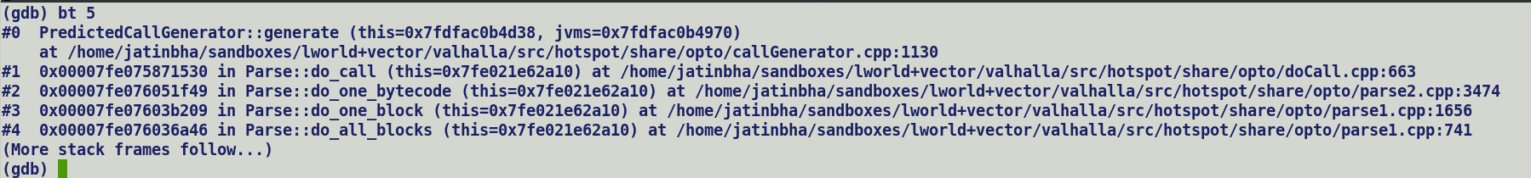

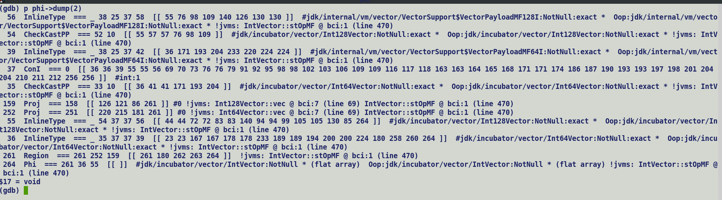

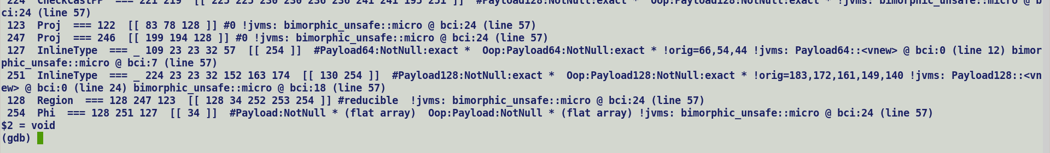

In above snippet Unsafe access operate over phi, which will eventually be connected with oop fields of incoming inline type node when InlineTypeNode are eliminated by process_inline_types. Unsafe access never follows safe field accesses semantics.

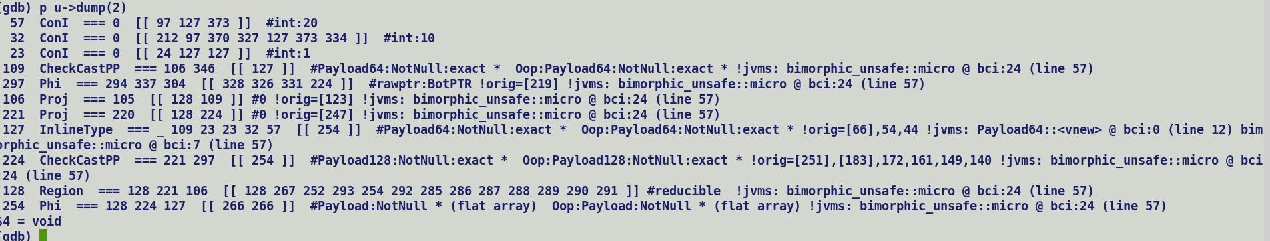

Dump after replacing first InlineTypeNode with its oop field.

FlatArray : - Packed arrays of Inline types, allocated over heap like usual primitive arrays.

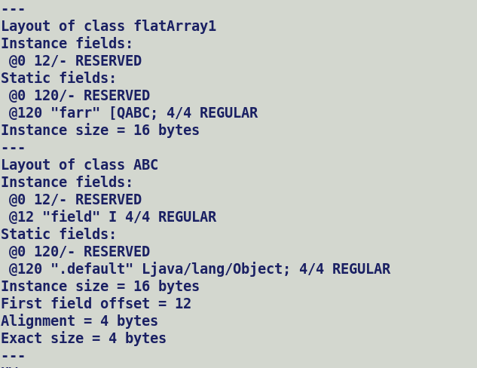

Parameter profiling in inhabited by OSR compilation.

https://bugs.openjdk.org/browse/JDK-8251554

Performance Degradations in JMH micros.

Failed intrinsification will be costlier with Valhalla since fallback implementation is composed of Unsafe APIs (get/put/makePrivate/finishPrivateBuffer), most of the Unsafe APIs are intrinsified by c2 compiler but finishPrivateBuffer is not due to missing Inductive Phi node for re-materialized InlineTypeNode during Unsafe.put operation.

<https://bugs.openjdk.org/browse/JDK-8317659>

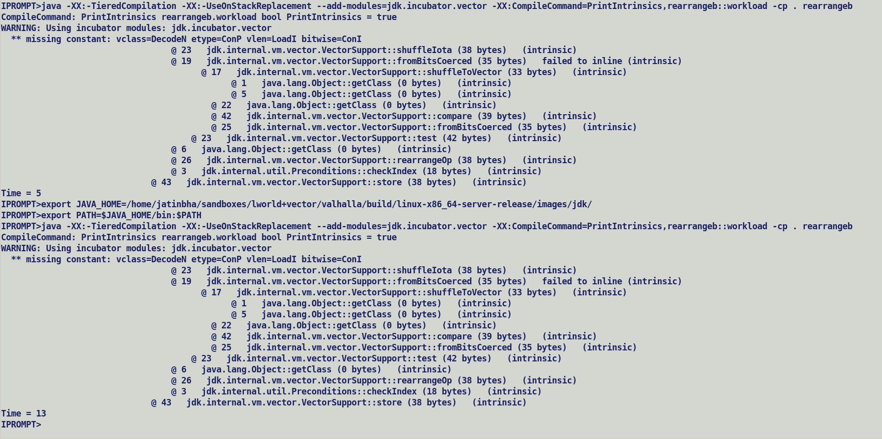

This will specially hurt in shuffle loading from arrays and any dependent API list slice / unslice since it’s a pure java implementation which moves to contents on index array in to VectorPayloads of value types.

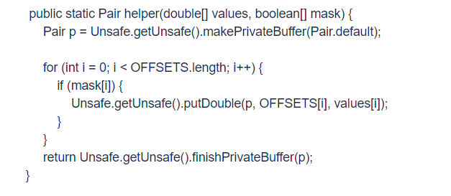

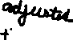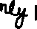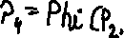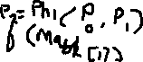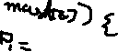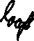

Entire InlineTypeNode is seen as a bundle for scalarized fields, thus re-materialized InlineTypeNode is overwritten by the default InlineType node if the mask of in last iteration is false.

P0 = INIT:

for (int I = 0; I < 2; I++) {

P1 = Phi (INIT, P3) // Formed for inductive variables (Primary/Secondary) , Missing because InlineTypeNode rematerialized during unsafe

if (mask[i]) { // put operation does not modify JVM state but just the memory state.

Unsafe.putDouble();

P2 = New_Value;

}

P3 = Phi (P1, P2) // Formed for converging values from multiple control paths.

}

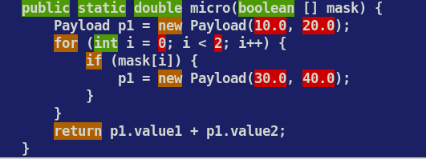

[Verified Inline Entry Point (RO)]

# {method} {0x00007fad13400408} 'micro' '([Z)D' in 'test_merge'

# parm0: rsi:rsi = '[Z'

# [sp+0x20] (sp of caller)

;; N1: # out( B1 ) <- in( B10 B9 ) Freq: 1

;; B1: # out( B10 B2 ) <- BLOCK HEAD IS JUNK Freq: 1

0x00007fada0993080: mov %eax,-0x18000(%rsp) ; {no_reloc}

0x00007fada0993087: push %rbp

0x00007fada0993088: sub $0x10,%rsp

0x00007fada099308c: cmpl $0x1,0x20(%r15)

0x00007fada0993094: jne 0x00007fada0993152 ;*synchronization entry

; - test_merge::micro@-1 (line 12)

0x00007fada099309a: mov 0xc(%rsi),%r11d ; implicit exception: dispatches to 0x00007fada0993110

;*baload {reexecute=0 rethrow=0 return_oop=0 return_scalarized=0}

; - test_merge::micro@19 (line 14)

;; B2: # out( B10 B3 ) <- in( B1 ) Freq: 0.999999

0x00007fada099309e: nop

0x00007fada099309f: nop

0x00007fada09930a0: test %r11d,%r11d

0x00007fada09930a3: jbe 0x00007fada0993110

;; B3: # out( B10 B4 ) <- in( B2 ) Freq: 0.999998

0x00007fada09930a9: cmp $0x1,%r11d

0x00007fada09930ad: jbe 0x00007fada0993110

;; B4: # out( B6 B5 ) <- in( B3 ) Freq: 0.999997

0x00007fada09930b3: movzbl 0x10(%rsi),%r10d



0x00007fada09930b8: vmovsd -0x60(%rip),%xmm0 # 0x00007fada0993060

; {section_word}



0x00007fada09930c0: vmovsd -0x60(%rip),%xmm1 # 0x00007fada0993068



; {section_word}

0x00007fada09930c8: test %r10d,%r10d

0x00007fada09930cb: jne 0x00007fada09930df ;*ifeq {reexecute=0 rethrow=0 return_oop=0 return_scalarized=0}

; - test_merge::micro@20 (line 14)

;; B5: # out( B7 ) <- in( B4 ) Freq: 0.499948

0x00007fada09930cd: vmovsd -0x65(%rip),%xmm2 # 0x00007fada0993070

; {section_word}



0x00007fada09930d5: vmovsd -0x65(%rip),%xmm3 # 0x00007fada0993078



; {section_word}

0x00007fada09930dd: jmp 0x00007fada09930e7

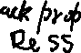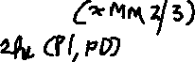

;; B6: # out( B7 ) <- in( B4 ) Freq: 0.500049



0x00007fada09930df: vmovapd %xmm1,%xmm2



0x00007fada09930e3: vmovapd %xmm0,%xmm3 ;*iinc {reexecute=0 rethrow=0 return_oop=0 return_scalarized=0}

; - test_merge::micro@33 (line 13)

;; B7: # out( B9 B8 ) <- in( B6 B5 ) Freq: 0.999997

0x00007fada09930e7: movzbl 0x11(%rsi),%r10d ;*baload {reexecute=0 rethrow=0 return_oop=0 return_scalarized=0}

; - test_merge::micro@19 (line 14)

0x00007fada09930ec: test %r10d,%r10d

0x00007fada09930ef: jne 0x00007fada09930f9 ;*ifeq {reexecute=0 rethrow=0 return_oop=0 return_scalarized=0}

; - test_merge::micro@20 (line 14)

;; B8: # out( B9 ) <- in( B7 ) Freq: 0.499948

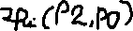

0x00007fada09930f1: vmovapd %xmm2,%xmm1



0x00007fada09930f5: vmovapd %xmm3,%xmm0 ;*iinc {reexecute=0 rethrow=0 return_oop=0 return_scalarized=0}

; - test_merge::micro@33 (line 13)

;; B9: # out( N1 ) <- in( B7 B8 ) Freq: 0.999997

0x00007fada09930f9: vaddsd %xmm1,%xmm0,%xmm0 ;*dadd {reexecute=0 rethrow=0 return_oop=0 return_scalarized=0}

; - test_merge::micro@47 (line 18)

0x00007fada09930fd: add $0x10,%rsp

0x00007fada0993101: pop %rbp

0x00007fada0993102: cmp 0x4a0(%r15),%rsp ; {poll_return}

0x00007fada0993109: ja 0x00007fada099313c

0x00007fada099310f: retq

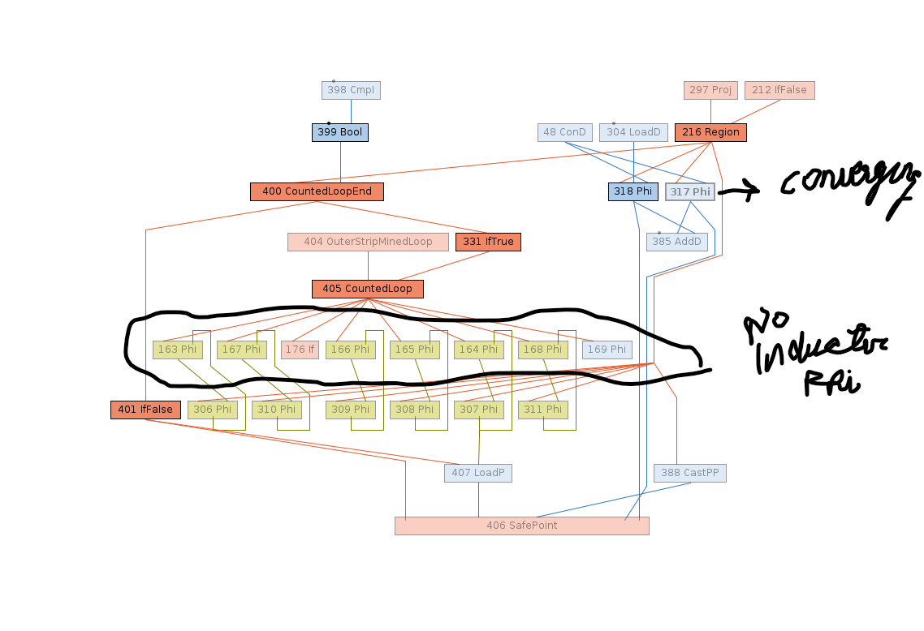

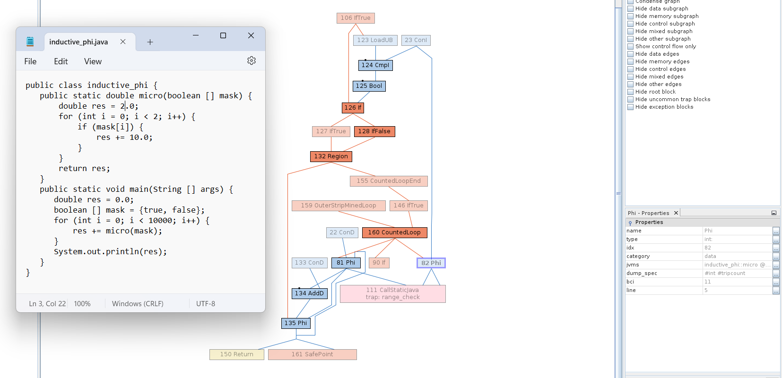

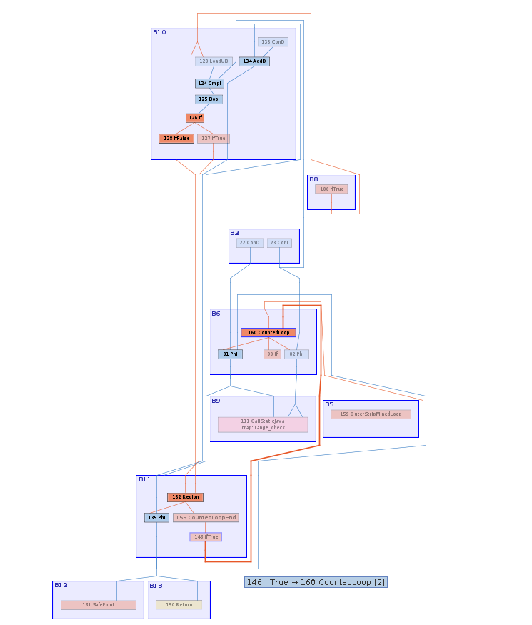

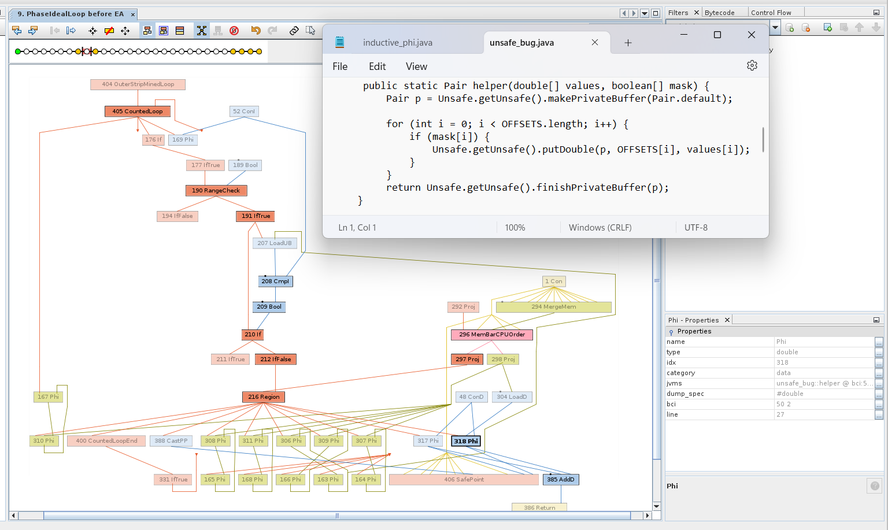

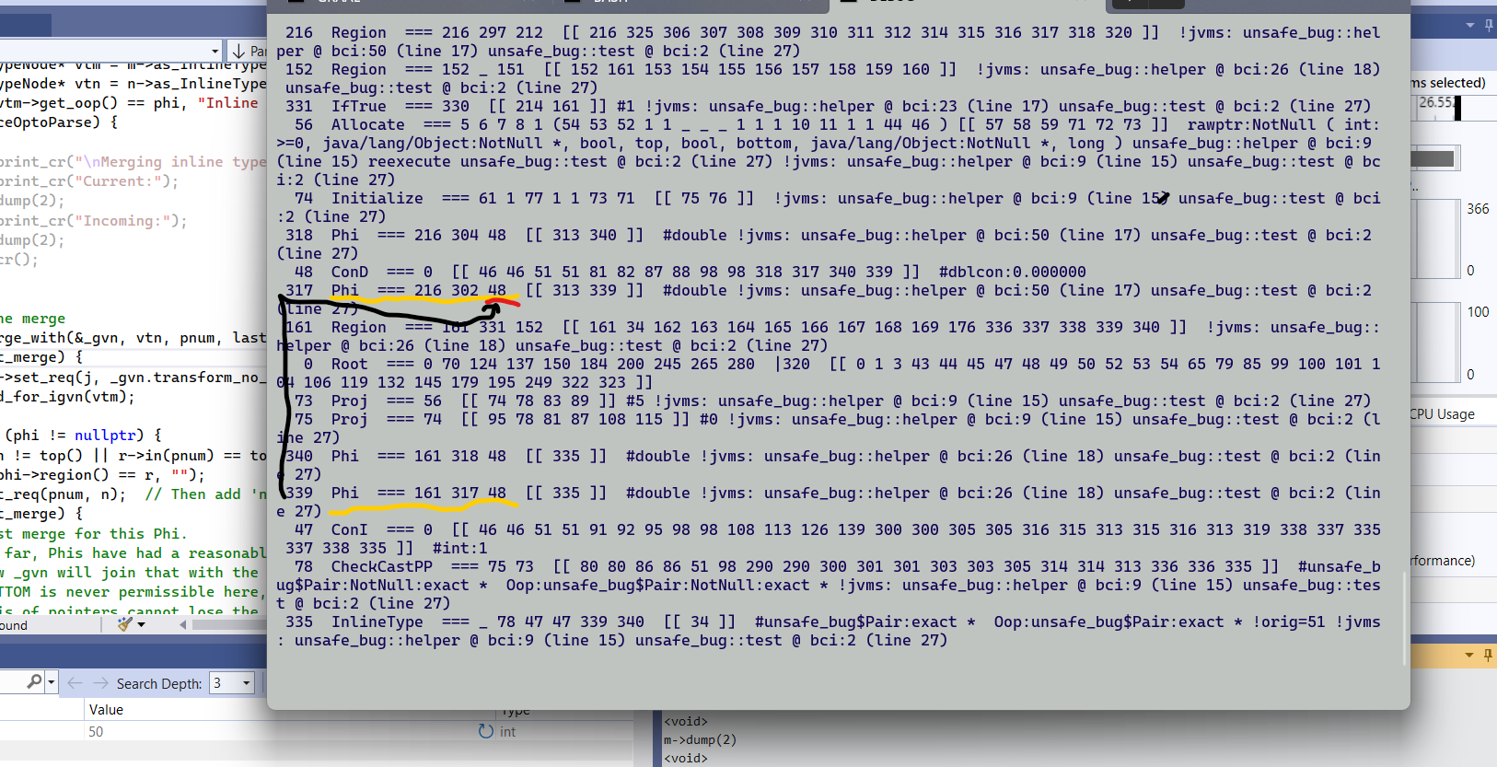

* 339 should dominate 317.
* 317’s second / default input should be 339. 339 is inductive phi whereas 317 is converging one which merge the values coming out of mask true block and loop header.
* One additional iteration of data flow analysis should automatically propagate updates to downstream users.

**Current IR Correct IR**

P0 = INIT P0 = INIT

for (…) { for (…) {

P3 = Phi (P0, P4) // 339 P3 = Phi (P0, P4) // RAU of P0 with P2 in the graph at merge point when P2 is fully connected.

If (mask[0]) { If (mask[0]) {

P1 = … P1 = …



} }

P4 = Phi(P0, P1) // 317 P4 = Phi (P3, P1)

} }

**Current IR**

P0[R0] = INIT

for (…) {

P1 [R1] = Phi (P0 [R0] , P4 [R4]) // 339

If (mask[0]) {

P3[R3] = …

}

P4[R4] = Phi(P0[R1], P3[R3]) // 317



}

Phi::Process() {

If (InlineType(in[i]) && Region(i) != in[i].region && P4.User.in(1) == P4.in(1)) {

Phi.set_req(i, get_P0_user_from_R1());

}

}

**Correct IR**

P0 = INIT P0 = INIT

for (…) { for (…) {

P2 = Phi (P0, P2) // 339 P3 = Phi (P0, P2) // RAU of P0 with P2 in the graph at merge point when P2 is fully connected.

If (mask[0]) { If (mask[0]) {

P1 = … P1 = …



} }

P2 = Phi(P0, P1) // 317 P2 = Phi (P3, P1)

} }



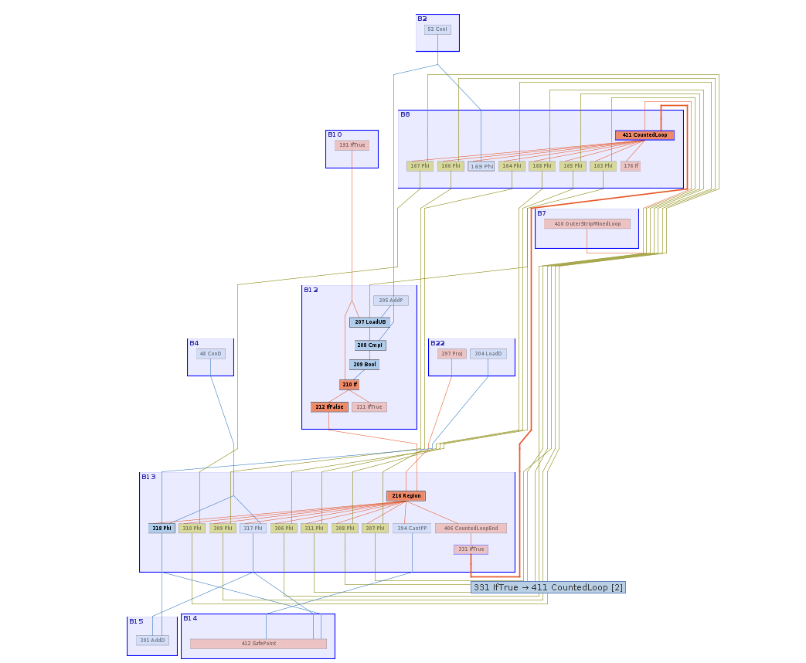

**Back edge : B3 -> B4**

**Loop Blocks: B4 (Header) -> B1 -> B2 -> B3 (Latch)**

B0 0: invokestatic #7 // Method jdk/internal/misc/Unsafe.getUnsafe:()Ljdk/internal/misc/Unsafe;

3: aconst_init #13 // class unsafe_bug$Pair

6: checkcast #2 // class java/lang/Object

9: invokevirtual #15 // Method jdk/internal/misc/Unsafe.makePrivateBuffer:(Ljava/lang/Object;)Ljava/lang/Object;

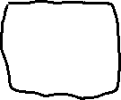

12: checkcast #19 // class "Qunsafe_bug$Pair;"

15: astore_2

16: iconst_0

17: istore_3



B4

18: iload_3

19: getstatic #21 // Field OFFSETS:[J

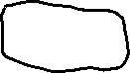

22: arraylength

23: if_icmpge 56



B1 26: aload_1

27: iload_3



28: baload

29: ifeq 50



B2 32: invokestatic #7 // Method jdk/internal/misc/Unsafe.getUnsafe:()Ljdk/internal/misc/Unsafe;

35: aload_2

36: checkcast #2 // class java/lang/Object



39: getstatic #21 // Field OFFSETS:[J



42: iload_3



43: laload

44: aload_0

45: iload_3

46: daload

47: invokevirtual #27 // Method jdk/internal/misc/Unsafe.putDouble:(Ljava/lang/Object;JD)V



B3 50: iinc 3, 1

53: goto 18



B5 56: invokestatic #7 // Method jdk/internal/misc/Unsafe.getUnsafe:()Ljdk/internal/misc/Unsafe;

59: aload_2

60: checkcast #2 // class java/lang/Object

63: invokevirtual #31 // Method jdk/internal/misc/Unsafe.finishPrivateBuffer:(Ljava/lang/Object;)Ljava/lang/Object;



66: checkcast #19 // class "Qunsafe_bug$Pair;"

69: areturn

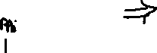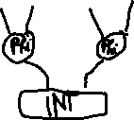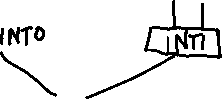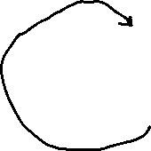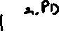

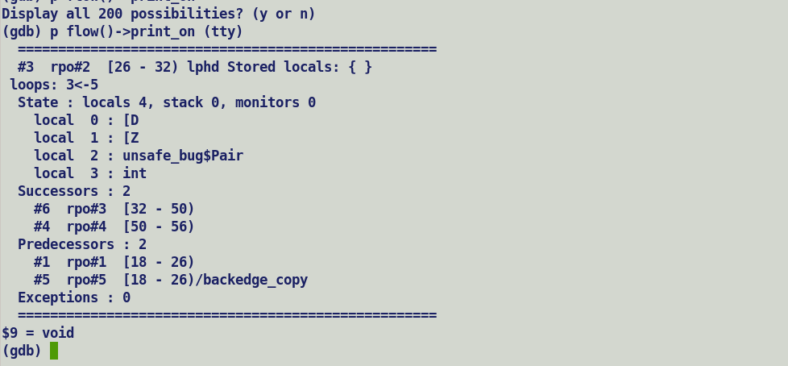

C1 allocates new instance for value objects and get / put operation directly modify the memory state, same goes for Interpreter.

C2 however creates a special IR node for value objects. Inductive phi nodes are created upfront during parsing when loop header block is encounters, during parsing c2 relies on the control flow information collected by ciTypeFlow. Since Unsafe.put does not modify JVM state as it returns a void, hence ciTypeFlow does not show a new definition for it with in the loop, when c2 queries the ciTypeFlow with incoming value object index it does not find any definition within the loop and treats it as an invariant definition and skip over creating an inductive phi node for it, later on when if block within the loop converges, it merges the newly rematerialized InlineTypeNode form modified memory state (due to putDouble) with incoming init value and only creates a converging phi node. This state is then propagated to loop header as it is through loop back edge.

Problem does not occur with Interpreter and C1 but only specific to C2 compiler.

Solution: -

* + 1. Lazy inductive phi node generation for unsafe operated value nodes.

ropagate the inductive phi node to all its users in downstream graph.

OR

* 1. Always create an inductive phi for incoming value objects in loop header, later on GVN will automatically replace imbalanced phis (with only one input)

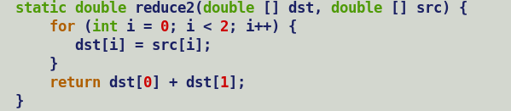

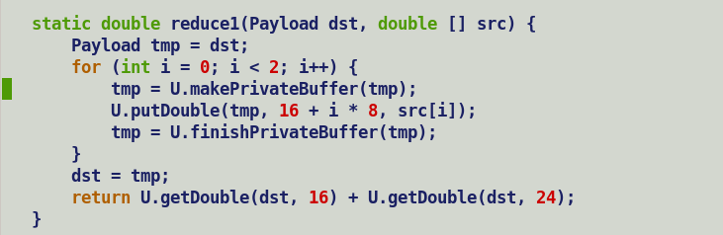

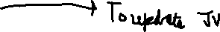

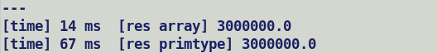

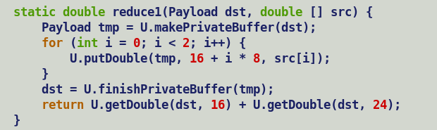

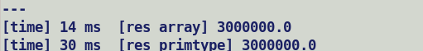





A) If makePrivateBuffer() not in-lined -> allocate + copy + larval at run time.

Compiler re-constructs InlineTypeNode from oop.

B) U.putDouble , if not intrinsfied checks for larval state over argument oop’s mark word.

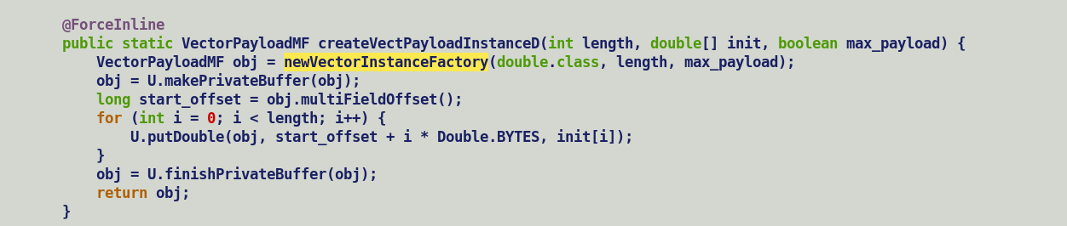

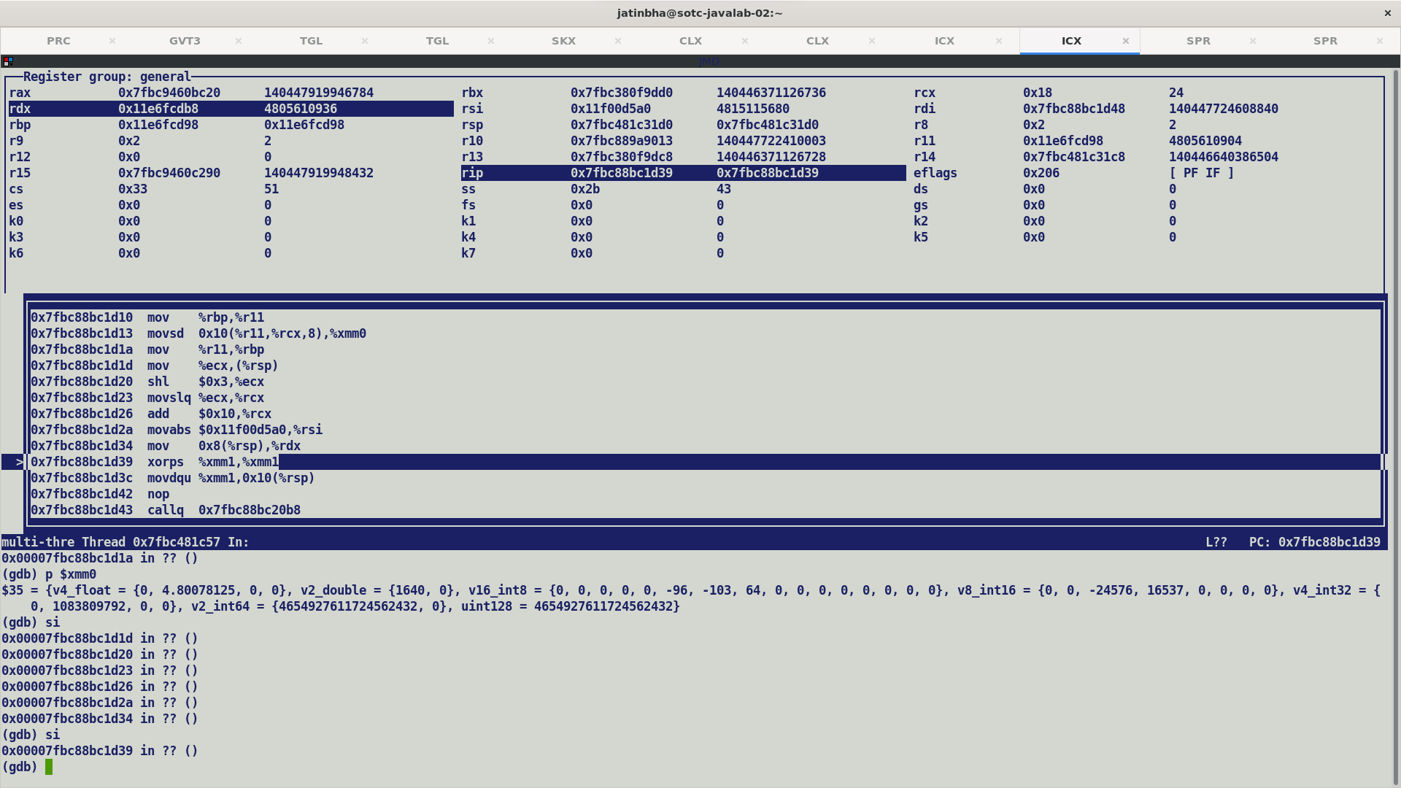

If putDouble is not intrinsified being a native method, it will fall over to unsafe C based implementation.

Thus, compiler will not be aware of any memory state changes and since it returns a void will not be re-materializing the InlineTypeNode during return value handling. Thus, finishPrivateBuffer will receive an un-modified default value payload and cause incorrectness.

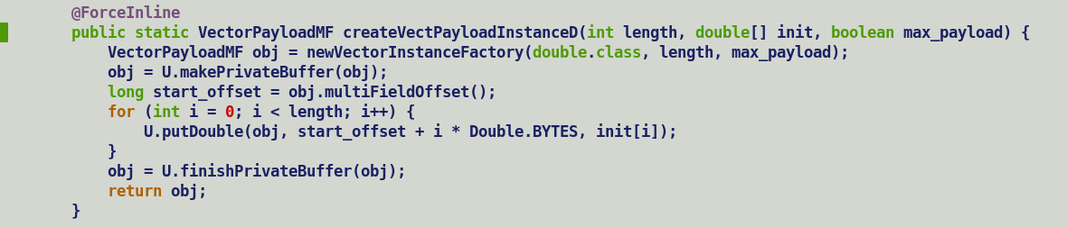

Solution:-

1. Disable scalarization b/w make and finish private buffer, this was also a suggestion from Oracle (Vladimir and Tobias)



1. Pack putDouble within makePrivateBuffer and finishPrivateBuffer APIs and special handling for put return processing.

Two problems due to unsafe APIs.

1. Missing Inductive Phi-Node since JVM state is not modified.
   1. This causes incorrectness issue.
2. If putDouble is not inline expanded, then finish private buffer will receive the default value objects.
   1. This is the reason behind failing cases with DeoptimizeALot.

Current deficiency: -

Payload obj = new Payload();  *// InlineTypeNode*

If ( ) {

obj = U.makePrivateBuffer(obj); *// oop*

} else {

… *// InlineTypeNode*

}

obj1 = merge_common();

*// Imbalanced Phi -> OK to have will only prevent scalarization*

*// and transform across PhiNode. Eventually, the path feeding InlineTypeNode will replace*

*// itself with buffer during process_inline_types.*

U.putDouble(obj1, value);

obj = U.finishPrivateBuffer(obj1);

makePrivateBuffer() -> intrinsic - > create allocate in larval state , update its memory state.

-> not in-lined then disable intrinsification if finish private buffer too.

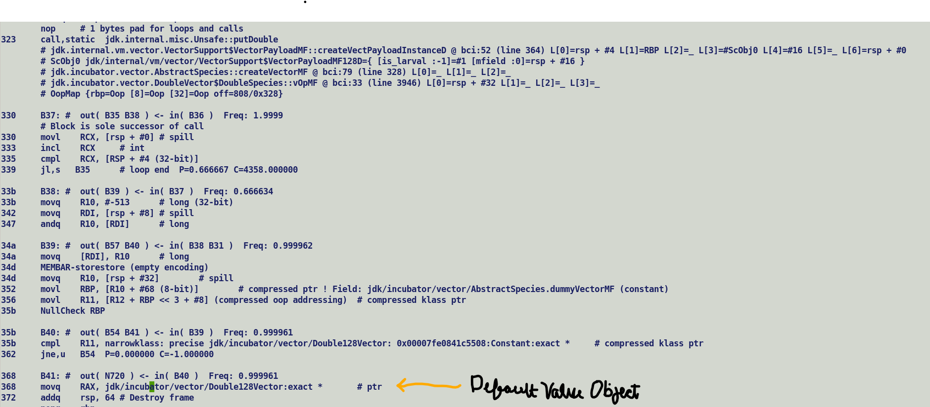

Unsafe APIs

makePrivateBuffer :-

|___ Inline-expanded :- Not generate scalarized IR (InlineTypeNode) return the value oop.

|___ No-inline-expansion :- Fall over to native implementation, return projection processing will try to re-materialized InlineTypeNode based on the return type. This needs to be curbed to have a common semantics with inline-expansion flow.

putDouble :-

|__ Inline-expansion :- Do not rematerialize InlineTypeNode IR from modified memory state.

|__ No-inline-expansion :- Falls over to native implementation and only updates the value oop. No InlineTypeNode re-materialization after call since returns a void, semantics comply with inline-expansion flow.

finishPrivateBuffer :-

|__ Inline-expansion :- Rematerialize InlineType node for incoming value object, if incoming value object is InlineTypeNode then disable intrinsic, transition out of larval state is done by native implementation, re-materialization on returned projection value.

|__ no-inline expansion :- Transitioning out of larval state done by native implementation.

Re-mat scalarization IR (InlineTypeNode) on return projection since return type is a value type.

<https://openjdk.org/jeps/8316779>

However, in comparison to primitive types, heap flattening of value class types can be inefficient, because it must account for null references. These are typically encoded by reserving some bits for a "null flag", and those bits are then unavailable to encode the object's field values. So, for example, a boxed Integer requires 32 bits to encode the int value, and at least 1 more bit for the null flag, probably leading to a 64-bit encoding. Will also impediment packed representations of value object arrays which is a prime requirement for low precision vectorization API operating over packed Float16 arrays.

Further, heap flattening of value class types is limited by the integrity requirements of objects and references: the flattened data must be small enough to read and write atomically, or else the encoded data may become corrupted. On common platforms, "small enough" may mean as few as 32 or 64 bits. So while many small value classes can be flattened, most value classes that declare 2 or more fields will have to be encoded as ordinary heap objects (unless the fields store primitives of types boolean, char, byte, or short). Even a boxed Double requires at least 65 bits (counting one for a null flag), which exceeds that atomic read/write capabilities of many systems

Vector Payload as nullable values vs null-restricted objects:-

Currently, vector Payload are primitive class objects which encapsulates packed multifield. Thus, the backing storage holding the vector value is always contiguous.

Making payload a value class will prevent flattening of payloads in concrete classes, thus preventing a packed representation.

Will not prevent scalarization of value objects which is orthogonal to flattening. While flattening provides cache friendly layout and packed encodings, scalarization allows optimizing compiler to replace aggregate accesses with scalars.

Thus, C2 will always create scalarized IR nodes (InlineType) for a nullable / null-restricted value objects. Main difference lies in the buffering behaviour and will impact re-materialization / object reconstruction which will introduce addition indirections for value non-flattened value objects i.e. vector payloads.

Primitives types do not have these constraints: a primitive-typed field is implicitly initialized to a zero value (or the equivalent) on creation, rather than null; and large primitive variables, of types long or double, are allowed to be non-atomically updated (see [JLS 17.7](https://docs.oracle.com/javase/specs/jls/se19/html/jls-17.html#jls-17.7)). Thus, for example, a large array of type int has half the memory footprint of a flattened array of type Integer.

while fields and array components are only inlined if the value object, plus a null flag, can fit in an atomic word size (such as 64 bits).

<https://openjdk.org/jeps/8316779#:~:text=while%20fields%20and%20array%20components%20are%20only%20inlined%20if%20the%20value%20object%2C%20plus%20a%20null%20flag%2C%20can%20fit%20in%20an%20atomic%20word%20size%20(such%20as%2064%20bits)>.

Because implicit constructors are necessary for the allocation of null-restricted fields and arrays, value classes that do not declare implicit constructors cannot be used as null-restricted types.

Store InlineTypeNode (ITN) to a buffer location, during process_inline_types ITN will be replaced by oop.

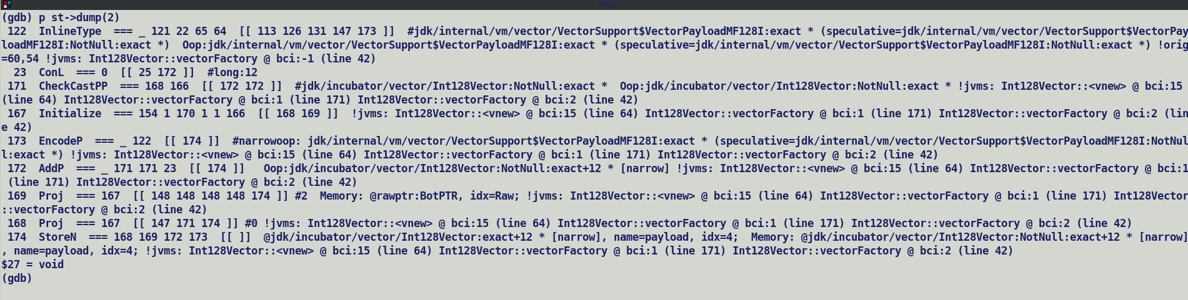

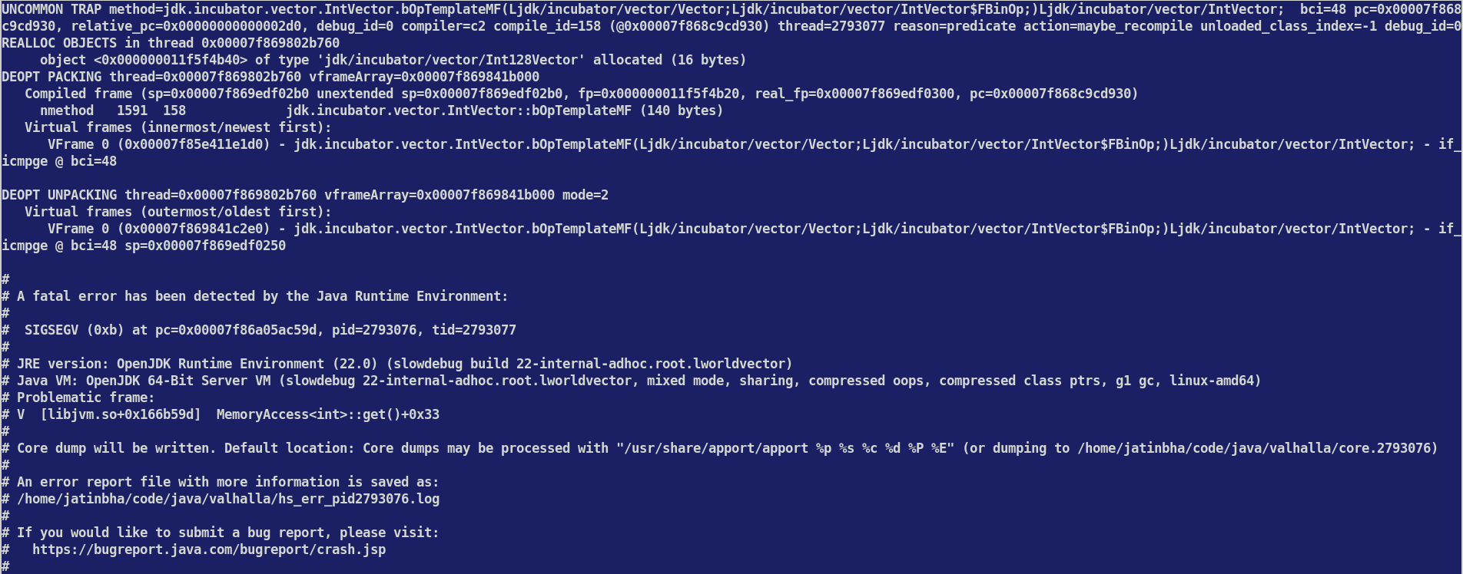

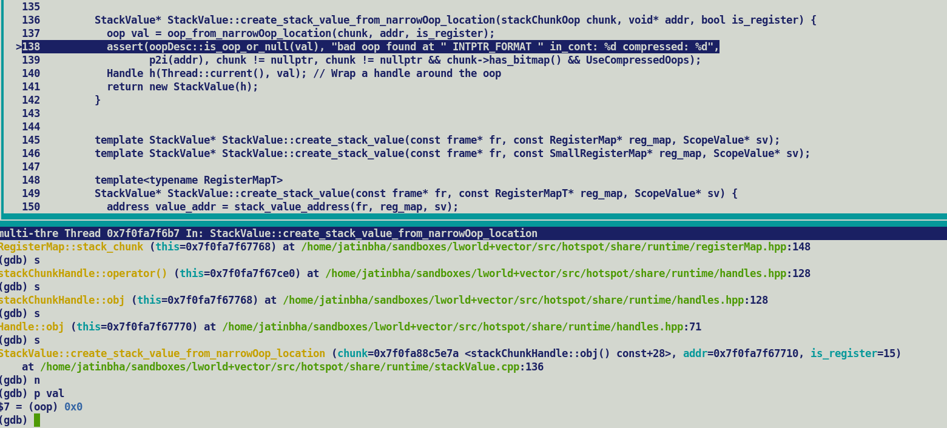

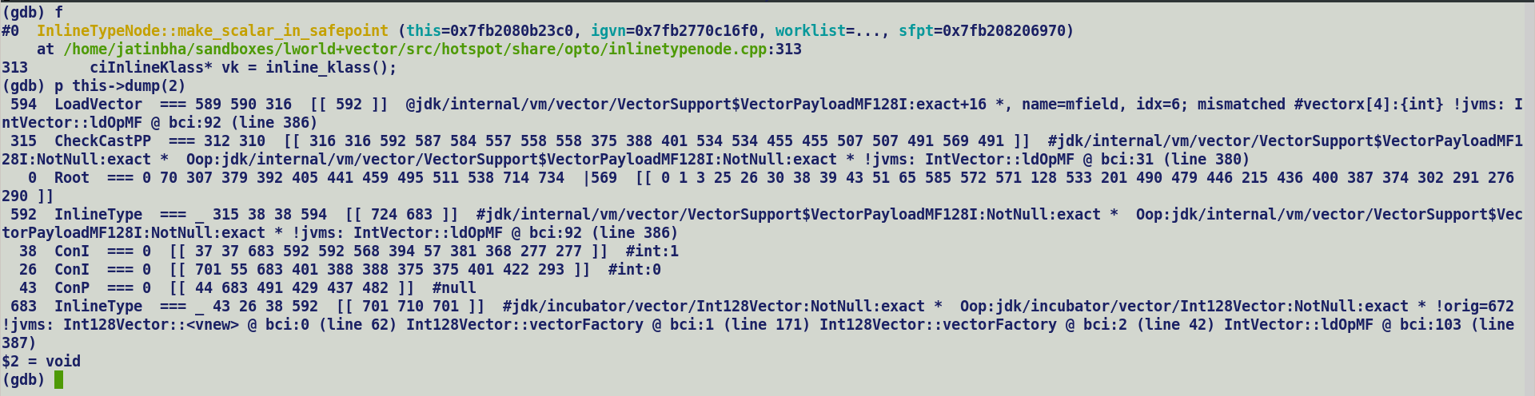

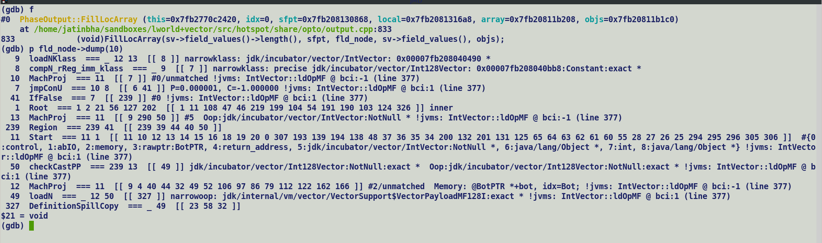

make_scalars_in_safepoint.

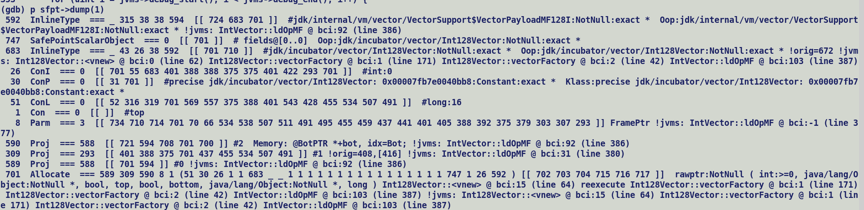



Scalarize payload

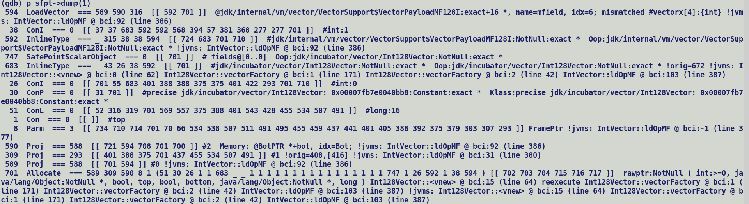



Replace payload with Scalarized object.

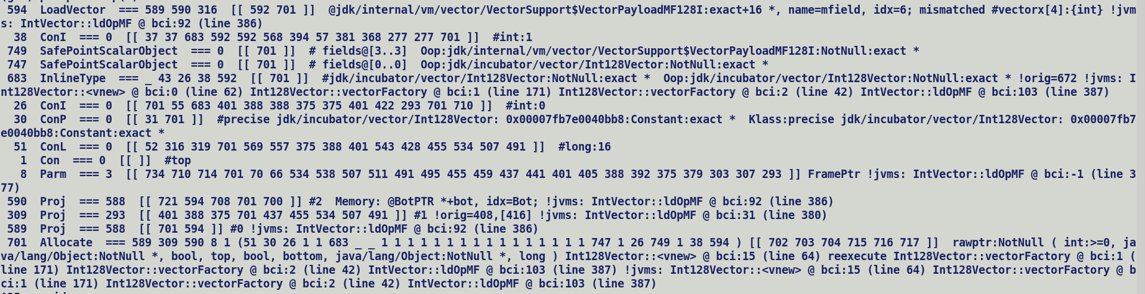



Vector.payload = ObjectValue (747)_1(init)_38(larval) + Field value (749)

749 -> Is scalarized despite of being a nullable value object.

If *make_scalar_in_safepoint* skip creating a SafepointScalarObjectNode for it i.e scalarization is disabled, then should be replaced by its oop during process_inline_type, this should ensure seamless access to oop value during deoptimization.

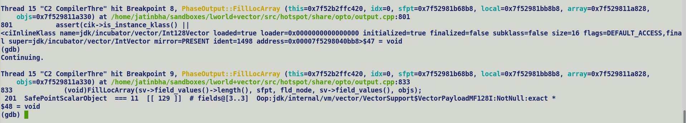

compute_reaching definitions for oop at safepoints.

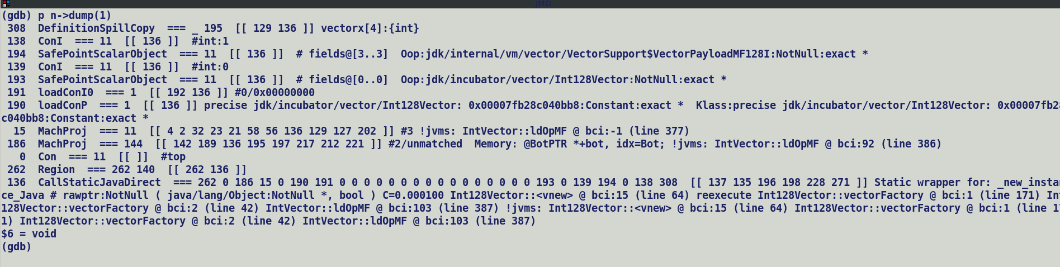

At safe point we see OopMaps (gc root set enumeration) and re-constructable objects (SafePointScalarObjectNodes not under GC preview since they are scalarized by compiler and SROAed, no allocations for them)

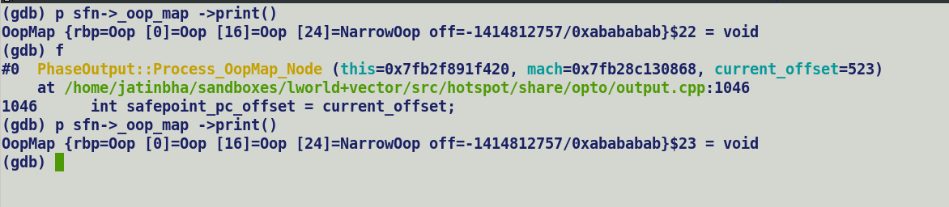

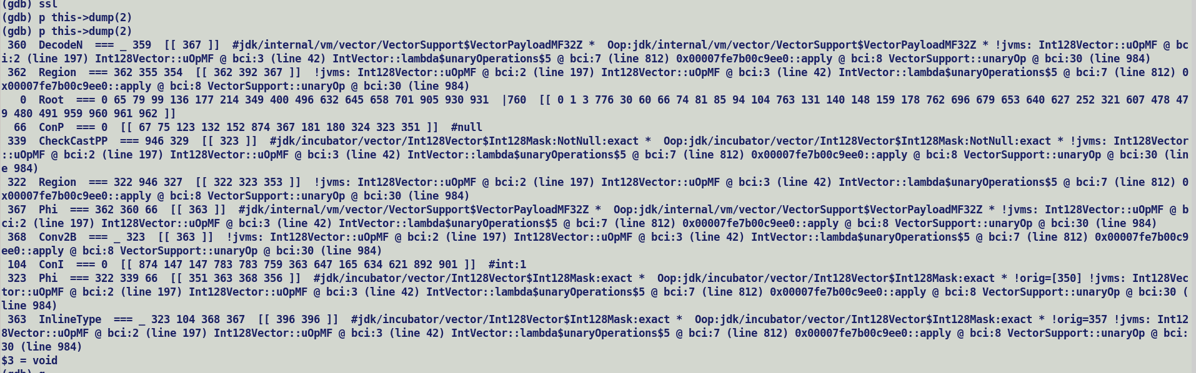



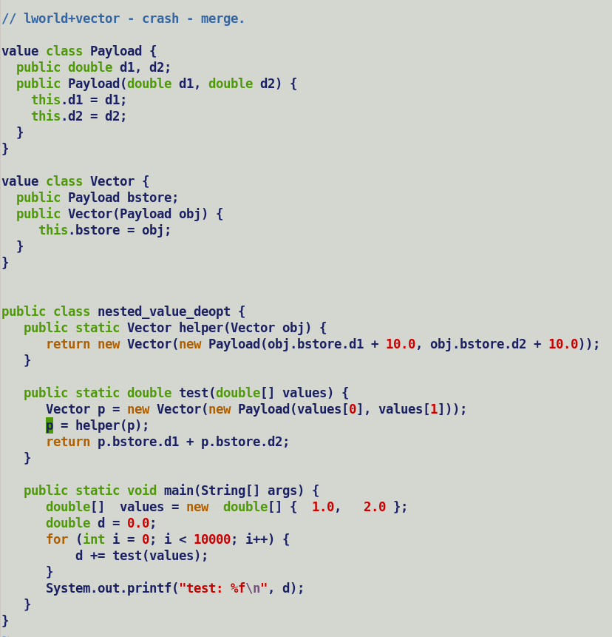

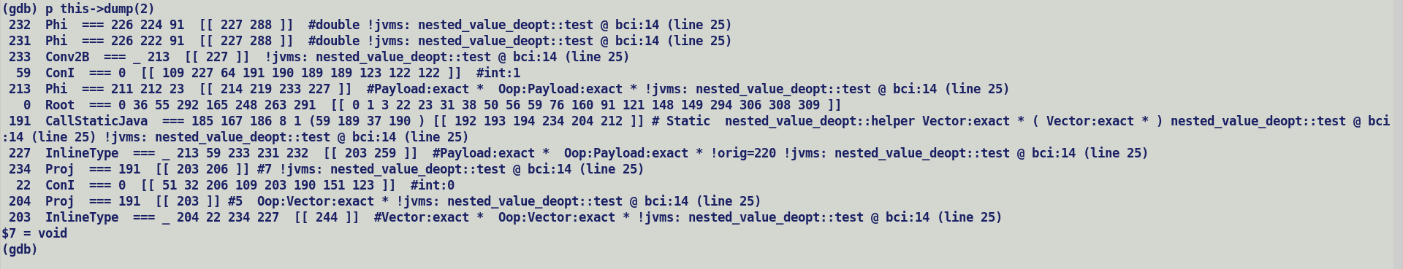

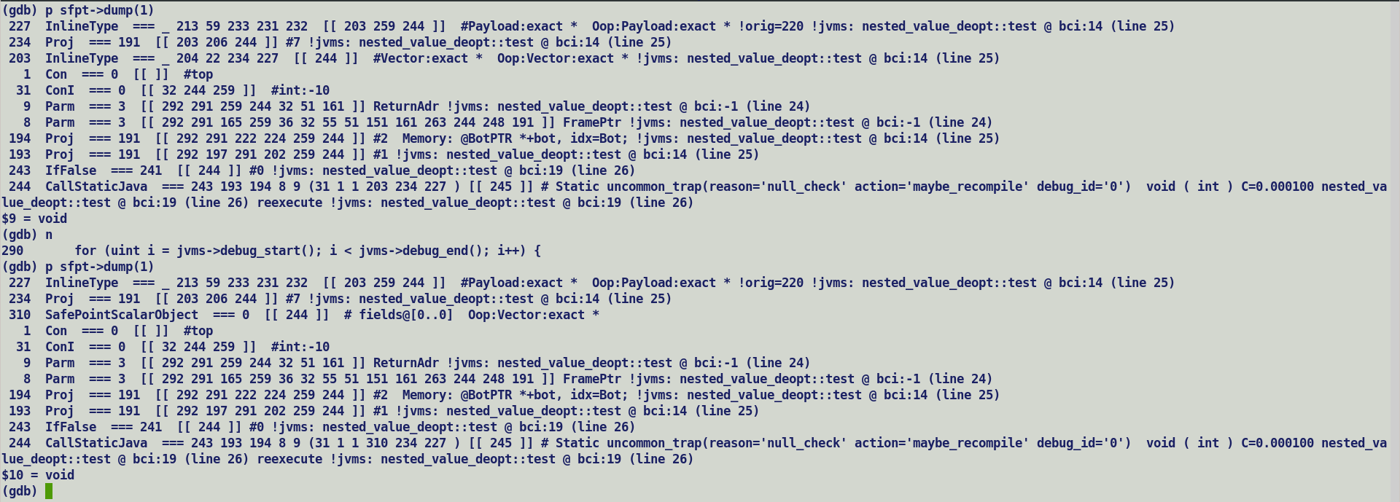

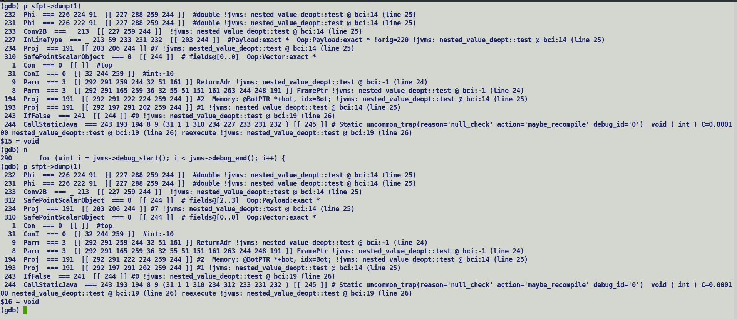

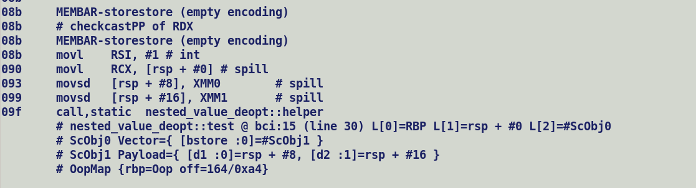

Value class instance and primitive classes instances

* Both are immutable objects and compiler is free to eliminate its allocation over heap and scalarize the objects so that individual field values can be directly passed to users.
* With value objects, compiler can freely take scalarization and allocation elimination decisions without escape analysis.
* Value range of value class object = Value Range of Primitive class object + null
* ciType for both these objects have T_PRIMITIVIE_OBJECT base.
* C2 compiler creates InlineTypeNode IR for both of them.
* Buffering of InlineTypeNode is performed only if it has a non-flattened user i.e. assignment to a non-flattened field or passing a value across method which does not accept solarized fields, or returning a value object from C2 compiled method to C1 / interpreter.
* Value object field is non-flattenable due to strict atomicity constraint imposed by Valhalla specifications on field value updates, i.e. entire flattened object should be updated in an atomic manner with one write operation, x86 and other CPUs do not support atomic writes greater than 64 bits. GLC cores added a new MOVDIR64B instruction to perform 64byte direct atomic stores but it follows WC semantics which requires issuing a M/SFENCE to enforce memory ordering constraint.
* Following code describes the C2’s InlineTypeNode IR construction during value / primitive type field access, these fields could be part of identity or value classes.

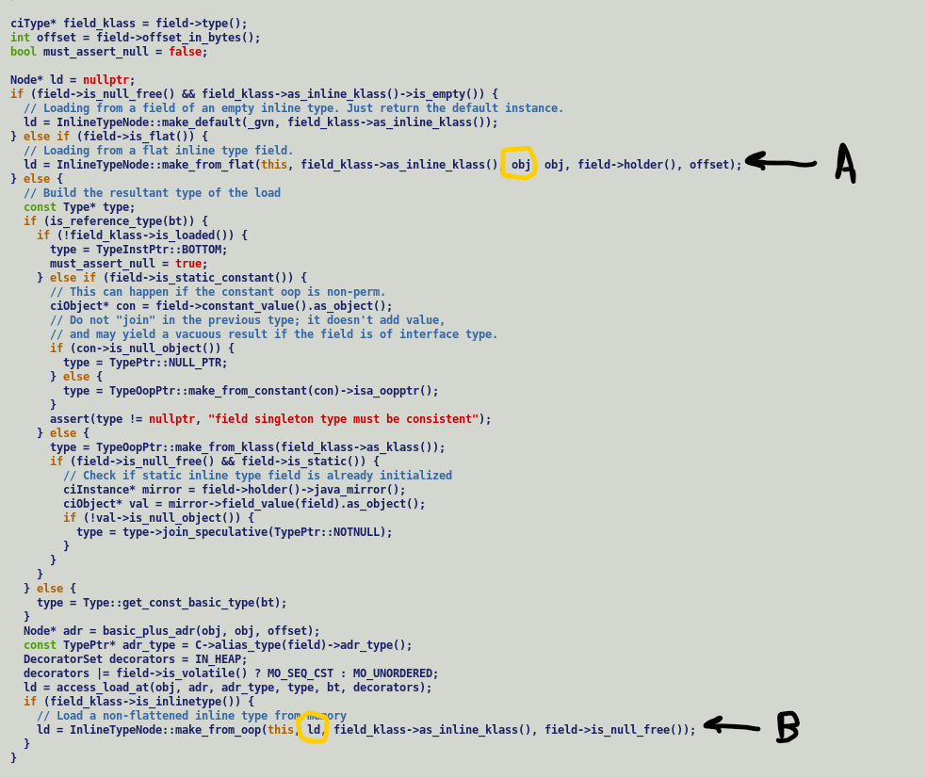

Field address computation of flattened field is done w.r.t to object as the base(A), thus it allows value forwarding from recent stores to those fields, on the other hand field address computation for a non-flattened field is done with respect to loaded oop (B), thus compiler re-constructs / loads individual fields from oop and ties them to InlineTypeNode IR, this is done to enable scalarization so that each field value can be directly passed on to its users.

Scalarization and flattening are orthogonal concepts, therefore value class fields are non-flattenable but still scalarizable. Since a value filed may hold a null value hence as per following excerpt [from JEP 401](https://openjdk.org/jeps/401#:~:text=.%20And%20these%20variables,at%20run%20time.) scalarized fields must carry additional flags to indicate a null value.

. And these variables actually store references which may be null, so the scalarized encoding needs an extra flag, say, to track the nullness of the reference. We'll use a { ... } notation below to represent these sets of fields and null flags, with the understanding that the set is only notational—there is no wrapper at run time.

As of now C2 is agnostic to this fact and freely scalarizes value object field into primitive field whose value ranges cannot take into account null values.

Aconst_init generated initial value is [guaranteed to be a non-null value](https://openjdk.org/projects/valhalla/design-notes/state-of-valhalla/03-vm-model#:~:text=aconst_init%20is%20the%20analogue%20of%20new%20for%20value%20objects%3B%20it%20leaves%20a%20reference%20to%20the%20initial%20value%20for%20a%20value%20class%20on%20the%20stack.%20This%20initial%20value%20is%20guaranteed%20to%20not%20be%20equal%20to%20null.)

Allocation Merging:-

InlineTypeNode -> To Buffer -> AllocateNode ->

F1 F2 F3 F4

| | | |

V V V V

InlineTypeNode

|

V

AllocateNode F1

| | |

| F2 V V

| | Store

V V

Store

Concrete Vector Layout:-

Int128Vector

|__> VectorPayloadI128MF (Non-flat)

C2 IR:-

Parsing:-



Process_Inline_Type –

1) Creates a ScalarSafePointObjectNode for InlineTypeNode(ITN) corresponding to concrete vector at safepoint.

2) Later during ITN removal stage, ITN corresponding to VectorPayalod is replaced by its buffered oop.



PhaseOutput:-

1. Process SafePointScalarObjectNode to create ScopeVariables for oop and fields which are eventually dumped into debug streams.

Runtime:-

1. Deoptimization reads both ScopeVariables and RegMap holding stack address of locations holding field values to re-initialize a re-materialized instance oops
2. Reference are passed using narrowOopLocations.

Value Classes reference can hold a null value and do not point to a default value.

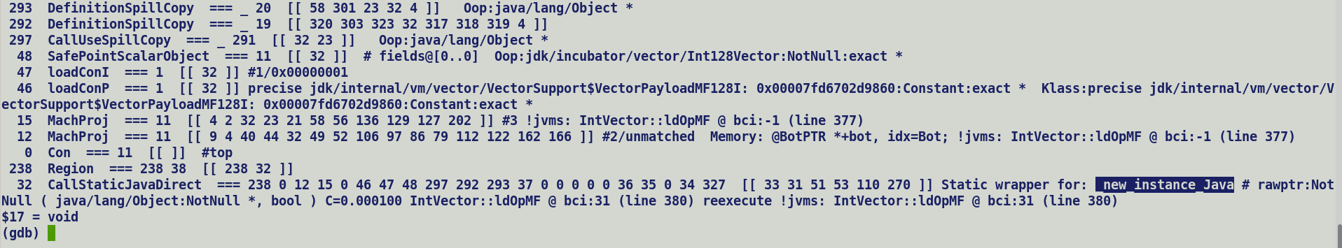

Quick notes on life cycles of multifield backed concrete Vector objects: -

1. ClassFileParser creates a separate FieldInfo for each base/synthetic multifields. Parser populates list of FieldInfo. This is used to compute object layout header.
2. ci Model :- Creates a ciField for each FieldInfo, for flat fields ciField / ciMultifields are part of container field list.
3. C2 IR always creates a Hierarchy of InlineTypeNodes which is agnostic to field flattening. Only difference b/w flat and non-flatted field lie in the address computation of field value loads from oop.
4. ScalarFieldObjectNode captures the state of object allocations eliminated by compiler through escape analysis OR if they are value objects live across a safe point (Call/SafePoint). For flat field compiler recursively stitches the leaf level flat field values to safe points.
5. PhaseOutput:- Emits scope variables for each ScalarFieldObjectNode and its initializing field values and pushes them to debug stream.
6. On de-optimization, runtime allocates a new instance for each ObjectVariable and initializes its fields using RegisterMaps and scope variables corresponding to field values.

Vec (Int128Vector) -> contains a null payload.

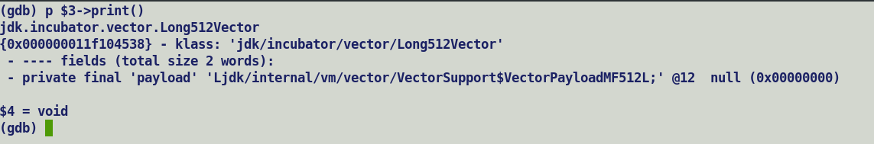

Source :-

A: IntVector vec = IntVector.fromArray(SPECIES, arr, 0);

B: vec = leaf (vec);

C: vec.lanewise(VectorOperators.ADD, 10);

Steps Breakdown for A&B :-

vptmp = new VectorPayloadI256MF(); -> make_uninitialized : InlineTypeNode

vptmp = Unsafe.makePrivateBuffer(vptmp); -> buffer it and return the oop to caller.

initializaiton_loop (arr) { -> update the memory state with new array contents.

Unsafe.put(vptmp….); -> do not re-materialize InlineTypeNode.

}

vptmp = Unsafe.finishPrivateBuffer(vptmp); -> Re-mat InlineTypeNode from modified memory state.

cvtmp = new Int256Vector (vptmp); -> Buffer VectorPayload InlineTypeNode, tie it to non-flat ’ payload’ field of concrete vector. Exact InlineTypeNode replacement will oop is deferred till process_inline_type in downstream flow.

* aconst_init
* withfield

cvtmp = call leaf (cvtmp); -> cvtmp is an L descriptor object, hence VectorBoxes are non-eliminatable and needs to be replaced by it buffer during box expansion.

….

Problem seen in existing support where both vector and payloads are value class instances: -

* In a small problem reproducer, concrete vector buffer passed to leaf method always contains a null payload.
* In Vector API JTREG tests a similar problem surfaced, where payload received by interpreter post de-optimization is null leading to SIGSEGV when operated upon by unsafe access API.

Q. When do we buffer?

A. Only in case of a non-scalarized usage of an InlineTypeNode, i.e. assignment to a non-flattened field, passing a value objects across method boundaries which does not accept scalarized arguments, or while returning a vector box.

In general, assignment to non-flat field should always be buffered. Buffering and scalarization are orthogonal concepts. Thus, non-flattened field can still be scalarized and directly passed to it users. In that case buffer allocation becomes redundant and should be eliminated, in other words if initializing field values are forwarded to its users then allocation becomes redundant.

Compiler still need to create a SafePointScalarObjectNode for eliminated allocation, this is needed for ObjectValue construction and subsequent use for object reconstruction during de-optimization.

For Vector we create a VectorBoxNode which is explicitly buffered / expanded only if there is direct usage of box.

Technically, we can replace VectorBox with direct InlineTypeNode and leave the buffering logic to infrastructure.

Vector boxing creates InlineTypeNode for both concrete vector and payload, so either we can defer the payload buffering to box expansion stage, OR we can create a buffered payload by construction. By taking former approach we do not need to worry about buffer elimination if allocations turn out to be redundant.

C2 (Scalarize value object and pass fields as scalars) -> C2I Adapter -> Interpreter

(Allocates value object and initializes it with scalarized field values held in registers).

C1 and Interpreter always pack the fields in buffer if InlineTypePassFieldsAsArguments is true using MacroAssembler::store_inline_type_fields_to_buf

TOCHECK

C2 calls C1 compiled callee should pack flat fields.

1. Larval Support in de-optimization, add additional bits in ScopeVariable.
2. Prevent larval state during scalarization – disable scalarization of larval state value objects.

Domain_cc -> calling convention domain is computed based on function’s extended signature i.e. fully flattened signature is InlineTypePassFieldsAsArgs is true(default).

While domain_sig is based on non-flattened view of value objects.

Disabling scalarization of value object in larval state will make argument in-compatible with calling convention signature.

Signature computation is done upfront by CompiledEntrySignature while generating method adapters.

A method may be passed multiple value objects of which one may be in larval state, as of now domain_cc computation fully flattens all the value argument, while domain_sig always assumes all value arguments to be passed as references.

Problem is very specific to lword since vector are never scalarized when passed across method and thus domain signatures are always composed of value object reference descriptors..

Disable method compilation when a larval transitioned value object is passed to a caller which expects scalarized arguments. For inlined method we directly propagate buffer values to downstream graph.

Intermediate SafePoints will miss capturing the state of InlineTypeNodes since b/w make and finish private buffer node scalarization is suppressed. But, given that intermediate graph always operate on buffer / oop hence it’s safe to skip bookkeeping over safe-points since we do not need any re-materialization b/w make and finish private buffer for a value object in larval state..

TODO:

* Merge lworld to lworld+vector
* Make VectorPayloads as null restricted implicitly constructable ententies.
* Validation
  + Functional
  + Performance.
* Check Performance dips in Vector API opensource use cases with Lworld+vector / JDK21/ JDK-22.
  + Jlama
  + JVector
  + Parqurt-mr
  + JavaFastPFOR
  + SIMDjson
  + Llama2.java
  + Elastic Search

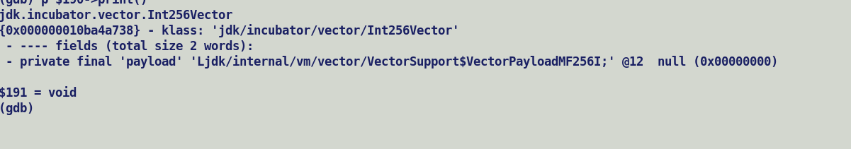

Calling convention :-

1. Value objects are scalarized, init filed is the first argument along with scalarized fields, since value objects are nullable, hence callee’s entry point make a nullness check and fall over to uncommon trap if it receives a null argument, else it loads the fields from oop and assign it to register as per target calling convention.
2. Primitive (null-restricted) value objects are guaranteed to be initialized and compiler can save on additional nullness (init) check in callees entry point.

Larval state can also be passed on the lines of init field, but given that a larval transitioned value object is non-scalarized, i.e. already exist as oop hence larval information implicitly captured in the oop and seamlessly passed to interpreter during deoptimization.

Check CompiledEntrySignature::compute_calling_convention, method->has_scalarized_arg(arg_num) only returns true for a Q descriptor value object (null-restricted), but currently extended signature computation treats both L and Q descriptor value object alike by assuming they are always initialized and delegates the nullness / initialization check to callee’s entry point.

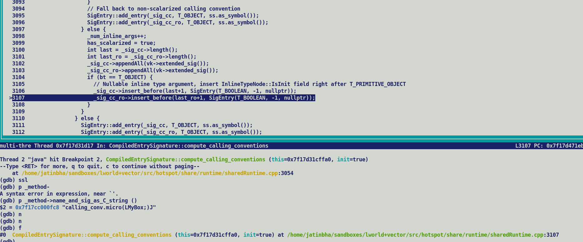

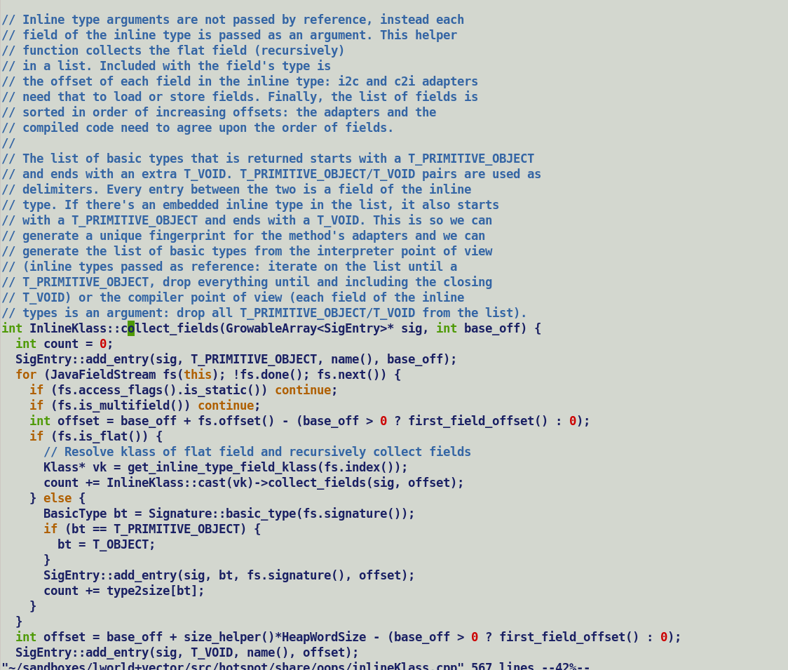

value class MyBox {

long f1;

long f2;

long f3;

long f4;

};

Total extended signatures = T_PRIMITIVE_OBJECT <FIELDS > T_VOID

<FIELDS> = T_LONG, T_LONG, T_LONG, T_LONG

One signature T_BOOL for init, total signature length 1 + 4 * 2 = 9.

C2 Flow Revisited:

Caller () {

LMyBox; Callee(LMyBox;) // a/ Argument pass fields are scalars, InlineTypeNode::pass_fields(in= true)

b/ Tie call projections to rematerialized InlineTypeNode.

Return LMBox; // InlineTypeNode::pass_fields (in = false), either buffer the value object or pass

// each field as a separate return scalarized value.

}

Field signatures adhere to target calling conventions.

Note: Look argument and return processing in DirectCallGenerator::geneate().

**Revisiting discussion on Mixed calling conventions for vector parameter.**

> -----Original Message-----

> From: Bhateja, Jatin <[jatin.bhateja@intel.com](mailto:jatin.bhateja@intel.com)>

> Sent: Friday, October 6, 2023 12:27 PM

> To: Vladimir Ivanov <[vladimir.x.ivanov@oracle.com](mailto:vladimir.x.ivanov@oracle.com)>

> Cc: Viswanathan, Sandhya <[sandhya.viswanathan@intel.com](mailto:sandhya.viswanathan@intel.com)>; Bhateja, Jatin

> <[jatin.bhateja@intel.com](mailto:jatin.bhateja@intel.com)>

> Subject: RE: Vector API Sync meeting

>

> Thanks Vladimir,

>

> Here are notes from yesterday's discussion on calling convention extensions.

>

> Best Regards,

> Jatin

>

> Valhalla – Mixed calling convention extension for vectors.

> Method specialization based on vector sizes (stretch)

> Argument type profiles (calling context specific).

> Parameter creation in callee method context (GraphKit::build_start_state) is

> purely based on method signatures.

> Vector API exposes abstract vector type to users, vector arguments

> signatures will always have Ldescriptor;

>

> Nomenclature: -

>

> Parameter: - Which a callee method receives and operates over. Also called as

> formal parameters.

> Arguments: - Actual values passed to call instance in caller context.

>

> Example class hierarchy for illustration: -

> Abstract Class: -

> - Concrete Value Class1 – Field count n

> - Concrete Value Class2 – Field count m

> Method call descriptor:

> ReturnType Method (AbstractClass arg1, AbstractClass arg2)

>

> Method signature is composed of Ldesctiptor; abstract class type parameter.

> Thus, method will not be decorated with has_scalar_argument flags which is

> set while creating method specific AdapterHandles only for value and primitive class instances are scalarized.

Calling convention freezes while generating methods Adapters, this happens during link time. An abstract value class arguments will always be passed as a reference, there is no scope to scalarize it later based on speculative types, look for detailed explanations below.

> However, parameter type profiling can associate concrete value types with

> parameter, and this will result into creation of additional CheckCastPP node

> which type cast the abstract typed argument into concrete value type node.

~~> It~~

~~> should also ensure creation of a new InlineTypeNode which rematerializes the~~

~~> fields from casted parameter.~~ ~~Casted Parameter will get tied to oop field of new~~

~~> InlineTypeNode.~~

Value object to reference conversions for a call argument, should not be impacted by speculative type, given that a speculative may be a concrete value class will necessitate passing value objects in scalarized form, but the calling conventions for the methods are bound at link time will not comply with scalarized representation of a speculative value parameter. So, creating an InlineTypeNode is of no use here, eventually in downstream flow at process_inline_types stage, these rematerialized objects will get replaced by their oop value.

This is the reasons why CheckCastPP inserted for type speculation does not rematerializes into an InlineTypeNode IR.

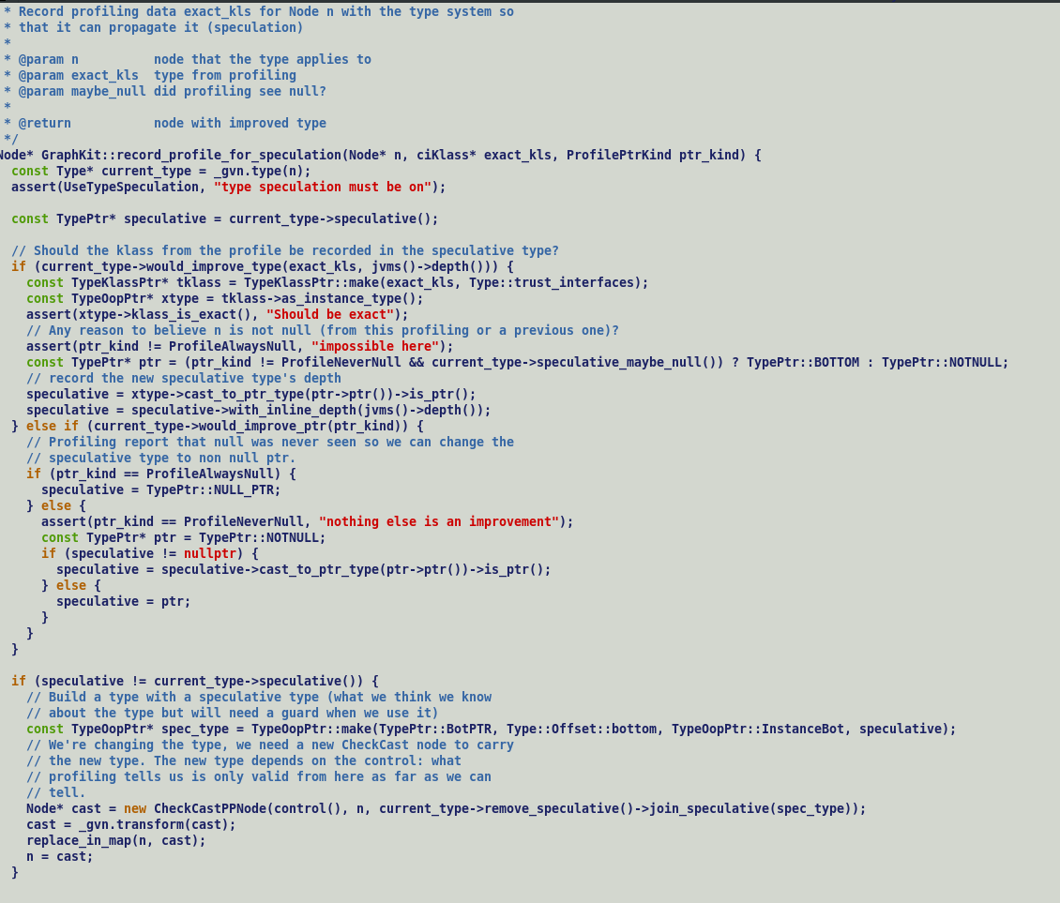



> GraphKit::record_profiled_parameter_for_speculation records the types of

> parameters for method specialization.

> Value argument will always undergo value to reference conversion i.e.,

> buffering if method is not in-lined~~, this is purely driven by parameter signatures~~

~~> which in this case are L descriptor references.~~

Both L and Q descriptor value object are scalarized when passed as call arguments.

For L descriptor value objects i.e. nullable value objects additional init argument is passed

which is used to make a null value check in callee’s inline entry point.

> Argument speculative type profiles are relevant in calling context i.e., mainly.

> for inline expanders which needs to meet closed world assumptions.

> We do record parameter types in ParametersTypeData but Valhalla unpack

> entry point currently do not handle those cases, as discussed we can defer mixed

> calling convention changes for the time being.

This is because of above reason, since method calling conventions is based on signatures are fixed during adaptor creation hence, a lazy scalarization based on speculative type will not be comply with calling convention contract.

>

> Reproducer shows inlined code generation of Paren::genHash() varies in

> specialized_calling::micro argument type profiles, C2 does perform bi-morphic

> inlining with multiple speculative types.

>

> abstract class Parent {

> public abstract int genHash();

> }

>

> value class Child1 extends Parent {

> int field1;

> int field2;

> public Child1 (int f1, int f2) {

> this.field1 = f1;

> this.field2 = f2;

> }

> public int genHash() { return field1 >> field2; } }

>

> value class Child2 extends Parent {

> int field1;

> int field2;

> int field3;

> int field4;

> public Child2 (int f1, int f2, int f3, int f4) {

> this.field1 = f1;

> this.field2 = f2;

> this.field3 = f3;

> this.field4 = f4;

> }

> public int genHash() { return (field1 + field2 >> field3) * field4; } }

>

> public class specialized_calling {

> public int micro(Parent obj) {

> return obj.genHash();

> }

> public static void main(String [] args) {

> int nesting_topology = Integer.parseInt(args[0]);

> specialized_calling obj = new specialized_calling();

> int res = 0;

> if (nesting_topology == 0) {

> for (int i = 0; i < 100000; i++) {

> if ((i & 1) == 0) {

> res += obj.micro(new Child1(i, i + 10));

> } else {

> res += obj.micro(new Child2(i, i + 10, i + 20, i + 30));

> }

> }

> } else if (nesting_topology == 1) {

> for (int i = 0; i < 100000; i++) {

> res += obj.micro(new Child1(i, i + 10));

> }

> } else {

> for (int i = 0; i < 100000; i++) {

> res += obj.micro(new Child2(i, i + 10, i + 20, i + 30));

> }

> }

> System.out.println("[res] " + res);

> }

> }

>

> Following is the type profiling information when nesting_topology = 0

>

> @ 1 Child2::genHash (20 bytes) inline (hot)

> @ 1 Child1::genHash (10 bytes) inline (hot)

> \-> TypeProfile (2581/5163 counts) = Child1

> \-> TypeProfile (2582/5163 counts) = Child2

> @ 31 Child1::<vnew> (20 bytes) inline (hot)

> @ 34 specialized_calling::micro (5 bytes) disallowed by

> CompileCommand

> @ 57 Child2::<vnew> (44 bytes) inline (hot)

> @ 60 specialized_calling::micro (5 bytes) disallowed by

> CompileCommand

>

>

>

>

>

> # {method} {0x00007fe54f400458} 'micro' '(LParent;)I' in 'specialized_calling'

> ;; N64: # out( B1 ) <- BLOCK HEAD IS JUNK Freq: 1

> 0x00007fe5ecdcf360: mov 0x8(%rsi),%r10d

> 0x00007fe5ecdcf364: movabs $0x7fe553000000,%r11

> 0x00007fe5ecdcf36e: add %r11,%r10

> 0x00007fe5ecdcf371: cmp %r10,%rax

> 0x00007fe5ecdcf374: jne 0x00007fe5ecdabaa0 ; {runtime_call

> ic_miss_stub}

> 0x00007fe5ecdcf37a: nop

> 0x00007fe5ecdcf37b: nop

> 0x00007fe5ecdcf37c: nop

> 0x00007fe5ecdcf37d: nop

> 0x00007fe5ecdcf37e: nop

> 0x00007fe5ecdcf37f: nop

> [Verified Entry Point]

> [Verified Inline Entry Point]

> [Verified Inline Entry Point (RO)]

> # this: rsi:rsi = 'specialized_calling'

> # parm0: rdx:rdx = 'Parent'

> # [sp+0x20] (sp of caller)

> ;; B1: # out( B8 B2 ) <- BLOCK HEAD IS JUNK Freq: 1

> 0x00007fe5ecdcf380: mov %eax,-0x18000(%rsp)

> 0x00007fe5ecdcf387: push %rbp

> 0x00007fe5ecdcf388: sub $0x10,%rsp

> 0x00007fe5ecdcf38c: cmpl $0x1,0x20(%r15)

> 0x00007fe5ecdcf394: jne 0x00007fe5ecdcf44e ;*synchronization entry

> ; - specialized_calling::micro@-1 (line 32)

> 0x00007fe5ecdcf39a: mov 0x8(%rdx),%r11d ; implicit exception:

> dispatches to 0x00007fe5ecdcf410

> ;; B2: # out( B5 B3 ) <- in( B1 ) Freq: 0.999999

> 0x00007fe5ecdcf39e: nop

> 0x00007fe5ecdcf39f: nop

> 0x00007fe5ecdcf3a0: cmp $0x1001488,%r11d ; {metadata('Child2')}

> 0x00007fe5ecdcf3a7: je 0x00007fe5ecdcf3be

> ;; B3: # out( B7 B4 ) <- in( B2 ) Freq: 0.499999

> 0x00007fe5ecdcf3a9: cmp $0x1001000,%r11d ; {metadata('Child1')}

> 0x00007fe5ecdcf3b0: jne 0x00007fe5ecdcf3e6 ;*invokevirtual genHash

> {reexecute=0 rethrow=0 return_oop=0 return_scalarized=0}

> ; - specialized_calling::micro@1 (line 32)

> ;; B4: # out( B6 ) <- in( B3 ) Freq: 0.499999

> 0x00007fe5ecdcf3b2: mov 0x10(%rdx),%r10d

> 0x00007fe5ecdcf3b6: sarx %r10d,0xc(%rdx),%eax ;*ishr {reexecute=0

> rethrow=0 return_oop=0 return_scalarized=0}

> ; - Child1::genHash@8 (line 13)

> ; - specialized_calling::micro@1 (line 32)

> 0x00007fe5ecdcf3bc: jmp 0x00007fe5ecdcf3d3 ;*invokevirtual genHash

> {reexecute=0 rethrow=0 return_oop=0 return_scalarized=0}

> ; - specialized_calling::micro@1 (line 32)

> ;; B5: # out( B6 ) <- in( B2 ) Freq: 0.499999

> 0x00007fe5ecdcf3be: mov 0x10(%rdx),%r11d

> 0x00007fe5ecdcf3c2: add 0xc(%rdx),%r11d

> 0x00007fe5ecdcf3c6: mov 0x14(%rdx),%r8d

> 0x00007fe5ecdcf3ca: sarx %r8d,%r11d,%eax

> 0x00007fe5ecdcf3cf: imul 0x18(%rdx),%eax

> ;; B6: # out( N64 ) <- in( B5 B4 ) Freq: 0.999998

> 0x00007fe5ecdcf3d3: add $0x10,%rsp

> 0x00007fe5ecdcf3d7: pop %rbp

> 0x00007fe5ecdcf3d8: cmp 0x498(%r15),%rsp ; {poll_return}

> 0x00007fe5ecdcf3df: ja 0x00007fe5ecdcf438

> 0x00007fe5ecdcf3e5: retq

ciTypeFlow guides c2 parser which propagates JVM state across the blocks. During parsing replacements are driven by bytecodes this is why parse time GVN does not expose explicit node replacements.

Source:

V = makePriviateBuffer(V);

Bytecode:

aload x

invokestatic makePrivateBuffer

astore x

Load and store happen for same local variable ‘x’. After make_private_buffer local variable will point to value object oop and will elevate any need to bookkeep object reconstruction information at intermediate safepoints till it encounters finish_private_buffer.

Post parse GVN (IncrGVN) receives the type and hash tables from parse time GVN and expose additional RAUW (replace all uses with) operations since bytecodes driven updates are only limited to parsing.

Caller -> Callee semantics for value type arguments.

C1 -> C2: C2 scalarizes the incoming value object while constructing JVM state (build_start_state). Static / virtual method resolution returns unpack entry points.

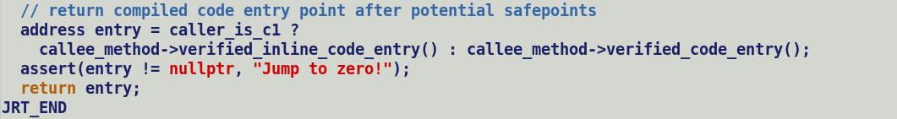

C2 - > C2: DirectCallGenerator::generate passes values objects as scalar fields, since a call node is a derivative of safepoint hence compiler book keeps SafepointScalarObjectNode to capture the value object type and field initialization values.

C2 -> c2i adapter (different entry points in adapter, ro , inline and regulate) -> Interpreter

Adapter allocates the buffer for value type arguments and populate the scalarized field from value held in registers.

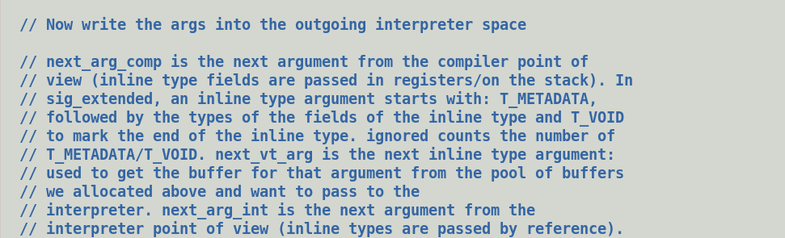

Ref: gen_c2i_adapter

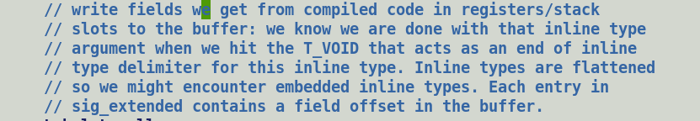

Interpreter -> i2c adapter -> Compiler is always passed buffered value objects and jumps to inline unpack entry points.

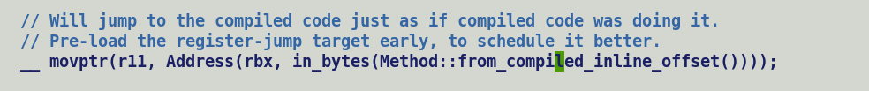

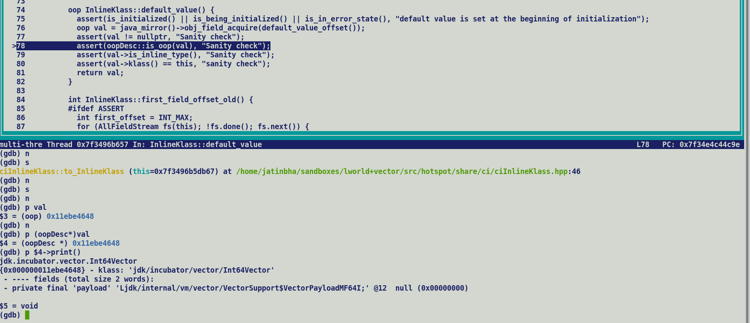

aconst_init is emitted factory constructor ( “vnew”) for both concrete and payload class. InlineTypeNode corresponding to it will be marked as null_free, in addition there scalarized IR nodes are marked as init and buffered since they point to default value oop. Thus, direct call of buffering API will return a default value but such a value cannot be transitioned into larval state. Passing a default oop to makePrivateBuffer should allocate a new instance and transition it to larval state.

Valhalla Integration Refresher (details in slides).

Oop Model Revisited:-

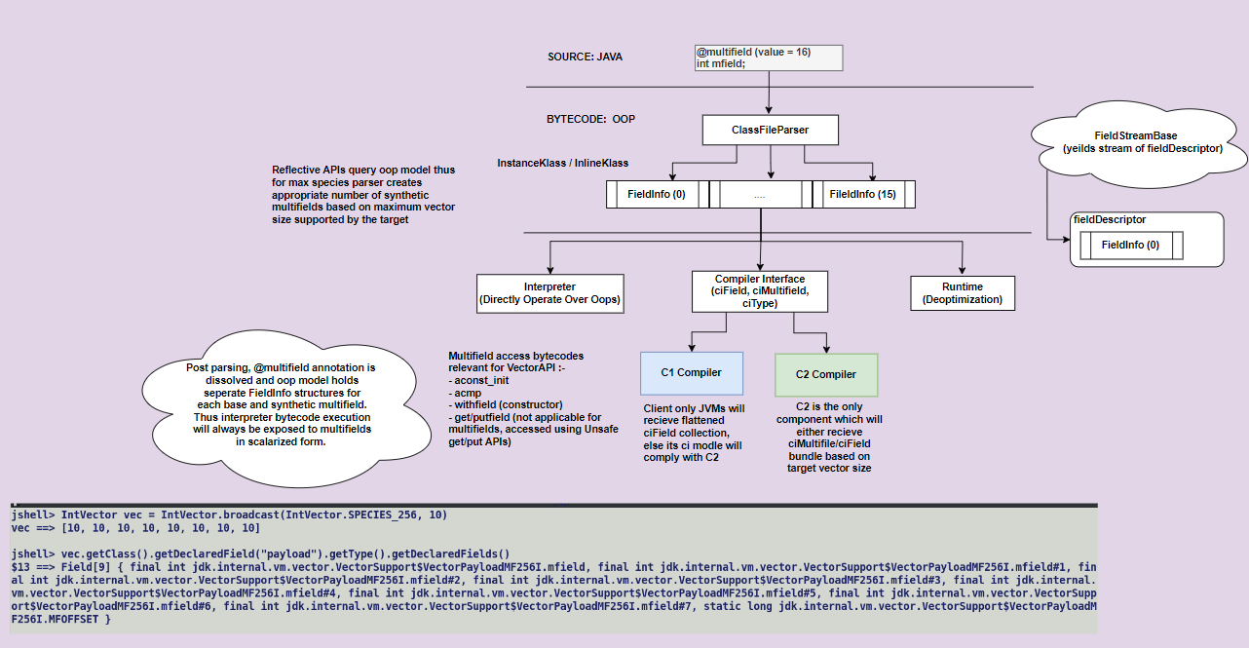

@multifield annotation processing

Create sperate FieldInfo for each base and synthetic multifield.

Layout computation (build_layout)

Ci Model Revisited :-

ciMultifield (hierarchical structure, queries VM for target vector size)

* Bundle_size
* Is_multifiled_base = true

field query APIs changes

VM Revisited:-

* VM symbols for new payload classes.
  + Dumps them in shared archive.
* CDS changes
  + Restore_unsharable_info
    - InlineKlassFixedBlock restoration.
    - Mirrors (value , primary)
* Concrete classes are no longer exposed to VM.

Runtime Revisited :-

* Deoptimization changes.
* Larval state propagation.

C1 Compiler Revisited:

* ciMuiltifield handling in withfield..

C2 Compiler Revisited:-

Vector.dummyVectorMF() generates a default inline type node:-

Default InlineTypeNode (Concrete Class), init = true, buffered = false

|_ > oop (Default.oop, where oop.payload = null)

|_> payload -> Default InlineTypeNode (VectorPayload) , init = false, buffered = true

|_ > oop (null)

|-> Replicate ZERO.

ldOpMF

* Allocated a new payload (PN)
* PN -> InlineTypeNode (VectorPayload), init = true, buffered = true

|_> oop (Payload.default, first multifield set to 0.)

|_> Replicate ZERO

* Transition to larval state, call makePrivateBuffer

|_> allocate new payload instance, set larval flag to ‘true’.

Unsafe.put

* Update the memory state of oop.

finishPrivateBuffer

* Rematerialize InlineTypeNode from modified oop.
  + - Call make_from_oop
    - InlineTypeNode (VectorPayload) , init = true, buffered = true

|_> oop = modified oop

|_> LoadVector modified_oop.

Make_from_oop

* + - * New InlineTypeNode (VeectorPayload), init = true, buffered = true
        + oop -> incoming ‘oop’ argument.
      * Load field value from field offset, in this case it will be loaded into vector if target supports the vector size.

Box the payload into concrete vector

* New ConcVectorPaylod -> vnew -> aconst_init + withfield
  + - * InlineTypeNode (ConcVector), init = true, buffered = true

|_> oop = (Default.oop, oop.payload = null).

|_> payload = Rematerialized InlineTypeNode. , payload is non-flat field, hence must be buffered

Since rematerialized node’s oop points to modified memory state oop hence no additional buffering needed.

This.vec() -> returns the payload value of a concrete box.

Return from VectorAPIs returns vector buffers.

* InlineTypeNode -> buffer -> allocates a new vector buffer -> InlineTypeNode::store to dump the values into buffer -> Re-creates a new InlineTypeNode and return it to the buffer caller.
* Buffering the field values of Vector
  + - * Dump the payload into buffer (GraphKit::access_store)
      * Store buffered InlineTypeNode at desired memory location, later on InlineTypeNode will be replaced by its oop field.



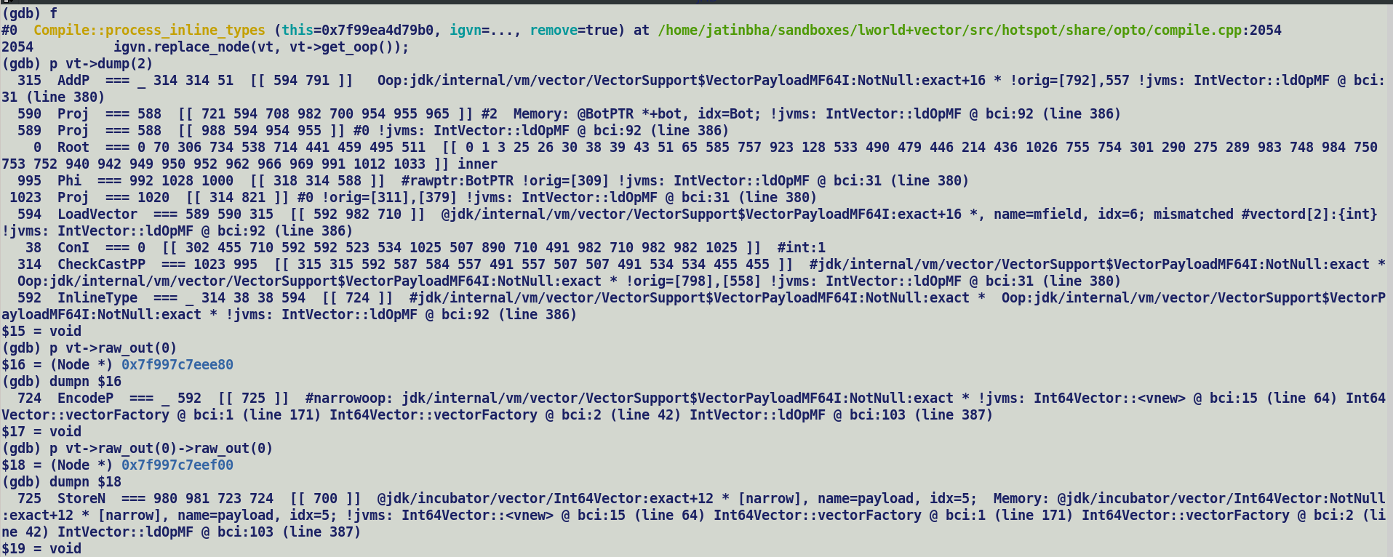

areturn processing will return buffered InlineTypeNode which will replace the scalarized node with its oop value during process_inline_types.

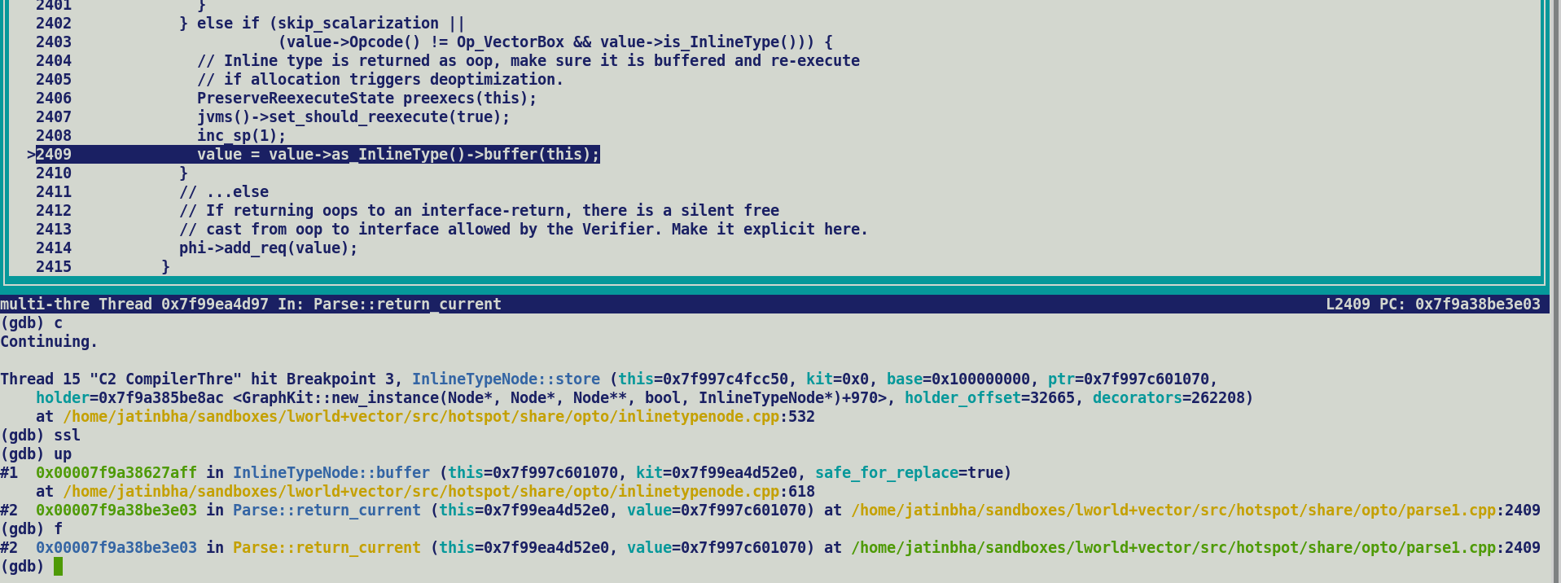

Boxing – Unboxing Cleanups:-

VectorBoxNode -> Un-buffered, Initialized InlineTypeNode

|_> oop -> null

|_> payload = InlineTypeNode (payload), un-buffered, initialized.

|_> oop -> null

|_> LoadVector

VectorUnboxNode ->

|_> Input -> VectorBoxNode / InlineTypeNode

Unboxing – Boxing Optimization Cleanups:-

|_> Fetch payload value from incoming InlineTypeNode, i.e. the field_value(0).

Box expansion:- Simply buffer the contents of vector since replacement of box by oop during process_inline_type node expects pre-buffered oop.

Box -> buffer();

Process_inline_types will automatically replace box by its oop.

To buffer we need the JVM state and control / memory edges, thus we need to create some light weight wrapper around InlineTypeNode node which captures the JVM state and VectorBoxAllocate node does exactly that, it’s a derivative of Call node. Valhalla stock makes buffering decisions during parsing where we have access to JVM state tied to each block, since vector APIs are expanded lazily during incremental inlining phase to allow constants to seep in, hence VectorBoxes are created at later stage. C2 reconstruction the JVM state from Calls before doing late inlining. Expansions are done during Optimization if boxes are not eliminated. At that point to create a buffer compiler needs to re-construction the JVM state and which is why VectorBoxAllocate nodes exist.

So we cannot get away with VBAs due to incremental inlining of Vector APIs and thus it’s not feasible to remove VectorBox nodes.

Non-inlined VectorSupport.unaryOp :- 5 – 12 edges of Start corresponds to argument passed to unaryOp.

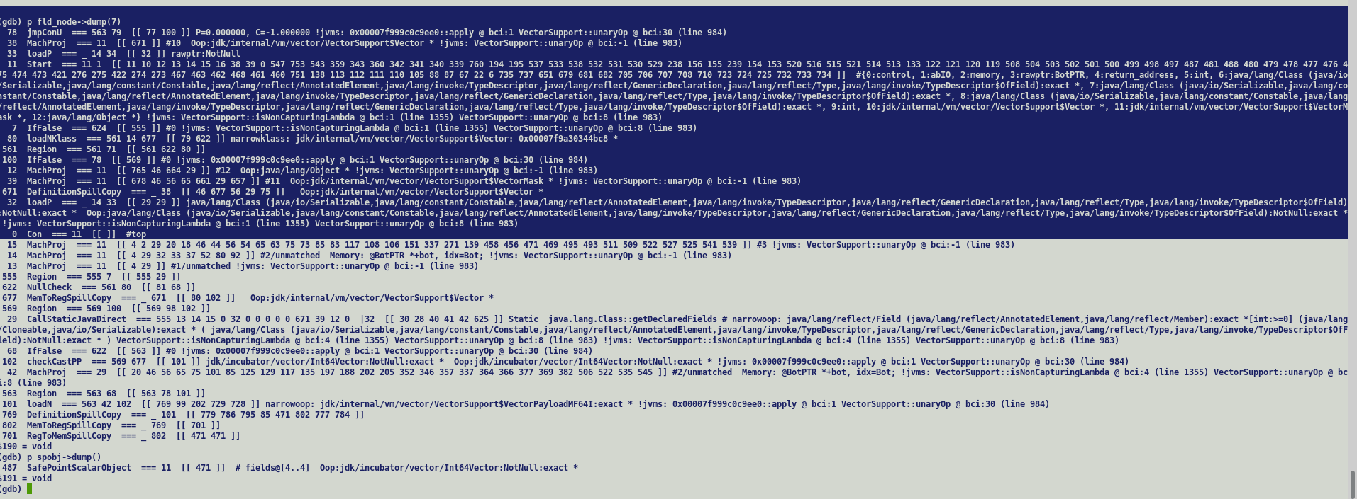

Graph dump at FillLocArray

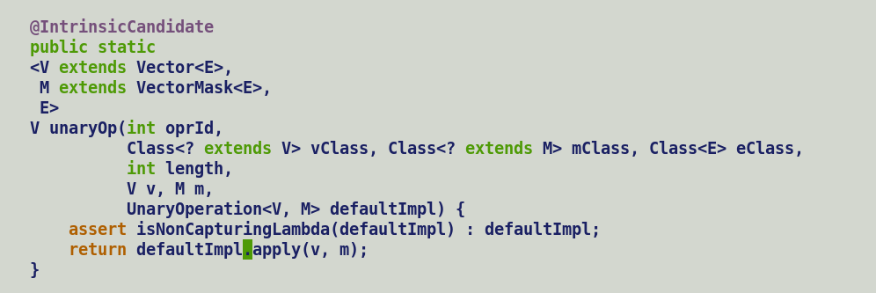

Safepoint at getDeclared fields in inNonCapturingLambda()..





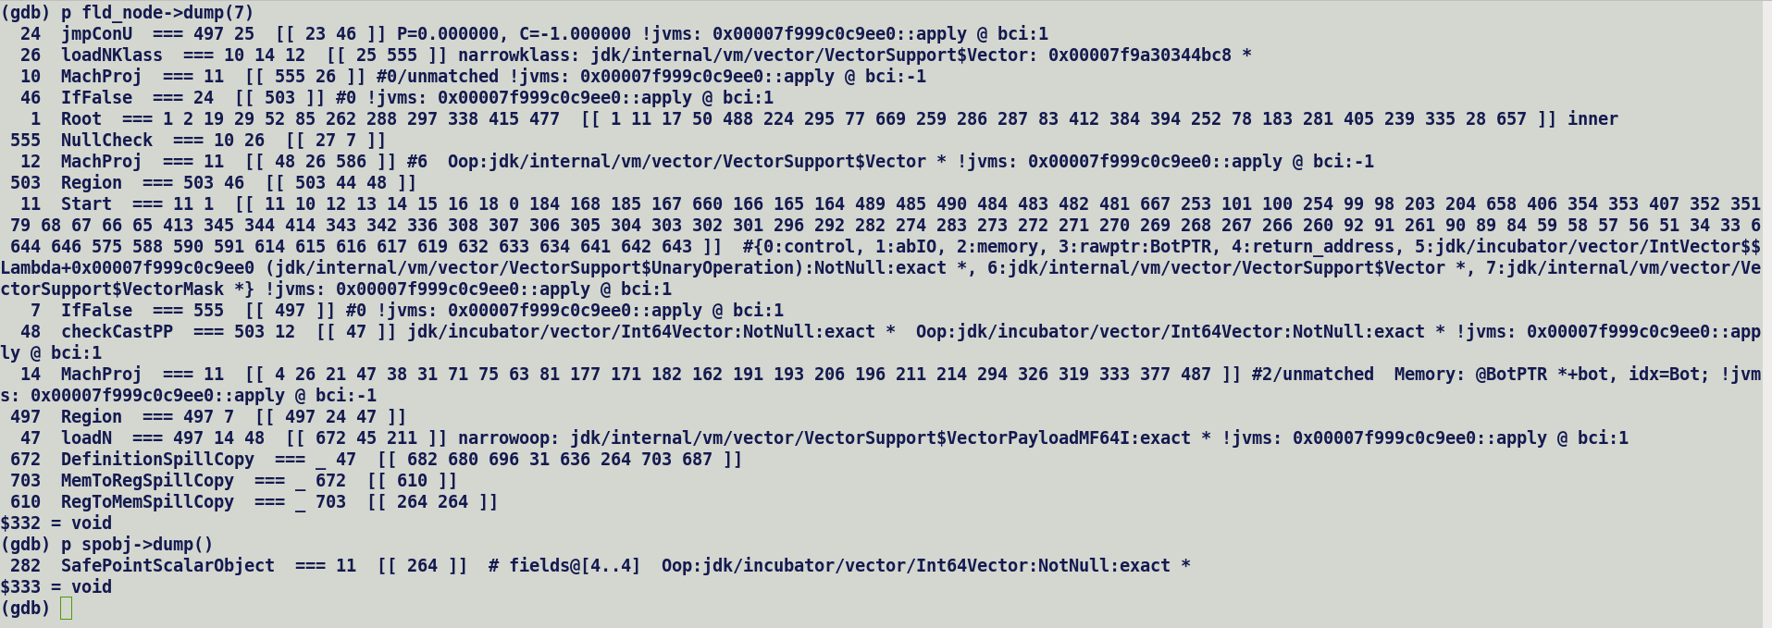

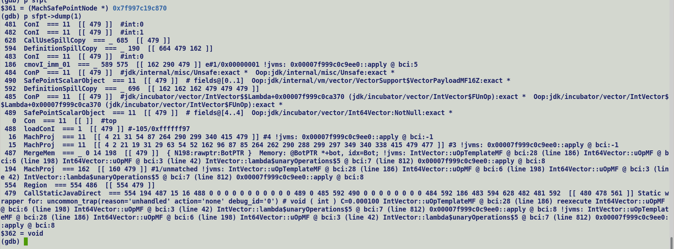

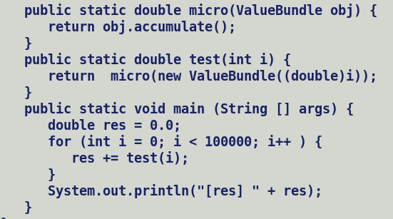



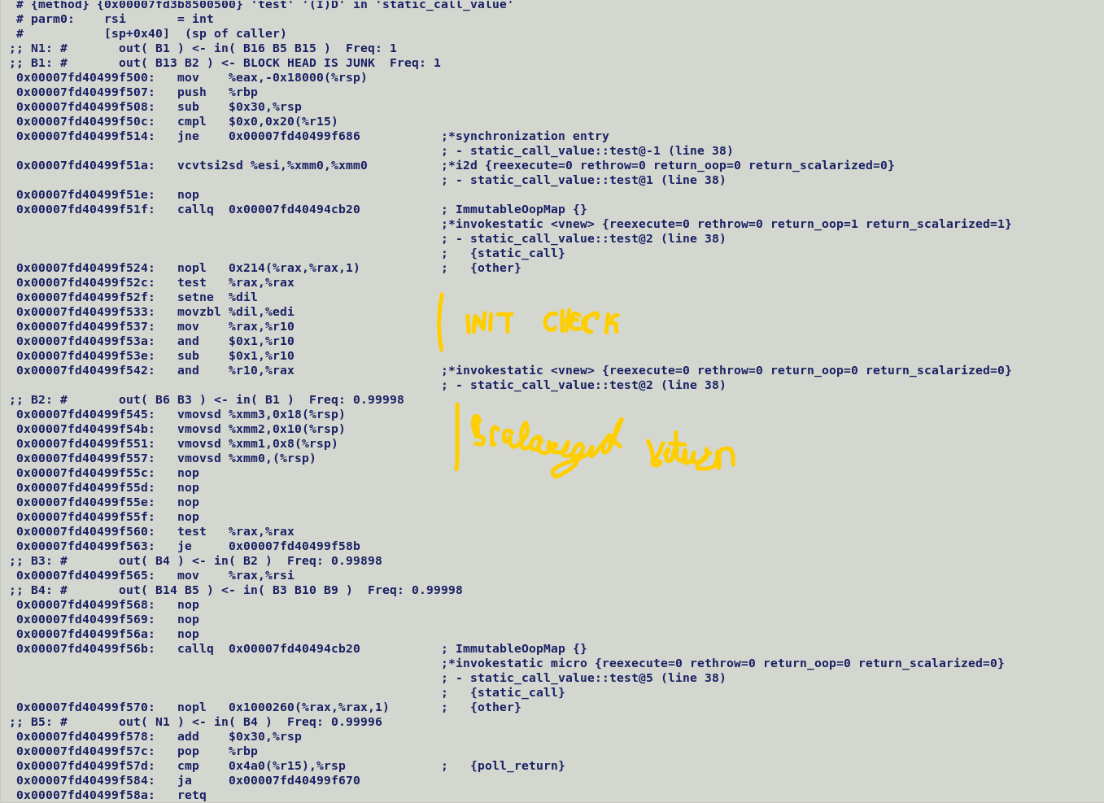



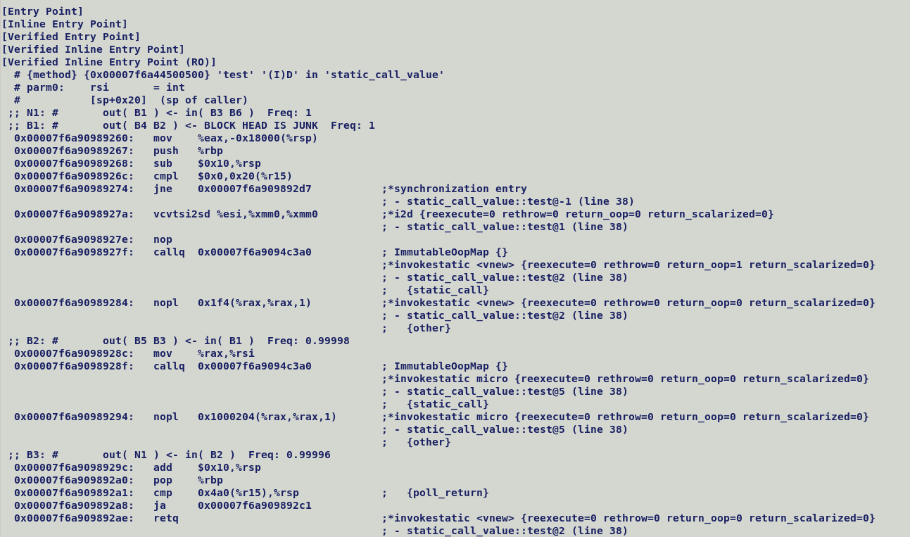

**Null-restricted value types support in lworld.**

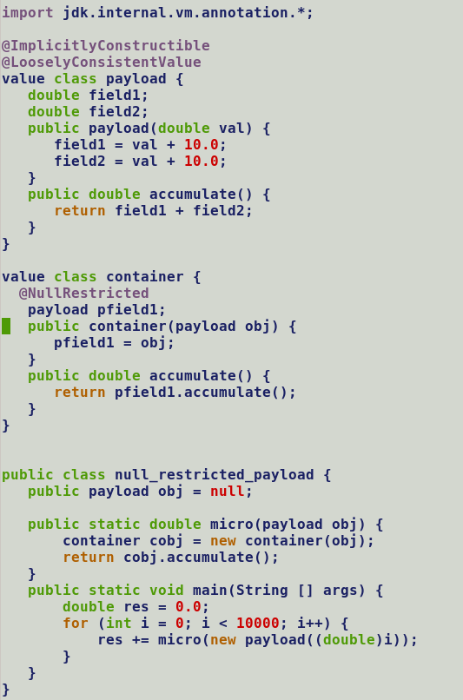



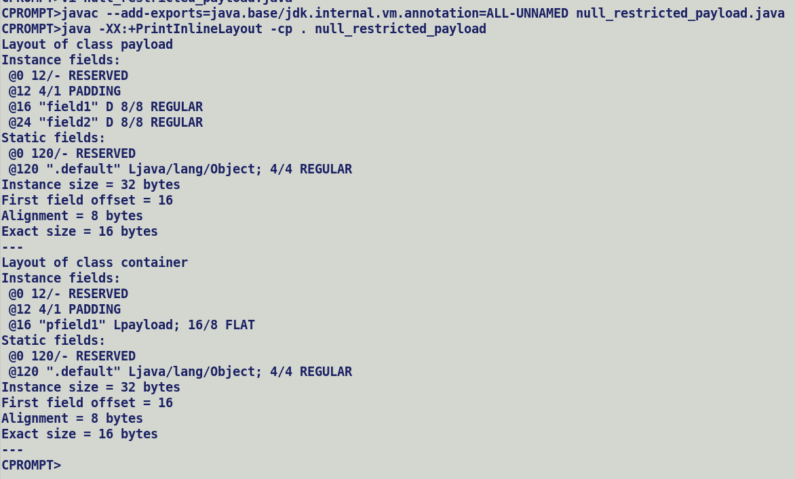



**For lworld+vector, make all payload classes implicitly constructible and loosely consistent and payload fields as null restricted.**



value class ValueBundle {

double field1;

double field2;

double field3;

double field4;

public ValueBundle(double val) {

field1 = val + 10.0;

field2 = val + 20.0;

field3 = val + 30.0;

field4 = val + 40.0;

}

public double accumulate() {

return field1 + field2 + field3 + field4;

}

}

public class static_call_value {

// inline_entry:

// if (obj1.mark.is_larval) {

// mov Reason_for_deopt(larval), %ebx

// call uncommon_trap_blob_addr();

// }

// if (obj2.mark.is_larval) {

// mov Reason_for_deopt(larval), %ebx

// call uncommon_trap_blob_addr();

// }

//

//public static double unsafe_micro(ValueBundle obj1, ValueBundle obj2) {

// .. Unsafe.put () // to test in larval.

// return Unsafe.get() + .....;

//}

public static double micro(ValueBundle obj) {

return obj.accumulate();

}

public static double test(int i) {

return micro(new ValueBundle((double)i));

}

public static void main (String [] args) {

double res = 0.0;

for (int i = 0; i < 100000; i++ ) {

res += test(i);

}

System.out.println("[res] " + res);

}

}

A) Pass non-scalarized fields.

java -Xbatch -XX:-TieredCompilation -XX:-PauseAtStartup -XX:CompileCommand=Print,static_call_value::test -XX:CompileCommand=DontInline,static_call_value::micro -XX:-InlineTypePassFieldsAsArgs -XX:+InlineTypeReturnedAsFields -XX:-UseOnStackReplacement -XX:-WizardMode -XX:+TraceCallFixup -XX:-PrintCompilation -XX:+TraceDeoptimization -cp . static_call_value

B) Pass scalarized fields

java -Xbatch -XX:-TieredCompilation -XX:-PauseAtStartup -XX:CompileCommand=Print,static_call_value::test -XX:CompileCommand=DontInline,static_call_value::micro -XX:+InlineTypePassFieldsAsArgs -XX:+InlineTypeReturnedAsFields -XX:-UseOnStackReplacement -XX:-WizardMode -XX:+TraceCallFixup -XX:-PrintCompilation -XX:+TraceDeoptimization -cp . static_call_value

C) Return non-scalarized fields.

java -Xbatch -XX:-TieredCompilation -XX:-PauseAtStartup -XX:CompileCommand=Print,static_call_value::test -XX:CompileCommand=DontInline,static_call_value::micro -XX:+InlineTypePassFieldsAsArgs -XX:-InlineTypeReturnedAsFields -XX:-UseOnStackReplacement -XX:-WizardMode -XX:+TraceCallFixup -XX:-PrintCompilation -XX:+TraceDeoptimization -cp . static_call_value

D) Return scalarized fields.

java -Xbatch -XX:-TieredCompilation -XX:-PauseAtStartup -XX:CompileCommand=Print,static_call_value::test -XX:CompileCommand=DontInline,static_call_value::micro -XX:+InlineTypePassFieldsAsArgs -XX:+InlineTypeReturnedAsFields -XX:-UseOnStackReplacement -XX:-WizardMode -XX:+TraceCallFixup -XX:-PrintCompilation -XX:+TraceDeoptimization -cp . static_call_value

E) Observation: Don’t Inline any call. Disable inlining of value factory constructor also. Its effect can be seen in increased stack size.

Response: This happens because InlineTypePassFieldsAsArgs was turned off.

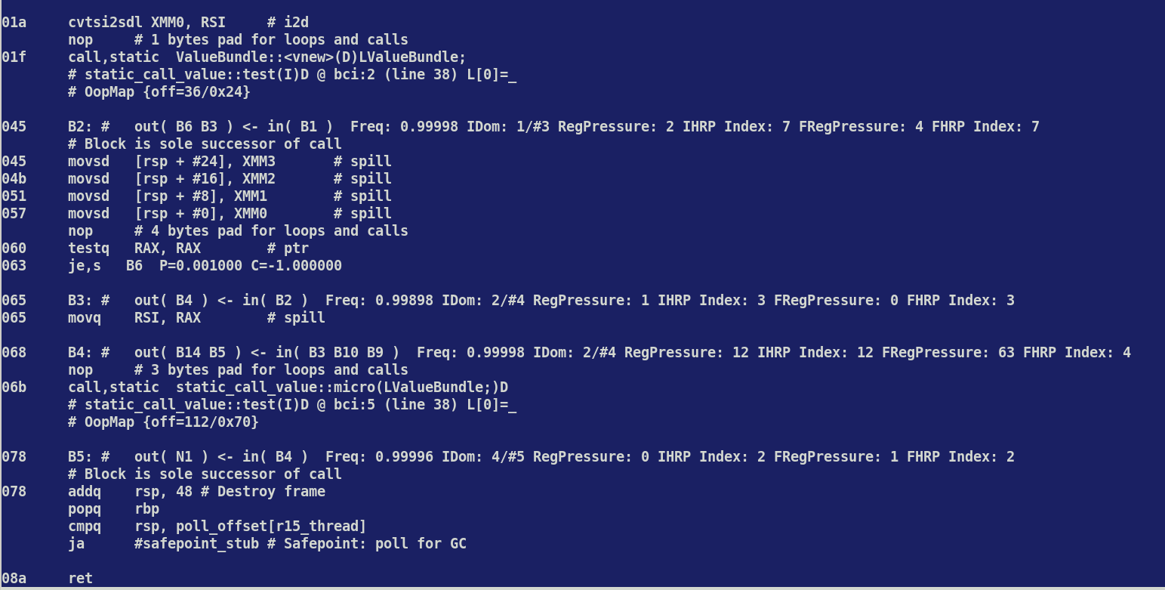

With InlineTypePassFieldsAsArgs enabled , even without inlining fields are freely scalarized as can be seen in following JIT code.



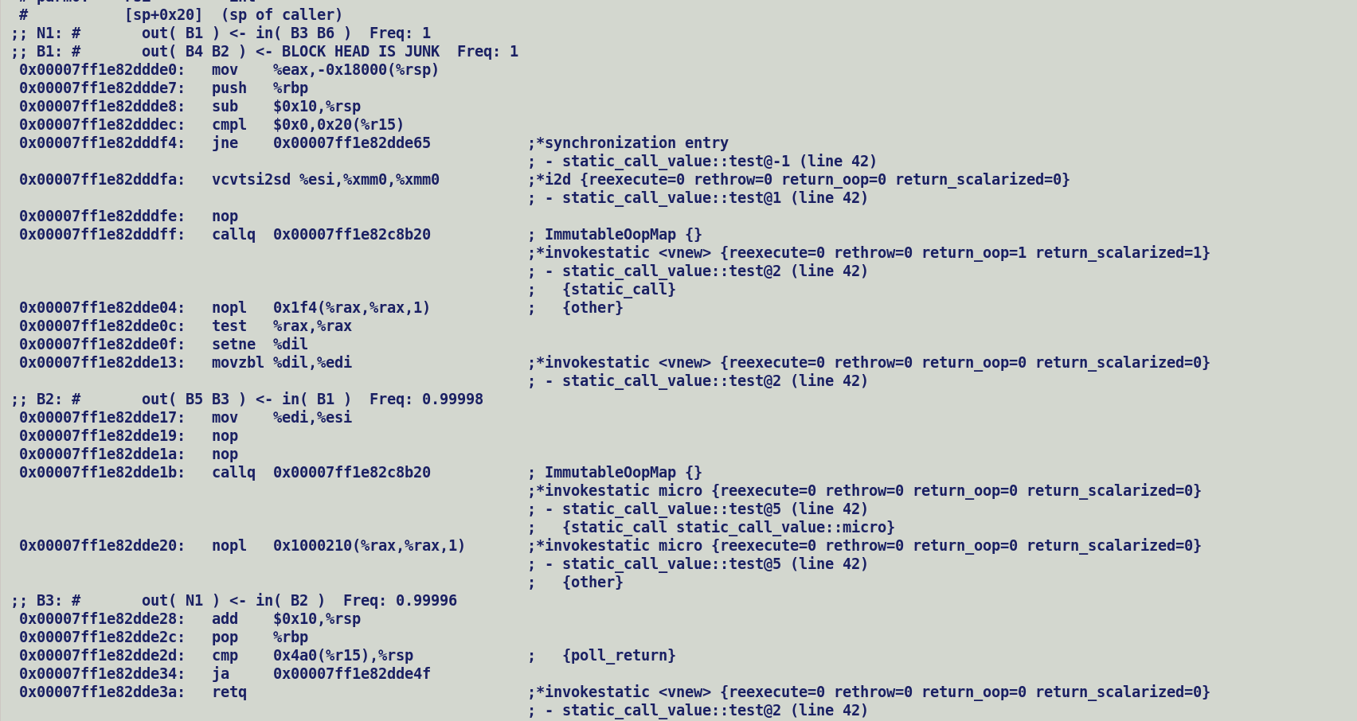



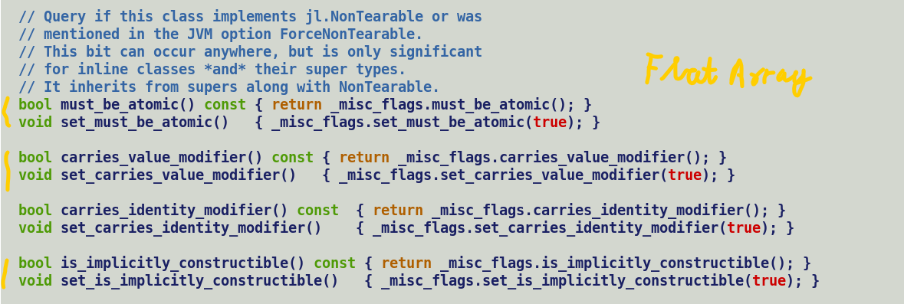

Scalarization Intercepts: -

* Method entry :-
  + build_start_state
    - scalarized arguments (multiple parameters for each scalarized fields), make_from_multi (in=T)
* checkcast
  + Profile driven or explicitly casted by a value type.
  + Profile application for type sharpening insert the checkcastpp nodes.
    - make_from_oop()
* Return value from a method.
  + Explicitly scalarized value based on return type signature.
    - make_from_multi(in=F)
  + Profile driven, return type speculation.
    - make_from_oop();
* New value object Allocation (aconst_init + withfield).

Larval state transition.

* + Disable scalarization.
  + Larval state entry through makePrivateBuffer(), exit though finishPrivateBuffer().
  + b/w state entry and exit, a checkcast may transform the oop to scalarized IR.

Test Scenarios

1. Vector API usecase (addressed):-

Caller:

v = makePrivateBuffer();

for () {

… Unsafe get / put.

}

v = finishPrivateBuffer();

1. Caller – Callee, scenario 1

Caller:-

v = makePrivateBuffer();

invokevirtual callee (v);

Callee:-

v = make_from_oop(v); // during start state construction.

…

1. Caller – Callee, scenario 2

Caller:-

V = Invokevirtual callee (); // make_from_multi (scalarized), make_from_oop (non-scalarized)

Callee

….

Return makePrivateBuffer (V)

1. Caller – Callee , scenario 3

Caller:-

V = makePrivateBuffer(v);

invokevirtual callee (v); // Abstract identity class argument descriptor (bi-morphic, poly-morphic)

Callee:-

….

Build_start_state

.. oop converted to InlineTypeNode if single sub-class abstract type parameter.

….

checkcast param1 , scalarize into InlineTypeNode based on profile.

1. For scalarized arguments (value type descriptor), C2 compiler always assume to receive scalarized objects and method body JIT code is generated based on that assumption.
2. Caller (C1/ Interpreter) -> Callee (C2)
   1. C1 use inline entry points to invoke C2 compiled method.
   2. Interpreter calls i2c adapter which after argument marshalling invokes inline entry points.

Solution to propagate larval state:-

* Pass explicit larval state argument if fields are scalarized.
* Checkcast to prevent scalarization if value object in larval state.
  + For Locally larval transitioned object, allocation is reachable, and its larval state can be checked.
  + For externally received oops, generate IR to check larval flags in oops mark word.
* If returning value object in scalarized form, pass explicit larval state on the lines of init value.
* Caller receiving a value object should emit a check based on larval projections (if scalarized returns) OR larval flag bit in oop’s mark word for non-scalarized return value oop.
* Inline entry points should disable scalarization for larval oops.
  + Compiler will re-materialize InlineTypeNode once finish_private_buffer is processed.
* Ideally we do not need to handle larval during de-optimization since we are dealing with oop buffers which internally hold the larval information in the mark word.

Performance implications: -

* Adding checks to test oop’s larval state is redundant for immutable value oops.
* Currently value object does pass init state along with field value.

We can also encode larval information in init value, but it will only handle nullable value objects.

Following are C2 scalarization intercepts: -

* Method entry :-
  + Initial JVM State construction:-
    - If incoming argument is a value type, based on type parameter descriptor AND JVM flag *InlineTypePassFieldsAsArgs* is true.
    - Create a separate Param for each scalarized arguments.
      * Uses InlineTypeNode::make_from_multi (in=TRUE).
* Checkcast bytecode:-
  + Sources:
    - Application of C1 / Interpreter generated profiles over incoming parameter / argument injects a CheckCastPP node which soon after type sharpening re-materializes InlineTypeNode.
    - Use added explicit type casting.
  + Uses InlineTypeNode::make_from_oop(). C)
* Returned value from a method.
  + Caller may receive scalarized value objects and creates a separate projection for each scalar field and binds it’s to scalarized InlineTypeNode.
    - Uses make_from_multi(in=F)
  + Profile driven, return type speculation.
    - Uses make_from_oop() to re-materialize InlineTypeNode IR from return value object.
* Allocated a new value object, constructor emits an aconst_init bytecode which creates an InlineTypeNode for default value object followed by creating a new InlineTypeNode with each withfield bytecode.

Idea here is to disable creation of a scalarized IR whenever a value object enters larval state through Unsafe.makePrivateBuffer() invocation , which is an unsafe API with native and C2 compiler intrinsic implementation.

Value object exits larval state through Unsafe.finishPrivateBuffer(). Between state entry and exit, a checkcast bytecode processing may again try to transform value oop to scalarized IR through intercept B.

Proposal to propagate larval state across method boundaries:-

1. Pass explicit larval state argument along with scalarized fields, this is because C2 always expects value objects to be passed as scalarized fields, Method::has_scalarized_args is set during adapter generation (AdapterHandlerLibrary::get_adapter). Even when interpreter and C1 invokes a method it jumps to its inline entry point which unpacks the incoming value object fields into GPRs. C2 while constructing initial

JVM state always expects to receive value object arguments in scalarized from.

1. Checkcast to prevent scalarization if value object in larval state.
   * For Locally larval transitioned object, allocation is reachable, and its larval state can be checked.
   * For externally received oops, generate IR to check larval flags in oops mark word.
2. If returning value object in scalarized form, pass explicit larval state on the lines of init value.
3. Caller receiving a value object should emit a check based on larval projections (if scalarized returns) OR larval flag bit in oop’s mark word for non-scalarized return value oop.
4. Inline entry points should disable scalarization for larval oops.
   * Compiler will re-materialize InlineTypeNode once finish_private_buffer is processed.

Ideally we do not need to handle larval during de-optimization since we are dealing with oop buffers which internally hold the larval information in the mark word.

Test Scenarios

1. Vector API usecase (addressed):-

Caller:

v = makePrivateBuffer();

for () {

… Unsafe get / put.

}

v = finishPrivateBuffer();

1. Caller – Callee, scenario 1

Caller:-

v = makePrivateBuffer();

invokevirtual callee (v);

Callee:-

v = make_from_oop(v); // during start state construction.

…

1. Caller – Callee, scenario 2

Caller:-

V = Invokevirtual callee (); // make_from_multi (scalarized), make_from_oop (non-scalarized)

Callee

….

Return makePrivateBuffer (V)

1. Caller – Callee , scenario 3

Caller:-

V = makePrivateBuffer(v);

invokevirtual callee (v); // Abstract identity class argument descriptor (bi-morphic, poly-morphic)

Callee:-

….

Build_start_state

.. oop converted to InlineTypeNode if single sub-class abstract type parameter.

….

checkcast param1 , scalarize into InlineTypeNode based on profile.

1. For scalarized arguments (value type descriptor), C2 compiler always assume to receive scalarized objects and method body JIT code is generated based on that assumption.
2. Caller (C1/ Interpreter) -> Callee (C2)
   1. C1 use inline entry points to invoke C2 compiled method.
   2. Interpreter calls i2c adapter which after argument marshalling invokes inline entry points.

Performance implications: -

* Adding checks to test oop’s larval state is redundant for immutable value oops.
* Currently value object does pass init state along with field value.

We can also encode larval information in init value, but it will only handle nullable value objects.

link_class_impl

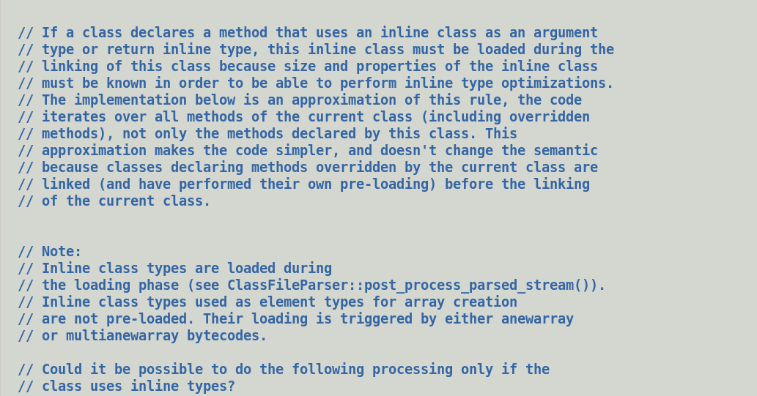

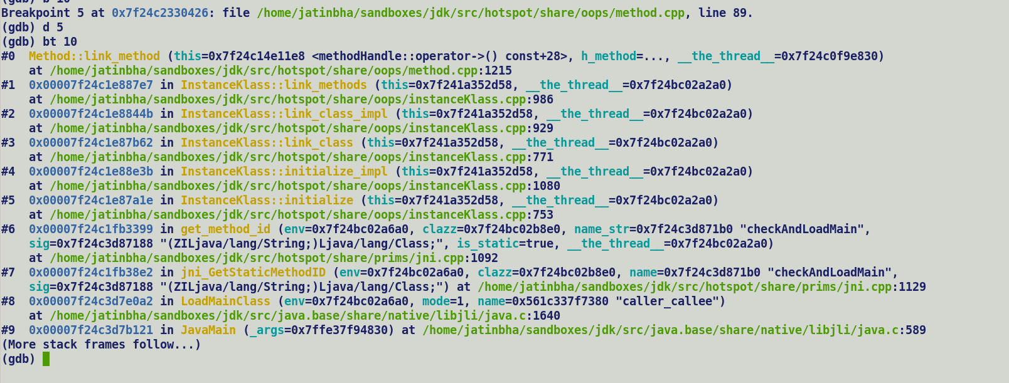

IC Miss -> IC_Miss_Stub-> Caller Stack Faram -> RegMap -> Receiver (based on value as perf Calling conventions, 0th argument RSI).

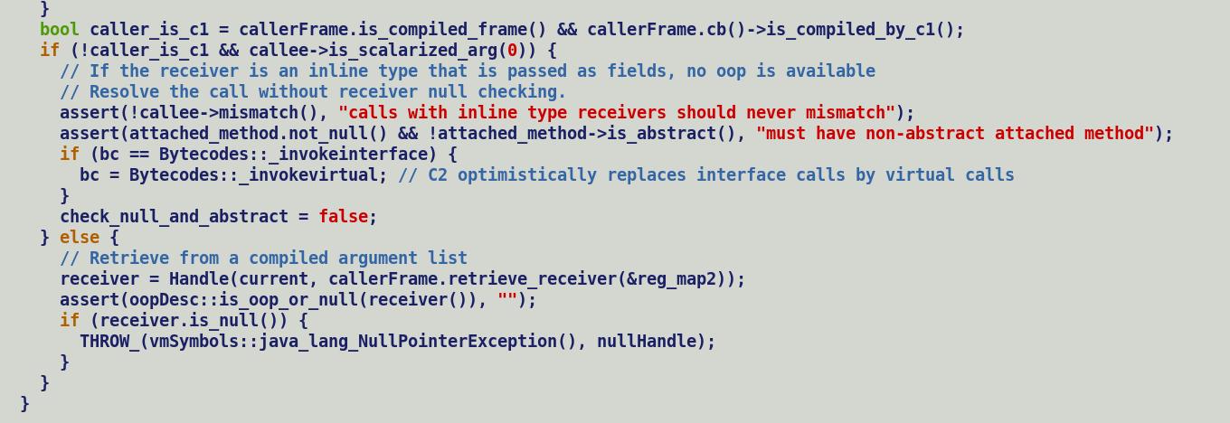

Value classes are implicitly final hence, method resolution context is class or its super classes. Resolution does not need to extract the klass out of actual receiver.

Virtual call site

Move receiver , $rsi

Call resolve_virtual_call // Runtime resolution and patching, for opt virtual calls with one receiver patch the call address to verified entry point.

// For virtual-calls, enter call site into monomorphic case and call UEP with receiver class check and fallback to is_miss_stub.

// is_miss_stub :- Runtime lookup of method based on actual receiver (caller frame RSI), Creates a CompiledICHolder entry (one for each receiver_klass and compiled method pair at call site). Transitions to callsite from clean to mono-morphic or from mono-morphic to polymorphic in case multiple receiver types). Re-patches the call site with resolved target method UEP entry.

In case patching is not safe, creates a transition stub and patches this stub entry point at call site. At runtime transition stub moves the callsite to monomorphic state and patch with actual UEP entry point).

Static Call

Call resolve_static_call_stub

+ static _call_stubs_to_interpreter

Move $RAX, 0x0

Call < placefolder> // c2i stub patching at runtime, move is patched to move klass pointer to RAX.

C2 Method

Caller

MOV RSI, RECEVIER

InvokeVirtual Callee // Initially

Monomorphic ->

If (receiver.class != Expected_class)

Call IC_Miss_Stub

IC_Miss_Stub->

Patch

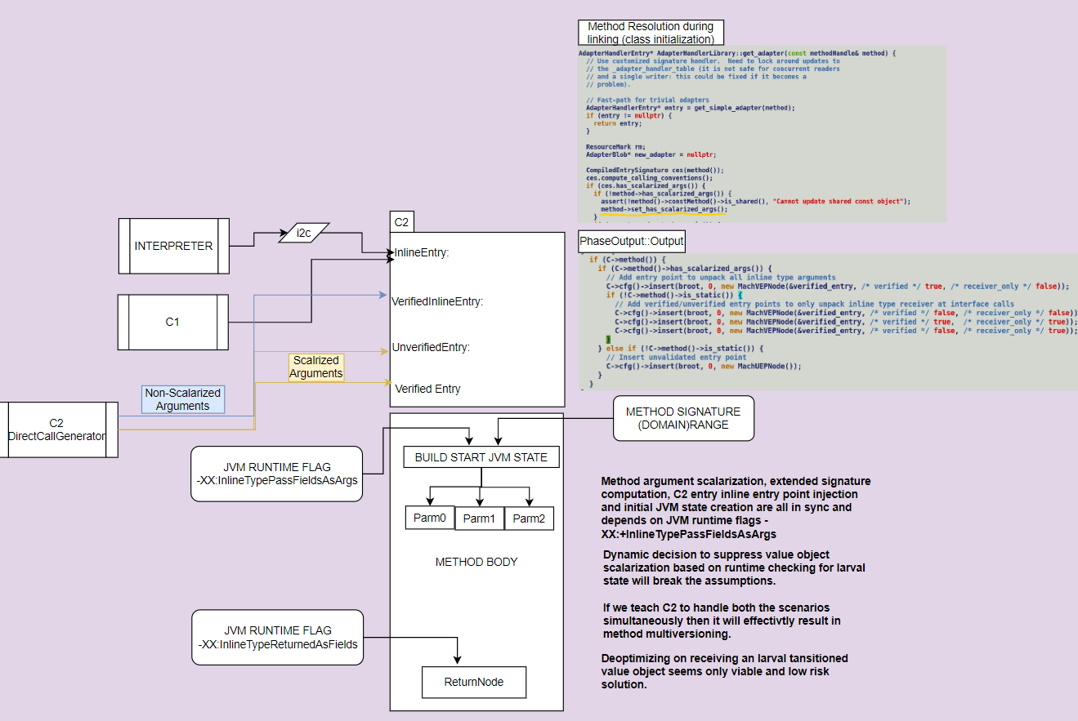

-XX:+TraceICs -XX:+TraceCallFixups.

**Scalarized calling convention to honour 255 JVM word limit in method descriptor.**

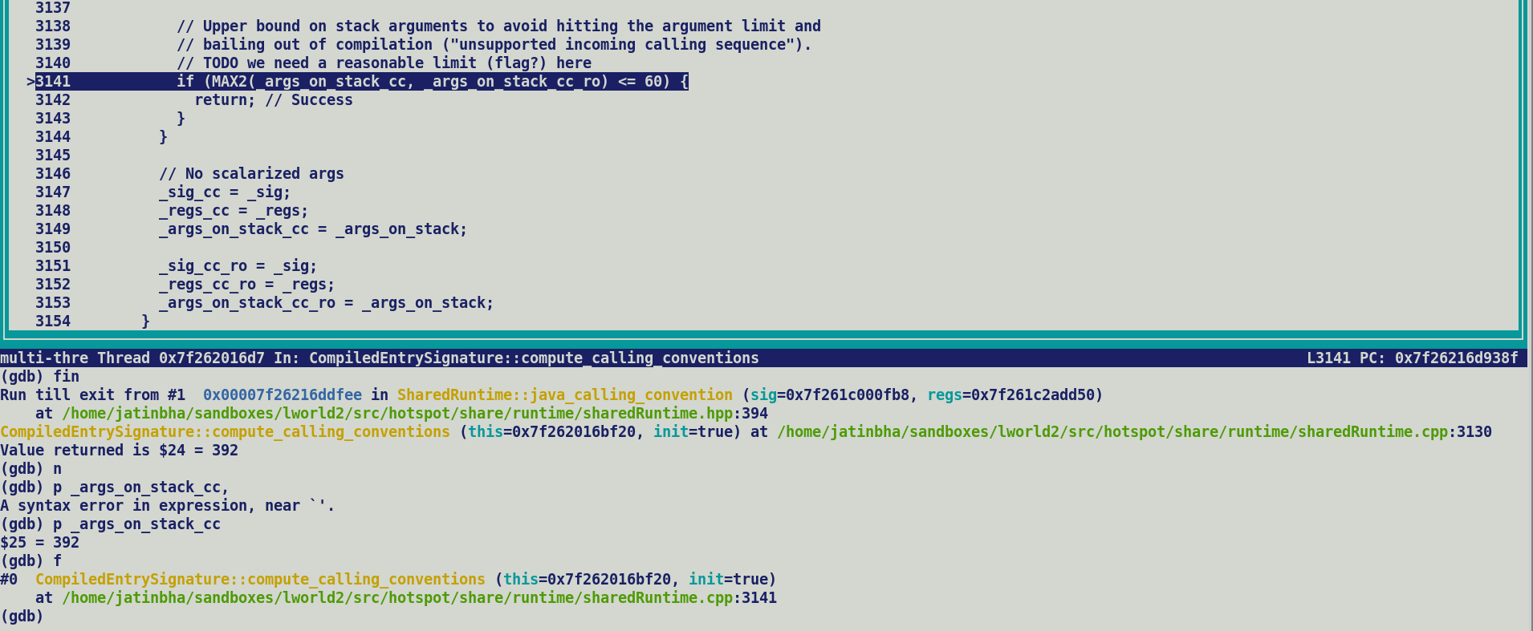

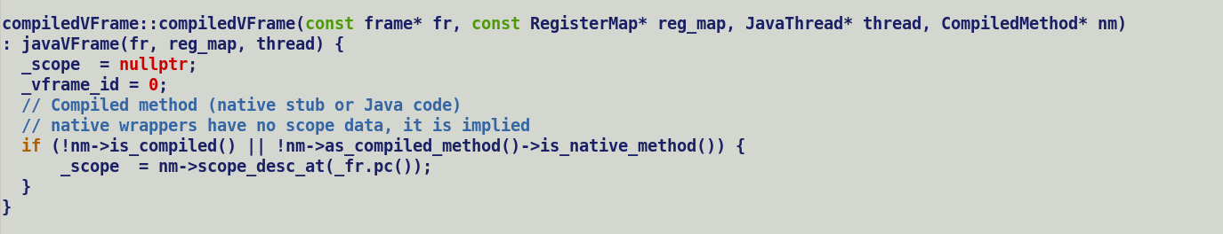

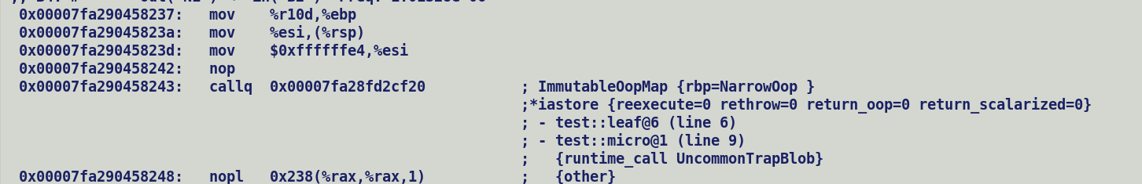



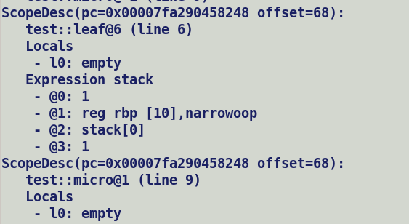



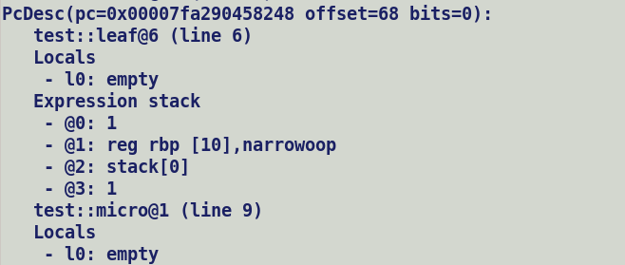



Uncommon trap in entry needs a corresponding Pc and Scope descriptor for Deoptimization unrolling and vframe stack creation.

Scopes are generated by compiler, need to patch the method entry descriptor to uncommon strap in entry point.

Inject a SafePoint at method entry and use its scope description for uncommon traps in entry points.

Proposal:-

-----------

I think there's a misunderstanding. In your example, makePrivateBuffer would return an Object. To pass 'p' to 'callee', it would first need to be casted to 'Pair' which would fail because 'p' is a larvae, see (1) in my original email. A larvae can only be passed as Object.

-----------

Marking would only be required for "implicit" casts via virtual dispatch, described by (4) in my original email. Example:

abstract class MyAbstract {

String toString();

}

value class Pair extends MyAbstract { // Implements toString() }

Caller :

MyAbstract a = makePrivateBuffer (new Pair());

invokevirtual toString (a).

Callee () :

... = Unsafe.finshPrivateBuffer(this);

Here, we would mark Pair::toString and add a check to the C2 compiled body to deopt if 'this' is a

larvae:

Callee () :

if (isLarvae(this)) deopt;

... = Unsafe.finshPrivateBuffer(this);

A cast would be needed here to convert the Object returned by makePrivateBuffer to 'Pair' and that cast would fail because a larvae is returned:

The key observation is, that with larvae checks at (speculative) checkcasts, the only way we could get a larvae in, is through 'this' and virtual dispatch (i.e., "implicit" casts). See the example from my previous email.

The solution that I'm proposing would mark methods for which such an implicit cast can happen and would then add a runtime check that would deopt if the scalarized argument is a larvae. To do that, we need to pass an oop in addition to the scalarized fields that would then be used on deopt.

current :-

oop = makePrivateBuffer() //

checkcastpp , oop -> InlineTypeNode == soop

unsafe.put (soop) // rematerialized non-inductive phi, ciTypeProfile does not discover JVM state changes, c2's loop header does not inject inductive phi.

finishprivatbuffer(soop) -> intrinsification fails.

Plan:-

makePrivateBuffer ->

- Intrinsic

- Buffers the InlineTypeNode, sets the larval state over allocation -> Re-mat InlineTypeNode [stock lworld implimentation]

- Enforce non-scalrization by modifying InlineTypeNode::field_value to load field value from oop instead of passing the scalar field input.

- If allocate == true, it create a new AllocateNode and sets _larval flag over it, but not actually emitting IR to set the larval bit in mark word.

- Non-intrinsic

- Returned value is of j.l.o type at succedding checkcast bytecode, de-optimize if value object is in larval state instead of bypassing it without

scalarization.

if (is_larval(oop)) {

Uncommon_trap();

}

inline_unsafe_access (is_store = true)

- InlineType -> oop -> modify -> do not re-mat inlinetype node since it may cause problem in loop.

finish private buffer

- Recieve InlineType Node, always expect to receive allocation node as oop..

- Reset larval bit of allocate node, this may be sweeped out.

- Creates a new InlineTypeNode and initializes it with incoming InlineTypeNode fields.

Plan:-

A makePrivateBuffer :-

1 - Intrinsic

- Buffers the InlineTypeNode, sets the larval state over allocation, emit IR to set larval bit of new allocation.

-Enforce non-scalrization by modifying InlineTypeNode::field_value to load field value from oop instead of passing the scalar field input.

2 - Non-intrinsic

- Returned value is of j.l.o.

B CheckCast :-

Inputs: oop , cast_type

If oop speculative type is sub-class of cast_type then no action needed, this will happen for Case A.1, larval InlineTypeNode

will be return without any processing.

For case A.2, emit runtime check for larval state to de-opt.

if (is_larval(oop)) {

Uncommon_trap(); // true-path

} else {

Re-mat InlineTypeNode from oop.

}

C inline_unsafe_access (is_store = true)

- InlineType -> oop -> modify -> do not re-mat inlinetype node since it may cause problem in loop.

- Add an assertion on oop field of InlineTypeNode should always be an alloc in larval state.

D finish private buffer

- Fail intrinsification if recive an InlineTypeNode, returned value object from DirectCall will auto-matically be rematerialized.

- If recieves an oop, transition it out of larval state.

- Remat InlineTypeNode from immutable oop.

As per existing makePrivateBuffer handling, when intrinsified, it allocates a new buffer, sets AllocateNode::_larval flag without setting the larval bit in its mark word and returns a re-materialized InlineTypeNode.

Thus, inline expander returns concrete type scalarized IR while non-intrinsic Unsafe_MakePrivateBuffer returns a java.lang.Object.

e.g Vector API use case.

ValuePayalod payload = Unsafe.makePrivateBuffer(this.vec());

For (...)

Unsafe.put(payload);

Payalod = Unsafe.finishPrivateBuffer();

Succeeding checkcast will now either receive an InlineTypeNode and if its type is sub-type of cast type pass the receiver as it is , else type cast receiver which in this case is a j.l.o object and re-materialize a InlineTypeNode from it if the oop is not in larval state else de-optimize.

Unsafe.put will directly modify the oop field, all we need to make sure is that we do not re-materialize an InlineTypeNode from modified oop as it this will pose problem in loops.

Existing finishPrivateBuffer intrinsic handling looks ok, it emits IR to reset larval bit of buffer.

Let me know if you have any comments on this.

@ImplicitlyConstructible -> Default initialization guarantee, Class level annotation.

@NullRestricted -> Null safety guarantee, field level annotation.

@LooselyConsistent -> Relax Atomicity constraints during object assignment, Class level annotation.

Integer![] -> ImplicitlyConstructible -> promote array flattening i.e. a packed layout of element of an array, but flat array is still allocated over heap.

@ LooselyConsistent

@ ImplicitlyConstructible

Value Float16 {}

Receiver loading during Parse::Parse Int64Vector::species() -> virtual method -> local 0 -> receiver (Parm0)

LoadN -> DecodeN <- LoadNode::make()

Non-flattened payload VectorPayloadMF64I

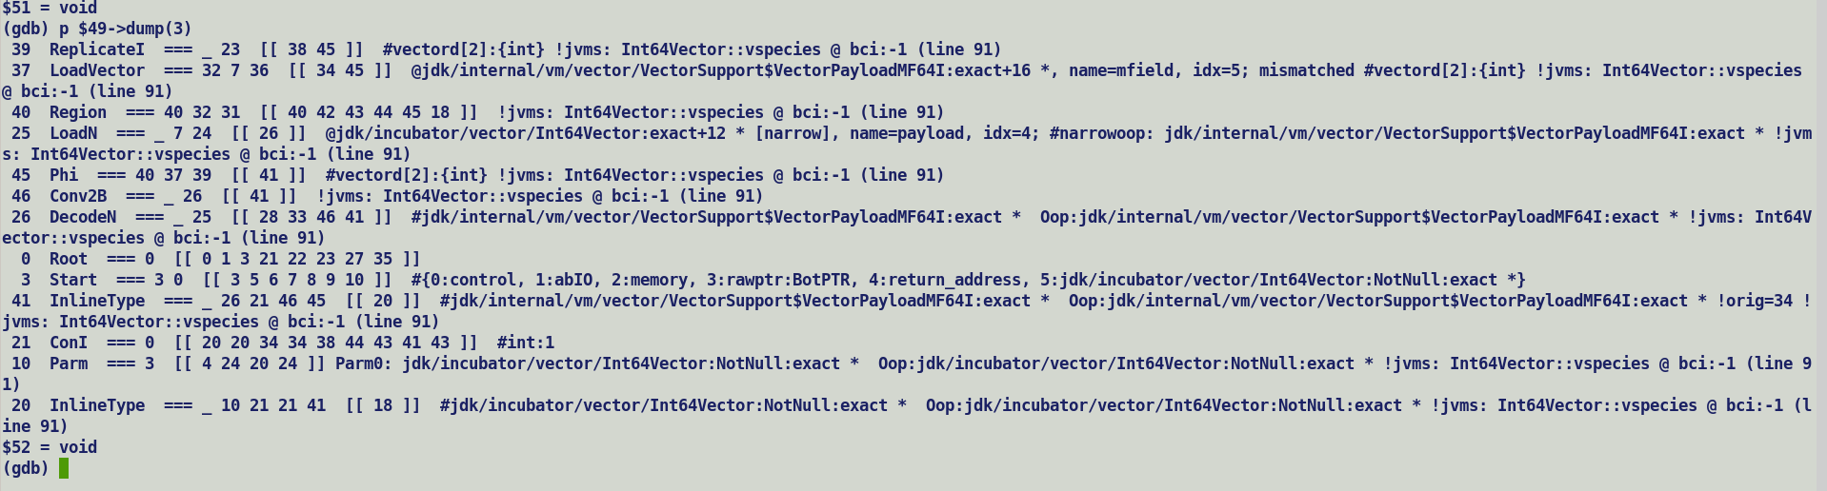

Int64Vector -> 2 byte mask -> non-intrinsics ABS masked not intrinsified.

--

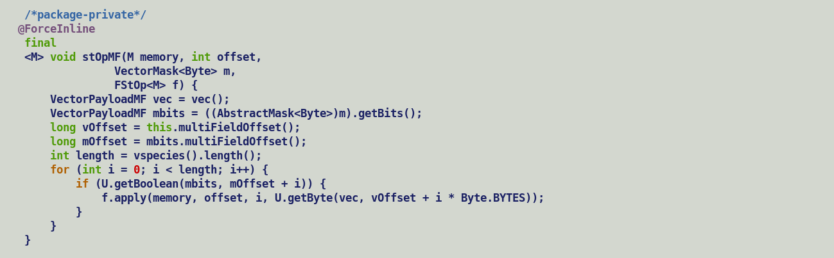



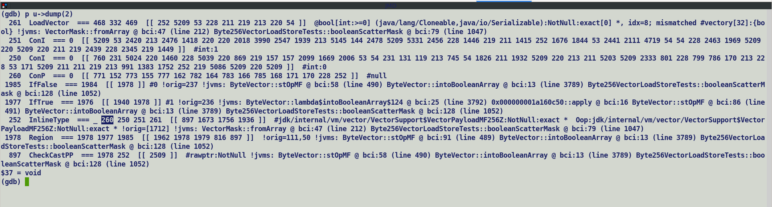

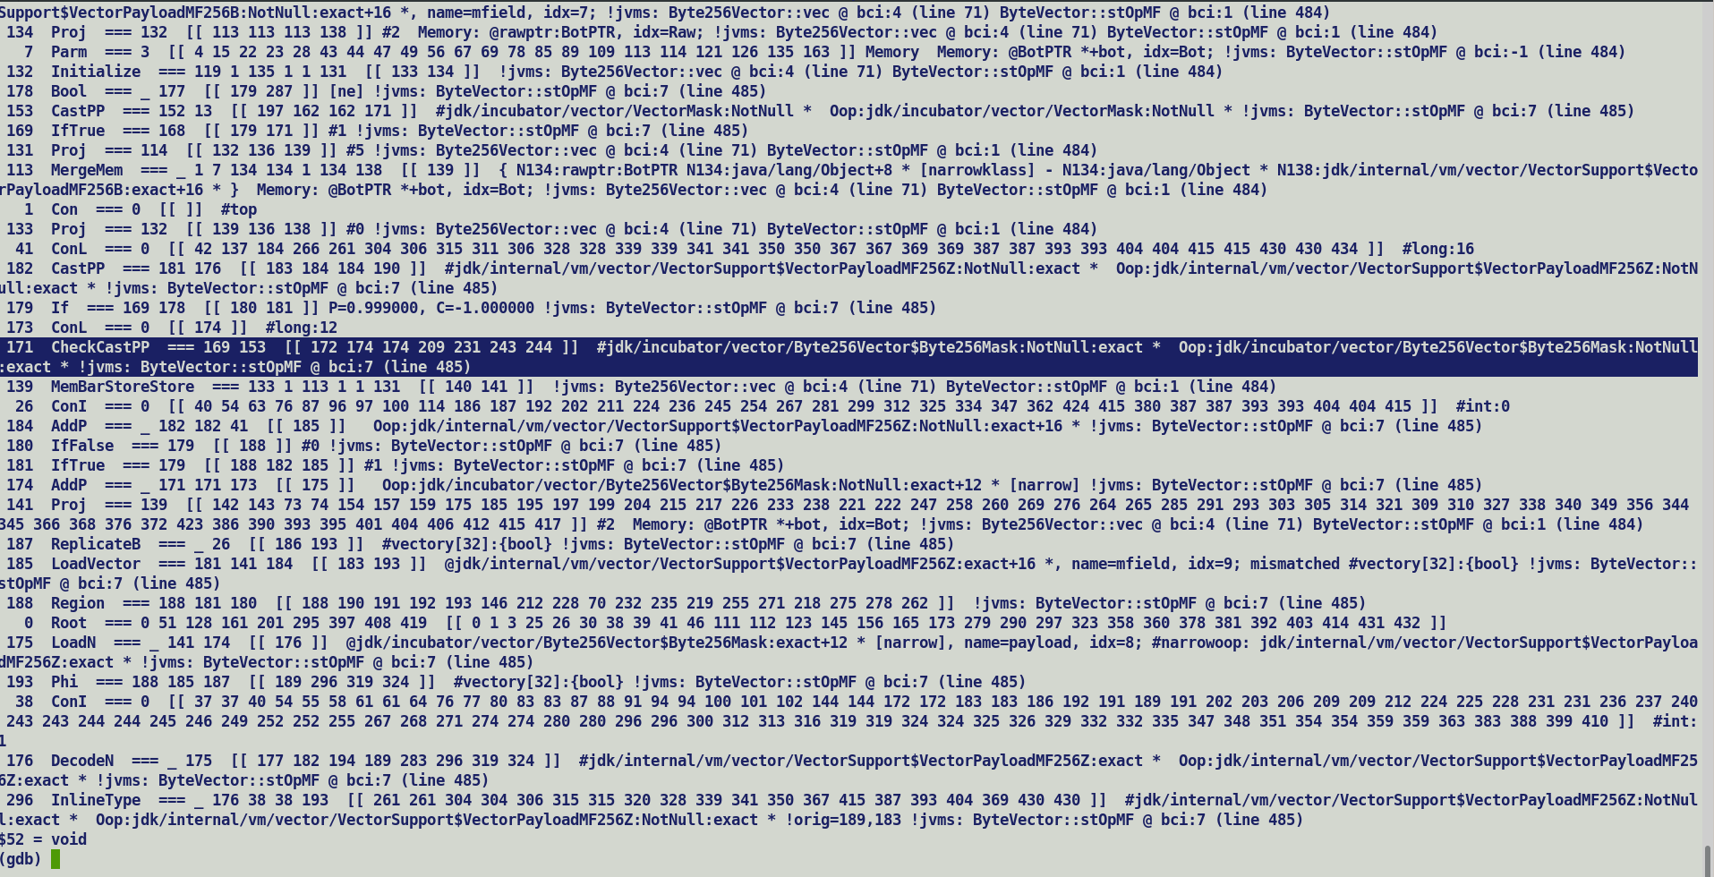



Check reason for missing scalarization after CheckCasting, this could prevent explicit Load of flat field (LoadN at casted mask + 12) and simplify the downstream graph which does null checking and introduces a Phi unifying default and vector loaded value.

OSR always passes the values as buffer, no scalarization on OSR entry…

C2 does not injects unpacking entry points for OSR compiled methods, thus, first intercept of scalarization is checkcast.

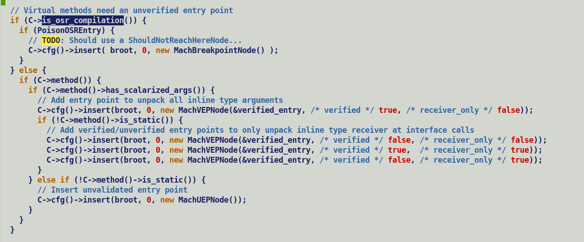

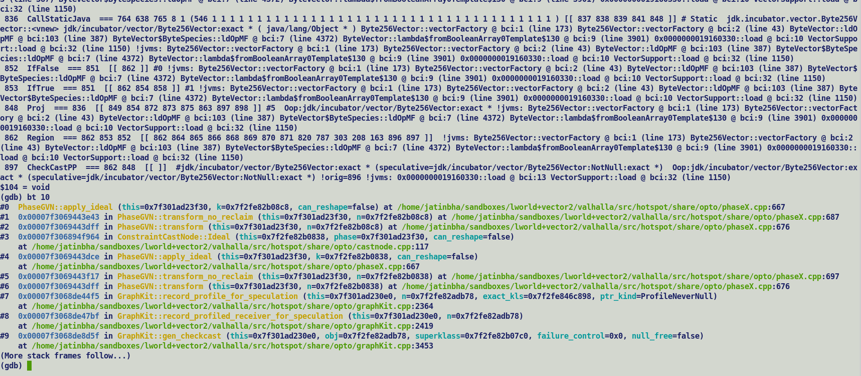

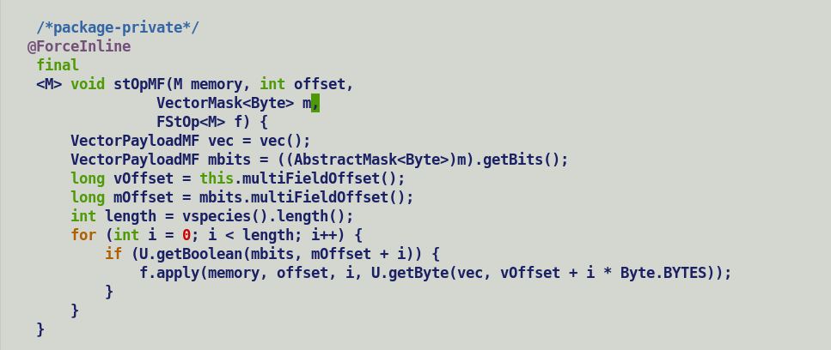



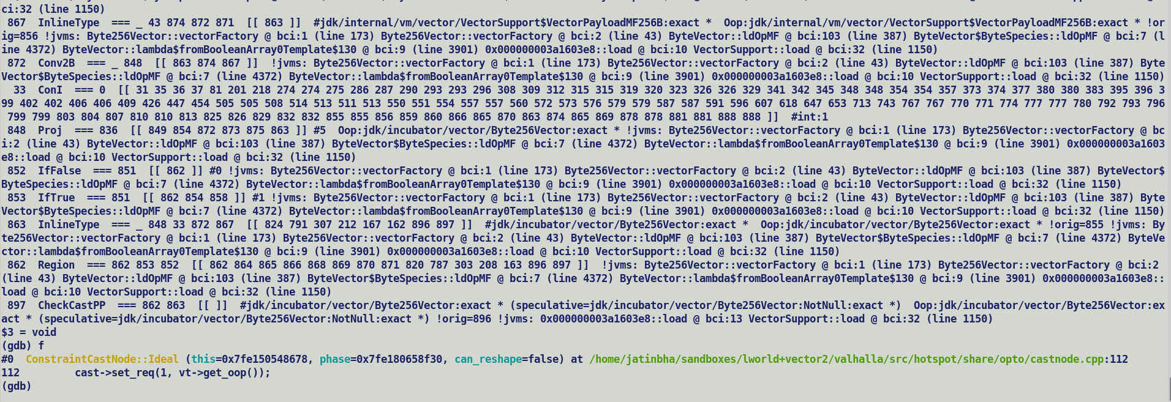

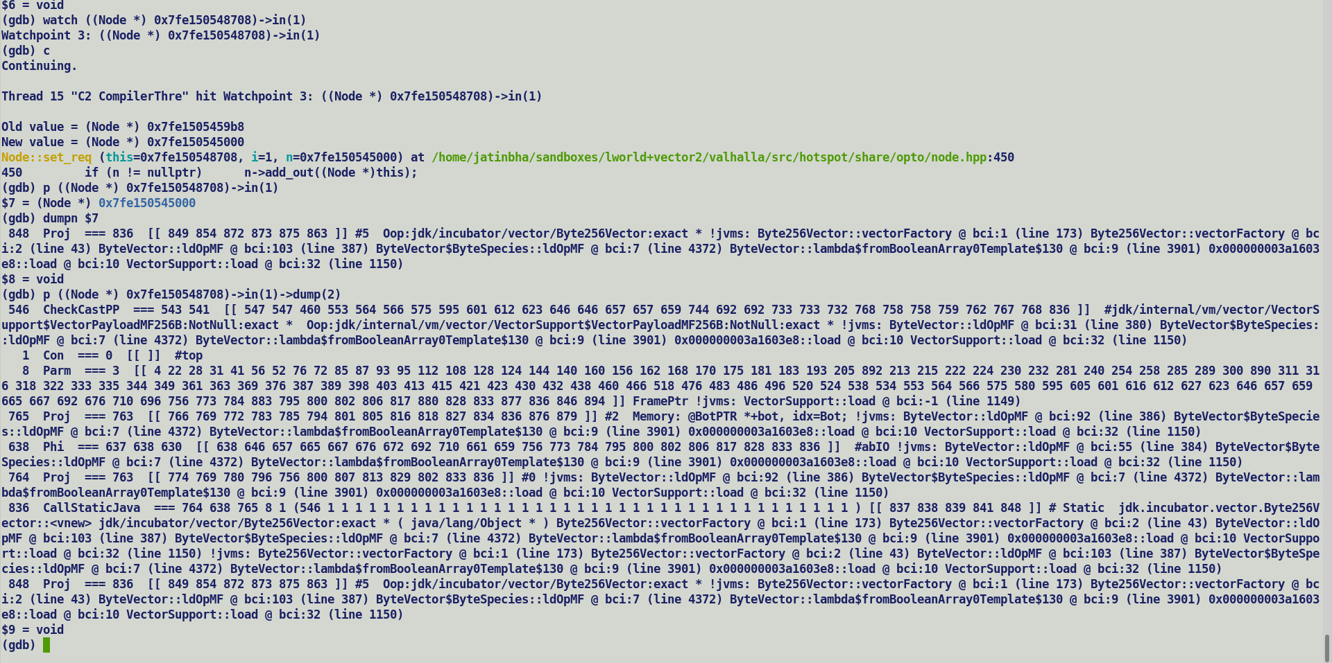

TOCHECK:

Internal padding post field flattening should be re-adjusted / removed in the container.

build_layout should automatically take care of this.

All publicly exposed abstract classes to be marked as sealed classes, which restricts its sub-classing to know concrete vector classes.

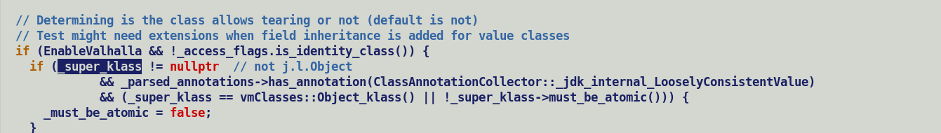



New NULL restricted array class API:-

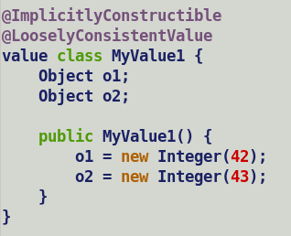



Q descriptor, and Valhalla specific bytecodes (withfield and aconst_inti) swept out with JEP 401 alignment.

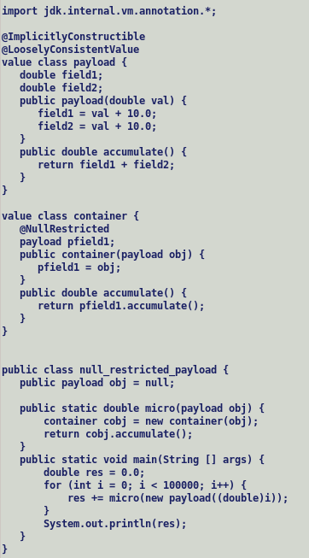

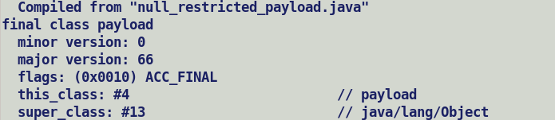

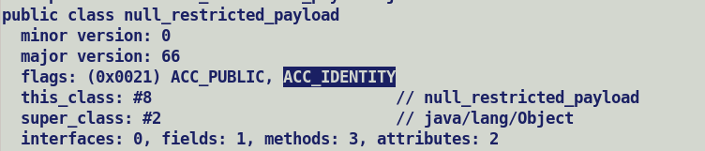

<https://bugs.openjdk.org/browse/JDK-8325660>

This is an umbrella CR to cover all cleanups required in C2 code after the transition to the JEP 401 model.  
Among the changes introduced by the new model, there are:  
  - the removal of primitive value classes and their associated `Q` descriptors  
  - the removal of the secondary mirror for value classes  
  - removal of the Qdesc bit in JVM_CONSTANT_CLASS constant pools entries.

Withfield

Aconst_init.

Another use significant use of larval state. value object to remain in mutable state during construction to enable updates to final field values, uptill now updates were done per field manner where with each field update a new value object was being created using withfield bytecode.

With the latest 401 transition model, withfields are replaced with regular putfield bytecode to update value objects in a pseudo mutable manner.

<https://openjdk.org/jeps/401#:~:text=System.out.println,of%20the%20constructor>

**Comparison of aliasing behaviour of array, field and multifield accesses.**

**=======================================================**

import jdk.internal.misc.Unsafe;

import jdk.internal.vm.annotation.MultiField;

//import jdk.internal.vm.annotation.ImplicitlyConstructible;

//import jdk.internal.vm.annotation.LooselyConsistentValue;

//@LooselyConsistentValue

//@ImplicitlyConstructible

//value class IntPayload {

class IntPayload {

@MultiField(4)

int payload;

IntPayload() {

payload = 0;

}

}

public class test_aliasing {

public static Unsafe UNSAFE = Unsafe.getUnsafe();

public static int micro1(int [] arr) {

UNSAFE.putInt(arr, 16, 10);

UNSAFE.putInt(arr, 20, 20);

UNSAFE.putInt(arr, 24, 30);

UNSAFE.putInt(arr, 28, 40);

return UNSAFE.getInt(arr, 20);

}

public static int micro2(IntPayload obj) {

UNSAFE.putInt(obj, 16, 10);

UNSAFE.putInt(obj, 20, 20);

UNSAFE.putInt(obj, 24, 30);

UNSAFE.putInt(obj, 28, 40);

return UNSAFE.getInt(obj, 20);

}

public static int micro3(int [] arr) {

arr[0] = 10;

arr[1] = 20;

arr[2] = 30;

arr[3] = 40;

return arr[1];

}

public static int micro4(IntPayload obj) {

obj = UNSAFE.makePrivateBuffer(obj);

UNSAFE.putInt(obj, 16, 10);

UNSAFE.putInt(obj, 20, 20);

UNSAFE.putInt(obj, 24, 30);

UNSAFE.putInt(obj, 28, 40);

obj = UNSAFE.finishPrivateBuffer(obj);

return UNSAFE.getInt(obj, 20);

}

public static int micro5(IntPayload obj) {

UNSAFE.putInt(obj, 16, 10);

UNSAFE.putInt(obj, 20, 20);

UNSAFE.putInt(obj, 24, 30);

UNSAFE.putInt(obj, 28, 40);

return (int) UNSAFE.getByte(obj, 22);

}

public static void main(String [] args) {

int res = 0;

int algo = Integer.parseInt(args[0]);

switch(algo) {

case 0: {

int [] arr = new int[4];

for (int i = 0; i < 10000; i++) {

res += micro1(arr);

}

} break;

case 1: {

int [] arr = new int[4];

for (int i = 0; i < 10000; i++) {

res += micro3(arr);

}

} break;

case 2: {

IntPayload obj = new IntPayload();

for (int i = 0; i < 10000; i++) {

res += micro2(obj);

}

} break;

case 3: {

IntPayload obj = new IntPayload();

for (int i = 0; i < 10000; i++) {

res += micro5(obj);

}

} break;

default:

assert false;

}

System.out.println("[res] " + res);

}

}

CPROMPT>javac --add-exports=java.base/jdk.internal.misc=ALL-UNNAMED --add-exports=java.base/jdk.internal.vm.annotation=ALL-UNNAMED -cp . test_aliasing.java

CPROMPT>

CPROMPT>java -Xbootclasspath/a:. -XX:-TieredCompilation -Xbatch --add-exports=java.base/jdk.internal.misc=ALL-UNNAMED -XX:-PauseAtStartup --add-exports=java.base/jdk.internal.vm.annotation=ALL-UNNAMED -XX:-PrintFieldLayout -cp . test_aliasing 2

[res] 200000

CPROMPT>

All the classes in BootClassPath are loaded by boot class loader, this grants a user class privileged access to jdk internal annotations. Java class file constant pool section records class references to capture external class dependencies, these are resolved lazily at field access or method invocation time, barring value based classes references with primitive class semantics i.e. value class decorated with ImplicitlyConstructible and LooselyConsistentValue annotations, which are loaded eagerly for layout computations of flattenable fields.

<https://openjdk.org/projects/valhalla/design-notes/state-of-valhalla/03-vm-model#:~:text=JVM%20is%20lazy%20about%20loading%20classes%20referred%20to%20by%20other%20classes%2C%20such%20as%20classes%20named%20in%20method%20and%20field%20descriptors%20or%20in%20CONSTANT_Class%20items>.

Unsafe based updates: -

* Instance field updates:

Each field store is recorded are separate alias index leading to multiple update slices in ***MergeMemNode*** benefit quick store forwarding.

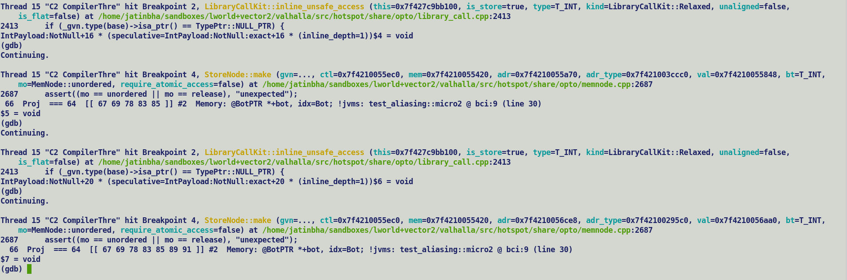

* Unsafe array element stores.
  + Resembles array aliasing scheme.

Arrays: All the array elements are aliased against same aliasing index; this results in formation of chain of memory store accesses favouring auto-vectorization. On the hind side store forwarding for a earlier access requires a traversal over memory chain.

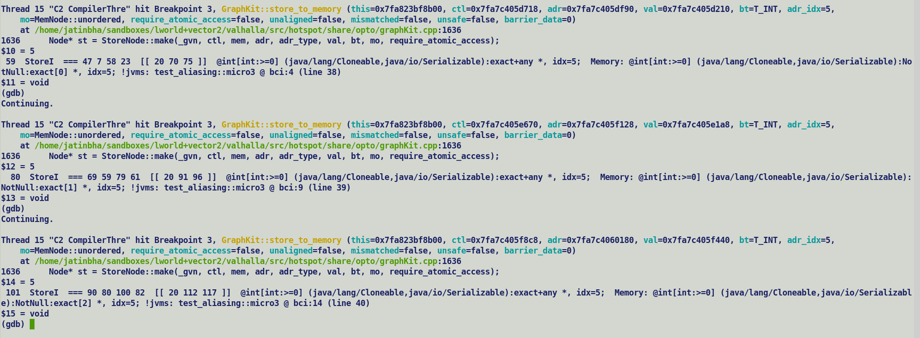

Multifield:-

Aliasing behaviour of scalar fields of multifield bundle resembles instance field access where each scalar field store is associated with different alias index, anyways entire bundle is loaded into a vector if target platform supports vector size corresponding to bundle size. In case bundle gets scalarized due to non-conforming target vector size for desired vector shape / species, complying with arrays in terms of aliasing behaviour may favour auto-vectorization of fall-back implementation on narrower vector size.

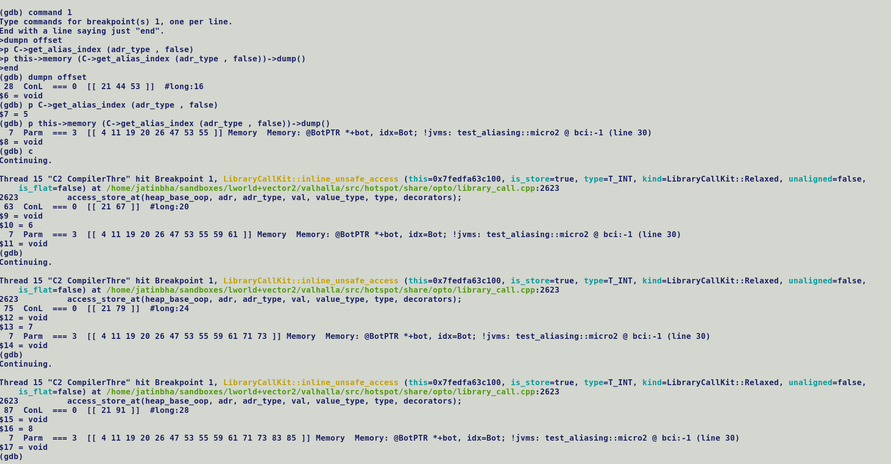

Subsequent load from offset 20 fetches the last stored value at corresponding alias index. However, this aliasing behaviour is different from array element store / load where each element corresponds to same alias index.

By adding a special check to strip off offset from the adr_type (TypeInstPtr) we can impart array aliasing semantics to multifield element accesses, this shall promote narrow vector auto-vectorization if target does not support vector size to accommodate multifield bundle.

Priority: Low, given that unsafe implementation part of sub-optimal fall-back implementation.

Complexity: medium

For arrays, address type compiler always uses TypeAryPtr of respective primitive type for alias computation, thus all the elements of arrays share same alias index. TypeAryPtr types are generated by construction for all array element accesses, for instance fields TypeInstPtr along with appropriate offset are associated with instances. Any special handling to share common alias index for all the scalar fields of multifield bundle will need to overlook the offset part of instance types.

Mismatched accesses:-

Wieder store and narrow reads results into mismatched accesses, this constraints escape analysis from eliminating a non-escaping memory in light of non-accessible field values, in addition store forwarding is disabled for vector mismatched accesses.

Refer ***MemNode::can_see_stored_value*** for more details..

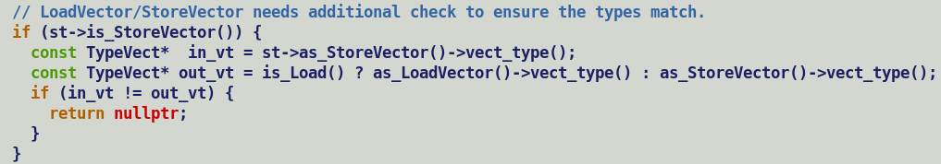

Note:

*TypeInstPtr::Instance_id* is used for instance type based graph splitting to promote value forwarding.

New Changes:-

Following ACC flags removed from AccessFlags list in lworld

bool is_value_class () const { return (_flags & JVM_ACC_VALUE ) != 0; }

bool is_primitive_class () const { return (_flags & JVM_ACC_PRIMITIVE ) != 0; }

Field flag test can be implemented using single BT + JCC CF instruction instead of SHIFTR + AND + TEST + JCC pallet.

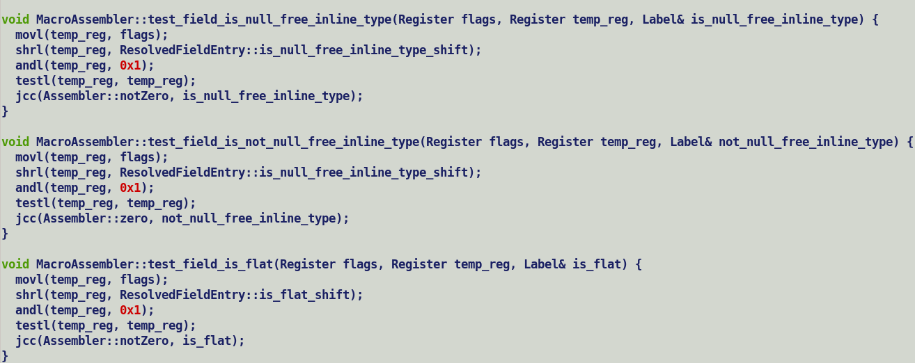

Redundant compare after flag effecting and.

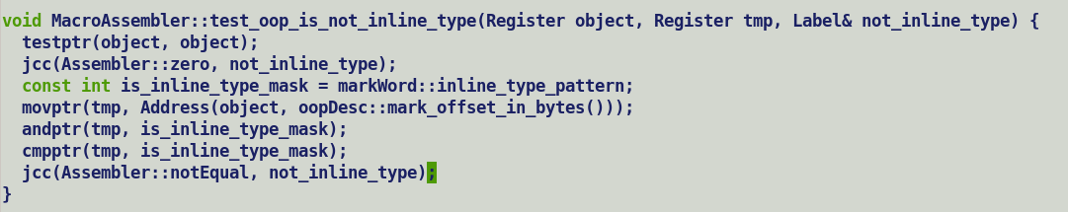

Check FieldInfo creation for synthetic fields



X86 specific portions of Valhalla (template interpreter, stubGenerators, sharedRuntime (pack/unpack adapters))

Withfield bytecode implementation based on old specifications, copies entire flat field bundle to container.

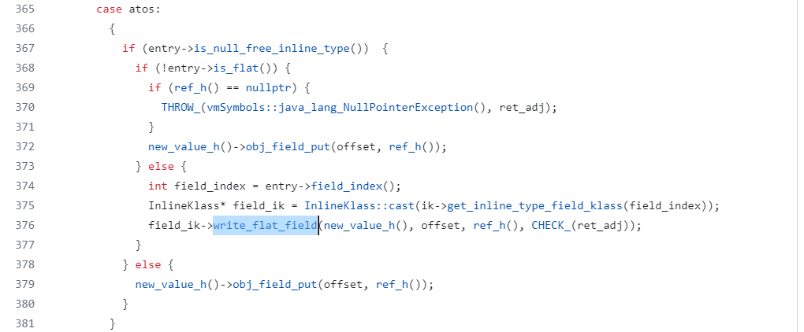

Changes in new code model as per JEP 401 modified specification. putfield copies entire flattened field using BarrierSetRuntime interface to comply with deprecated withfield bytecode semantics.



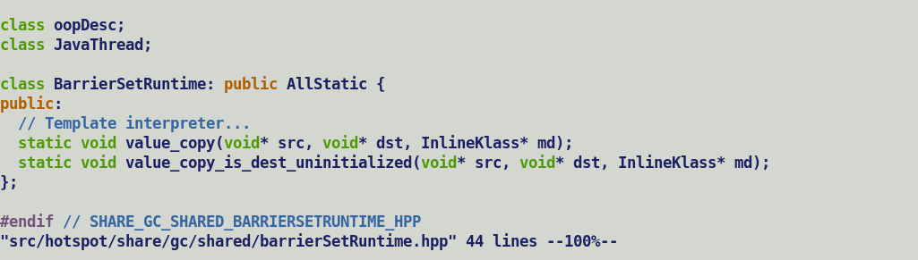

Preload attribution for eager class loading for layout computations.

Field marked as null restricted loads their value classes eagerly during class file parsing, this is unlike identity class which are loaded lazily after actual resolution time. No explicit preload attribution needed in these cases.



_new value object allocation is now on the lines of identity object instantiation

Q. How this this take into account the default value / initialization, if constructor does this initialization then this departure is not memory efficient but comply with true value semantics.

A.

Klass mirrors departure from earlier code model



Only one mirror per value class instead of primary and secondary ones.

Check / Revisit:-

* New
* Flat arrays
* C1 / Interpreter return only scalarization.
* Argument scalarization only for C2.
  + Needs different entry points.
* Fat Field Info for Multifield?
  + Will cause problem with unsafe, tearing of a single field is not possible.
  + One fat multifield FieldInfo to represent entire multifield
    - Field query APIs which accept offset for individual scalarized fields will point to same fat FieldInfo.
  + Since FieldInfo strictly comply with JVM specification, and @multifiled is an annotation over field, hence generating multiple FieldInfo (synthetic) based on annotation processing is the right approach, a Fat field will depart from JVM semantics of a FieldInfo.
    - Also, Each FieldInfo contains field descriptor, index and offset information, having one FieldInfo shared across entire bundle with auxiliary structure will complexify field lookups based on offset and index.
* Withfield bytecode is now deprecated, restricting the access to multifield only though unsafe APIs without any direct getfield / putfield will simplify the implementation. It will be a generic handling of multifield even beyond vector API.
  + JVM can flag an error for any non-unsafe access of multifield based on the field annotation.
    - Test Varhandle based accesses for multifield.
  + It will also allow creating just a single FileldInfo runtime representation for a multifield along with an auxiliary structure (to record multifield details), as opposed to what we have today i.e. separate FieldInfor for base and synthetic multifield.
  + Layout builder can be turned to read multifield as a bundle, it’s a minor modification.
  + Value Payload constructor should also be modified to initialize multifield in a loop using unsafe API.
  + In short only way to access (read / write) a multifield will be through an unsafe API with holder object and field offset, it will be a mismatched access.
  + Scalarization of multifield will be completely delegated to C2 as opposed to doing it in ci model.
    - C1 will not need any special handling for multifield given that direct get / putfield operation is prohibited. We can add an assertions in C1 for the same.



* + - ciField:-

is_multifield() = false

ciMultifield : ciField

-> bundle size.

-> Is_multifield () = true;

Cleanup base multifield / multifield flags and associated handling.



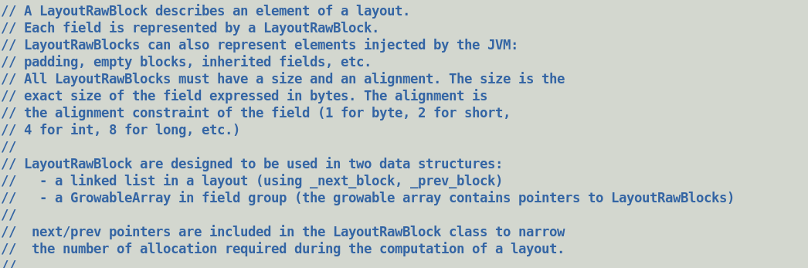



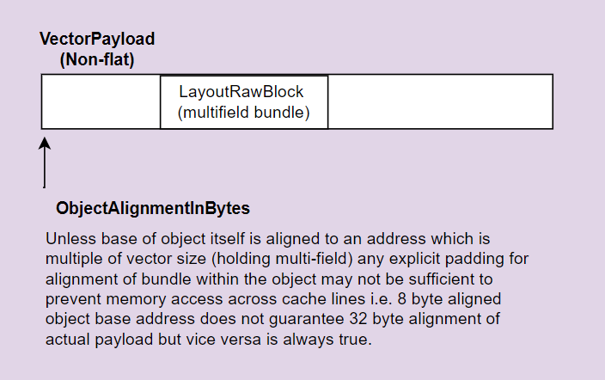

Multifield:-

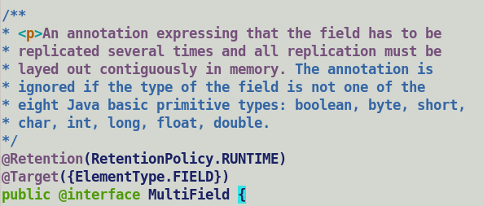



Currently multifields can be applied to primitive type fields, in future it could be used to replicate null restricted value class type fields.

Behaviour of recursive application of multifield over primitive type field is currently undefined. Java languages compiler allow decorating a fields with multiple annotations but in case of multiple multifield annotations compiler should throw an error.

ARM SVE can support up to 2048 bit vector, existing concrete vector classes are defined for maximum 512 bit vector. A byte level multifield can support maximum bundle size of 128.

@multifield(value = -1) signifies a MaxVectorSpecies.

@MultiFleld and @NullRestricted are orthogonal annotations, null restriction only applies to fields of value types and promotes flattening. @Multifiled replicates the layout the field over which its applied.

@mutifield size is needed for layout computation and instance size estimation which is then encoded into layout_helper.

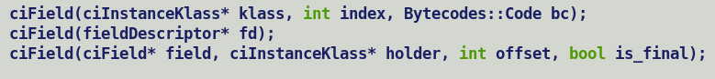

First intercept of ciTypeFlow analysis in compiler is during parsing look for get_flow_analysis in Parse::Parse..





Compressed UNSIGNED5 encoded field stream.

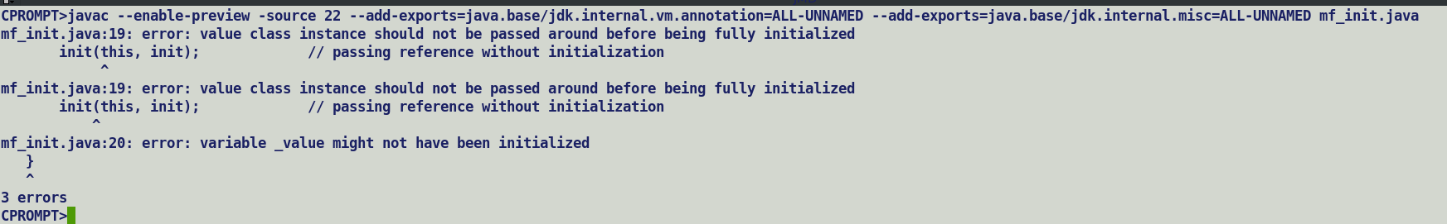

Primitive / null restricted value class constructors are factory methods <vnew> and return a fully initialized value objects.

<https://openjdk.org/projects/valhalla/design-notes/state-of-valhalla/03-vm-model#:~:text=a%20factory%20method%20simply%20returns%20the%20object%20being%20constructed>.

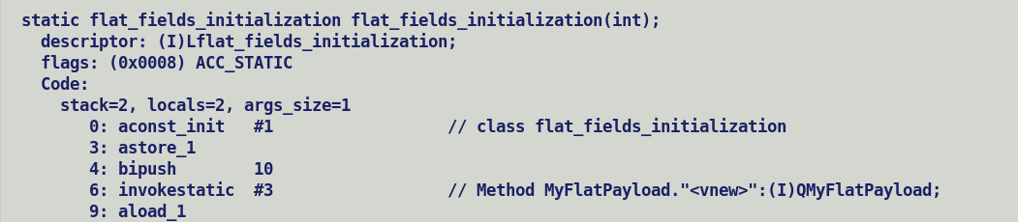

With new code model this has now changed.

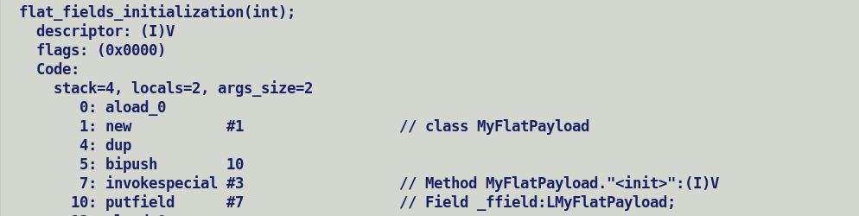

Redundant null checking for object marked as null-free inline type.

* Since in new code model values are initially allocated over heap hence an explicit nullity check.

An empty value object will now incur a penalty of header allocation per value, earlier empty null restricted value objects were pointing to a default value allocated during InlineKlass initialization, a small tweak in _new handling can return default value allocated during InlineKlass initialization.

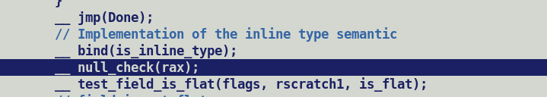

New -> Default InlineTypeNode

Each field update with putfield -> JVM state updated with newly created inline type node.



Is_larval should prohibit returning a scalarized value during read field access.

Scalar value of larval value must not be propagated.

Value class preloading mandator for layout computation of flat fields.

* Done as a part of post processing after class stream parsing by iterating over value class fields.

Need for keeping VectorPayloads in java.base modules

1) Pre-loading during VM startup and explicitly record offsets for their fields of interest in an auxiliary structure for faster loops.

* Value classes associated with payload field are automatically loaded eagerly for layout computations.

2) Current VectorAPI support, does record payload offset since payload is part of top level VectorPayload class, with Valhalla payload is pushed down to leaf level concrete vector class, since they are flat fields.

* Recoded offsets are no longer used during box expansions

3) Thus, we do not need explicit bookkeeping mentioned above in point #2.

Value Class



Is_inline_klass() = true

Abstract Value



Is_inline_klass() = false;

Inline class instantiates to a value. Abstract classes are non-instantiable.

Preloading of a value class is mandatory for layout computations of flat value type fields.

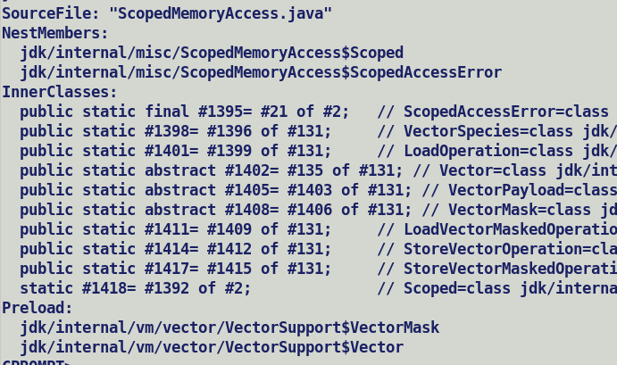

ciInstanceKlass::get_non_flat_field_by_offset:-

* Returns granular synthetic multifield by directly iterating over compressed FieldInfo using JavaFieldStream iterator.

compute_non_static_fields

* Computes a list of ciField and ciMultifields by directly iterating over compressed FieldInfo using JavaFieldStream iterator and creating a hierarchical ciMutifield structure only if target vector can accommodate entire multifield bundle.

ciInstanceKlass::get_field_by_offset

* Performs a DFS walk over list of _nonstatic_fields and returns the granular multifield .

ciInlineKlass::field_index_by_offset

* Based on the flag argument performs a linear / dfs walk over _nonstatic_fields and returns index corresponding field offset.
* Currently only called from C2 which prefers always linear walk, routines has been made generic to handle invocations from other client (c1).

Float64Shuffle.toArray() -> should store two indices into integral array.



If (obj != null) {

obj = CastPP obj not_null // Propagates constrained type for subsequent data flow analysis.

}

Post-merge follow-ups

* Initialization of multifield during putifield bytecode processing by interpreter.
  + Putfield bytecode is emitted to initialized base multifield as a part of constructors of VectorPayloads.
* Initialization of scalarized multifield during putfield processing by compilers.
  + is_multifield_base is set over ciField only if it’s a non-scalarized multifield i.e. accommodable in vector.
  + First step in put/get field processing search for ciField corresponding to field index.
  + For scalarized multifield ci model returns first field of multifield bundle, from correctness standpoint compiler must update all the fields of the multifield bundle, but all it receives back from ci is the head of the bundle.
  + The runtime uses a per class representation with fields sorted by field index, which facilitates operations like class file reconstruction or validation of class redefinition. The JIT compilers use a per instance representation with fields sorted by offset.
* ~~Field re-assignment during De-optimization iterates over fieldInfos which always creates separate FieldInfo for each base and synthetic multifields, this will not match with compiler piggybacked field value in vectors.~~
* Boolean broadcast
  + As per JLS, a single Boolean variable value is held in a VM word (32 bit) whereas array of booleans is treated as a byte array. Primitive multifield bundle is similar to array in memory layout.
* Shuffle/Mask recursive constructor, JVM state propagation issue with new code model.

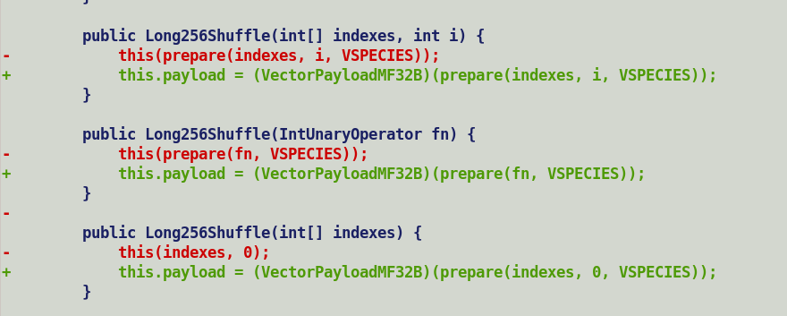

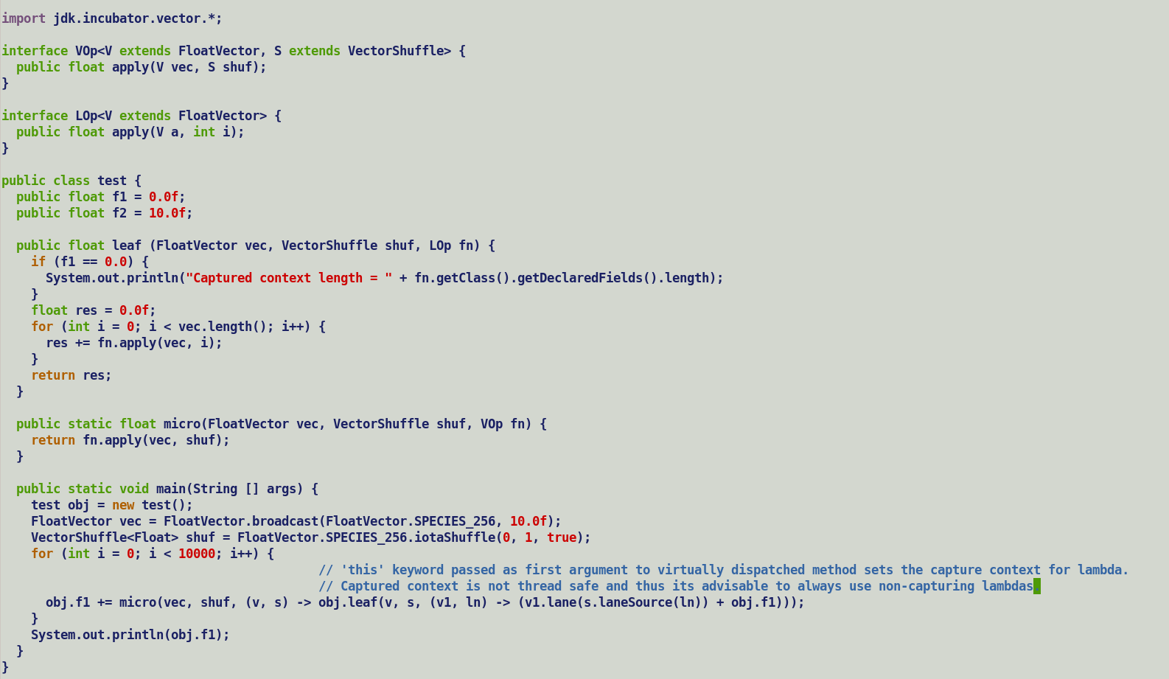



**New Code Model Scheme: -**

Treats value allocations as identity object allocations.

Source:

var val = new VectorPayloadMF64B();

ByteCode:

new #class_type -> Must be in larval state

invokespecial #class.<init> -> constructor should receive this in larval state and transition out of larval state before exiting.

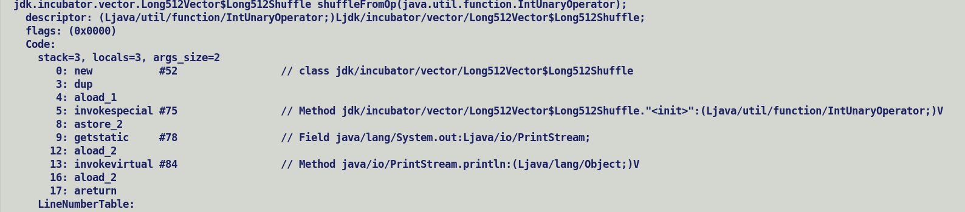

areturn from a constructor must transition the value object (InlineTypeNode) out of larval state.

MyValue (Payload obj) {

this.payload = obj;

}

MyValue(function) {

this(prepare(function));

}

var obj = new MyValue(function)

==============================

New LMyValue; => InlineTypeNode -> Larval

Invokespecial <init> => Larval receiver not to be scalarized. is_object_constructor().

New code model treat values are identity objects with respect to allocation, constructors are no longer factories which used to return a value using areturn bytecode, instead constructor now ends with a return bytecode after applying the desired initializations on incoming un-initialized value.

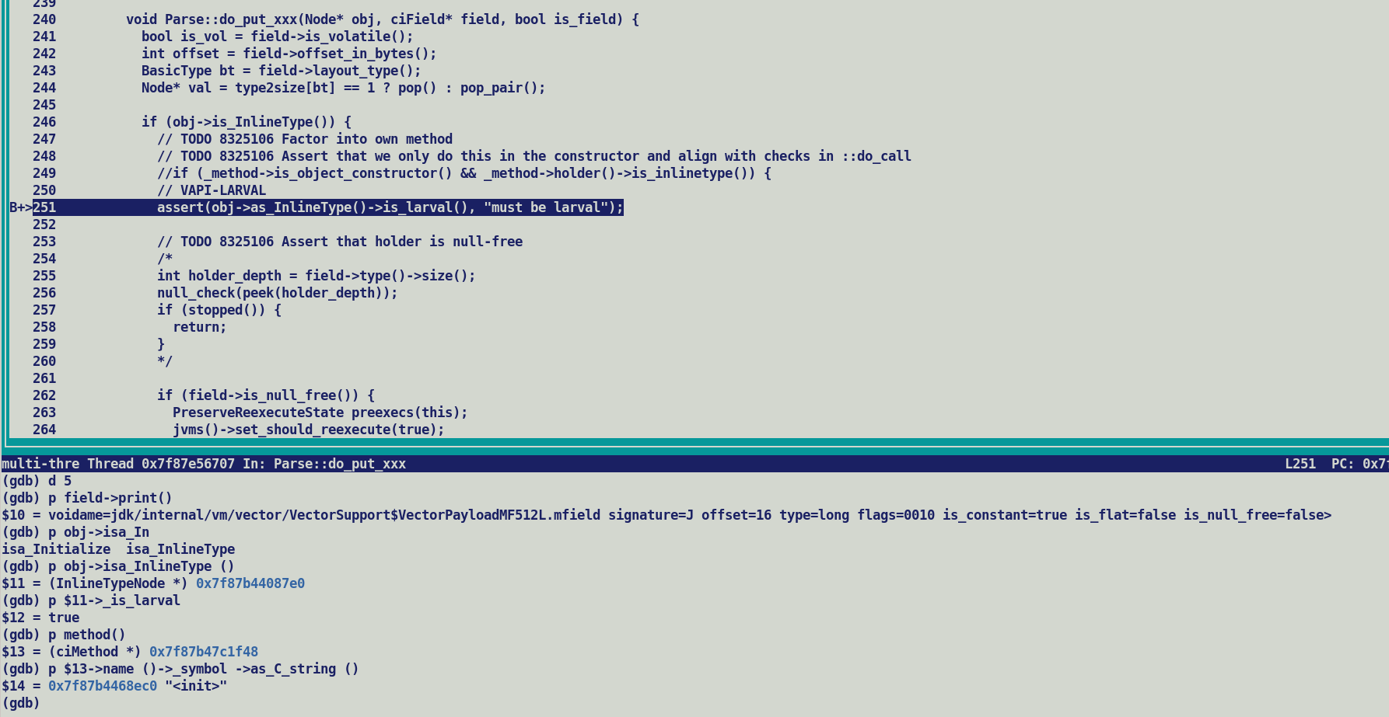

Value1 = new MyValue (10, 20); // Immutable

Value2 = new MyValue(Value1.field, 30) // 1. Update by explicit transition to mutable state using Unsafe.makePrivateBuffer

// 2. Create a new value altogether.

Latar case breaks down into two steps. New value allocation, which will transition IR to larvae (InlineTypeNode::_larval = true), this will be followed by invokespecial <init> to initialize field values using regular putfield bytecode.

Thus, a put over value should always receive a value in larval state. Post updates, new inline type node replaces the original value in the JVM state map maintained by SafePointNode.



To check

* replacements must also reflect into callers JVM state to allow any update on a larval receiver to be back propagated to caller. This is important for cases where larvae transition of receiver is trigged through unsafe API.
* Case where a bulky constructor is not inlined

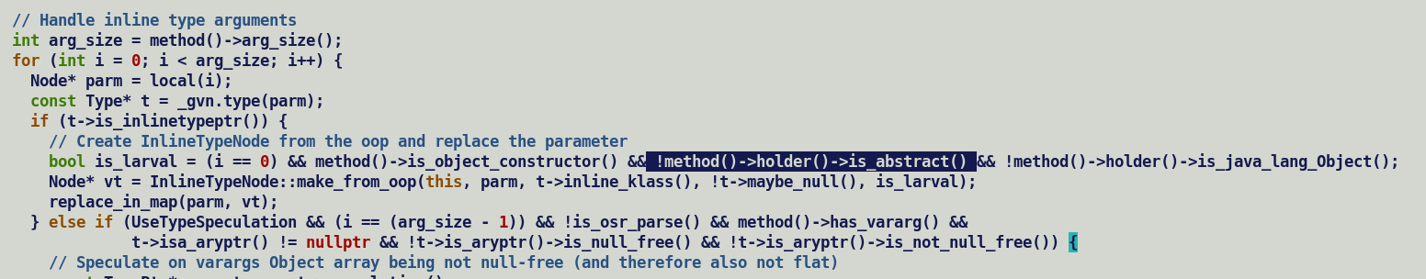

Abstract class method receivers are never scalarized.

Method which expects Non-scalarizable inlinetype arguments are passed buffered values.

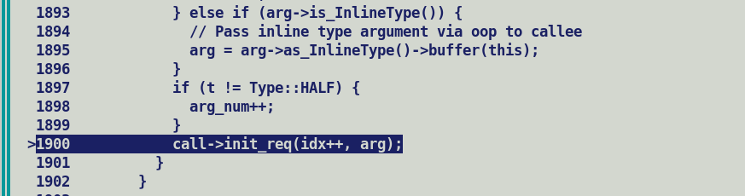

Post-return re-materialization from updated buffer.

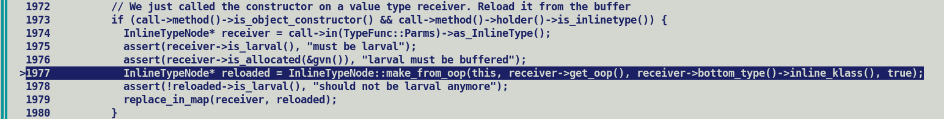

Non-inlined method receives values as this pointer and scalarizes it in the callee.

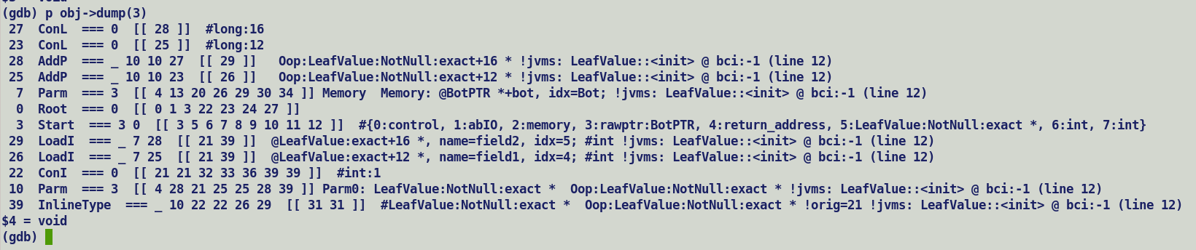



Buffers are kept in sync with InlineTypeNode field updates during putfield processing in *Parse::do_put_xxx.*

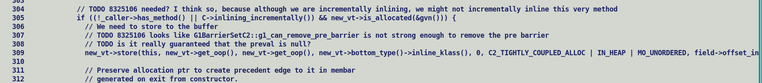

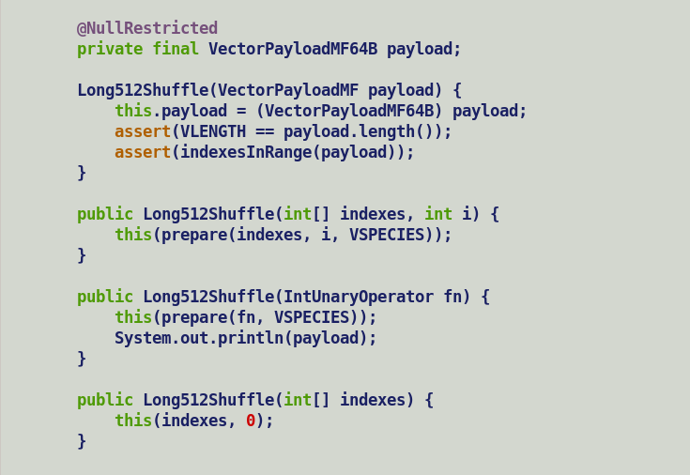



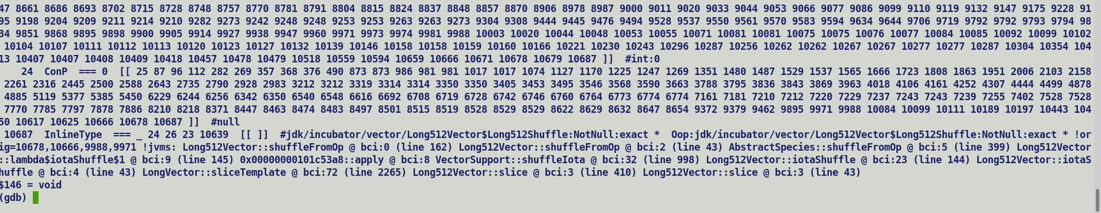

Value received by the constructor is not buffered, since the constructor was inlined hence updates are propagated back to the caller by way of JVM state updates.

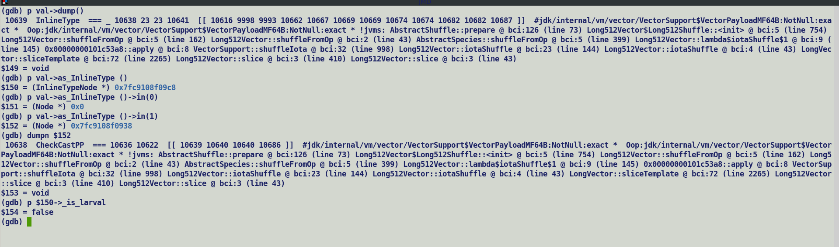

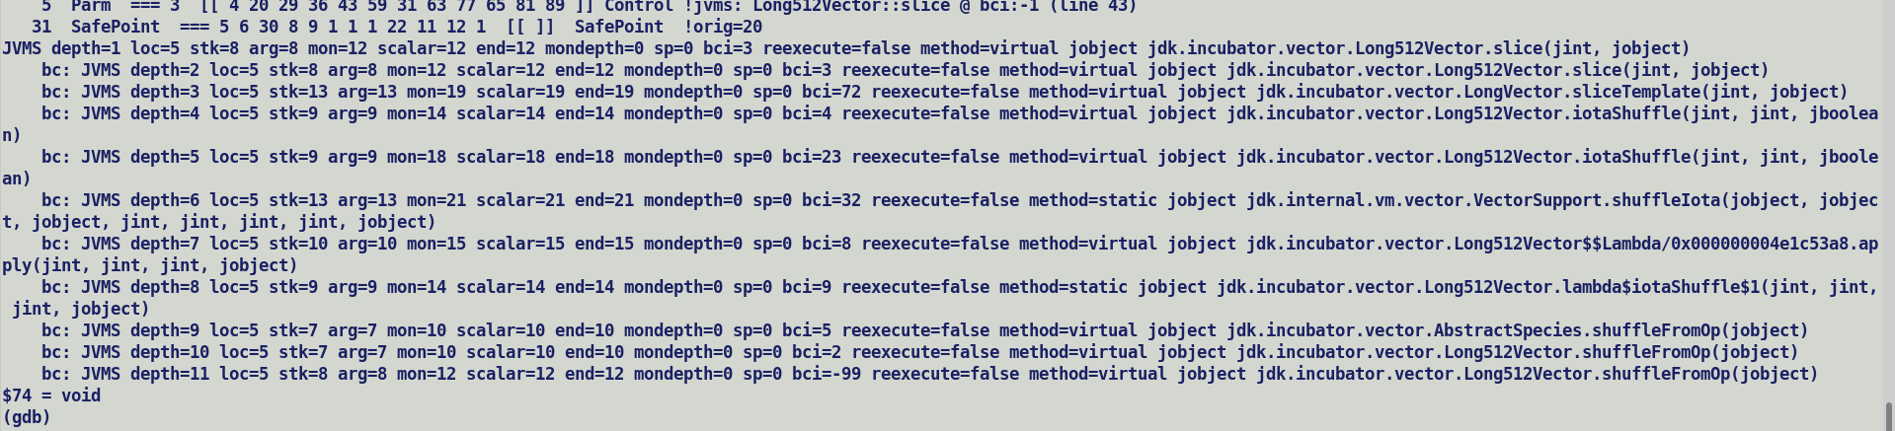

Lworld+vector JEP 401

1) Constructors are no longer a factory method, and are identical to regular identity constructors which accepts a uninitialized this object and updates its field values, this objects are in larval state during the lifetime of construction.

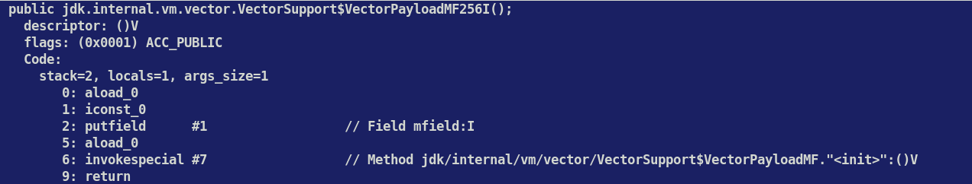

2) Deviation in putfield semantics, must update all the synthetic fields.

3) Intercepts for VectorPayloadMF creation / modification and returning.

a. vector / mask / shuffle factories ( new + constructor + areturn)

b. makeprivate buffer (noinline ? return j.l.o) + checkcast (scalarization) | disable scalarization return oop.

c. finishPrivate buffer (noinline ? return j.l.o) + checkcast (scalarization)

Q. When is make_from_multi used to construct InlineTypeNode ?

A. Make from multi (or make from multiple) is an API which stitches the individual field value to an InlineTypeNode.

Its called during initial state construction to scalarize the inline type arguments OR while handling value objects returned by non-inlined method invocations.

abstract value classes are not inline_types.

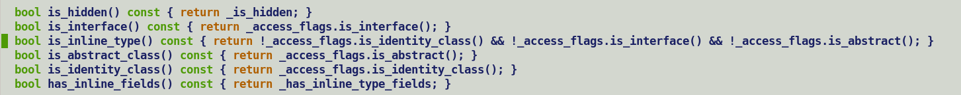

Intercepts for VectorPayload creation.

1) All the leaf level fallback APIs like bOpMF, uOpMF, tOpMF receive vector, shuffle and mask arguments, internally they first allocate a payload using factory methods, perform desired operations over it and then wrap them into concrete payloads.

2)

Nits:

API incoming args VBox (output of intrinsic) | Oop (output of non-intrinsic) => VUnbox

VBox -> Safepoint -> SafepointScalar + fields (Vector)

VectorNode

|

V

VBox

VectorBox IR never encapsulate an oop, it’s the oop representation of vector box which signify a vector with a backing storage.

Scalarization happens only if VBox is visible at SafePoint, as oop is already allocated over heap and not re-allocatable.

------------

IntVector res = null;

If (some_cond) {

res = VectorBox : IntVector.fromArray();

}

Phi null, res 🡺 merge_through_phi => VectorBox [ Phi null : LoadVector]

|

SafePointNode => SafePointScalarObject [ VectorBox : IntVector] => Phi

Test 1:

======

import jdk.incubator.vector.*;

import java.util.Arrays;

public class null_converged {

public static final VectorSpecies<Float> FSP = FloatVector.SPECIES_256;

public static final FloatVector zero = FloatVector.broadcast(FSP, 0);

public static void micro(boolean some_cond, float [] res, float [] arr, int cnt) {

FloatVector vres = zero;

if (some_cond) {

vres = FloatVector.fromArray(FSP, arr, 0);

}

// Phi = entry:zero , some_cond_blk:vres [Float256Vector]

// non-scalarized, boxed, no-box elimination, Phi Oop tied to safe-point.

// SafePointScalarObjects not created, oop is already in heap, and box not eliminable.

if ((arr[0] + cnt) >= 99999.0f) {

// UCT

System.out.println(vres);

}

vres.intoArray(res, 0);

}

public static void main(String [] args) {

float [] arr = {0, 1, 2, 3, 4, 5, 6, 7};

float [] res = new float[8];

for (int i = 0; i < 100000; i++) {

micro((i % 2) == 0, res, arr, i);

}

System.out.println(Arrays.toString(arr));

}

}

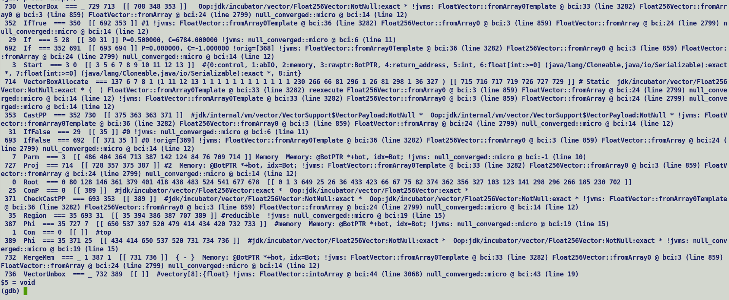

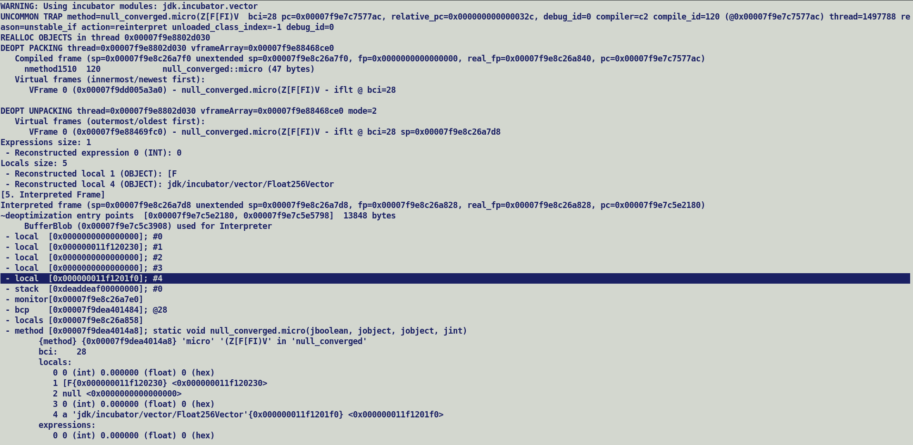

commit a53345ad03e07ab2a990721a506ebc25eed0f7c9

Author: Cesar Soares Lucas <cslucas@openjdk.org>

Date: Mon Jul 17 23:01:35 2023 +0000

8287061: Support for rematerializing scalar replaced objects participating in allocation merges

Reviewed-by: kvn, vlivanov

DEF1 --------🡪 DEF2

DEF1 -🡪 REG2MEM …… MEM2REG --🡪 DEF2

Parse

--------

IncrementalInlining (OFF) -> Intrinsification during parsing.

Optimize

-------------

IncrementalInlining (ON)

LoadVector -🡪 VectorBox -> Intrinsification during Lazy Inlining.

PhaseVector

SafePointScalarObjectNode

SafePoint …………SafePointScaleObjetNode(IDX)…………….IDX: LoadVector (field)

Matcher

---------------------------------------------------------------------------------

RA

----

LoadVector -> REG2MEM ------- MEM2REG --- VectorBox

EA eliminated Concrete Vectors bookkeeps their backing storage arrays fields at safe points, since arrays are already allocated over heap, hence its reference is passed as Location::oop / narrowOop and during remineralization directly assigned to newly allocated boxed object.

Non-escapable Int256Vector -> EA (-XX:+DoEscapeAnalysis + -XX:+PrintEscapeAnalaysis) are scalarized boxes are eliminated and a SafePointScalarObjectNode is created for rematerilization at SafePoint, field value i.e. an array based backing storage field is tied to safepoint for reassignment after box remineralization during deoptimization.

Re-materialize payload

------------------------------

If (payload.location())

If (Loacation.type() == Vector) // TypeVect (SPILL | VectorNode)

If (Loacation == Register)

Field value passed as vector. [A]

Else

Field value passed over stack (Reg2Mem spilling) [B]

Else

// EA eliminated non-escapable vector boxes, backing storage as array are allocated over heap.

Field value passed as oop / narrowOoop. [C]

Else

Unexpected Payload if not an ConP or Object [D]

EA can mark arrays with size less than EliminateAllocationArraySizeLimit to scalar replacible, non-constant length arrays are not eliminable since all its element initializations are not known at compile time. Mainly array only taking part in array copy are eliminatable, an element load is prevents its elimination.

For vector API use case backing storage are loaded / stored at element granularity preventing its elimination.

Only dummyVector created for type inferencing by directly instantiating the concrete vector boxes in internal implementation are eliminatable and since they are @Stable hence a constant after first initialization.

Static field are part of klass mirrors.

Existing Implementation re-mat of payload takes care of 4 cases [A,B,C,D] because backing storage is an array.

With payloads as Values, backing storage is never allocated in case payload is flattened into the concrete box[1].

Payload is only allocated iff it’s a non-flat field without @Nullrestricted attribution[2].

Here [1] corresponds to case [A] and [B] , case [C] is not possible with Value payload, case [D] corresponds to [2] where a separate ObjectValues are allocated for eliminated payloads and VectorBoxes.

Callee side box elimination for abstract value parameters: -

------------------------------------------------------------------------------

Single subclass parameters based on CHA anyways receive granular exact sub-class type.

For Vector API, resolution of concrete classes references in species initialization within abstract classes will load all the concrete vector classes when abstract class is loaded. Thus, an abstract class parameter will always observe multiple sub-classes.

Parameter profiles are applied after initial state construction (build_start_state), for an abstract value class parameter application of sharper concrete value type will scalarize the incoming parameter. But original incoming parameter will still be passed as a buffered value argument from caller side.

Parameter scalarization decisions are taken upfront during signature computations (CompiledEntrySignature) during method adapter creation.

Thus, with existing Valhalla framework and current vector API implementation it will not be possible to dismantle value boxes and just pass the vector across the method call, a boxing penalty will still be incurred by non-inlined routines since vector API only exposes abstract classes to users and all the internal JDK classes also makes use of abstract vector classes in method parameter.

JEP 471 Deprecates sun.misc.Unsafe and removal in future.

* lworld+vector support Java side changes alignment with VarHandle.

Mid and Backend will have no impact.

* VarHandle based value object update

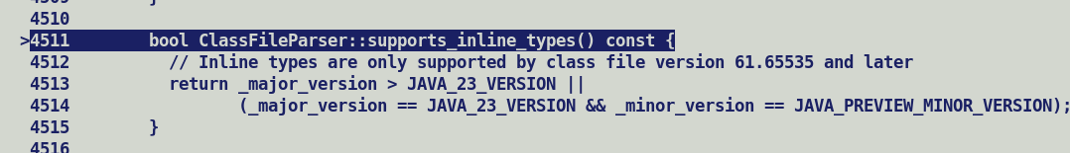

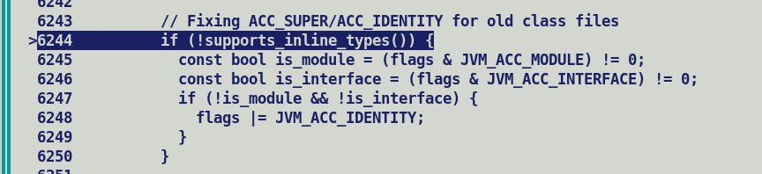

Klass resolution stack trace during new object construction

* Loading: .class file using appropriate class loader.



* Linking:
  + Symbol resolution



* + - Method invocation.
    - Field Access
    - New Instance allocation.

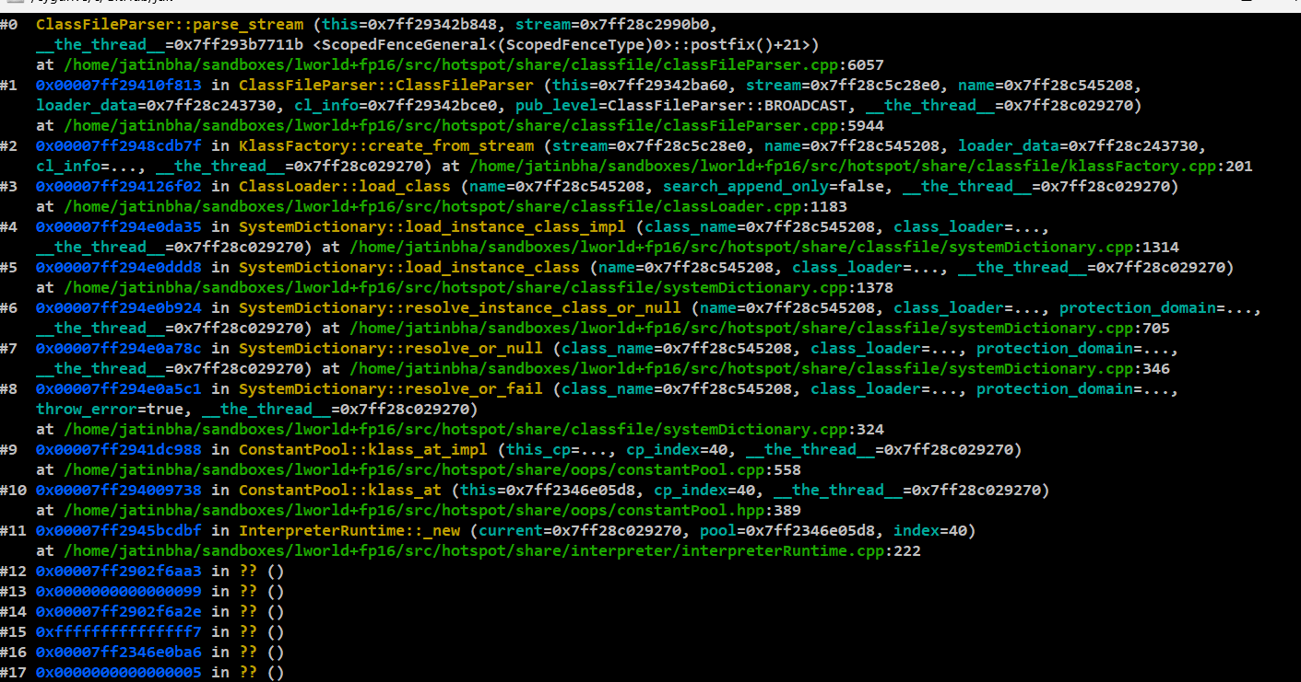

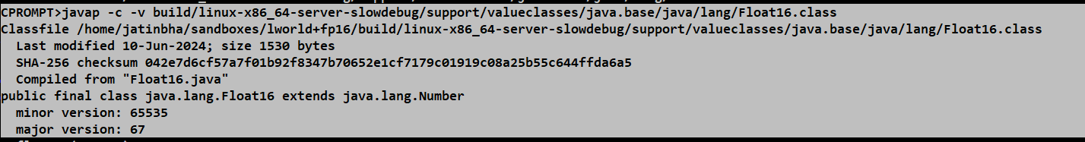

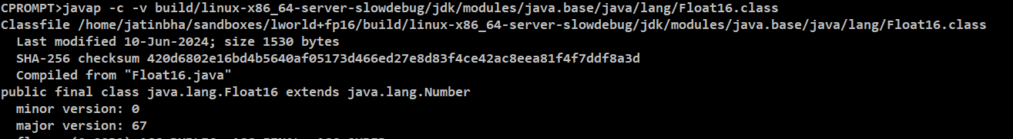

Resolution path ordering rules must give preference to valueclasses. Handled using module patching technique.

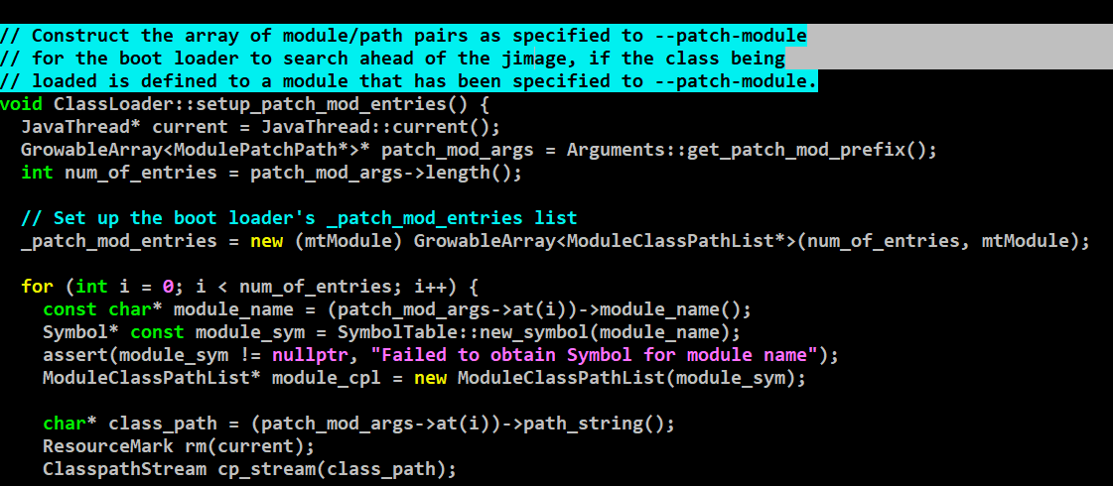

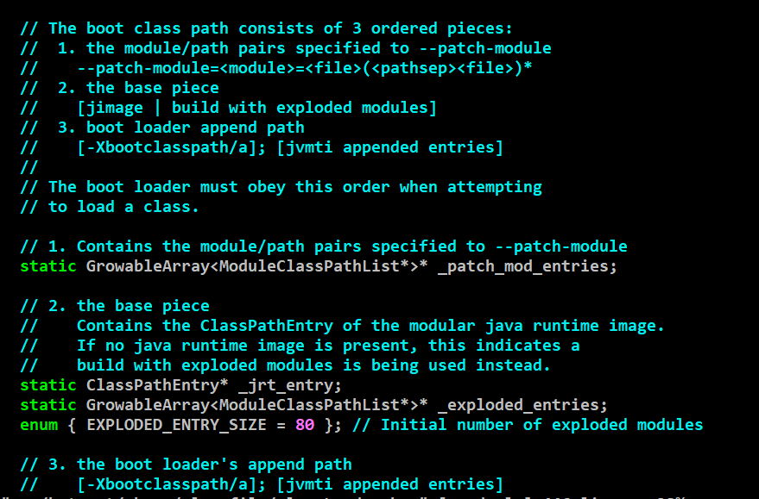

InlineKlass type field pre-loading during holder loading.

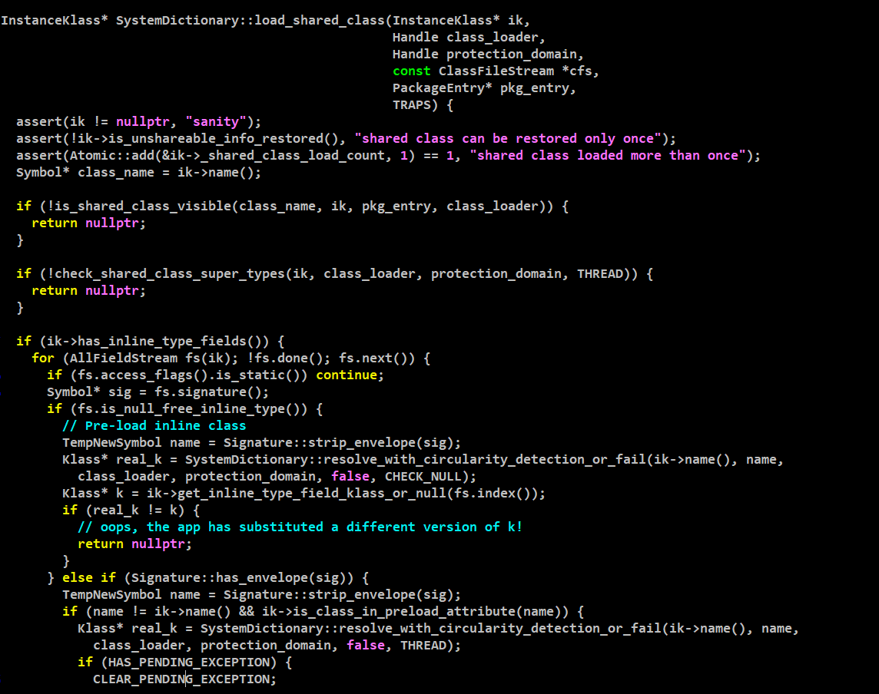

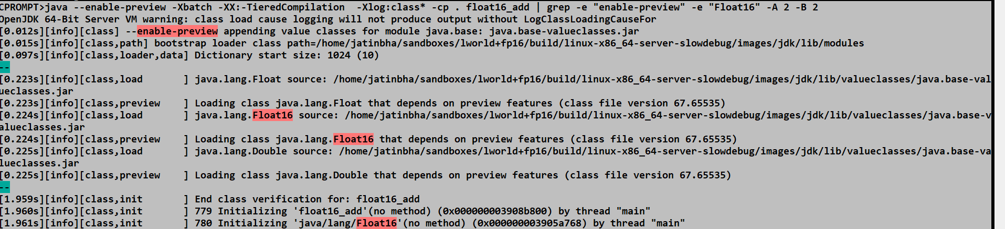

With –enable-preview and EnableValhalla => ValueBased Classes are inferred as InlineKlass, else as InstanceKlass.



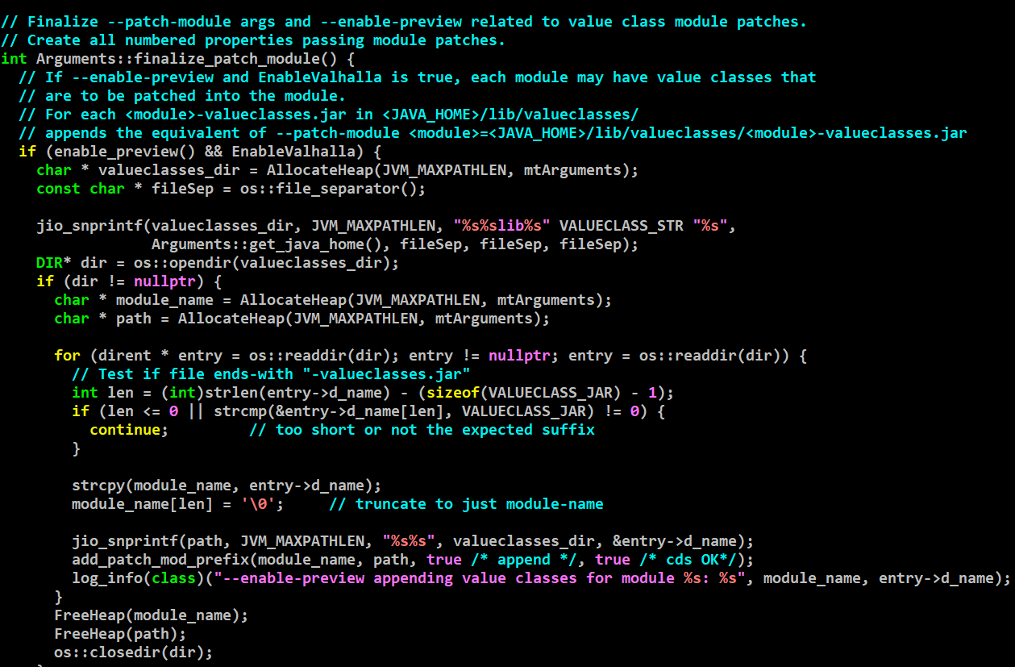

Flattening ensures contiguity in layout of backing storages of individual value object in an array, else SLP will observe non-contiguous loads / stores and will not auto-vectorize. SLP contiguity detection is based on memory address (VPointer),

A change in InterpreterRuntime::anewarray is sufficient to ensure contiguous allocation of backing storage of values.

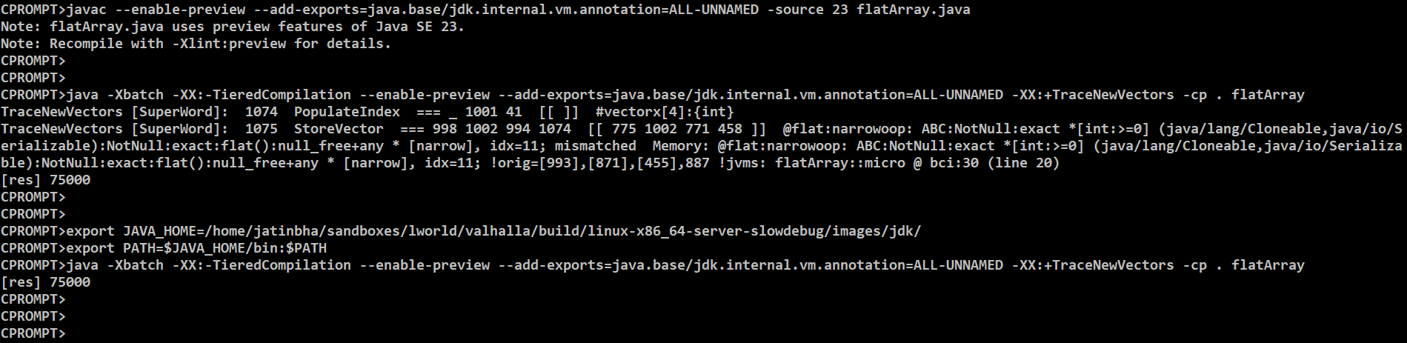

**2D flat arrays:**

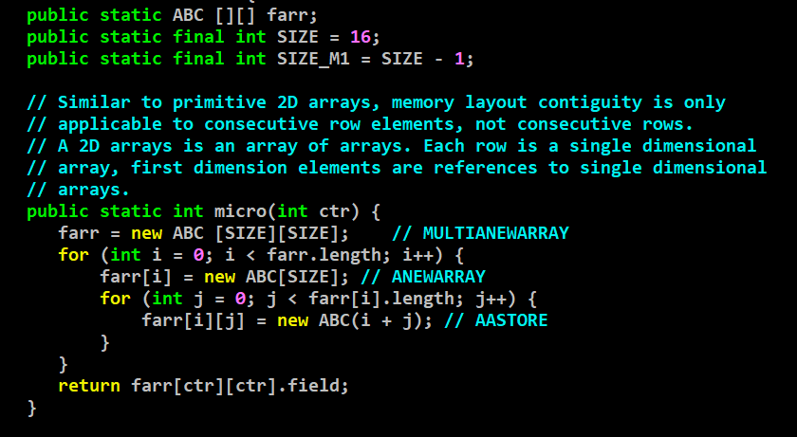

(gdb) p $20->print()

[[QABC;

{0x000000011f0137b0} - klass: 'ABC'[][]

- length: 16

- 0 : a 'ABC'[16] {0x000000011f013800}

- 1 : a 'ABC'[16] {0x000000011f013850}

- 3 : a 'ABC'[16] {0x000000011f0138f0}

- 4 : a 'ABC'[16] {0x000000011f013940}

- 5 : a 'ABC'[16] {0x000000011f013990}

- 6 : a 'ABC'[16] {0x000000011f0139e0}

- 7 : a 'ABC'[16] {0x000000011f013a30}

- 8 : a 'ABC'[16] {0x000000011f013a80}

- 9 : a 'ABC'[16] {0x000000011f013ad0}

- 10 : a 'ABC'[16] {0x000000011f013b20}

- 11 : a 'ABC'[16] {0x000000011f013b70}

- 12 : a 'ABC'[16] {0x000000011f013bc0}

- 13 : a 'ABC'[16] {0x000000011f013c10}

- 14 : a 'ABC'[16] {0x000000011f013c60}

- 15 : a 'ABC'[16] {0x000000011f013cb0}

GNR => AMX_FP16

Load store in tile needs a contiguous memory layout, 2D primitive class arrays do not fit into that requirement.

Single dimension matrix of primitive FP16 class offer contiguous layout guarantee.

JEP-471 only deprecates externally visible Unsafe interfaces part of sun.misc.Unsafe.

This does not effect, jdk.internal.misc.Unsafe APIs which are heavily used in VarHandles, Valhalla based Vector APIs.

lworld+vector

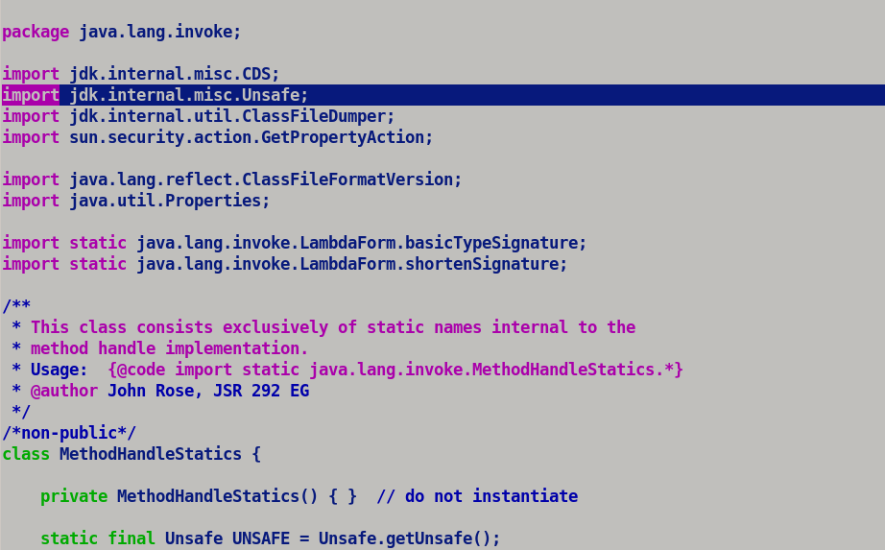

Flat Array Bug:-

**No NPE post deoptimization**

CPROMPT>java -XX:+TraceDeoptimization -XX:+PrintDeoptimizationDetails --add-exports=java.base/jdk.internal.vm.annotation=ALL-UNNAMED -XX:-TieredCompilation -XX:CompileOnly=check_null_assignment::test2 -Xbatch --enable-preview -cp . check_null_assignment

CompileCommand: compileonly check_null_assignment.test2 bool compileonly = true

field : 10

field : 10

UNCOMMON TRAP method=check_null_assignment.test2(I)V bci=10 pc=0x00007ffad8b43008, relative_pc=0x0000000000000048, debug_id=0 compiler=c2 compile_id=82 (@0x00007ffad8b43008) thread=705621 reason=unstable_if action=reinterpret unloaded_class_index=-1 debug_id=0

reassign fields for object of type [LMyValue;!

REALLOC OBJECTS in thread 0x00007ffae402a650

object <0x000000011f891070> of type 'MyValue'[] allocated (80 bytes)

DEOPT PACKING thread=0x00007ffae402a650 vframeArray=0x00007ffae466f750

Compiled frame (sp=0x00007ffaeae3e830 unextended sp=0x00007ffaeae3e830, fp=0x0000000000003a98, real_fp=0x00007ffaeae3e850, pc=0x00007ffad8b43008)

nmethod1243 82 check_null_assignment::test2 (18 bytes)

Virtual frames (innermost/newest first):

VFrame 0 (0x00007ffae46555d0) - check_null_assignment.test2(I)V - if_icmpne @ bci=10

DEOPT UNPACKING thread=0x00007ffae402a650 vframeArray=0x00007ffae466f750 mode=2

Virtual frames (outermost/oldest first):

VFrame 0 (0x00007ffae4670a30) - check_null_assignment.test2(I)V - if_icmpne @ bci=10 sp=0x00007ffaeae3e7e0

Expressions size: 2

- Reconstructed expression 0 (INT): 15000

- Reconstructed expression 1 (INT): 15000

Locals size: 2

- Reconstructed local 1 (OBJECT): [LMyValue;

[1. Interpreted Frame]

Interpreted frame (sp=0x00007ffaeae3e7e0 unextended sp=0x00007ffaeae3e7e0, fp=0x00007ffaeae3e838, real_fp=0x00007ffaeae3e838, pc=0x00007ffad899aa60)

~deoptimization entry points [0x00007ffad899aa60, 0x00007ffad899e078] 13848 bytes

BufferBlob (0x00007ffad8976210) used for Interpreter

- local [0x0000000000000000]; #0

- local [0x000000011f891070]; #1

- stack [0xdeaddeaf00003a98]; #1

- stack [0xdeaddeaf00003a98]; #0

- monitor[0x00007ffaeae3e7f0]

- bcp [0x00007ffa8c715c5a]; @10

- locals [0x00007ffaeae3e850]

- method [0x00007ffa8c715c70]; static void check_null_assignment.test2(jint)

{method} {0x00007ffa8c715c70} 'test2' '(I)V' in 'check_null_assignment'

bci: 10

locals:

0 0 (int) 0.000000 (float) 0 (hex)

1 a 'MyValue'[16] {0x000000011f891070} <0x000000011f891070>

expressions:

0 15000 (int) 0.000000 (float) 3a98 (hex) -2401018183117948264 (long)

-1.193551171177837e+148 (double) 0xdeaddeaf00003a98 (longhex)

1 15000 (int) 0.000000 (float) 3a98 (hex)

**Interpreter Throws correct exception on null value assignment for NullRestrictedArray.**

CPROMPT>java -XX:+TraceDeoptimization -XX:+PrintDeoptimizationDetails --add-exports=java.base/jdk.internal.vm.annotation=ALL-UNNAMED -Xint -XX:CompileOnly=check_null_assignment::test2 -Xbatch --enable-preview -cp . check_null_assignment

CompileCommand: compileonly check_null_assignment.test2 bool compileonly = true

field : 10

field : 10

Exception in thread "main" java.lang.NullPointerException: Cannot store to object array because "<local1>" is null or is a null-free array and there's an attempt to store null in it

at check_null_assignment.test2(check_null_assignment.java:36)

at check_null_assignment.main(check_null_assignment.java:42)

CPROMPT>

PreserveReexecuteState preexecs(this);

* Allocation runtime de-opts in slow path.
* Special cases where compiler wants to delegate error / exception handling to interpreter.

Valhalla Refresher: -

----------------------------

Make an InlineTypeNode from multi (multiple output nodes [StartNode, CallNode (multiple projections)])

a) During incremental inlining.

invokevirtual/invokestatic <value argument>

* Parser
  + CallStatic/DymamicJavaNode <scalarized_argument_list>
* Optimizer
  + Late Inline Call generator.
    - Re-compose InlineTypeNode from scalarized argument so that inline expander receives an InlineTypeNode representing a bundle of scalarized fields.
      * InlineTypeNode::make_from_multi.

b) Initial start state construction.

c) During return value processing in DirectCallGenerator::generate.

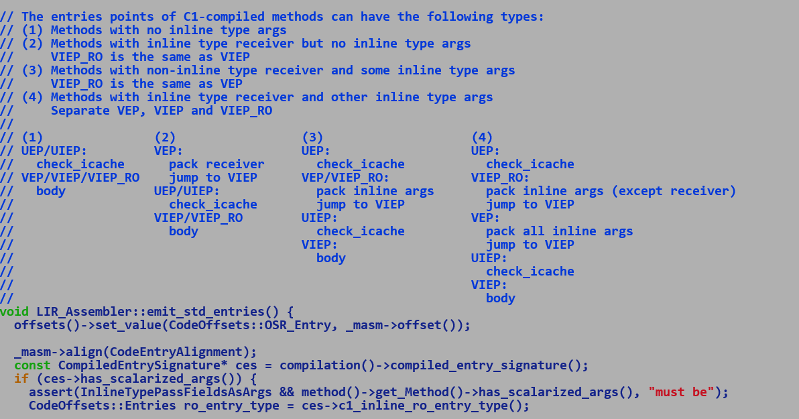

Interpreter / C1 => Unpacks return value if InlineTypeReturnedAsFields is true, always expects buffered values parameters.

C2 => Support scalarization on entry and exits using special entry points for scalarization or by tying individual scalarized return fields *Compile::return_values* to return node, on caller side scalarized projections are re-assembled to form an InlineTypeNode which is passed to down stream graph.

Merge: -

1) src/java.base/share/classes/java/lang/classfile/attribute/PreloadAttribute.java becomes LoadableDescriptorAttribute.java

- Null restricted value class field types must load eagerly before FieldLayoutComputation to ascertain exact class layout size recorded int layout helper of mark word.

2) New LayoutRawBlock types.

NULL_MARKER, // stores the null marker for a flat field

INHERITED_NULL_MARKER // a super-class used this slot to store a null marker

3)InlineKlassFixedBlock: no longer derivative of MetaSpaceObj, hence not saved in CDS archive which calls *metaspace_pointers_do*  on its derivatives during pointer swizzling.

4)

Explicit vs Implicit larval state transitions:-

* Implicit driven by object construction, newly allocated object is in larval state while its various fields are being updated by constructor.
* Explicitly transitioned to larval state by usage of Unsafe.makePrivateBuffer().

5) Additional ImplicitConstructibility on super class enforced, earlier only LooselyConsistenValue was necessary to be applied on entire class hierarchy above value non-atomic value class.

TEMP:

Parse3.cpp changes for Valhalla regressions.

6) With new code model, constructors are no longer factories and are identical to identity constructors which receive a this pointer and updated each field individually using putfield bytecode. For multifield we only emit a single putfield bytecode in the constructor thus same value is replicated across all the synthetic / base multifield.

For Valhalla (lworld)

---------------------------

CPROMPT>git diff make/langtools/src/classes/build/tools/symbolgenerator/CreateSymbols.java

diff --git a/make/langtools/src/classes/build/tools/symbolgenerator/CreateSymbols.java b/make/langtools/src/classes/build/tools/symbolgenerator/CreateSymbols.java

index b5dfaf1247c..749a1d6c826 100644

--- a/make/langtools/src/classes/build/tools/symbolgenerator/CreateSymbols.java

+++ b/make/langtools/src/classes/build/tools/symbolgenerator/CreateSymbols.java

@@ -2585,7 +2585,7 @@ private boolean readAttribute(ClassFile cf, FeatureDescription feature, Attribut

}

((FieldDescription) feature).constantValue = value;

break;

- case "Preload":

+ case "LoadableDescriptors":

case "SourceFile":

//ignore, not needed

break;

======================= ./LOGS_VALHALLA_avxlevel0/test-results/jtreg_test_hotspot_jtreg_compiler_valhalla/text/newfailures.txt ======================

# newfailures.txt

compiler/valhalla/inlinetypes/TestBufferTearing.java

compiler/valhalla/inlinetypes/TestNewAcmp.java

======================= ./LOGS_VALHALLA_avxlevel2/test-results/jtreg_test_hotspot_jtreg_compiler_valhalla/text/newfailures.txt ======================

# newfailures.txt

compiler/valhalla/inlinetypes/TestBufferTearing.java

compiler/valhalla/inlinetypes/TestNewAcmp.java

compiler/valhalla/inlinetypes/TestNullableInlineTypes.java

======================= ./LOGS_VALHALLA_avxlevel3/test-results/jtreg_test_hotspot_jtreg_compiler_valhalla/text/newfailures.txt ======================

# newfailures.txt

compiler/valhalla/inlinetypes/TestBufferTearing.java

compiler/valhalla/inlinetypes/TestNewAcmp.java

compiler/valhalla/inlinetypes/TestNullableInlineTypes.java

======================= ./LOGS_VALHALLA_avxlevel1/test-results/jtreg_test_hotspot_jtreg_compiler_valhalla/text/newfailures.txt ======================

# newfailures.txt

compiler/valhalla/inlinetypes/TestBufferTearing.java

compiler/valhalla/inlinetypes/TestDeoptimizationWhenBuffering.java

======================= ./LOGS_VALHALLA_avxlevelKNL/test-results/jtreg_test_hotspot_jtreg_compiler_valhalla/text/newfailures.txt ======================

# newfailures.txt

compiler/valhalla/inlinetypes/TestBufferTearing.java

compiler/valhalla/inlinetypes/TestDeoptimizationWhenBuffering.java

compiler/valhalla/inlinetypes/TestNewAcmp.java

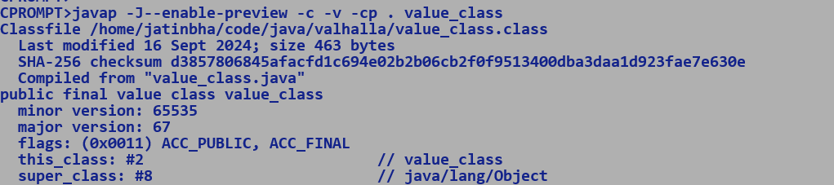

Larval Value :

* <https://bugs.openjdk.org/browse/JDK-8046159>

Explicit :- User triggered larval state migrations using Unsafe.makePrivateBuffer and Unsafe.finishPrivateBuffer.

Implicit :- Marked on new value object allocation, IR specific property. New value object, is unbuffered, in_larval is initialized, is_null_free with oop pointing to ZERO/NULL OBJECT.

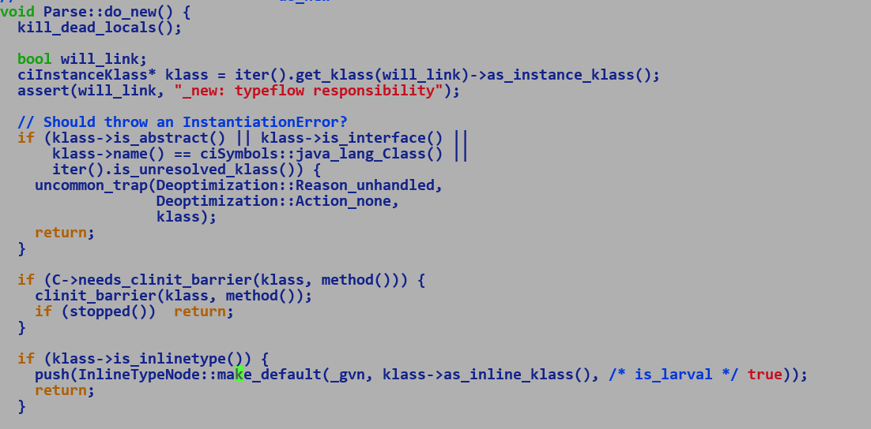

Q. Exit point of implicit larval state.

A. Soon before passing the value object to super constructor we transition it out of larval state.

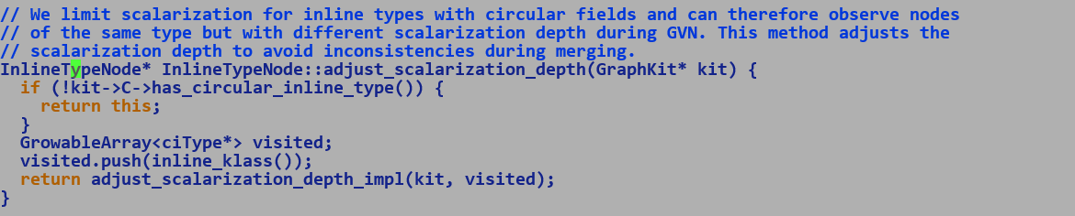

If a value object is allocated and assigned to a non-flat field soon after construction then its buffered by access routines.

Assigning value object to a non-flat field automatically buffers the value object.

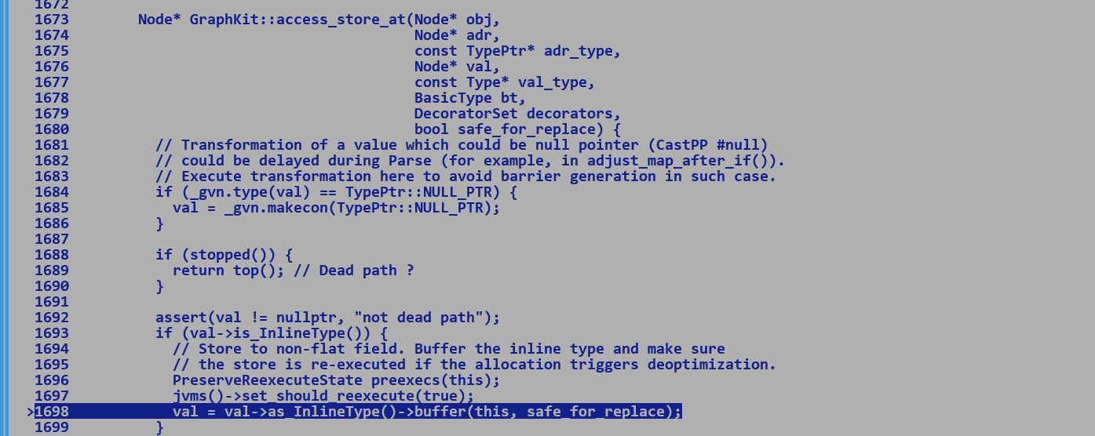

In addition to honouring the value object construction semantics which guarantees that all the fields must be initialized before super constructor call (this is opposed to identity object where super constructor is first statement to be executed in the constructor).

In this case we transition to newly created value object out of larval state before making the call to super constructor…

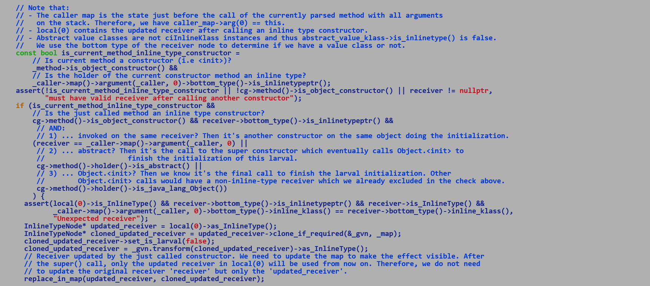

Thus, the lifetime of implicit larval state is b/w value object allocation and super constructor call.

Compiler does not allow passing ‘this’ value object to any other scope before super type construction

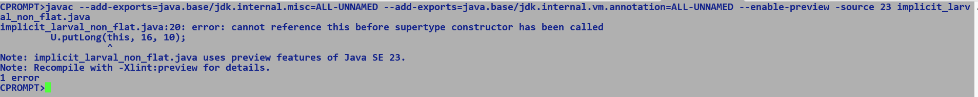

While in larval state value object cannot be scalarized.

Q. Any scenario where implicit larval state needs to be propagated during deoptimization.

A. Unsafe APIs which update value object in mutable state cannot be called before super constructor call. GC object movement preserve explicit larval state, but not implicit ones since its only marked at IR level but its not going to result into any violation.

Explicit Larval States:-

* Enters or exits larval state using Unsafe.makePrivateBuffer and Unsafe.finishPrivateBuffer APIs.
* Unlike implicit larval state, life time of explicitly created larval value object can span across multiple blocks, control flows or across activations.
* C2 compiler should not attempt scalarization of a value object in larval state.
* Compile must record explicit larval state while rematerializing value object during de-optimization.
* Currently, at IR level explicit larval state is associated with AllocateNode while implicit larval state is part of InlineTypeNode.
* Explicitly transitioned larval value object is always buffered.

Uses of explicitly marked larval value objects.

* For virtual dispatch as receiver object
* Passed as argument in non-scalarized form.
* Return value of method.

Performance of unsafe updates vs creating a new immutable vector with each lane update.

* Multifield annotated field is a bundle of scalars, only the base or the topmost field of the bundle is visible to used, synthetic fields are accessed using unsafe APIs.
* Multifields always have a flat layout.

Problems with use of explicit scalar fields in place of multifields.

* Multifield guarantees flat contiguous layout.
* Exact layout of fields in class is determined at runtime and could be different from sequence of fields in source. Existing layout computation groups the field into different groups and sorts the field within each group based on the field sizes, thus even though homogeneous primitive fields will be laid of contiguously currently, but their ordering may vary in future, this will make Vector load / store operation from / to group of scalar fields tricky and non-deterministic. FIXED LAYOUT CAN BE ENFORCED THROUGH A NEW ANNOTATION to lift the concerns around layout randomization.
* Group of scalar fields can be updated without Unsafe.put / get APIs by generating a new immutable VectorPayload with each lane update, this removes the complexity associated with explicit larval state transitions and implementation is well aligned with existing Valhalla infrastructure with only Java side changes need to VectorAPI and minimal changes in compiler to load / store the flat payload to / from vector.
* Unsafe.makePrivateBuffer allocates a buffer replaces existing InlineTypeNode with the buffer in larval state to prevent any accidental scalarization. This also makes the flow complex at convergence points where a buffer meets an InlineTypeNode, in such a case we should buffer the InlineTypeNode and create Phi node converging the two buffers.
* Finish Private Buffer, re-materializes InlineTypeNode from buffer.
* Sending explicitly transitioned larval values across method calls is again tricky as function signatures are fixed during linking and expect to receive value objects in scalarized form. We also need to prevent any scalarization of larval argument in callee context since larval transition imparts temporal identity semantics to a value object and any update over larval value object in callee must be reflected back to caller.
  + - * This is not straight forward given that C2 compiler always expects value object to be scalarized before method body in method entry points.

Exploring Non multifield based solution :-

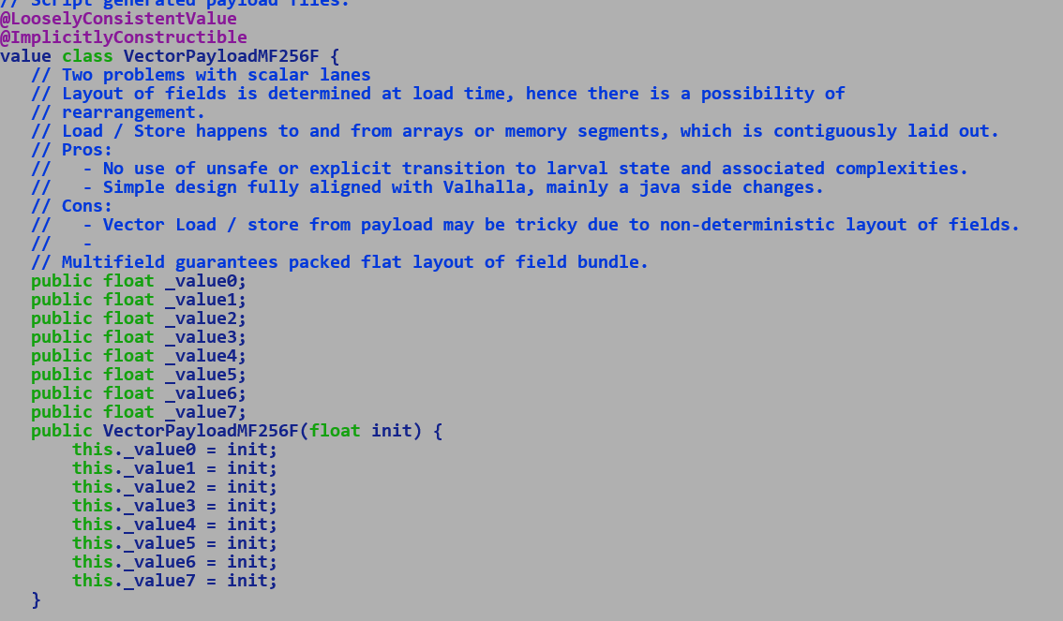

Test for dry run:

FloatVector.fromArray(SPECIES, ARR, IDX) // Static method.

.lanewise(VectorOperators.ADD, 100.0f)

.intoArray(RES, IDX);

LoadVector (BASE(ARR) + IDX * SIZEOF(ARR.ELEMENT))

|

V

VectorPayloadMF256F -> it’s a value class with 8 float type fields, thus in a stock implementation an InlineTypeNode corresponding to it should have 8 inputs and not one monolithic vector input.

Inserting synthetic VectorExtractIR

LoadVector ( make_from_flat_impl will recursively traverse any flat field and will create scalar inputs corresponding to each scala field) => if we want any special handling to load from first field and assume contiguity in memory then it will again be a hack based on either a attribute over first such field and skipping over subsequent ciFields which is very hacky, if we only create one ciField for representing sequence of scalars then C2 solution is similar to what we have currently and existing multifiled based solution is much more elegant.

| | | | | |

V V V V V V

VectorExtract[0]

| VectorExtract[1]

| | VectorExtract[2] -> Q. Will such extraction will be specific to VectorPayloadMF256F

| | | VectorExtract[3] A. This structure is just created preserve IR contracts, Unbox – Boxing

|------🡪 VectorPayloadMF256F 🡨------------------------| will sweep out this intermediate logic and directly operate over

| LoadVector, new make_from_vector to create necessary logic, again there is a constraint, type and lane count of vector must comply with type and number of fields in the value class.

Another kludge, since VectorPayloadMF256F has scalar field for each vector lane, hence corresponding InlineTypeNode will have eight scalar inputs, one oop field pointing to the buffer node, one init field. There is no space left to have a pointer to LoadVector other than utilizing oop field or to create a specialized InlineTypeNode for VectorPayload which along with scalar inputs also has and edge to Vector , and then do we expect extracts to be inserted b/w Vector and scalar inputs ?

We chose this path to avoid the complexity of explicit larval state, but C2 IR may get complexified. So multifield based approach is definitely elegant way of handling it.

…..

Fully explore individual scalar fields…

VectorPayloadMF256F vec1 = v1.vec();

VectorPayloadMF256F vec2 = v2.vec();

float [] workarray = new float[8];

for (int I = 0; i< 8; i++) {

workarray[i] = U.getInt(vec1, I * 4) + U.getInt(vec2, I * 4);

}

VectorPayloadMF256F tpayload = new VectorPayloadMF256F();

tpayload = U.updateBuffer(tpayload, workarray[i], length); // Not – intrinsified, thus compile will always buffer the tpayload before passing it.

// It also returns the updated value buffer. Which will be automatically rematerialize InlineTypeNode during return value processing.

// If we create its intrinsic then it will also buffer the value, emit multiple Load / Stores pairs to load the contents of workarray and store it into buffer, towards the end since updateBuffer returns the update value hence intrinsic will rematerialize InlineTypeNode from updated buffer and return to caller.

Pros:

* Scope of mutable state is limited to updateBuffer.
  + It will be exactly on the lines of implicit larval state, which a new value object enters on construction, and it ends just before the super call construction.
  + Larval marking will be at IR level.
  + Thus a value object will be in larval state during U.updateBuffer and will leave the larval state before exit
  + U.updateBuffer expects to operate on buffer value.
* We do not hit problem of missing inductive phi node in loop since Unsafe.put returns a void and thus ciTypeFlow does not infer an inductive phi node.
* Out new updateBuffer returns update value object.
* We are not breaking constructor constraints.

Idea is to create a new Unsafe API to update multifield which returns updated value object, larval state transition is restricted to this API and since it return a value object hence ciTypeFlow will have no problem in inferring the induction variable if this appears in a loop.

V updateMultifield (V VALUE_OBJECT, int MULTIFIELD_OFFSET, type[] ARRAY, int LEN)

Recently filed JBS [[JDK-8199429] [valhalla] value type (re)constructors expressions should not be discardable - Java Bug System (openjdk.org)](https://bugs.openjdk.org/browse/JDK-8199429)

In in line with above strategy.

**11/12/2024**

Important Entry Points:-

* KlassFactory
  + Each class has a list of primary and secondary super classes, the primary super class list is composed of parent classes which this class extends while secondary super classes comprise a list of interfaces implemented by this class.
* CompiledEntrySignature
  + Custom-calling convention b/w C2 compiled methods to use additional APX registers to pass flat fields of the value object.

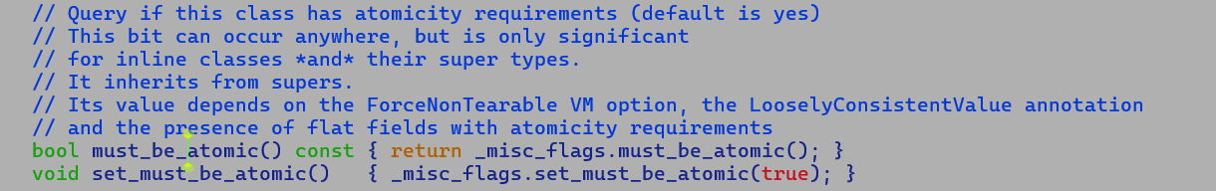

* Value class instance must be updated atomically, to relax this, annotate the Value class with LooselyConsistentValue annotation.
  + To enforce atomic update, value instances are not flattened by default, and value type field holds a pointer to an instance. 64-bit pointer updates are naturally atomic (especially on targets like x86) if pointers are aligned to 8-bytes boundary.
  + Small value type fields with sizes less than 64-bit can be automatically flattened without any concerns regarding non-atomic updates or word tearing.
* NullableFieldFlattening
  + the layout must include a null marker and must also be atomic
* Preload attribute has been renamed to “LoadableDescriptors”, we need to pre-load Implicitly constructible value classes for field layout computation. Use -Xlog:class+preload to dump the list of preloaded classes.
  + Preload attribute is part of classfile holding a flat field.

New Set of global added to Valhalla

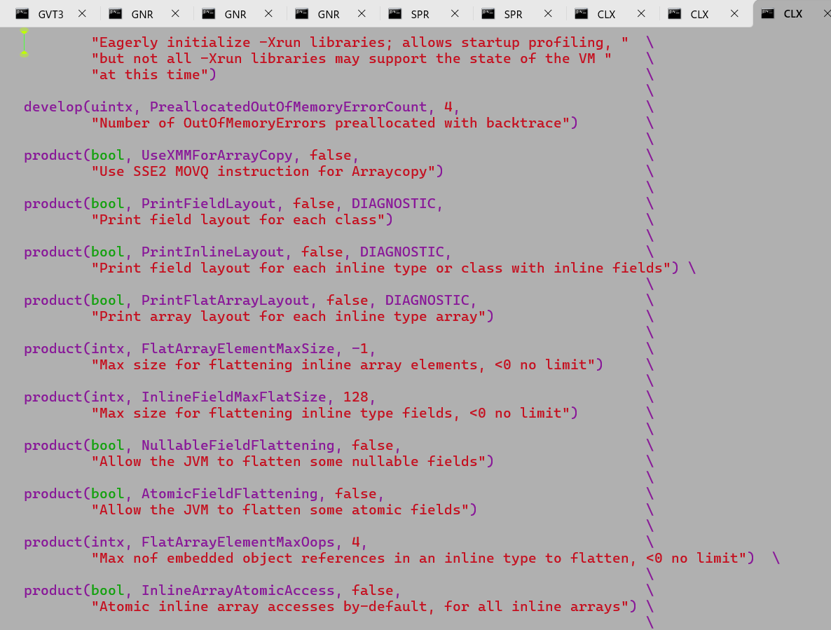

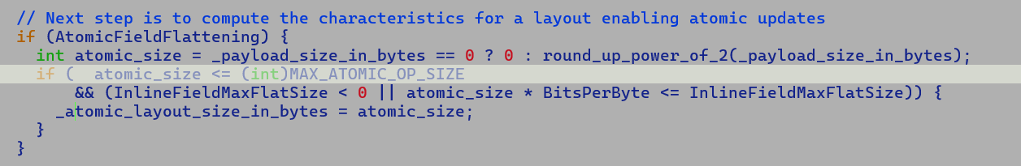

Atomic fields are flattened only if cumulative size of files of field value class is less than 64 bytes.

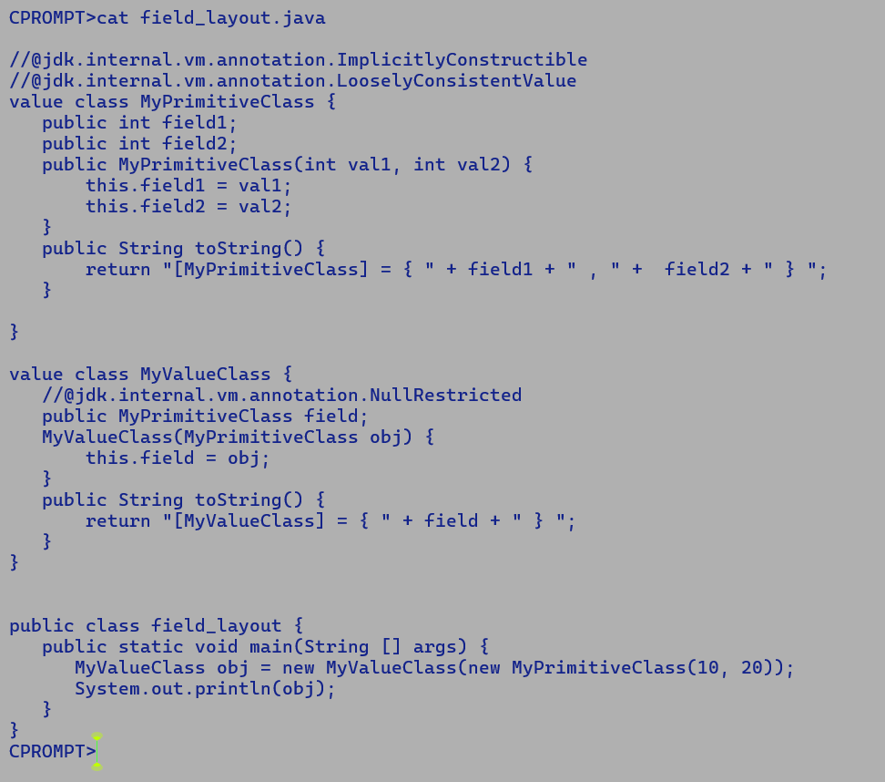

Case A) Default option layout

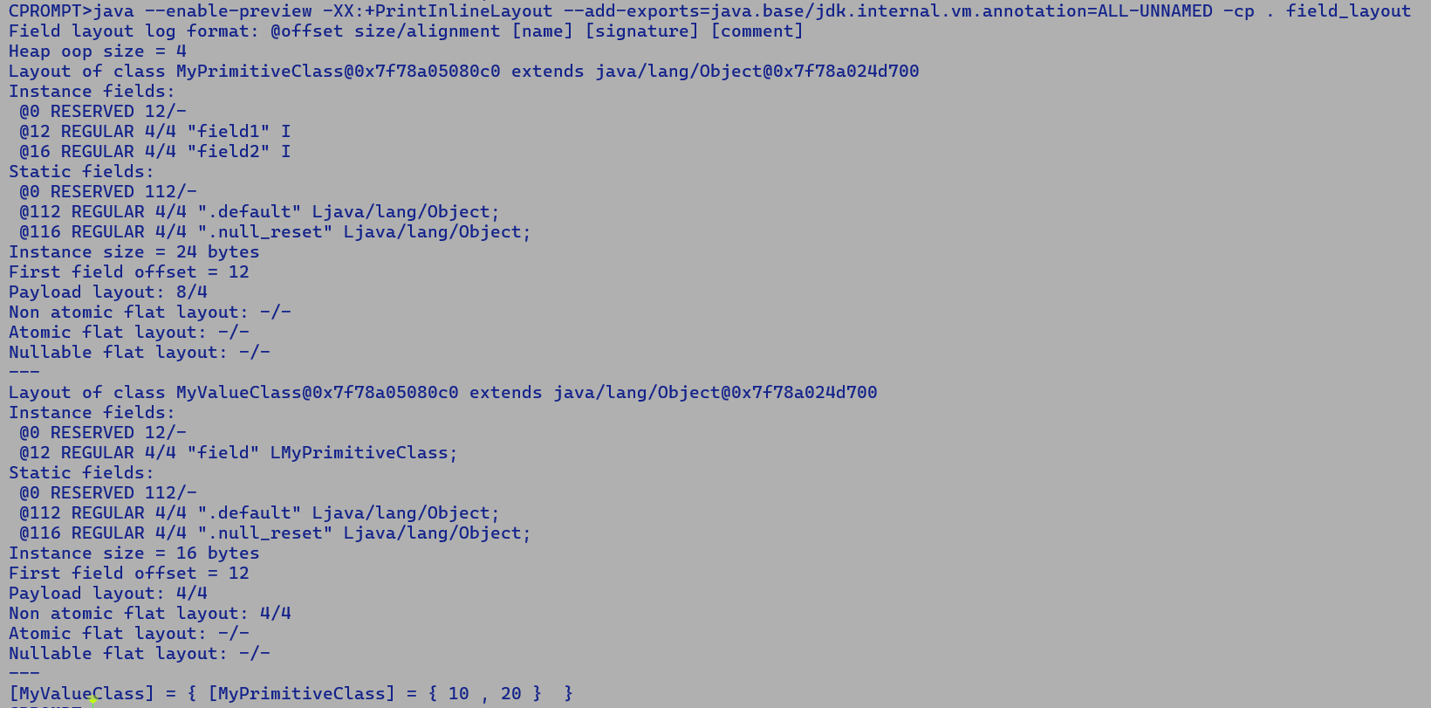

Case B) When flattening is enforced through annotations.

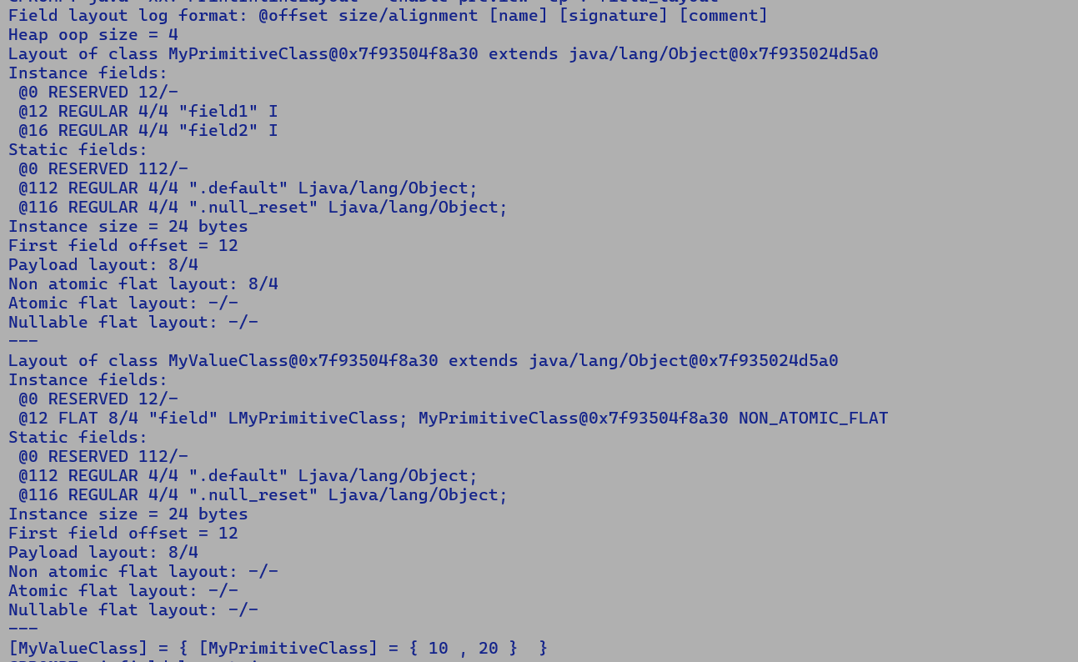

Case C) With NullableFieldFlattening enabled.

java --enable-preview -XX:+PrintInlineLayout -XX:+NullableFieldFlattening --add-exports=java.base/jdk.internal.vm.annotation=ALL-UNNAMED -cp . field_layout

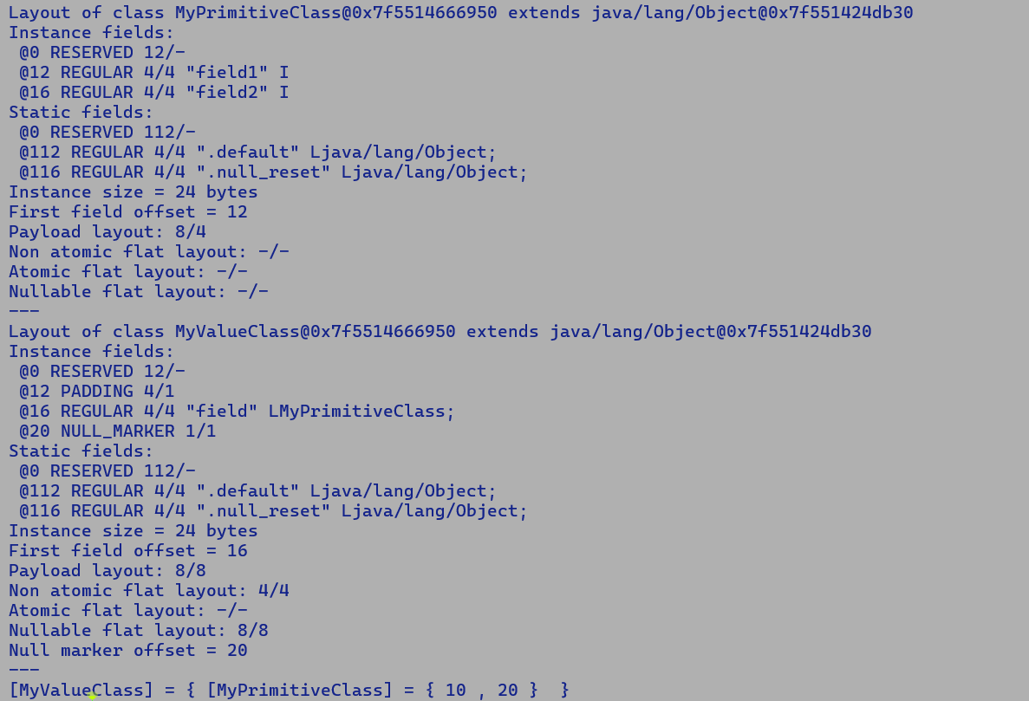

With NullableFieldFlattening VM aggressively flattens nullable value type fields, under the max flat size constraint of 128 byte (default), tuneable through InlineFieldMaxFlatSize runtime flag.

CPROMPT>java -Xbatch -XX:-TieredCompilation --enable-preview -XX:+AtomicFieldFlattening -XX:InlineFieldMaxFlatSize=64 --add-exports=java.base/jdk.internal.vm.annotation=ALL-UNNAMED -XX:+PrintInlineLayout -XX:-PauseAtStartup -cp . field_layout

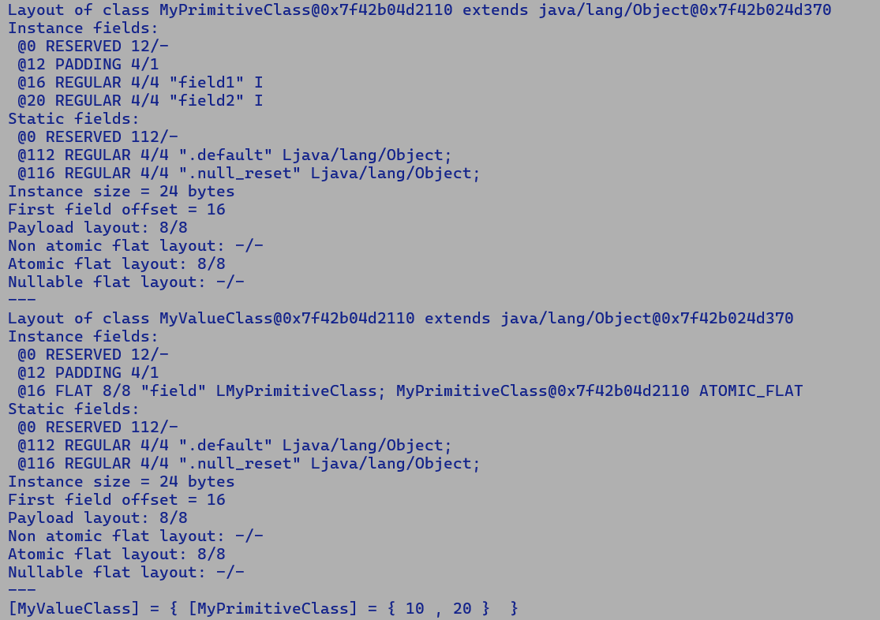



Preloading of value class for layout computation is only performed for null-restricted fields.

To relax tearing constraints either use -XX:+AtomicFieldFlattening or mark the field value class with LooselyConsistentValue annotation.

In latter case flat field type is NON-ATOMIC-FLAT

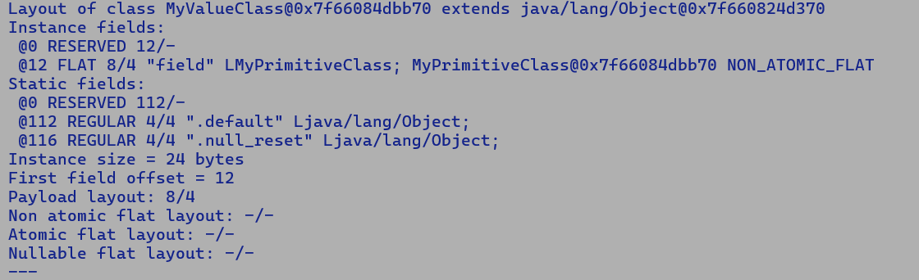



To Check:

* For above test, value type field (MyPrimitiveClass) get flattened when InlineFieldMaxFlatSize = 64 but not with 32, even though MyPrimitiveClass instance has two integer fields together accounting for 8 byte payload.



* InlineFieldMaxFlatSize is in bits , hence flat size of 32 is less than combined size of MyPrimitiveClass fields i.e. 8 byte x 8 bits = 64 IIRC it was in bytes earlier. Since Vector API 512-bit multifield backed payloads were flattened with default options.

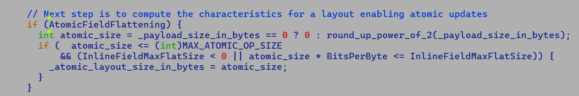

atomic_size <= (int)MAX_ATOMIC_OP_SIZE

MAX_ATOMIC_OP_SIZE is fixed to 64 bits as that’s the maximum implicit atomic type supported by x86 and other targets.

So even with AtomicFieldFlattening set to true we combined size of value class fields being flattened must be less than 64 bits…

The only way to counter this limitation is to use LooselyConsistentValue annotation which relaxes the atomic update and word tearing constraints.

[TODO] Flat array changes to be checked

**Probable issues with VectorAPI – mainline box expansion.**

Replacement of VBA with allocated node during box expansion can result in cloning of VBox node which is a user of VBA, this was done to fix an incorrect control flow bug though following change list

commit b026d0b480dcd4c0a3346078dd10047653ed3751

Author: Roland Westrelin <roland@openjdk.org>

Date: Wed Oct 25 13:32:56 2023 +0000

8312980: C2: "malformed control flow" created during incremental inlining

Co-authored-by: Emanuel Peter <epeter@openjdk.org>

Reviewed-by: thartmann, epeter

This can result in cloning of VBox, which remains unexpanded since expand_vbox_node skips over newly generated macros during box expansion and eventually may lead of assertion failure after PhaseVector which expects all boxes should have been eliminated.

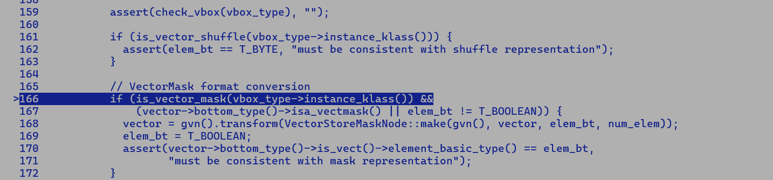

Remove shuffle constraint for byte array backing storage with next merge…

Checkpoint (13/12/2024) -

* Merge is trough
* Post merge bug fixes.
  + Validation, stand-alone add kernel (code/java/Valhalla/Add.java)
    - Assertion failure post PhaseVector due to unexpected VectorBox nodes.
    - Macro node cloning only happens with InlineFieldMaxFlatSize below 512, additional replacement nodes at the safepoint when processed by ReplacedNode::apply ends up cloning VectorBox are only seen is flat size is less than Species size.

TBD:-

Validation at all AVX levels…

DeopmitizeAlot, SafepointAlot.

All Valhalla and Vector API regression.

Vary InlineFieldMaxFlatSize from 0 to 512

Different combinations of Valhalla flags.

17/12/2024

---------------

* Problem of un-expanded VectorBox nodes post PhaseVector resulting in assertion failure.
  + During box elimination, we tend to buffer the contents of VectorBox IR, in case InlineFieldMaxFlatSize is less than the size of the vector being buffered, the payload field is flattened. Thus payload which is an InlineTypeNode is buffered and stores the contents of multifield. This newly buffered payload replaces the old InlineTypeNode in the IR graph and this pair is piggybacked onto an auxiliary structure ReplacedNode for lazy replacements.
  + Later at the time of actual node replacement, the algorithm clones the path comprising of user nodes of replacement node, this results in cloning VectorBoxNode which remains unexpanded through PhaseVector.
  + Two questions:-
    - IR transforms and node replacements must preserve the IR semantics. That’s the contract followed by every IR transformation.
      * Q. Check the real need for cloning the user chain as replacing just the top-level node without disturbing the user chain looks fine in most cases.
      * A.
        + GVN node sharing of data path nodes (one without a controlling edge) is agnostic to basic blocks as compiler banks on post matcher GCM pass to correctly schedule these nodes through eager scheduling (move a node into deepest dominator block of its use operand nodes) and late scheduling (move the node into LCA block of users of this node) to build a proper post matcher CFG graph, it also progressively hoists invariant nodes into shallowest loop.
        + Thus, a legal node replacement of a call should only impact the user dominated by the call node.
  + Problem does not occur if the payload gets flattened out.



CallNode

|_ memory projection

|_ io projection

|_ catch / exception landing pads

|_ data projection

|_ control projection



1 idom 5 , 4 ,2



5 idom 3,



3 idom 6



6 idom 7

19/12/2024

* Post-merge fixes
  + Assertion failure post PhaseVector due to un-expanded cloned VectorBox node created during node replacement.
    - Node replacement entry is created during buffering.
    - Compiler buffers an InlineTypeNode only if it has a non-scalarized use like store to a non-flat field, In all other cases it directly forward the fields of InlineTypeNode to its users.
    - It's safe to prevent replacement of the buffered node with an unbuffered node in this case as it will prevent cloning VectorBox user of InlineTypeNode during actual replacement. The unbuffered node will eventually be swept out as it will not have any non-scalarized user.
  + Crash during de-optimization when InlineFieldMaxFlatSize is less than payload size.
    - For non-flat payload compiler must bookkeep two SafePointScalarObjectNode for eliminated objects at Safepoints, one for VectorBox and the other for payload, since both are separate value type instances with the former having the latter as its non-flat field.
* 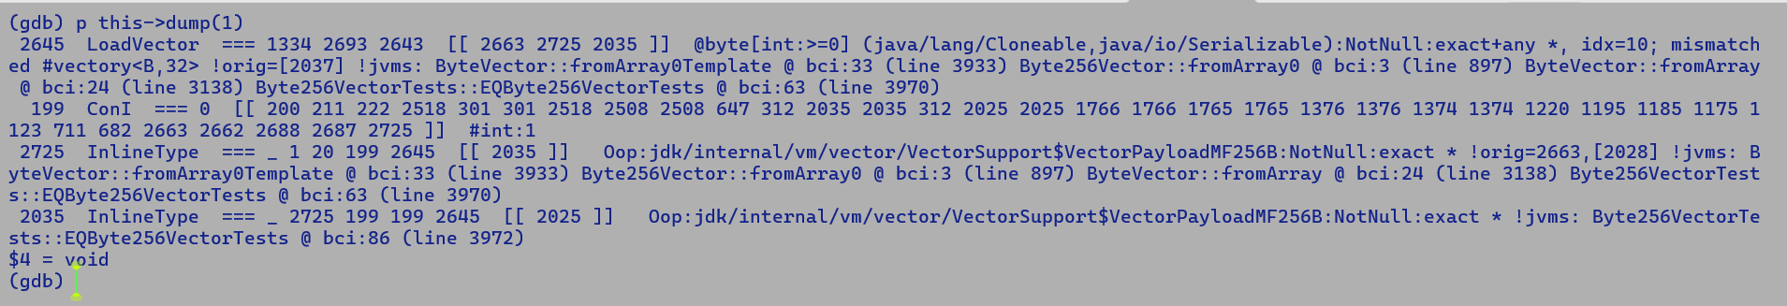
* 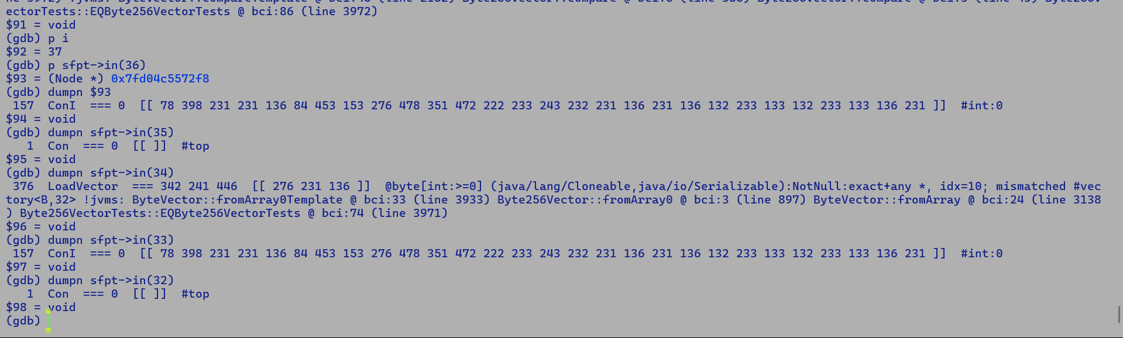

24/12/2024

* Nullfree type pumping intercepts into ciTypeFlow.
  + Through fields – ciType of NullRestricted field is marked as nullfree.
  + Direct access to constant oop (ldc) of inline type.
    - This guarantees to a non-null value
    - ciType for such an constant oop access is marked as nullfree.
  + Meet of two nullfree types of same class results into a null free ciType.

Flat-field load

* Base
  + Flat field InlineType Node population – Field addresses are computed w.r.t to base field.
    - InlineTypeNode (field) [ in1 : Base + Offset(Field + Field.f1 , in2 : Base + Offset (Field + Field.f2)]
  + Non-flat field Load : Field addresses are computed w.r.t to loaded field reference
    - Fld = LoadP Base, Base , offset
    - InlineTypeNode (field) [in1 : Fld + Offset(Field.f1) , in2: Fld + Offset(Field.f2)]

Boolean element load from mask payload

* Flat field
  + LoadUB VectorOop, Offset(FlatField offset + multifield offset )
* Non-flat field
  + T1 = LoadP VectorOop, Offset(Non-FlatField )
  + Addr = 16 + T1 + I * SIZEOF(BOOLEAN)
  + T2 = LoadUB T1, Addr,

Multifield access is similar to array access.

// Split instance or boxed field load through Phi.

Load (Phi M1, M2) (Addr) => Phi [R] [ in1: Load M1, Addr1 in2 : Load M2 , Addr2]

This prevents the boxing of the Phi node as Loads to the field pushed back across Phi may directly access the value being boxed through the memory chain.

* Crash during process_inline_types
  + Root cause:
    - Original graph shape
      * InlineTypeNodeA [oop : InlineTypeNodeB [ oop : top] […] ] [ …]
      * During idealization we prevented wiring oop of InlineTypeNodeB to A if it's not buffered.
        + An inline type node connected to an oop field of another InlineTypeNode is generated by make_from_oop.
        + If the oop is also an InlineType then make_from_oop scalarizes the oop as C2 represent every value object as an InlineTypeNode.
        + Above idealization simply removes the scalarized oop and forwards its oop field to the users.
        + In this particular case since the oop of InlineTypeNodeB was tied to top and was not buffered hence we prevented this idealization.
        + Later during process_inline_type phase, the compiler expects to receive a buffered InlineTypeNodeB since it has a non-scalar user because it was tied to oop field of InlineTypeNodeA. This results into an assertion failure.
* Why is TOP connected to oop of InlineTypeNodeB ?

27/12/2024

Method signature:- Method_name (AbstractType param) Return Type

* Signature computation and calling convention are fixed upfront by CompiledEntrySignature.
* AbstractType parameters are not scalarized.
* Parameter profiles are annotated after initial method state construction.
* Scalarization of value objects is not enforced based on speculative type information.

Q. Is this sub-optimal, will scalarization add any value in the above case ?

A. No, given that the original argument was of abstract type and not of an inline type, rematerializing an InlineTypeNode will explicitly load each field value from the incoming parameter. Thus, we incur a field load penalty similar to an explicit get field operation.

* + - Scalarization of value objects is beneficial if the value instance is passed in scalarized form, i.e., the method receives a separate argument for each field of value object, in such a case individual field value can directly be forwarded to its users in the callee context and we save a costly load operation.

Null check cut-out logic :-

**===================**

**For identity instance:-**

If (obj != null) {

Not_null_obj = CastPP obj NotNull

} else {

Uncommon_trap

}

**For value instance:-**

make_scalarized_IR from oop =

If (obj.is_init == 1) {

CastPP not_null

ITN1 = InlineTypeNode (make_from_oop(not_null_obj))

} else {

ITN2 = InlineTypeNode (make_default if null_free else make_null)

}

ITN1.merge_with(ITN2);

Regular LoadN Identity

===================

LoadN (InlineTypeNode ) => EncodeP

EncodeP is later decoded using DecodeP node.

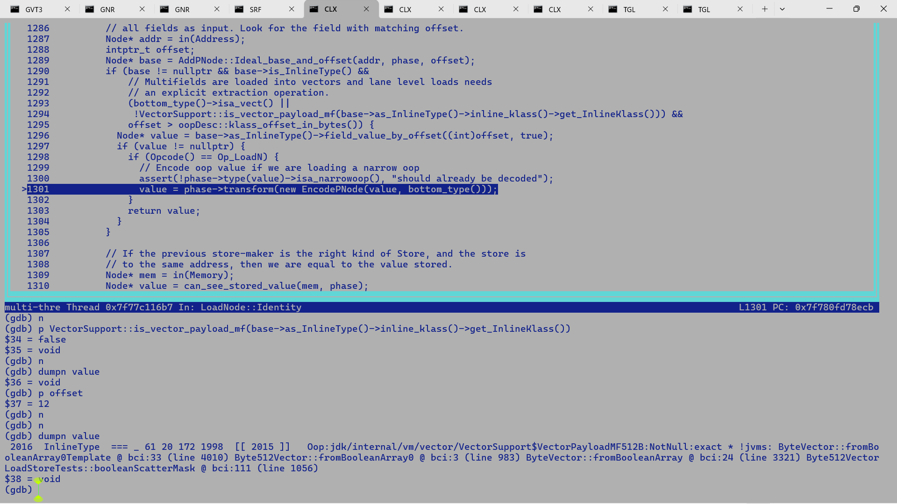

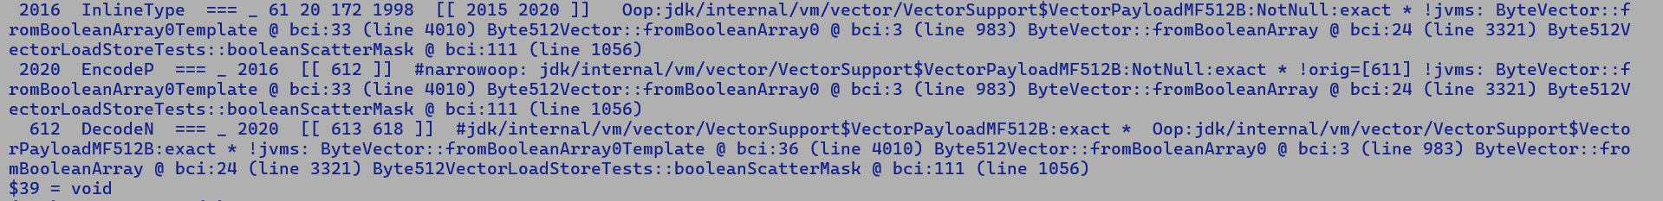

Complimentary transform

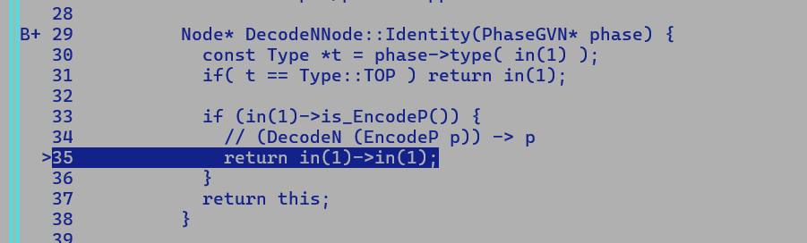

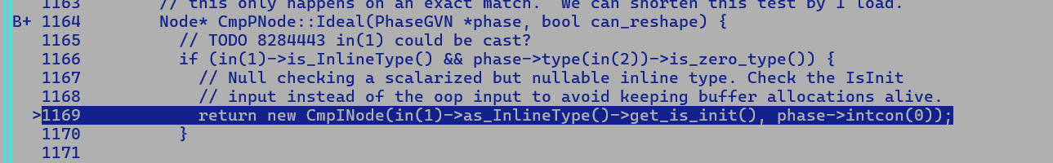

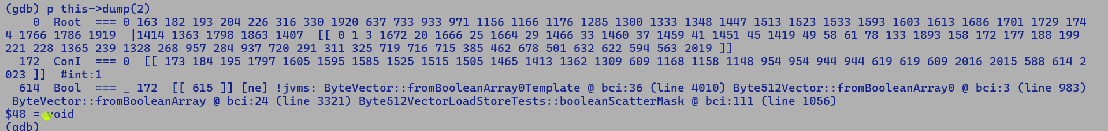

2/1/2025

Pre-Optimization Graph

CallStatic VectorSupport.Load

* Re-construct InlineTypeNode from returned oop.
* Using make_from_oop
* Non-flat payload is first loaded from oop and then re-materialized.

CallStatic

|

Proj

|

| --

| |

| LoadN LoadVector

| | oop |

| InlineType

| |

|_oop__ InlineType

|

Post-incremental inlining: Replace CallStatic with VectorBoxNode

VectorBoxNode

|

Proj

|

| --

| |

| LoadN LoadVector

| | oop |

| InlineType -----------🡪 (A)

| |

|_oop__ InlineType

|

LoadN -> VectorBoxNode => payload InlineType

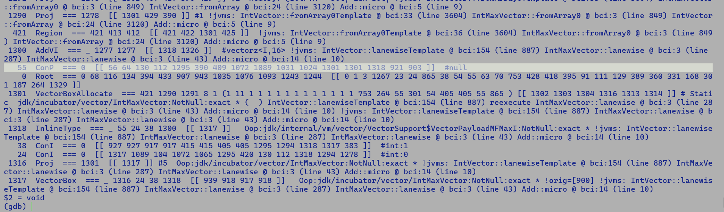

LoadN -> Load Narrow pointer -> thus above load transform should result into an EncodeN IR.

Before tying loaded non-flat field address to oop field of re-materilized InlineType payload, we need to decode this compressed oop back to 64 bit virtual address, thus a DecodeN succeeds LoadN, in this case EnocodeN + DecodeN will futhuer get folded and compiler will directly forward payload InlineTypeNode to its users, in this case it will be stitched to the oop field of node (A).

Later InlineTypeNode::Ideal will further simplify this pattern by forwarding the oop of InlineTypeNode which in turn is connected to inline type node A’s oop field.

Thus in this case unbuffered payload with null oop which also has a non-scalarized user in the form of non-flattened payload field load causes assertion failure during InlineType node replacement which expects node should be buffered upfront for successful replacement.

One solution is to buffer the payload before oop forwarding i.e. In InlineTypeNode::Ideal , we must buffer the payload if its not flattened as it will definitely have a non-scalarized user, this should fix the issue.

--- FIXME

To be addressed with next merge or separately.

JVMState* jvms = clone_jvms(C, vbox_alloc);

GraphKit kit(jvms);

PhaseGVN& gvn = kit.gvn();

---

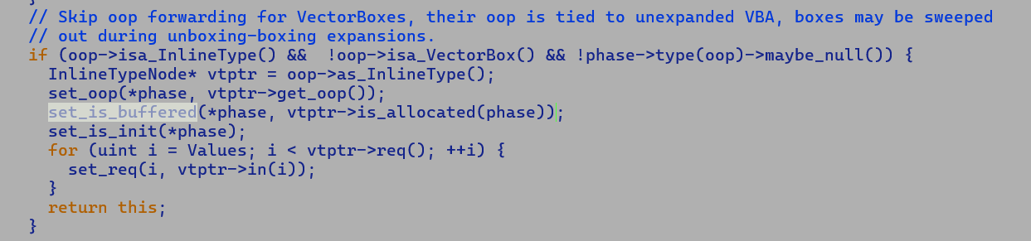

Vector APIs are intrinsified during incremental inlining where CallStatic nodes are replaced by VectorBoxes, thus any field Load from returned value happens over InlineTypeNode generated during inline expansion.

Note:-

InlineTypeNode oop and field values must comply all the time. A default InlineTypeNode’s oop always point to default_oop and its field values must be initialized to default values. Thus, vector payload should be un-initialized inline type node with vector input, uninitialized InlineType node set its Init field but is not buffered, so IR invariants are preserved.

Vector Box annotated with NotNull type to prevent explicit null pointer checking.



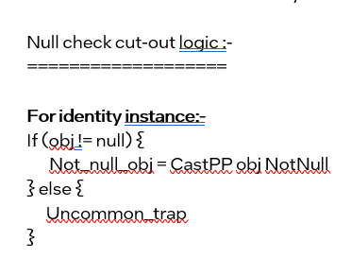

Without VectorBox, unbox_vector receives NotNull annotated checkcasted return value of Intrinsic static Call IR.

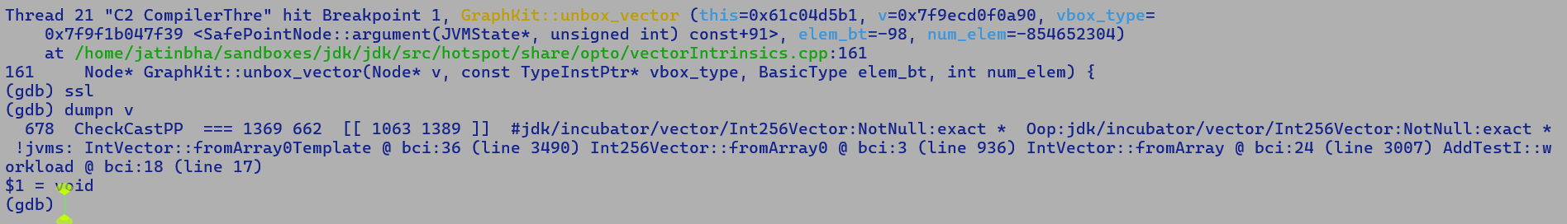

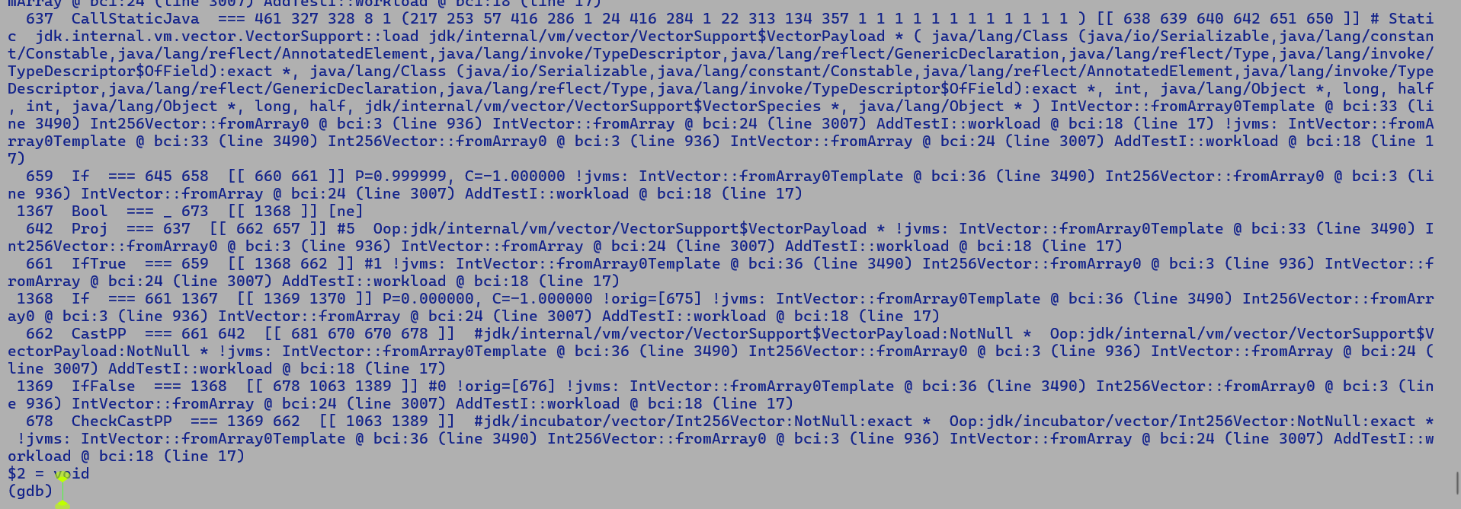

CheckPP is inserted by gen_checkcast..

**TSX on GNR**

Two software interfaces TSX-NI

* RTM - New instructions, XBEGIN, XEND delimits transaction region, XABORT aborts the transaction.
* HLE – Prefix xacquire and xrelease appended to selected atomic instruction, this delimits transaction region.

Mini-application with 4 threads performing concurrent write access RTM region.

#include <stdio.h>

#include <pthread.h>

#include <stdlib.h>

#include <string.h>

#include <stdint.h>

#include <assert.h>

#include <signal.h>

#define __GNU_SOURCE

#include <unistd.h>

typedef struct _large_atomic {

int _field1;

int _field2;

int _field3;

int _field4;

} large_atomic;

void fall_back_handler_func(int tid) {

printf("[tid=%d] RTM Aborted\n", tid);

}

#define REG_RIP 16

#define REG_RDX 12

void sig_action(int sig, siginfo_t* si, void* ucontext) {

printf("Called Signal Hnalder\n");

ucontext_t* const uc = (ucontext_t*) ucontext;

if (sig == SIGSEGV) {

printf("Caught SIGSEGV\n");

printf("RIP = %p\n", (intptr_t*)uc->uc_mcontext.gregs[REG_RIP]);

} else if (sig == SIGABRT) {

printf("Caught SIGABRT\n");

}

}

void* micro1(void * obj) {

large_atomic * lobj = (large_atomic*)obj;

pid_t tid = gettid();

printf("[tid] : %d \n" , tid);

for (int i = 0; i < 10; i++) {

asm volatile (

"jmp 0f \n\t"

"1: \n\t"

"movl %1, %%edi \n\t"

"call fall_back_handler_func \n\t"

"jmp 2f \n\t"

"0: \n\t"

"xbegin 1b \n\t"

"movq %0, %%rax \n\t"

"movl $10, (%%rax) \n\t"

"movl $20, 0x4(%%rax) \n\t"

"movl $30, 0x8(%%rax) \n\t"

"movl $40, 0xc(%%rax) \n\t"

"xend \n\t"

"2: \n\t"

: : "m"(lobj), "r"(tid) : "%rax", "%edi"

);

}

}

void* micro2(void * obj) {

large_atomic * lobj = (large_atomic*)obj;

pid_t tid = gettid();

printf("[tid] : %d \n" , tid);

for (int i = 0; i < 10; i++) {

asm volatile (

"jmp 0f \n\t"

"1: \n\t"

"movl %1, %%edi \n\t"

"call fall_back_handler_func \n\t"

"jmp 2f \n\t"

"0: \n\t"

"xbegin 1b \n\t"

"movq %0, %%rax \n\t"

"movl $100, (%%rax) \n\t"

"movl $200, 0x4(%%rax) \n\t"

"movl $300, 0x8(%%rax) \n\t"

"movl $400, 0xc(%%rax) \n\t"

"xend \n\t"

"2: \n\t"

: : "m"(lobj), "r"(tid) : "%rax", "%edi"

);

}

}

void* micro3(void * obj) {

large_atomic * lobj = (large_atomic*)obj;

pid_t tid = gettid();

printf("[tid] : %d \n" , tid);

for (int i = 0; i < 10; i++) {

asm volatile (

"jmp 0f \n\t"

"1: \n\t"

"movl %1, %%edi \n\t"

"call fall_back_handler_func \n\t"

"jmp 2f \n\t"

"0: \n\t"

"xbegin 1b \n\t"

"movq %0, %%rax \n\t"

"movl $1000, (%%rax) \n\t"

"movl $2000, 0x4(%%rax) \n\t"

"movl $3000, 0x8(%%rax) \n\t"

"movl $4000, 0xc(%%rax) \n\t"

"xend \n\t"

"2: \n\t"

: : "m"(lobj), "r"(tid) : "%rax", "%edi"

);

}

}

void* micro4(void * obj) {

large_atomic * lobj = (large_atomic*)obj;

pid_t tid = gettid();

printf("[tid] : %d \n" , tid);

for (int i = 0; i < 10; i++) {

asm volatile (

"jmp 0f \n\t"

"1: \n\t"

"movl %1, %%edi \n\t"

"call fall_back_handler_func \n\t"

"jmp 2f \n\t"

"0: \n\t"

"xbegin 1b \n\t"

"movq %0, %%rax \n\t"

"movl $10000, (%%rax) \n\t"

"movl $20000, 0x4(%%rax) \n\t"

"movl $30000, 0x8(%%rax) \n\t"

"movl $40000, 0xc(%%rax) \n\t"

"xend \n\t"

"2: \n\t"

: : "m"(lobj), "r"(tid) : "%rax", "%edi"

);

}

}

int main() {

struct sigaction act;

memset(&act, 0, sizeof(act));

act.sa_sigaction = sig_action;

act.sa_flags = SA_SIGINFO | SA_RESTART;

sigemptyset(&act.sa_mask);

sigaction(SIGSEGV, &act, NULL);

sigaction(SIGABRT, &act, NULL);

pthread_t t1;

pthread_t t2;

pthread_t t3;

pthread_t t4;

large_atomic obj = {0,0,0,0};

pthread_create(&t1, NULL, micro1, (void*)&obj);

pthread_create(&t2, NULL, micro2, (void*)&obj);

pthread_create(&t3, NULL, micro3, (void*)&obj);

pthread_create(&t4, NULL, micro4, (void*)&obj);

pthread_join(t1, NULL);

pthread_join(t2, NULL);

pthread_join(t3, NULL);

pthread_join(t4, NULL);

printf("large_atomic._field1 = %d\n", obj._field1);

printf("large_atomic._field2 = %d\n", obj._field2);

printf("large_atomic._field3 = %d\n", obj._field3);

printf("large_atomic._field4 = %d\n", obj._field4);

return 0;

}

Under SDE full -rtm_mode we emulate RTM.

GNR>sde64 -gnr -rtm_mode full -icount -itrace_execute_emulate -- ./a.out

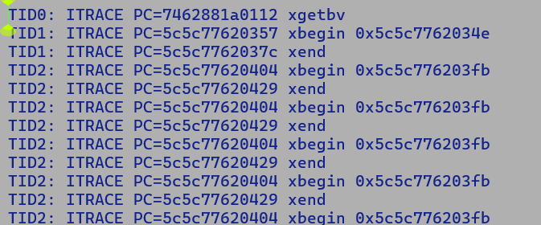

GNR>cpuid -1 | grep -e RTM -e TSX -e HLE

HLE hardware lock elision = false

RTM: restricted transactional memory = false

RTM transaction always aborts = false

IA32_TSX_FORCE_ABORT MSR = false

TSXLDTRK: TSX suspend load addr tracking = true

GNR>sde64 -gnr -rtm_mode full -- ./a.out

[tid] : 627190

[tid] : 627191

[tid=627190] RTM Aborted

[tid] : 627192

[tid] : 627193

[tid=627191] RTM Aborted

large_atomic._field1 = 100

large_atomic._field2 = 200

large_atomic._field3 = 300

large_atomic._field4 = 400

GNR>sde64 -gnr -rtm_mode full -- ./a.out

[tid] : 627197

[tid] : 627198

[tid=627197] RTM Aborted

[tid] : 627200

[tid] : 627199

large_atomic._field1 = 1000

large_atomic._field2 = 2000

large_atomic._field3 = 3000

large_atomic._field4 = 4000

**Without SDE – Transaction aborts on every invocation.**

GNR>./a.out

[tid] : 627216

[tid=627216] RTM Aborted

[tid=627216] RTM Aborted

[tid=627216] RTM Aborted

[tid=627216] RTM Aborted

[tid=627216] RTM Aborted

[tid=627216] RTM Aborted

[tid=627216] RTM Aborted

[tid] : 627217

[tid=627217] RTM Aborted

[tid=627217] RTM Aborted

[tid=627217] RTM Aborted

[tid=627217] RTM Aborted

[tid=627217] RTM Aborted

[tid=627217] RTM Aborted

[tid=627217] RTM Aborted

[tid=627217] RTM Aborted

[tid=627217] RTM Aborted

[tid=627217] RTM Aborted

[tid=627216] RTM Aborted

[tid=627216] RTM Aborted

[tid=627216] RTM Aborted

[tid] : 627218

[tid=627218] RTM Aborted

[tid=627218] RTM Aborted

[tid=627218] RTM Aborted

[tid=627218] RTM Aborted

[tid=627218] RTM Aborted

[tid=627218] RTM Aborted

[tid=627218] RTM Aborted

[tid=627218] RTM Aborted

[tid=627218] RTM Aborted

[tid=627218] RTM Aborted

[tid] : 627219

[tid=627219] RTM Aborted

[tid=627219] RTM Aborted

[tid=627219] RTM Aborted

[tid=627219] RTM Aborted

[tid=627219] RTM Aborted

[tid=627219] RTM Aborted

[tid=627219] RTM Aborted

[tid=627219] RTM Aborted

[tid=627219] RTM Aborted

[tid=627219] RTM Aborted

large_atomic._field1 = 0

large_atomic._field2 = 0

large_atomic._field3 = 0

large_atomic._field4 = 0

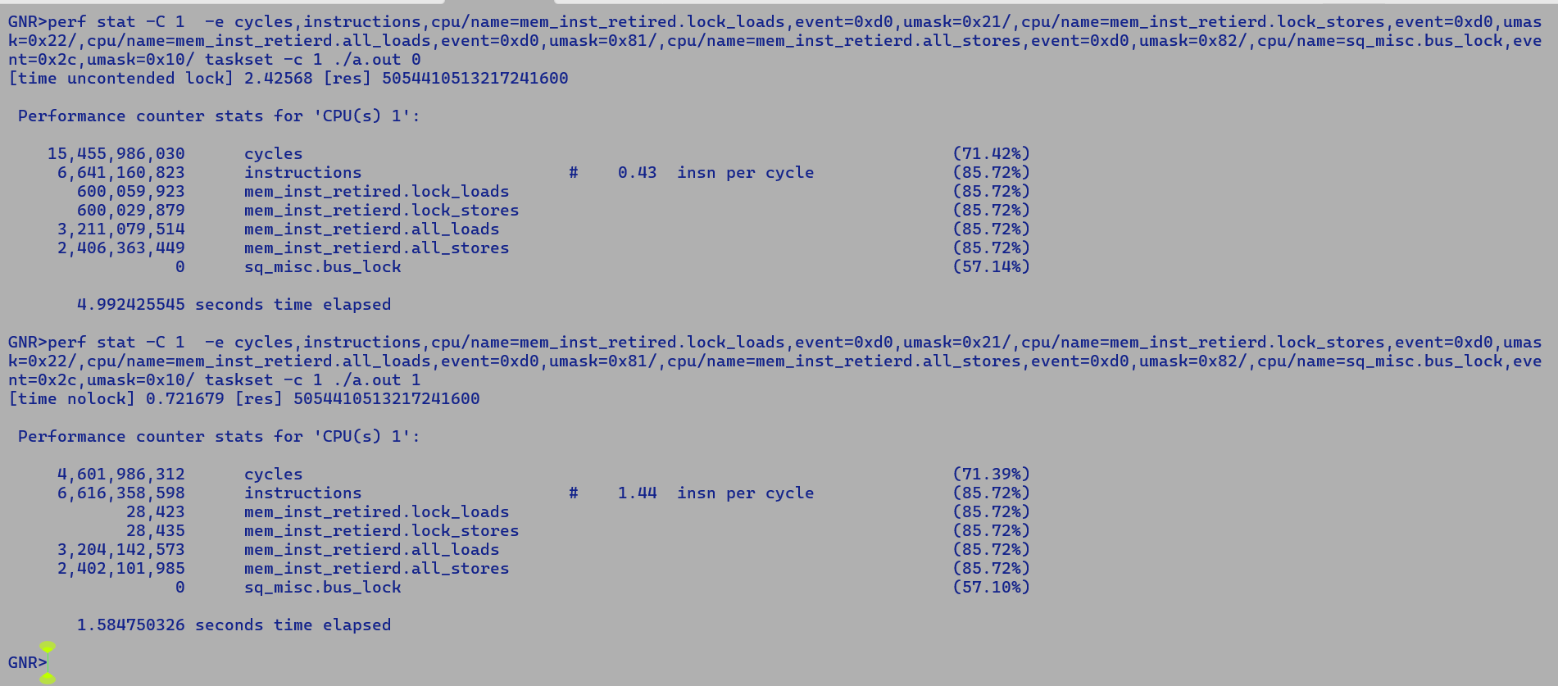

Above experiment was done using single threaded micro executing on single core with strong thread affinity, thus there is no chance of core to core context switch there by nullifying any fabric related latencies. Performance degradation is purely attributed to LOCK prefix.

14/3/2025

**lworld to lworld+vector merge**

**-----------------------------------------.**

Important updates:-

* Depricated methods:
  + lworld+fp16 : oopFactory:: new_valueArray(Klass* klass, int length, TRAPS); deprecated use following it its place

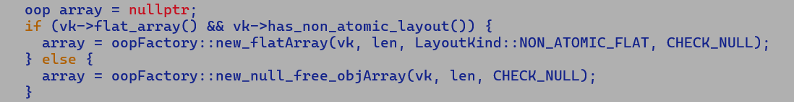

* + Or directly use ValueClass::newNullRestrictedArray() defined in jdk/internal/value/ValueClass.java to allocated a null restricted array.

New nullable and non-nullable flat field layout kinds.

sandboxes/lworld/src/hotspot/share/oops/layoutKind.hpp

Atomic updates of flat fields.

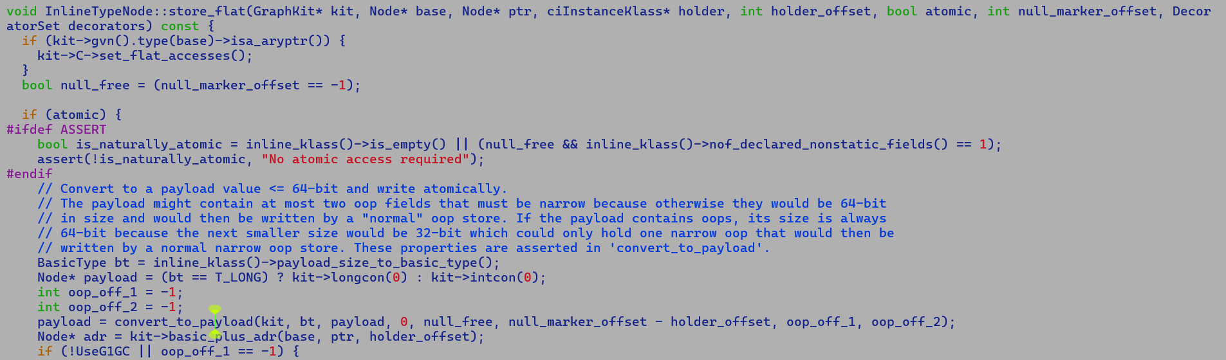



Existing 64-bit payload base atomic updates are in line with John’s comments.

“

*We are investing heavily in flattening within atomic containers, which CURRENTLY are merely 64 bits in size. I’m eager to find out, at some point, if we can make those containers any bigger.*

*Currently, if we need an atomic container, and the value type (with optional null-flag byte) overflows 64 bits, we give up and use a pointer to an immutable buffer, a separate object in the heap with no size limits.*

*This impacts objects of more than one or two fields.*

*The benefits we claim are not limited to heap footprint of larger objects, but it does impact some of our numbers. 128 bit R/W/CAS at full speed would be much nicer, and a lightweight TSX might nice also.*

*This is why I have pushed for MOV2 of register pairs in and out of 128-bit memory.*

*“*

Objects for TSX Benchmarking using c-micros:-

1. Measure performance impact of large atomic updates.
   * Micro TSX offers an order of magnitude lower latency entry/exit into the transaction region in comparison to HLE based TSX.
2. Measure performance impact of 64 bytes direct store b/w flat fields.
   * These are streaming stores and will require the emission of a costly memory.
   * But the atomic payload size is 8 times (512 bits) of what we currently support, using 64-bit atomic stores.
3. Measure performance of Vector Stores wrapping it within locks. The processor breaks the data into chunks of 64 bits.
4. Experiment with volatile int128_t read / writes <https://developer.arm.com/documentation/ka004805/latest/>

In the x86 TSO memory model, 512-bit vector store operations are not atomic, and without proper synchronization, another core reading a portion of that data may receive stale or incorrect values, as atomicity is only naturally guaranteed for aligned 64-bit operations within a single cache line.

TBC…

MicroTSX

==========

@ImplicitlyConstructible : Every lane is initialized on construction.

value class VectorFloat256 {

public float f1;

public float f2;

public float f3;

public float f4;

……

public float f8;

public VectorFloat256(float init) {

this.f1 = init;

this.f2 = init;

……

this.f8 = init;

}

}

class VectorBox {

@NullRestricted

public VectorFloat256 payload; // Flat-layout withing container

}

VectorFloat256 var = VectorFloat.broadcast(10.0f);

VectorBox container = new VectorBox();

container.payload = var;

// Currently since null-restricted payload greater than 64 bit in size are allocated in buffer and 64-bit pointer to its // // this buffer is assigned to payload field, hence assignment is naturally atomic, but introduces an additional

// indirection while accessing the vector lane. This is not cache-friendly.

Flattening will have the following benefits

* + Save additional heap space for object header since actual data carrying field will anyways be allocated in both flat-field as part of container object and non-flat in a separate heap buffer.
  + Saves in-direction while loading/storing vector lanes from vector box instances.
  + Primary requirement here is that reading and writing of the payload should be atomic in nature.
* Currently, for loosely consistent flat field assignments, we break the field bundle into individual components and perform component-level assignments. This is not atomic. For less than 64 bit combined size recently we append the field value into a 64-bit payload and write it atomically.
* Breaking this down further
* Cost of assigning a payload field with with 10 sub-components
  + Non-flat
    - Allocation cost into buffer.
    - Individual components store
      * This is important as fields are present in scalarized form at IR level.
      * Each store will demands and entry in RS, AGU access for address compuration.
      * With SPR we allow issuing a store pair within same catchline [ this is a micro-architectural optimization].
  + Flat field
    - No allocation cost
    - Individual component stores withing a micro-tsx region.
  + So we do perform component stores in both the cases but save the extra header allocation and indirection cost, but in the hind side pay some cycles penalty for entry and exit from TSX region.

Q. Should varying the component sizes of a payload be an objective of benchmarking?

A. Yes, in addition there are multiple moving parts here

- Object header size is fixed (12 bytes currently), in the future with Lilliput we are targeting 8 and 4 byte fixed object header sizes.

- For a payload with many components, the entry/exit overhead will get normalized.

- Pointer indirection is a heavy operation as in the worst case we may incur LLC misses, flat field will get benefits of next line prefetching.

- Valhalla doesn’t intend to flatten primitive type array fields.

- It supports recursive flattening; this will be mainly useful to benchmark as we will save a lot many indirection to access a deeply nested field.

- At a finer level, we need to find a threshold when indirections, allocation, and field header size penalty dominate the entry / exit load from the TSX region

Initial benchmarking can be done using TSX on HW under an assumption that MicroTSX will significantly reduce the entry/ exit load.

* CMP128XCHG
  + Compares the 64-bit value in EDX:EAX (or 128-bit value in RDX:RAX if operand size is 128 bits) with the operand (destination operand). If the
  + Values are equal, the 64-bit value in ECX:EBX (or 128-bit value in RCX:RBX) is stored in the destination operand.
  + Compiler Change:
    - Create a new IR PackedStore
    - Emit field compaction IR (LShift + ORs) to move them into a 128-bit pair to be stored atomically into the destination.
    - Additional cost to measure: compaction logic + CMPEXCHANG128 latency.
    - Savings: Multiple stores, object header, indirection, gains may be significant with deeply nested fields.
  + This can be benchmarked in a c-micro for the payload of 4 floating point fields and integral fields.
    - For floating point, there is an additional domain crossover penalty of 3 cycles b/w XMM and GPR register moves.
  + This solution also fits well with the new Valhalla payload packing scheme for flat fields.

**[PackComp1] [PackComp2] // Packed RegL components.**

**| |**

**|_____ ______|**

**| |**

**(RM: RDX) | | (RM : RAX)**

**[ PackComp]**

**|**

* MOVDIR64B
  + MOVDIR64B r16/r32/r64, m512 A V/V MOVDIR64B Move 64-bytes as direct-store with guaranteed 64-byte write atomicity from the source
  + memory operand address to destination memory address specified as offset to ES segment in the register operand.
* TSX
  + Value object equivalent c-structure.
  + Vary the number of component fields and measure performance for the following scenarios
    - XBEGIN … STORES … XEND
    - Non-flat : Allocation + FIELD STORES, NATURALLY ATOMIC ASSIGNMENT TO PAYLOAD.
  + Vary the nesting depths of payload field access using recursive value types.
    - Same experiment as above.
  + Vary the number of object allocations and assignment to components to measure the saving from spatial locality in flat vs non-flat layout,
  + Vary the frequency of payload field writes within a loop that allocates two boxes, adds them, and then assigns the resultant payload.
* Micro TSX – cycle accurate analysis to get an estimate of speedups in entry/exit load.
* Simulate TSX using synchronized regions guarded by locks.
  + Same objectives as TSX, leaf replace XBEGIN with lock acquisition and XEND with lock release.
* The design of BM should be such that we can plug in different locking implementations guarding synchronised regions.
* VMOVDQA128 is also atomic, but it mandates 16 byte aligned layout, thus will need extra padding in field layout.
  + In addition vector insert operation has 3 cycle penalty, thus packing 4 float fields needs 12 cycles.
  + Padding + extract

Java Object Layout

class MyClass {

public float f1;

public float f2;

}

MyClass obj = new MyClass()

ObjectSizeAlignmentInBytes = 8 bytes

Address: 8X.

Header:

markWord : 8 bytes

Compressed Klass Pointer: 4 bytes

---------------------

Payload: 8x + 12 = 8x + 8 + 4 = 8 (x + 1) + 4 , thus is 4 byte aligned

F1

F2

------ Packing F1 and F2 in one 64 byte quad word and writing it at the offset of F1 will not be atomic.

* Java object layout is determined at run time.
* F1 will be at 4 byte aligned address, a 4 byte aligned address is not 8 byte aligned but reverse is true.

bool InlineTypePassFieldsAsArgs = true {pd product} {default}

bool InlineTypeReturnedAsFields = true {pd product} {default}

bool UseArrayFlattening = true {product} {default}

bool UseAtomicValueFlattening = false {product} {default}

bool UseFieldFlattening = true {product} {default}

bool UseNonAtomicValueFlattening = true {product} {default}

bool UseNullableValueFlattening = false {product} {default}

java --enable-preview -XX:+PrintInlineLayout -XX:+UseAtomicValueFlattening --add-exports=java.base/jdk.internal.vm.annotation=ALL-UNNAMED -cp . flatten_fields

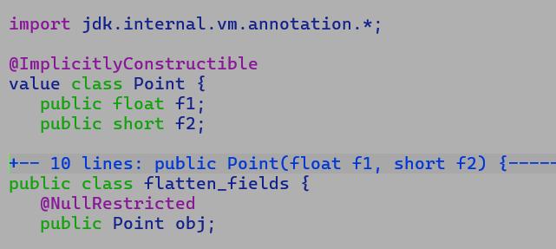

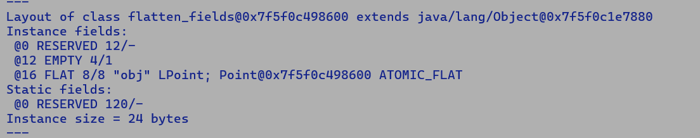

java --enable-preview -XX:+PrintInlineLayout -XX:+UseNullableValueFlattening --add-exports=java.base/jdk.internal.vm.annotation=ALL-UNNAMED -cp . flattenx_fields

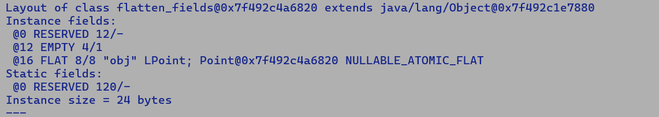

7/4/2025

**lworld merge to lworld+vector**

**TODOs**

* Remove MF signatures from vmSymbols.cpp
* Checkout process_for_merge_stores_igvn

Valhalla changes since last merge

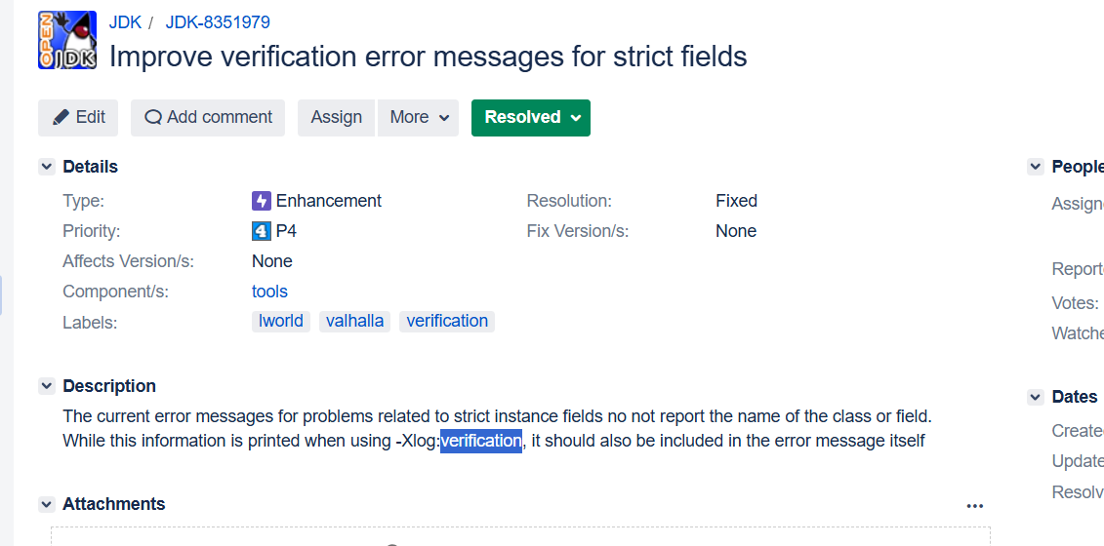

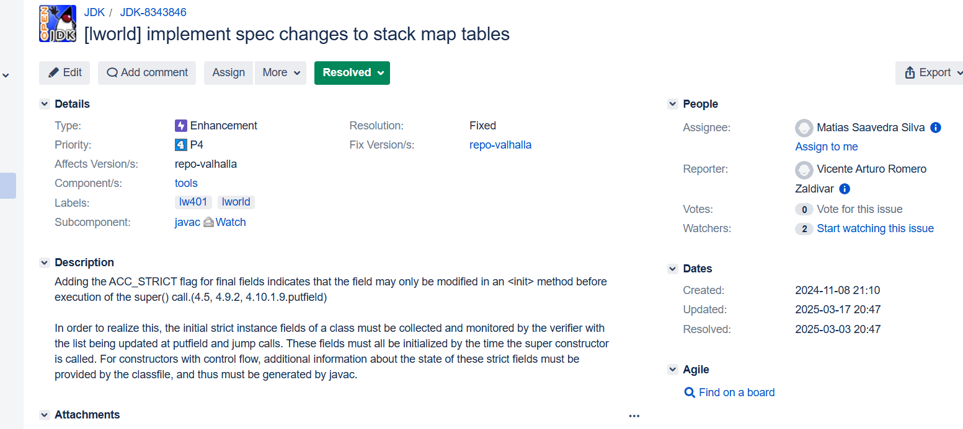

Removal of ImplicitlyConstructible annotation

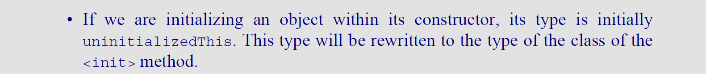

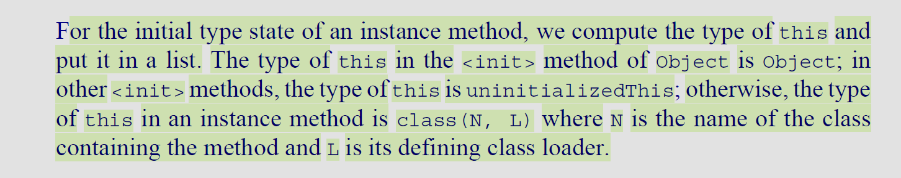

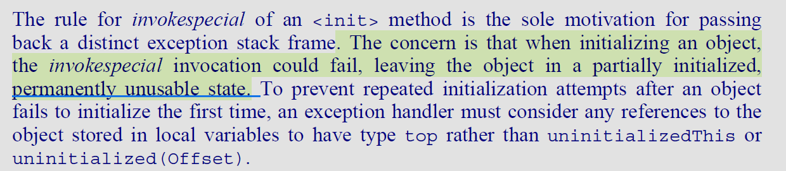

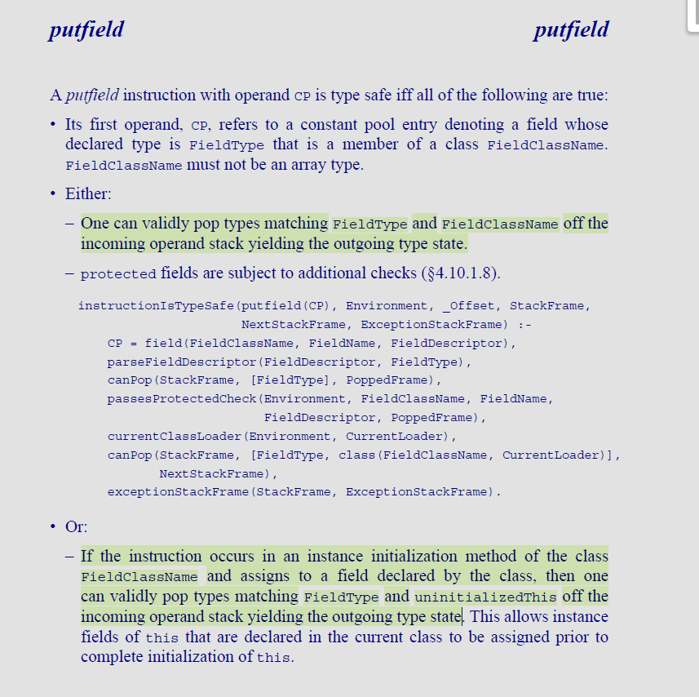

**Minimum vector payload size is 8 bytes, payloads will flatten under the looks atomicity update constraint if the payload byte size is less than InlineFieldMaxFlatSize and -XX:-UseAtomicValueFlattening.**

**JEP draft: Strict Field Initialization in the JVM (Preview)**

https://openjdk.org/jeps/8350458

Post merge bug fixing: -

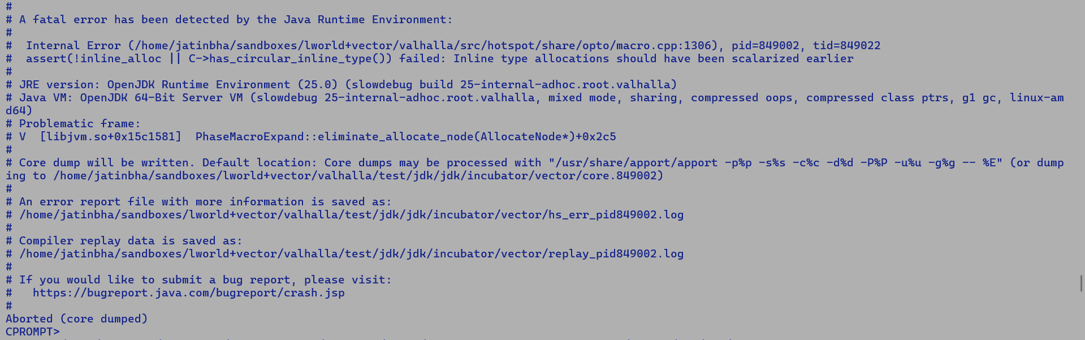

InlineTypeNode is buffered only if there is a non-scalarized user, buffering intercepts.

* Currently, we buffer value objects before passing them as method arguments if InlineTypePassArgumentsAsFields is false.
* While returning a value object, if InlineTypeReturnAsFields is set to false.

In IR form, the inline type node is scalar replicable, as it directly forwards the field values with getfield bytecode.

An allocation is scalar replicable if the compiler can identify the initializing values of all instance fields.

**RFR: SafePointScalarObjectNode* PhaseMacroExpand::create_scalarized_object_description(AllocateNode *alloc, SafePointNode* sfpt)**

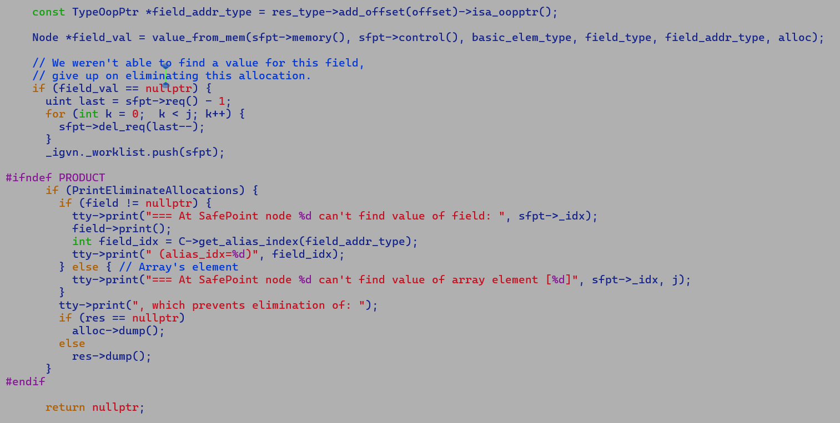

Allocation

* Non-escaping -- marked by escape analysis.
* Scalar replaceable. – marked by escape analysis.
  + A non-escaping allocation that is not scalar replaceable cannot be eliminated.

**All buffered, inline-type nodes are scalar replaceable by construction, as they were created out of InlineTypeNode, which has separate input edges for each field value.**

**Larval values are not eliminatable.**

14/4/2025

## 

Initial Graph:-

T0 = CallStatic VectorSupport.blend

P1 = Projection T0, 5

ILT1 = make_from_oop(P1)

* LoadN
* DecondeN
* LoadVector
* InlineTypeNode (VectorPayloadMF256F)
* IntlineTypeNode (Float256Vector)

After incremental inlining:-

Replace CallStatic with

* VectorBlend => InlineTypeNode => VectorBoxNode.
* LoadNodeN from VectorBoxNode should return field value

Q: What is special about VectorBoxes?

A. VectorBoxes are synthetic structures that allocate InlineTypeNode for both payload and container field; they are expanded lazily

during PhaseVector, if they survive unboxing-boxing optimization, at that point both box and payload are buffered.

Thus, vector boxes implicitly emulate following semantics of putfield without any upfront buffering for payloads, i.e.

var payload = new Payload()

var vector = new Vector();

vector.payload = payload; =======🡺 [a]

In regular flow, putfield [a] buffers the InlineTypeNode if it’s a non-flat value field. Checkout Parse::set_inline_type_field for more details…

15/4/2025

AVX2 failures

# newfailures.txt

jdk/incubator/vector/Byte128VectorTests.java

======================= ./LOGS_VECTOR_avxlevel2/test-results/jtreg_test_hotspot_jtreg_hotspot_vector_1/text/newfailures.txt ======================

# newfailures.txt

compiler/vectorapi/TestReverseByteTransforms.java [FIXED]

compiler/vectorapi/VectorCommutativeOperSharingTest.java -- Redundant boxing preventing elimination of otherwise dead XorV node. [FIXED]

compiler/vectorapi/VectorMemoryAlias.java [FIXED]

**Analysis of redundant boxing:-**

A) Existing VectorAPI-mainline flow:-

Graph after parsing

T0 = CallStaticJavaNode _vectorSupport_lanewise

T1 = DataProj T0

CallStaticJavaNode <UCT1> T1

CallStaticJavaNode <UCT2> T1

Graph after incremental inlining

T0 = VectorBox (AddVI)

T1 = DataProj T0

CallStaticJavaNode <UCT1> T1

CallStaticJavaNode <UCT2> T1

Graph after PhaseVector Scalarize VBOX

Like escape analysis, scalarize_vbox_Node removes redundant VectorBoxes by bookkeeping the re-construction information at safepoint site.

In above case VectorBox is eliminated and re-construction information comprising

of encapsulated vector (AddVI) and Boxtype is added SafePointNode and SafePointScalarObjectNode captures the boxtype and starting edge index of boxed field values.

T0 = AddVI

CallStaticJavaNode <UCT1> T1

CallStaticJavaNode <UCT2> T1

B) VectorAPI-Valhalla flow

Graph after parsing

T0 = CallStaticJavaNode _vectorSupport_lanewise

T1 = DataProj T0

T2 = InlineTypeNode (make_from_oop) -> InlineTypeNode (concrete vector) + InlineTypeNode (vector payload)

CallStaticJavaNode <UCT1> T2

CallStaticJavaNode <UCT2> T2

Graph after incremental inlining

T0 = VectorBox (AddVI)

T1 = DataProj T0

T2 = InlineTypeNode (make_from_oop) -> InlineTypeNode (concrete vector) + InlineTypeNode (vector payload)

CallStaticJavaNode <UCT1> T2

CallStaticJavaNode <UCT2> T2

In the above case, unlike mainline flow, during scalarization of vector boxes out edges are not directly connected to CallNode, which leads to preserving their redundant boxes, thus, we end up expanding redundant boxes. Since VectorBoxAllocationNode is indeed a safe point node itself, it carries JVMState along with

control and memory edges. This imposes additional scheduling constraints on VBA, and post expansion

it ends up into control paths before actual vector operation and degrades the performance.

We also make a prior attempt to eliminate buffering InlineTypeNode during process_inline_type, but even here since VectorBox is not directly connected to CallStaticJavaNode (safepoints) we end up losing the opportunity to

optimize away redundant boxes..

The problem started because we disabled forwarding oop values of InlineTypeNode during idealizations

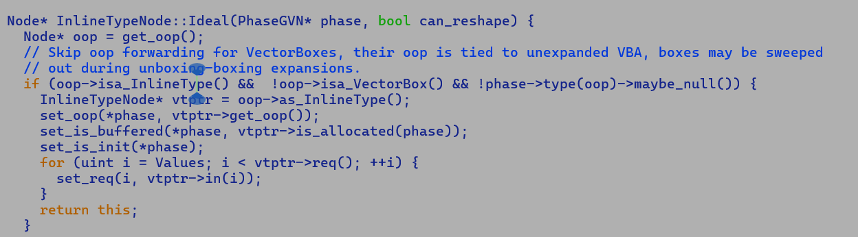

This was done to fix observing unbufferend IR node during late process_inline_type satage.

Initial Graph:-

===============

AddVI

|

v

InlineTypeNode (oop: null) (VectorPayloadMF) [non-flat payload]

|

v

VectorBoxNode (Concrete Vector Box) (oop: VectorBoxAllocateNode)

|

V

InlineTypeNode (oop: VectorBoxNode)

|

V

CallStaticJavaNode

Earlier Post Idealization Graph :-

=========================

AddVI

|

v

InlineTypeNode (oop: null) (VectorPayloadMF) [non-flat payload]

|

v

VectorBoxNode

|

V

AddP

|

V

LoadVector

|

V

InlineTypeNode (oop:null) (VectorPayloadMF) [non-flat payload]

|

V

InlineTypeNode (oop: VectorBoxAllocateNode)

|

V

CallStaticJavaNode

Above graph pattern was incorrect because VBA tied to InlineTypeNode will not get expanded, PhaseVector box expansion does not handle such patterns

.Easiest fix is to forward the VectorBox as input to CallStaticJavaNode, as we do not want intermediate reconstruction IR comprising of chain of InlineTypeNode which was generated during during parsing..

With above fix we no longer incur additional boxing penalty.

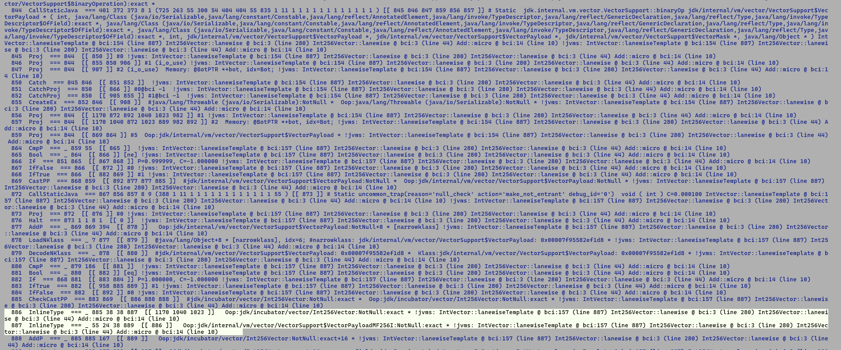

And VectorBoxes are directly forwarded to CallStaticJavaNode…. This enable eliminating them during process_inline_type …

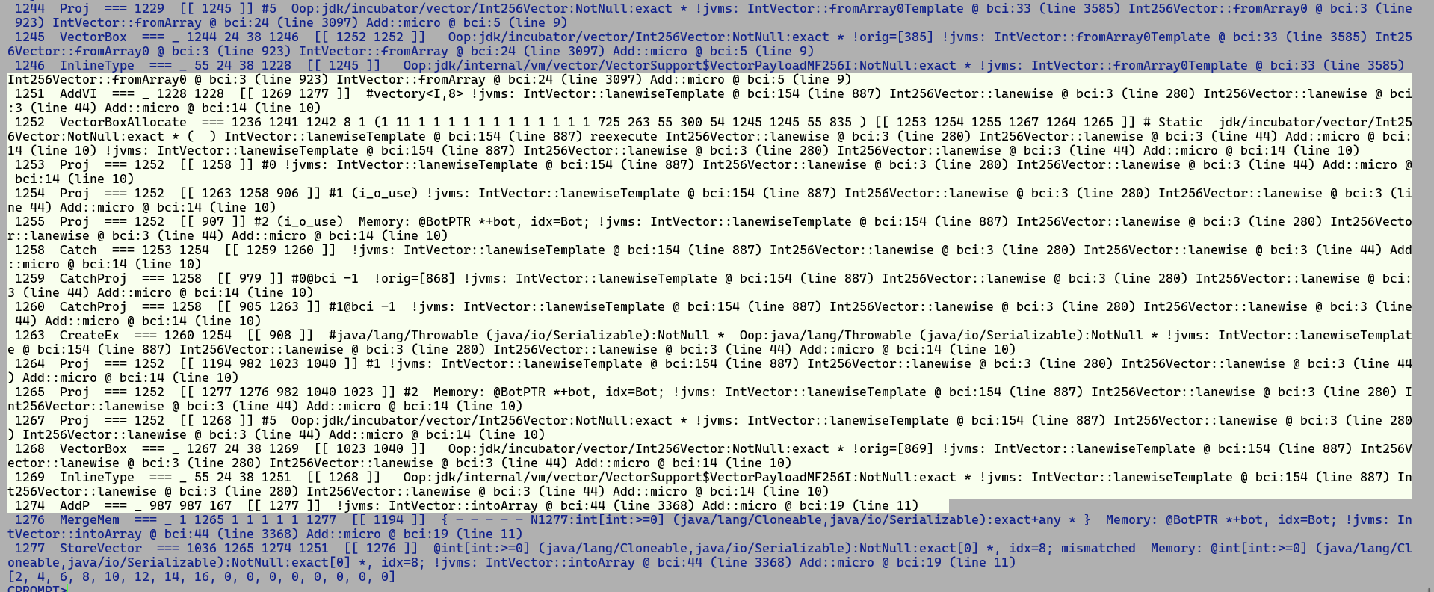

**Implicit larval state verification examples**

Testing methodology :

1. Develope a test in java.
2. Generate bytecode by compiling with javac
3. Disassemble .class file to .jasm file.

java -cp . -jar asmtools.jar jdis test_larval.class > test_larval.jasm

1. modify jasm file
2. assemble back to .class file.

java -cp . -jar asmtools.jar jasm test_larval.jasm > test_larval.class

1. run JVM while will perform bytecode verification during linking.

**Case 1) Passing uninitializedThis to a method expecting a type argument.**

public static Method main:"([Ljava/lang/String;)V"

stack 4 locals 2

{

new class MyValue;

astore_1;

getstatic Field java/lang/System.out:"Ljava/io/PrintStream;";

aload_1;

invokestatic Method micro:"(LMyValue;)I"; //// 🡪 UninitializedThis passed to static method.

invokedynamic InvokeDynamic REF_invokeStatic:Method java/lang/invoke/StringConcatFactory.makeConcatWithConstants:

"(Ljava/lang/invoke/MethodHandles$Lookup;Ljava/lang/String;Ljava/lang/invoke/MethodType;Ljava/lang/String;[Ljava/lang/Object;)Ljava/lang/invoke/CallSite;":

makeConcatWithConstants:"(I)Ljava/lang/String;" {

String "[res] \u0001"

};

invokevirtual Method java/io/PrintStream.println:"(Ljava/lang/String;)V";

return;

}

CPROMPT>java --enable-preview -cp . test_larval

Error: Unable to initialize main class test_larval

Caused by: java.lang.VerifyError: Bad type on operand stack

Exception Details:

Location:

test_larval.main([Ljava/lang/String;)V @8: invokestatic

Reason:

Type uninitialized 0 (current frame, stack[1]) is not assignable to 'MyValue'

Current Frame:

bci: @8

flags: { }

locals: { '[Ljava/lang/String;', uninitialized 0 }

stack: { 'java/io/PrintStream', uninitialized 0 }

Bytecode:

0000000: bb00 024c b200 042b b800 05ba 0006 0000

0000010: b600 07b1

**Case 2) Passing initialized instance to a constructor expecting to receive an uninitializedThis on stack frame.**

public static Method main:"([Ljava/lang/String;)V"

stack 4 locals 2

{

new class MyValue;

dup;

bipush 10;

bipush 20;

invokespecial Method MyValue."<init>":"(II)V";

dup;

bipush 10;

bipush 20;

invokespecial Method MyValue."<init>":"(II)V";

astore_1;

getstatic Field java/lang/System.out:"Ljava/io/PrintStream;";

aload_1;

invokestatic Method micro:"(LMyValue;)I";

invokedynamic InvokeDynamic REF_invokeStatic:Method java/lang/invoke/StringConcatFactory.makeConcatWithConstants:

"(Ljava/lang/invoke/MethodHandles$Lookup;Ljava/lang/String;Ljava/lang/invoke/MethodType;Ljava/lang/String;[Ljava/lang/Object;)Ljava/lang/invoke/CallSite;":

makeConcatWithConstants:"(I)Ljava/lang/String;" {

String "[res] \u0001"

};

invokevirtual Method java/io/PrintStream.println:"(Ljava/lang/String;)V";

return;

}

CPROMPT>java --enable-preview -cp . test_larval

Error: Unable to initialize main class test_larval

Caused by: java.lang.VerifyError: Bad operand type when invoking <init>

Exception Details:

Location:

test_larval.main([Ljava/lang/String;)V @16: invokespecial

Reason:

Invalid type: 'MyValue' (current frame, stack[1])

Current Frame:

bci: @16

flags: { }

locals: { '[Ljava/lang/String;' }

stack: { 'MyValue', 'MyValue', integer, integer }

Bytecode:

0000000: bb00 0259 100a 1014 b700 0459 100a 1014

0000010: b700 044c b200 052b b800 06ba 0007 0000

0000020: b600 08b1

**Case 3) Accessing a field of an uninitialzedThis**

public static Method main:"([Ljava/lang/String;)V"

stack 4 locals 2

{

new class MyValue;

astore_1;

getstatic Field java/lang/System.out:"Ljava/io/PrintStream;";

aload_1;

getfield Field MyValue.field1:"I";

invokedynamic InvokeDynamic REF_invokeStatic:Method java/lang/invoke/StringConcatFactory.makeConcatWithConstants:

"(Ljava/lang/invoke/MethodHandles$Lookup;Ljava/lang/String;Ljava/lang/invoke/MethodType;Ljava/lang/String;[Ljava/lang/Object;)Ljava/lang/invoke/CallSite;":

makeConcatWithConstants:"(I)Ljava/lang/String;" {

String "[field1\u0001"

};

getstatic Field java/lang/System.out:"Ljava/io/PrintStream;";

aload_1;

bipush 10;

bipush 20;

invokespecial Method MyValue."<init>":"(II)V";

invokevirtual Method java/io/PrintStream.println:"(Ljava/lang/String;)V";

getstatic Field java/lang/System.out:"Ljava/io/PrintStream;";

aload_1;

invokestatic Method micro:"(LMyValue;)I";

invokedynamic InvokeDynamic REF_invokeStatic:Method java/lang/invoke/StringConcatFactory.makeConcatWithConstants:

"(Ljava/lang/invoke/MethodHandles$Lookup;Ljava/lang/String;Ljava/lang/invoke/MethodType;Ljava/lang/String;[Ljava/lang/Object;)Ljava/lang/invoke/CallSite;":

makeConcatWithConstants:"(I)Ljava/lang/String;" {

String "[res] \u0001"

};

invokevirtual Method java/io/PrintStream.println:"(Ljava/lang/String;)V";

return;

}

CPROMPT>java --enable-preview -cp . test_larval

Error: Unable to initialize main class test_larval

Caused by: java.lang.VerifyError: Bad type on operand stack

Exception Details:

Location:

test_larval.main([Ljava/lang/String;)V @8: getfield

Reason:

Type uninitialized 0 (current frame, stack[1]) is not assignable to 'MyValue'

Current Frame:

bci: @8

flags: { }

locals: { '[Ljava/lang/String;', uninitialized 0 }

stack: { 'java/io/PrintStream', uninitialized 0 }

Bytecode:

0000000: bb00 024c b200 042b b400 05ba 0006 0000

0000010: b200 042b 100a 1014 b700 07b6 0008 b200

0000020: 042b b800 09ba 000a 0000 b600 08b1

**Case 4) Updating the filed of an uninitializedThis**

public static Method main:"([Ljava/lang/String;)V"

stack 4 locals 2

{

new class MyValue;

astore_1;

aload_1;

iconst_1;

putfield Field MyValue.field1:"I";

aload_1;

bipush 10;

bipush 20;

invokespecial Method MyValue."<init>":"(II)V";

getstatic Field java/lang/System.out:"Ljava/io/PrintStream;";

aload_1;

getfield Field MyValue.field1:"I";

invokedynamic InvokeDynamic REF_invokeStatic:Method java/lang/invoke/StringConcatFactory.makeConcatWithConstants:

"(Ljava/lang/invoke/MethodHandles$Lookup;Ljava/lang/String;Ljava/lang/invoke/MethodType;Ljava/lang/String;[Ljava/lang/Object;)Ljava/lang/invoke/CallSite;":

makeConcatWithConstants:"(I)Ljava/lang/String;" {

String "[field1\u0001"

};

invokevirtual Method java/io/PrintStream.println:"(Ljava/lang/String;)V";

getstatic Field java/lang/System.out:"Ljava/io/PrintStream;";

aload_1;

invokestatic Method micro:"(LMyValue;)I";

invokedynamic InvokeDynamic REF_invokeStatic:Method java/lang/invoke/StringConcatFactory.makeConcatWithConstants:

"(Ljava/lang/invoke/MethodHandles$Lookup;Ljava/lang/String;Ljava/lang/invoke/MethodType;Ljava/lang/String;[Ljava/lang/Object;)Ljava/lang/invoke/CallSite;":

makeConcatWithConstants:"(I)Ljava/lang/String;" {

String "[res] \u0001"

};

invokevirtual Method java/io/PrintStream.println:"(Ljava/lang/String;)V";

return;

}

CPROMPT>java --enable-preview -cp . test_larval

Error: Unable to initialize main class test_larval

Caused by: java.lang.VerifyError: Bad type on operand stack in putfield

Exception Details:

Location:

test_larval.main([Ljava/lang/String;)V @6: putfield

Reason:

Type uninitialized 0 (current frame, stack[0]) is not assignable to 'MyValue' (constant pool 4)

Current Frame:

bci: @6

flags: { }

locals: { '[Ljava/lang/String;', uninitialized 0 }

stack: { uninitialized 0, integer }

Bytecode:

0000000: bb00 024c 2b04 b500 042b 100a 1014 b700

0000010: 05b2 0006 2bb4 0004 ba00 0700 00b6 0008

0000020: b200 062b b800 09ba 000a 0000 b600 08b1

0000030:

**Case 5) Returning an uninitialized object**

public static Method micro:"(II)LMyValue;"

stack 4 locals 3

{

new class MyValue;

astore_2;

aload_2;

areturn;

}

public static Method main:"([Ljava/lang/String;)V"

stack 2 locals 2

{

bipush 10;

bipush 20;

invokestatic Method micro:"(II)LMyValue;";

astore_1;

getstatic Field java/lang/System.out:"Ljava/io/PrintStream;";

aload_1;

getfield Field MyValue.field1:"I";

invokedynamic InvokeDynamic REF_invokeStatic:Method java/lang/invoke/StringConcatFactory.makeConcatWithConstants:

"(Ljava/lang/invoke/MethodHandles$Lookup;Ljava/lang/String;Ljava/lang/invoke/MethodType;Ljava/lang/String;[Ljava/lang/Object;)Ljava/lang/invoke/CallSite;":

makeConcatWithConstants:"(I)Ljava/lang/String;" {

String "[field1\u0001"

};

invokevirtual Method java/io/PrintStream.println:"(Ljava/lang/String;)V";

return;

}

CPROMPT>java --enable-preview -cp . test_larval

Error: Unable to initialize main class test_larval

Caused by: java.lang.VerifyError: Bad return type

Exception Details:

Location:

test_larval.micro(II)LMyValue; @5: areturn

Reason:

Type uninitialized 0 (current frame, stack[0]) is not assignable to 'MyValue' (from method signature)

Current Frame:

bci: @5

flags: { }

locals: { integer, integer, uninitialized 0 }

stack: { uninitialized 0 }

Bytecode:

0000000: bb00 024d 2cb0

**Case 6) Assigning an uninitialized instance to a reference of same type.**

public static Method micro:"(II)LMyValue;"

stack 4 locals 4

{

new class MyValue;

astore_2;

aload_2;

astore_3;

aload_2;

dup;

iload_0;

iload_1;

invokespecial Method MyValue."<init>":"(II)V";

areturn;

}

public static Method main:"([Ljava/lang/String;)V"

stack 2 locals 2

{

bipush 10;

bipush 20;

invokestatic Method micro:"(II)LMyValue;";

astore_1;

getstatic Field java/lang/System.out:"Ljava/io/PrintStream;";

aload_1;

getfield Field MyValue.field1:"I";

invokedynamic InvokeDynamic REF_invokeStatic:Method java/lang/invoke/StringConcatFactory.makeConcatWithConstants:

"(Ljava/lang/invoke/MethodHandles$Lookup;Ljava/lang/String;Ljava/lang/invoke/MethodType;Ljava/lang/String;[Ljava/lang/Object;)Ljava/lang/invoke/CallSite;":

makeConcatWithConstants:"(I)Ljava/lang/String;" {

String "[field1\u0001"

};

invokevirtual Method java/io/PrintStream.println:"(Ljava/lang/String;)V";

return;

}

CPROMPT>java --enable-preview -cp . test_larval

[field110

Inference: Assignments are translated into stack load and store operations and as long as unassigned reference is not passed to another context it does not result into a verification error.

public static Method micro:"(II)LMyValue;"

stack 4 locals 4

{

new class MyValue;

astore_2;

aload_2;

astore_3;

getstatic Field java/lang/System.out:"Ljava/io/PrintStream;";

aload_3;

invokestatic Method java/lang/String.valueOf:"(Ljava/lang/Object;)Ljava/lang/String;";

invokedynamic InvokeDynamic REF_invokeStatic:Method java/lang/invoke/StringConcatFactory.makeConcatWithConstants:

"(Ljava/lang/invoke/MethodHandles$Lookup;Ljava/lang/String;Ljava/lang/invoke/MethodType;Ljava/lang/String;[Ljava/lang/Object;)Ljava/lang/invoke/CallSite;":

makeConcatWithConstants:"(Ljava/lang/String;)Ljava/lang/String;" {

String "obj => \u0001"

};

invokevirtual Method java/io/PrintStream.println:"(Ljava/lang/String;)V";

aload_2;

iload_0;

iload_1;

invokespecial Method MyValue."<init>":"(II)V";

areturn;

}

CPROMPT>java --enable-preview -cp . test_larval

Error: Unable to initialize main class test_larval

Caused by: java.lang.VerifyError: Bad type on operand stack

Exception Details:

Location:

test_larval.micro(II)LMyValue; @10: invokestatic

Reason:

Type uninitialized 0 (current frame, stack[1]) is not assignable to 'java/lang/Object'

Current Frame:

bci: @10

flags: { }

locals: { integer, integer, uninitialized 0, uninitialized 0 }

stack: { 'java/io/PrintStream', uninitialized 0 }

Bytecode:

0000000: bb00 024d 2c4e b200 032d b800 04ba 0005

0000010: 0000 b600 062c 1a1b b700 07b0

**Case 7) Casting an uninitialized instance using checkcast.**

public static Method micro:"(II)LMyValue;"

stack 4 locals 4

{

new class MyValue;

astore_2;

aload_2;

checkcast class MyValue;

astore_3;

aload_2;

iload_0;

iload_1;

invokespecial Method MyValue."<init>":"(II)V";

areturn;

}

CPROMPT>java --enable-preview -cp . test_larval

Error: Unable to initialize main class test_larval

Caused by: java.lang.VerifyError: Bad type on operand stack

Exception Details:

Location:

test_larval.micro(II)LMyValue; @5: checkcast

Reason:

Type uninitialized 0 (current frame, stack[0]) is not assignable to 'java/lang/Object'

Current Frame:

bci: @5

flags: { }

locals: { integer, integer, uninitialized 0 }

stack: { uninitialized 0 }

Bytecode:

0000000: bb00 024d 2cc0 0002 4e2c 1a1b b700 03b0

0000010:

**Case 8) Meeting of uninitialzedThis and initialized instance at a convergence point.**

public static Method micro:"(II)LMyValue;"

stack 4 locals 3

{

aconst_null;

astore_2;

iload_0;

iload_1;

if_icmple L20;

new class MyValue;

astore_2;

goto L30;

L20: stack_frame_type append;

locals_map class MyValue;

new class MyValue;

dup;

iload_1;

iload_0;

invokespecial Method MyValue."<init>":"(II)V";

astore_2;

L30: stack_frame_type same;

aload_2;

areturn;

}

CPROMPT>java --enable-preview -cp . test_larval

Error: Unable to initialize main class test_larval

Caused by: java.lang.VerifyError: Inconsistent stackmap frames at branch target 24

Exception Details:

Location:

test_larval.micro(II)LMyValue; @24: aload_2

Reason:

Type uninitialized 7 (current frame, locals[2]) is not assignable to 'MyValue' (stack map, locals[2])

Current Frame:

bci: @11

flags: { }

locals: { integer, integer, uninitialized 7 }

stack: { }

Stackmap Frame:

bci: @24

flags: { }

locals: { integer, integer, 'MyValue' }

stack: { }

Bytecode:

0000000: 014d 1a1b a400 0abb 0002 4da7 000d bb00

0000010: 0259 1b1a b700 034d 2cb0

Stackmap Table:

append_frame(@14,Object[#2])

same_frame(@24)

**Larval values generated using Unsafe makePrivateBuffer should adhere to the same semantics as uninitialized instance generated by new bytecode.**

**16/6/2025**

**https://openjdk.org/jeps/401**

**records are used to opt out of separate internal state, while value classes are used to opt out of identity. Each of these choices can be made orthogonally.**

* **Internal state comprises of the data/field values of an object.**
* **Two records with same field value are considered same, but still carry different identity.**
* **Records are immutable objects but carry identity.**
  + **Compile / EA can eliminate records similar to identity objects.**
* **Value objects opt out of identity.**



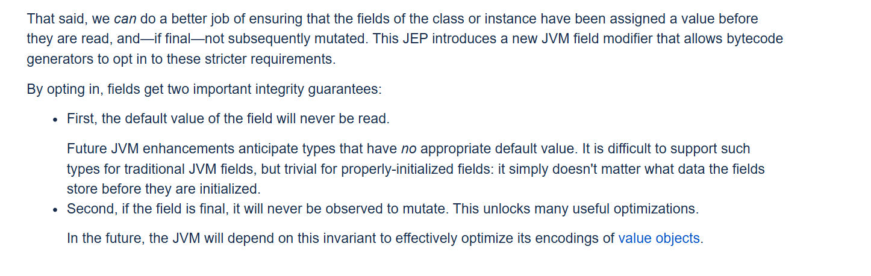

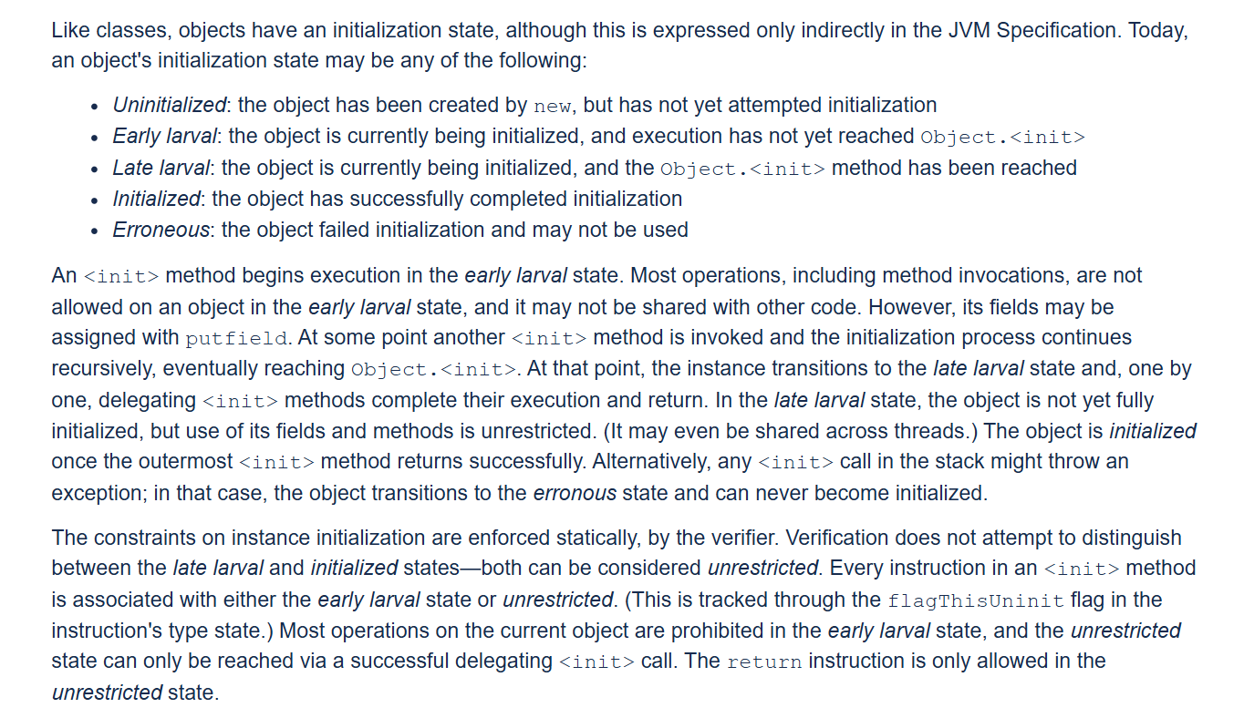



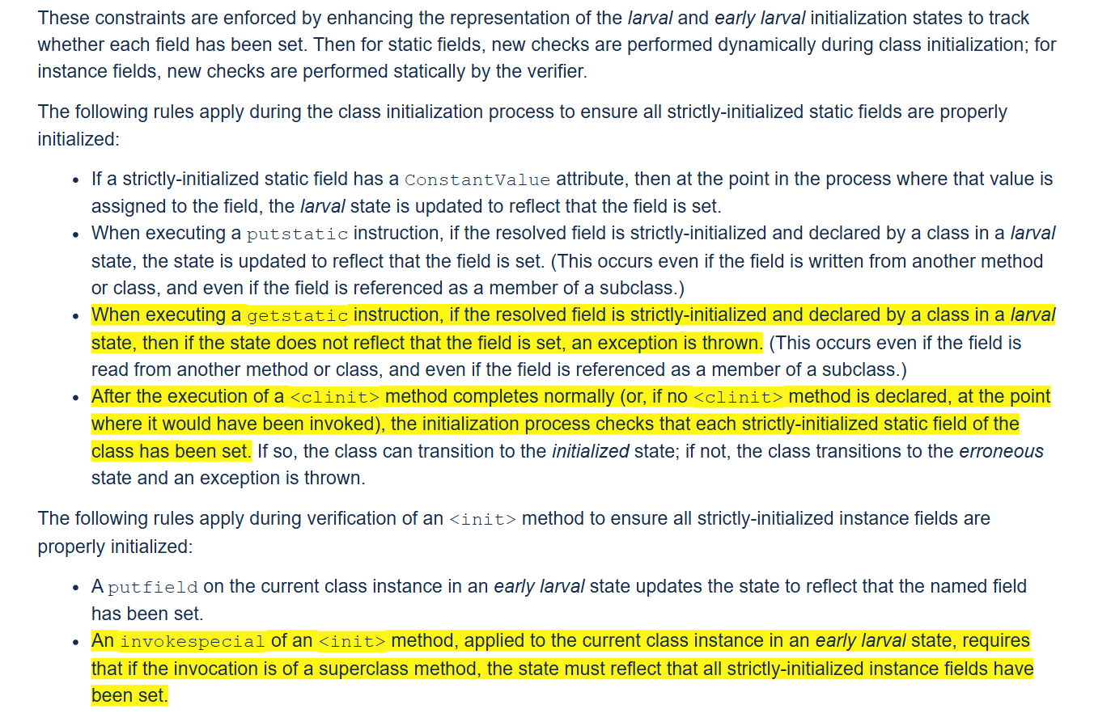

**(It is not allowed to perform getfield on the current class instance in an *early larval* state.)**



**TestCase:**



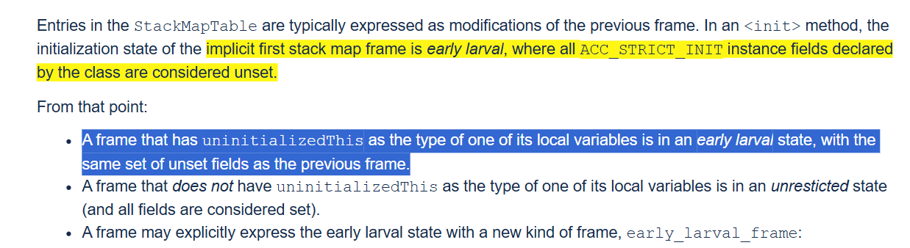



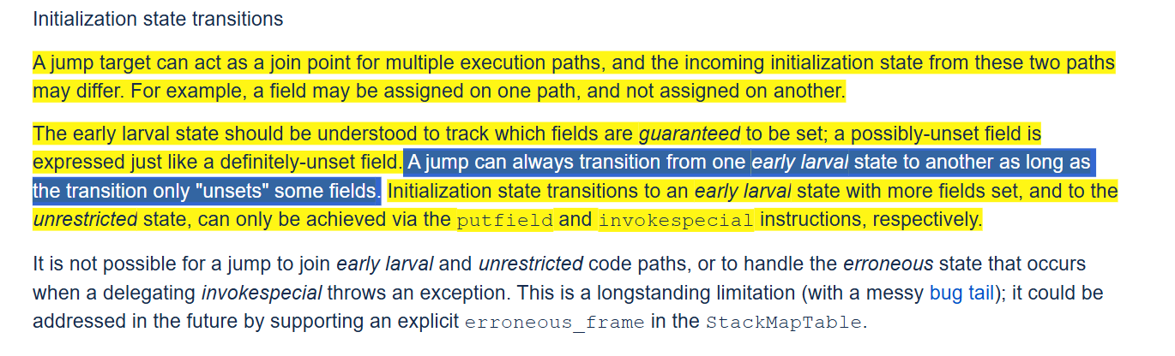



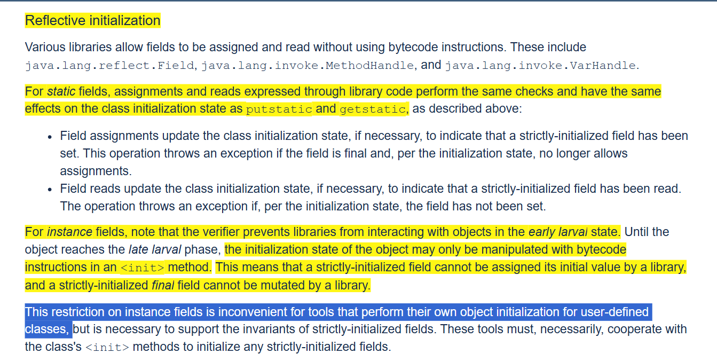

**3 ways to initialize fields**

* **Get/putfield**
  + **This is the only way to modify the object's initialization state.**
* **Reflective access** 
  + **Do not modify the initialization state of the object.**
* **Unsafe**

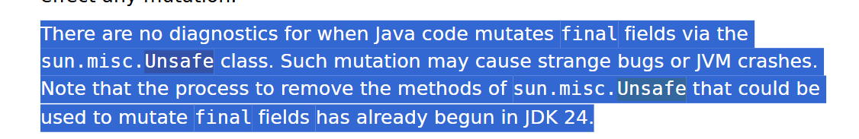

[**https://openjdk.org/jeps/8349536**](https://openjdk.org/jeps/8349536)

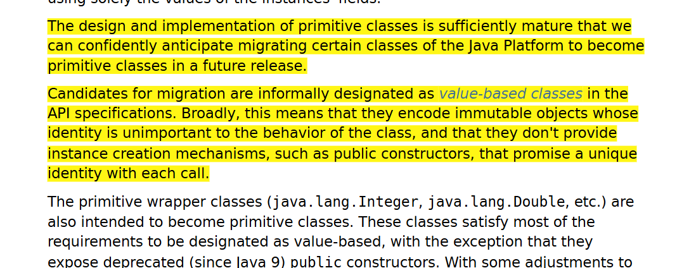

[**https://openjdk.org/jeps/390**](https://openjdk.org/jeps/390)

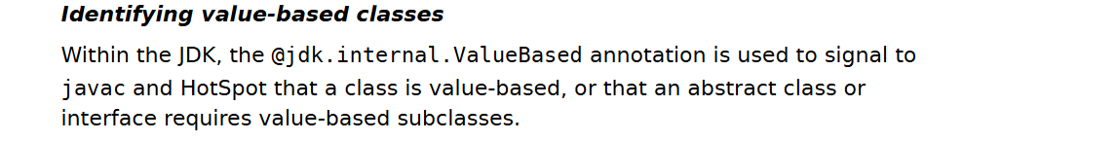

**@Strict annotation guarantees that the initialization state of the field is always initialized/set at the time of reading its value, it implicitly also ensures that none of the field of a value object is default initialized, earlier we used two separate annotations @ImplicitlyConstructable and @NullRestricted which ensured that value object never holds a null value from creation and during its entire lifetime.**

**With the new scheme, @Strict + @NullRestricted makes sure that the value object never holds a null value and all its fields are initialized during construction.**

**New @Strict semantics are currently under development**

**As removing field initialization from the constructor does not throw any runtime exception**

**public super class strict_fields version 69:0**

**{**

**@-jdk/internal/vm/annotation/Strict { }**

**public 0x0800 Field re:F;**

**@-jdk/internal/vm/annotation/Strict { }**

**public 0x0800 Field im:F;**

**public Method "<init>":"(FF)V"**

**stack 2 locals 3**

**{**

**aload_0;**

**invokespecial Method java/lang/Object."<init>":"()V";**

**return;**

**}**

**public static Method main:"([Ljava/lang/String;)V"**

**stack 4 locals 2**

**{**

**new class strict_fields;**

**dup;**

**fconst_1;**

**fconst_2;**

**invokespecial Method "<init>":"(FF)V";**

**astore_1;**

**getstatic Field java/lang/System.out:"Ljava/io/PrintStream;";**

**aload_1;**

**getfield Field im:"F";**

**aload_1;**

**getfield Field re:"F";**

**fadd;**

**invokedynamic InvokeDynamic REF_invokeStatic:Method java/lang/invoke/StringConcatFactory.makeConcatWithConstants:**

**"(Ljava/lang/invoke/MethodHandles$Lookup;Ljava/lang/String;Ljava/lang/invoke/MethodType;Ljava/lang/String;[Ljava/lang/Object;)Ljava/lang/invoke/CallSite;":**

**makeConcatWithConstants:"(F)Ljava/lang/String;" {**

**String "aggregate = \u0001"**

**};**

**invokevirtual Method java/io/PrintStream.println:"(Ljava/lang/String;)V";**

**return;**

**}**

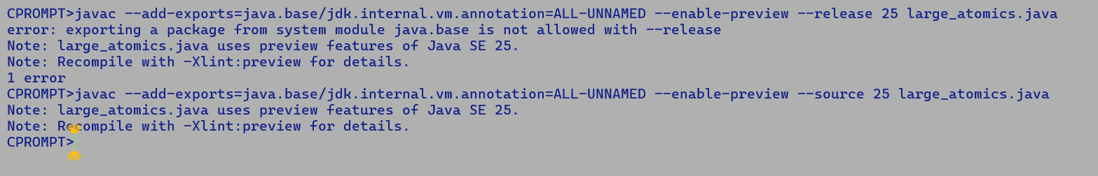

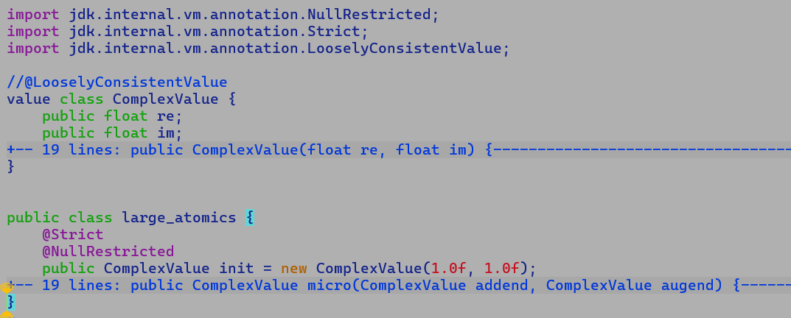

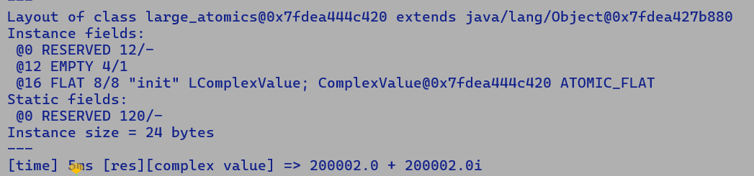

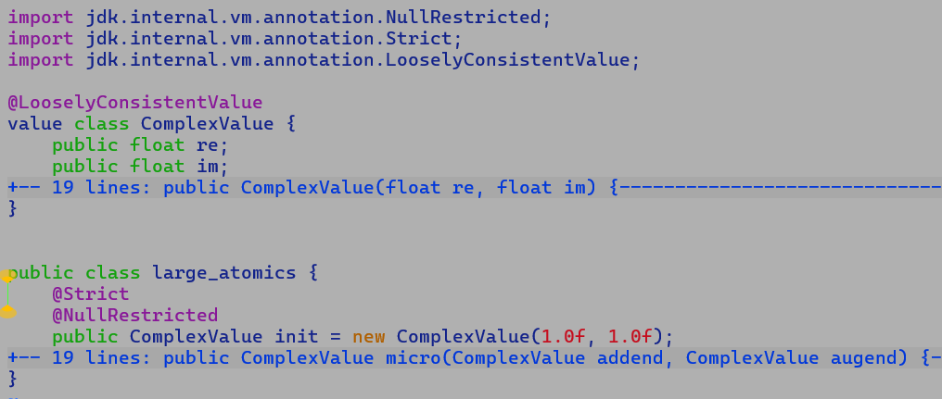

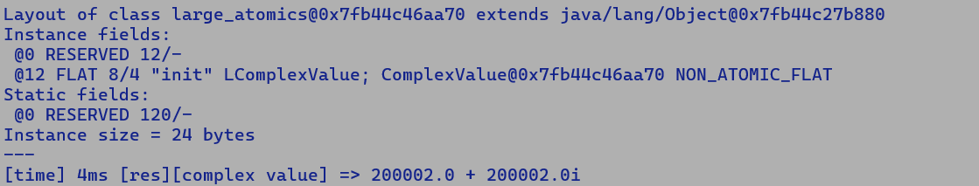

**Some differences b/w existing lworld+vector and lworld**

**Lworld+vector:-**

* **Earlier new value allocation created InlineTypeNode in larval state.**

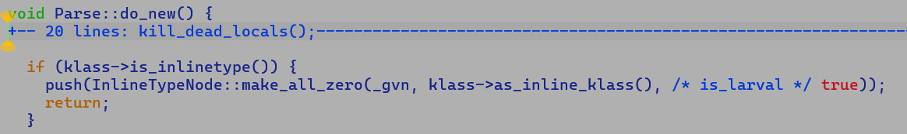

**New lworld code handled value object allocation on the lines of identity object allocation….**

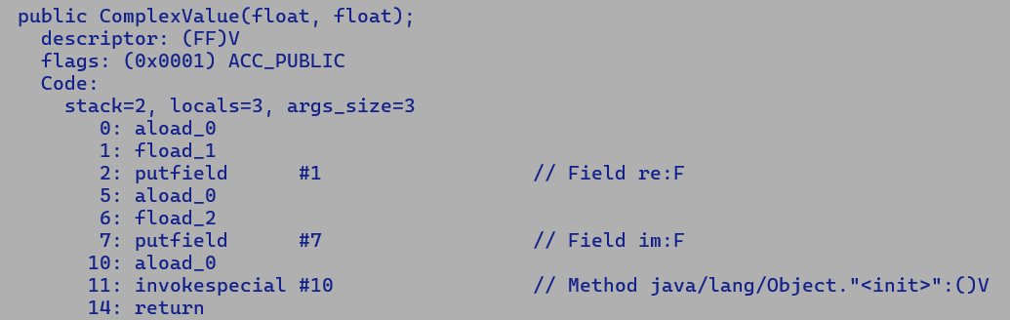



* **In the new scheme, scalarization of a new object is performed once it exits the larval state, i.e., towards the end of object construction.**
* **Rest of the flow**
  + **InlineTypeNode creation intercepts, new method state creation, argument/return value is the same.**
    - **make from oop**
    - **make_from_multi**
      * **Build start state.**
      * **Combines values objects, returned as fields on caller side.**
* **Unsafe.put* no longer perform problematic inlinetypenode re-construction towards the end as value is buffered once it enters larval state, during update using unsafe APIs, and re-construction happens only during finishPrivateBuffer.**

**To ensure atomic update of a flat value type field with a size less than 64 bits, its constituent field values are dumped into a 64-bit register, which is then stored into 8 byte aligned flat field starting address; for x86 targets a store of a quadword at 8 byte aligned memory is naturally atomic.**

**AI:**

* **Extend the existing payload-based atomic update infrastructure for a 128-bit payload size.**
* **C-micro to evaluate the performance of 128-bit atomic stores using the movdqa instruction.**
  + **Tricky part is the number of instructions needed to assemble the scalar field values into a 128 bit payload.**

[**https://openjdk.org/jeps/401#:~:text=In%20the%20future%2C%20128%2Dbit%20flattened%20encodings%20may%20be%20possible%20on%20platforms%20that%20support%20atomic%20reads%20and%20writes%20of%20that%20size.%20And%20the%20Null%2DRestricted%20Value%20Types%20JEP%20will%20enable%20heap%20flattening%20for%20even%20larger%20value%20classes%20in%20use%20cases%20that%20are%20willing%20to%20opt%20out%20of%20atomicity%20guarantees**](https://openjdk.org/jeps/401#:~:text=In%20the%20future%2C%20128%2Dbit%20flattened%20encodings%20may%20be%20possible%20on%20platforms%20that%20support%20atomic%20reads%20and%20writes%20of%20that%20size.%20And%20the%20Null%2DRestricted%20Value%20Types%20JEP%20will%20enable%20heap%20flattening%20for%20even%20larger%20value%20classes%20in%20use%20cases%20that%20are%20willing%20to%20opt%20out%20of%20atomicity%20guarantees)**.**

**Performance impact of field flattening: -**

**import jdk.internal.vm.annotation.Strict;**

**import jdk.internal.vm.annotation.NullRestricted;**

**import jdk.internal.vm.annotation.LooselyConsistentValue;**

**//@LooselyConsistentValue**

**value class ComplexValue {**

**public float re;**

**public float im;**

**public ComplexValue(float re, float im) {**

**this.re = re;**

**this.im = im;**

**}**

**ComplexValue add(ComplexValue augend) {**

**return new ComplexValue(this.re + augend.re, this.im + augend.im);**

**}**

**public String toString() {**

**StringBuilder sb = new StringBuilder();**

**sb.append("[complex value] => ");**

**sb.append(re);**

**sb.append(" + ");**

**sb.append(im);**

**sb.append("i ");**

**return sb.toString();**

**}**

**}**

**public class large_atomics {**

**@Strict**

**@NullRestricted**

**public ComplexValue init = new ComplexValue(1.0f, 1.0f);**

**public void micro(ComplexValue augend) {**

**init = init.add(augend);**

**}**

**public static void main(String [] args) {**

**large_atomics obj = new large_atomics();**

**for (int i = 0; i < 1000000; i++) {**

**obj.micro(new ComplexValue((float)i, (float)i));**

**}**

**long t1 = System.currentTimeMillis();**

**for (int i = 0; i < 1000000; i++) {**

**obj.micro(new ComplexValue((float)i, (float)i));**

**}**

**long t2 = System.currentTimeMillis();**

**System.out.println("[time] " + (t2-t1) + "ms [res]" + obj.init);**

**}**

**}**

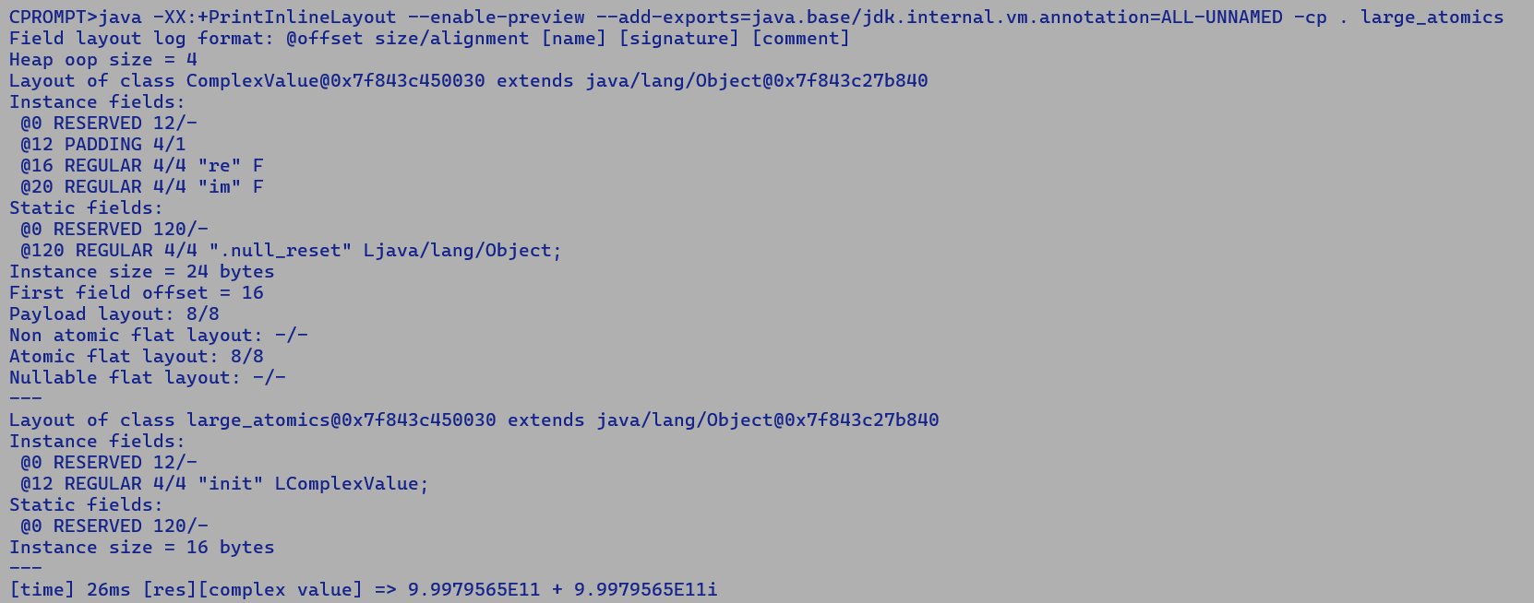



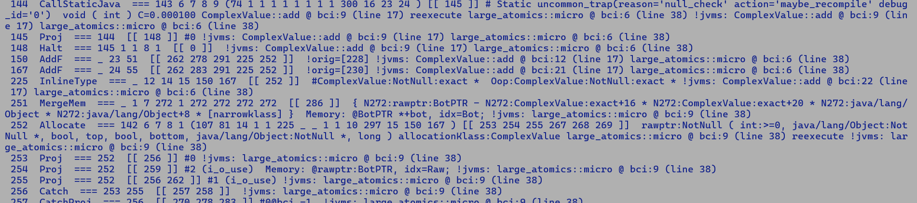

**Non-flat field incurs the same performance penalty as boxing does, as an InlineTypeNode is only buffered if it has a non-scalarized user, like a non-scalarized access, or is passed/returned from a method, as in non-scalarized form. e.g., InlineTypeReturnedAsFields, InlineTypePassFieldsAsArgs.**

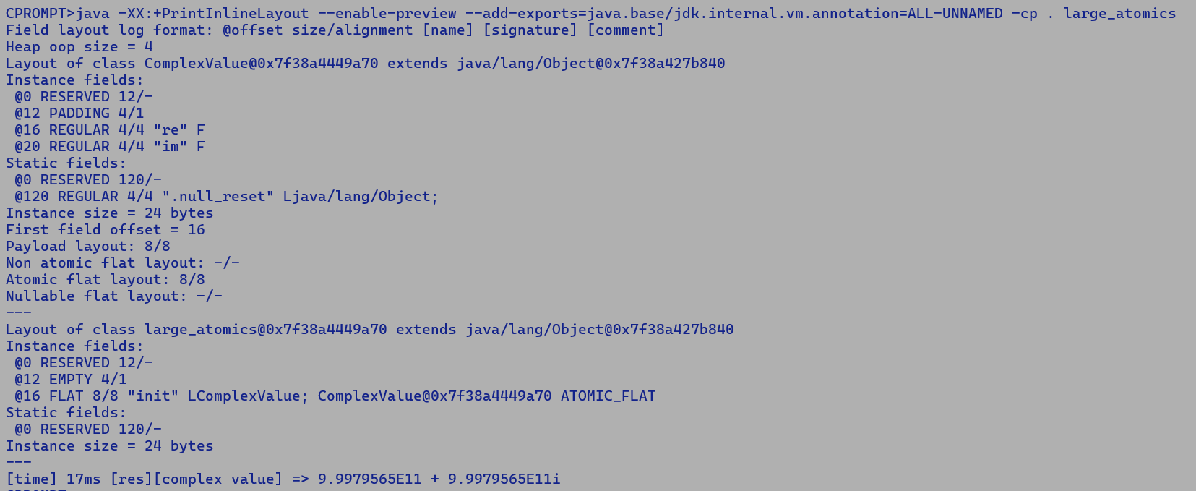



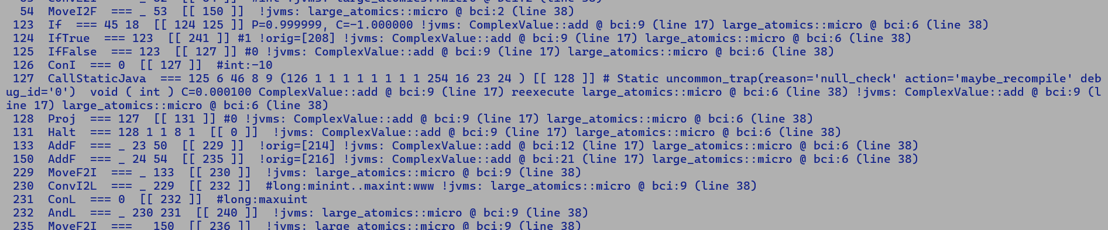

**Instruction sequence to guarantee atomic writes**

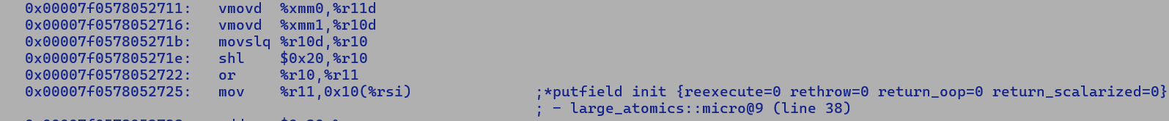

**Next steps**

* **Performance comparison of ATOMIC vs NON-ATOMIC flat field writes.**
* **Performance comparison of a large flat field NON-ATOMIC writes vs non-flat field writes.**
* **Performance comparison of large flat field NON-ATOMIC writes vs ATOMIC flat field write using MOVDQA.**
  + **Hypertuning using different atomic write schemes**
* **Vary the payload size from 32 – 512 in steps of 32.**
* **Measure the performance of micro**

**128 bit value object**

**NON-ATOMIC FLAT vs NON-FLAT performance**

**Field = @NullRestricted , @Strict**

**Value Class @LooselyConsistentValue**

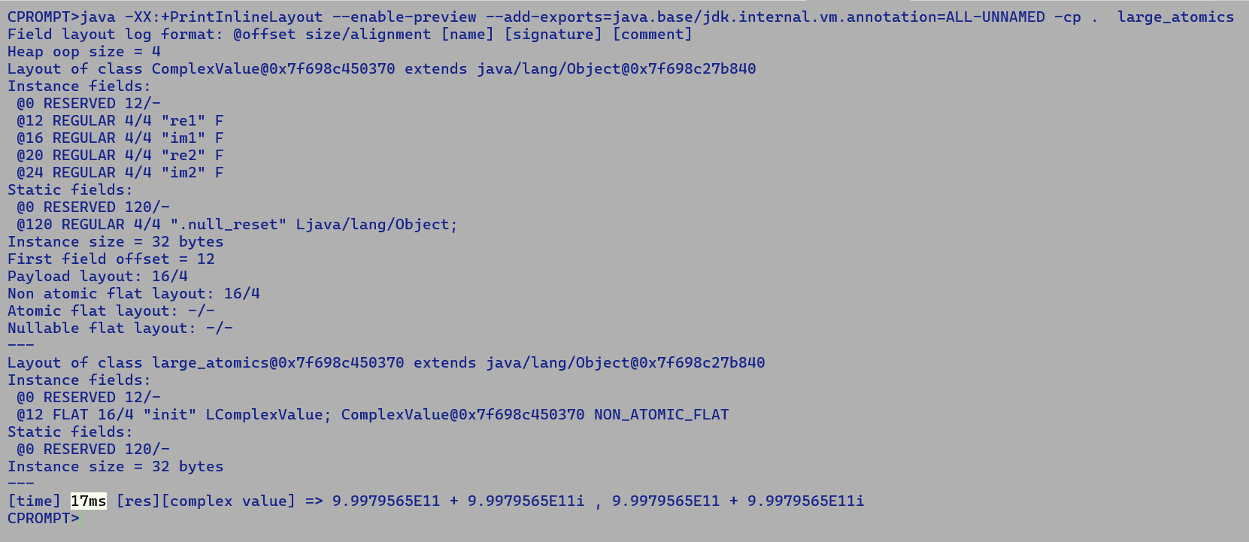

**Field = @NullRestricted, @Strict**

**Value Class = Not @LooselyConsistentValue**

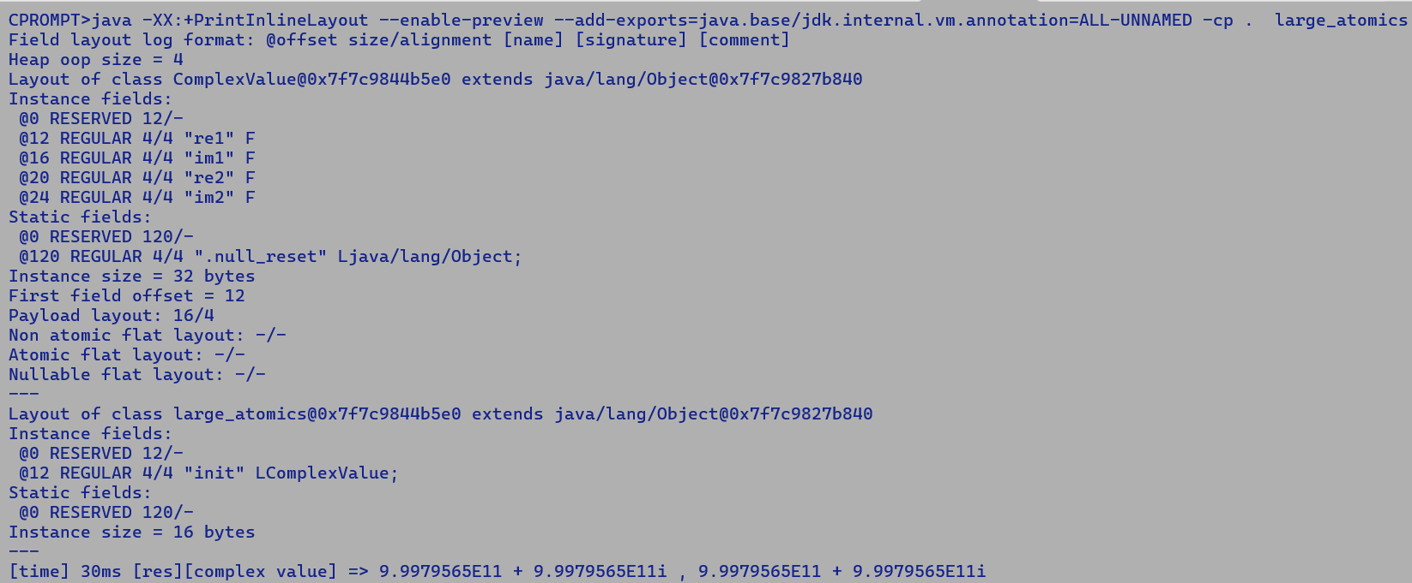

**64-bit value payload ATOMIC vs NON-ATOMIC FLAT vs NON-FLAT field update performance**

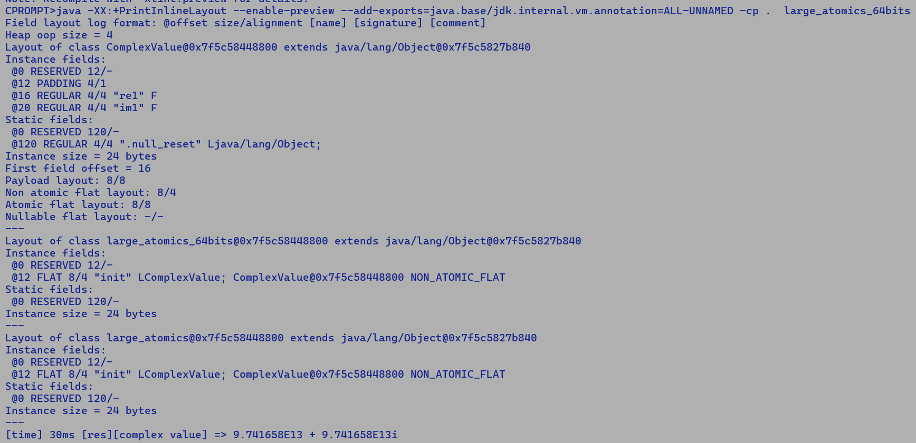



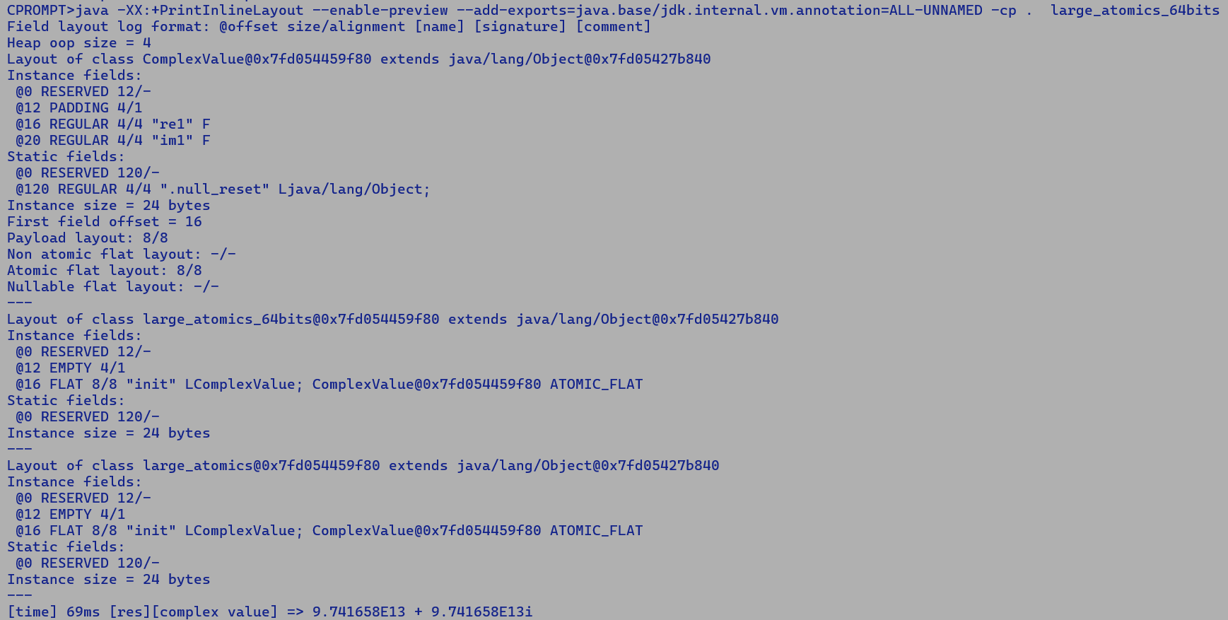



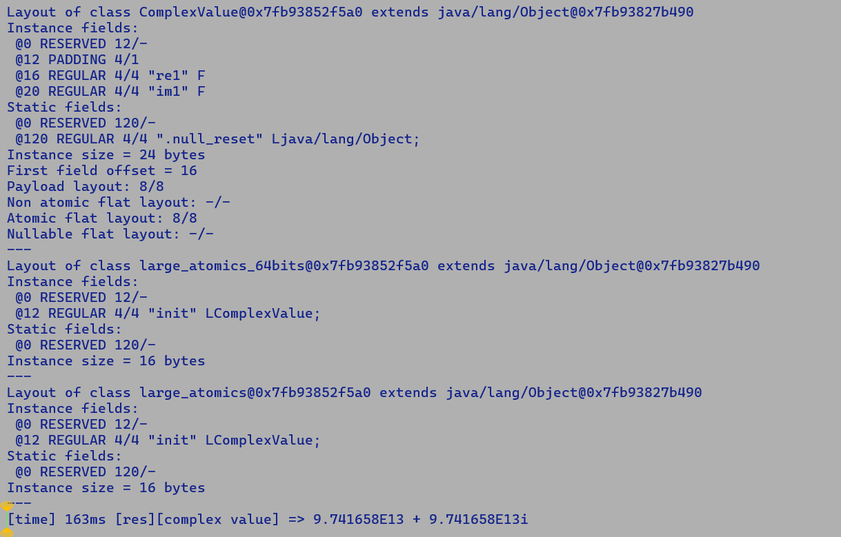



* **Objectives of this performance analysis: -**
* **Is Atomic flattening of a 128-bit payload always performant over a non-flat field?**
  + **Find the performance delta with a non-flat field, as it will determine the headroom which we have to experiment with different atomic update schemes, TSX, Micros, CMPXCHG16B, and LOCK.**
* **What is the break-even payload size when non-atomic flattening matches with a non-flat field?**
  + **Field flattening will always occupy a lesser heap size, since we are saving the header allocation. if a valuetype field is not flattened, then we allocate it on the heap. each object has a header and a payload. by flattening the fields, we save the header size.**
    - **Based on the access pattern of fields, flattening may improve or degrade the performance.**
    - **If a flat field is sandwiched b/w two scalar fields, but micro-access two delimiting fields very often, the intermediate field flattening may move the scalars on different cache lines.**

**Probable implementations: -**

* **Extend the existing payload-based atomic field flattening sequence using MOVDQA.**
  + **MOVDQA expects the memory address to be 16-byte aligned.**
  + **To ensure this, the field layout needs to be adjusted.** 
    - **This may not be an acceptable solution object layouts cannot be altered based on target constraints.**
* **Use CMPXCGH16B to implement 128-bit atomic stores.**
* 
  + Compares the 64-bit value in EDX:EAX (or 128-bit value in RDX:RAX if operand size is 128 bits) with the operand (destination operand). If the
  + Values are equal, the 64-bit value in ECX:EBX (or 128-bit value in RCX:RBX) is stored in the destination operand.
  + Compiler Change:
    - Create a new IR PackedStore
    - Emit field compaction IR (LShift + ORs) to move them into a 128-bit pair to be stored atomically into the destination.
    - Additional cost to measure: compaction logic + CMPEXCHANG128 latency.
    - Savings: Multiple stores, object header, indirection, gains may be significant with deeply nested fields.
  + This can be benchmarked in a c-micro for the payload of 4 floating point fields and integral fields.
    - For floating point, there is an additional domain crossover penalty of 3 cycles b/w XMM and GPR register moves.
  + This solution also fits well with the new Valhalla payload packing scheme for flat fields.

**[PackComp1] [PackComp2] // Packed RegL components.**

**| |**

**|_____ ______|**

**| |**

**(RM: RDX) | | (RM : RAX)**

**[ PackComp]**

**|**

**All floating-point fields: -**

**Instruction sequence for atomic-flat field update.**

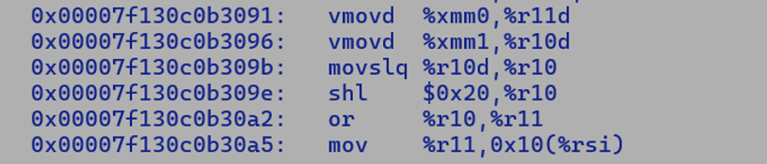



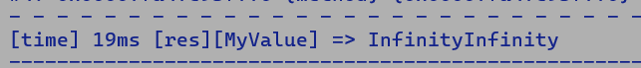

**Instruction sequence for non-atomic field update.**





**Instruction sequence for non-flat field update.**

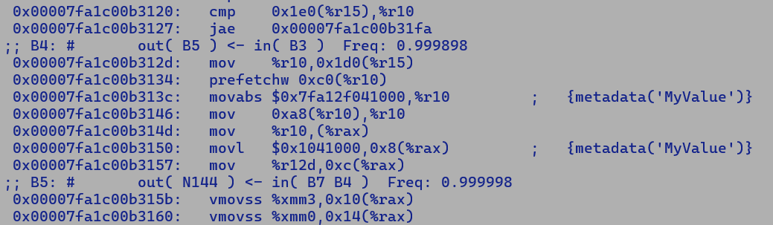



**C2 internally represent all value objects using scalarized InlineTypeNode representation unless it encounters a non-scalarized use like non-flat value type field, where it re-boxes the value object before assignment for non-flat field.**

**Atomic vs non-flat field performance delta in case of floating-point fields where we also incur a domain cross over penalty**

* **100 * (1 - (19/21))**
* **9.52 %**

**All Integral fields: -**

**Instruction sequence for atomic flat field update**

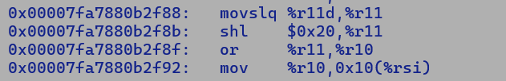



**Instruction sequence for non-atomic flat field update.**





**Instruction sequence for non-flat field update.**

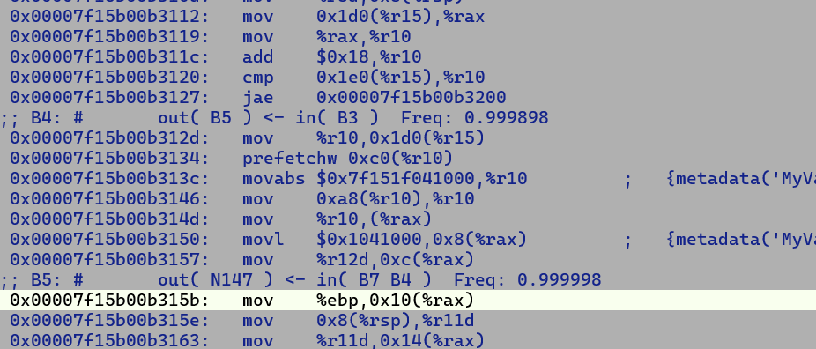

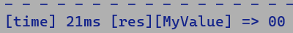

**Non-atomic flattening is unconstrained, and the compiler faithfully inlines the flat field.**

**Performance delta b/w atomic flattening and non-flat field = (1 – (16 / 21)) * 100 = 23.80 %**

**There is higher headroom to accommodate additional instructions needed for 128-bit atomic flattening of integral fields vs floating point fields.**

**26/6/2025**

**---------------**

**Newly allocated object starts out in uninitializedThis state, which is a larval state, it runs through bytecode verification during linking.**

**Even though the same semantics apply to explicit larval objects, they are not subjected to bytecode verification.**

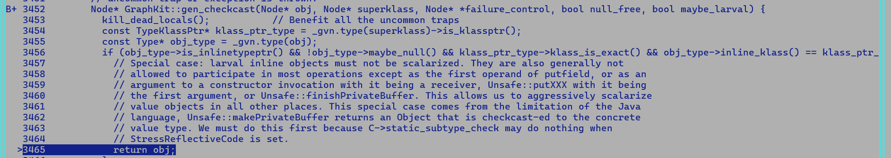

**Post construction newly allocated object is initialized and is scalarized.**

**Currently, we are not setting explicit larval flan on Allocation IR, which new allocation compiler using javac will new and invokespecila consecutively, but any crafted bytecode sequence may have a gap b/w them, but we rely on bytecode verification to catch any undefined behaviour and only semantically correct and verified bytecode sequence is exposed to JIT compiler. Thus, we do not need explicit _larval flag setting on value objects allocated using the new operator, but the same is mandatory for explicitly generated larval values that bypass the bytecode verification stage.**

**new**

**…….**

**…….**

**MyValue.<init>**

**Test point:**

**Non-intrinsic Unsafe.makePrivateBuffer(), return type j.l.o, is not an inlinetype. Also, disable speculative unique subclassing for abstract class with a single concrete subclass using -XX:-UseUniqueSubclasses**

**Optimization:**

* **Use VectorStore to store contiguous field values during InlineTypeNode::store_flat, if all the field are contiguous in memory e.g.**
* **(gdb) p base->dump(1)**
* **1220 LoadF === _ 1187 194 [[ 1203 ]] @MyVector:exact+40 *, name=lane7, idx=13; #float !jvms: explicit_larval_value_updates$2::apply @ bci:45 (line 93) explicit_larval_value_updates::micro @ bci:3 (line 109)**
* **1218 LoadF === _ 1187 188 [[ 1203 ]] @MyVector:exact+36 *, name=lane6, idx=12; #float !jvms: explicit_larval_value_updates$2::apply @ bci:45 (line 93) explicit_larval_value_updates::micro @ bci:3 (line 109)**
* **1216 LoadF === _ 1187 182 [[ 1203 ]] @MyVector:exact+32 *, name=lane5, idx=11; #float !jvms: explicit_larval_value_updates$2::apply @ bci:45 (line 93) explicit_larval_value_updates::micro @ bci:3 (line 109)**
* **1214 LoadF === _ 1187 176 [[ 1203 ]] @MyVector:exact+28 *, name=lane4, idx=10; #float !jvms: explicit_larval_value_updates$2::apply @ bci:45 (line 93) explicit_larval_value_updates::micro @ bci:3 (line 109)**
* **1212 LoadF === _ 1187 170 [[ 1203 ]] @MyVector:exact+24 *, name=lane3, idx=9; #float !jvms: explicit_larval_value_updates$2::apply @ bci:45 (line 93) explicit_larval_value_updates::micro @ bci:3 (line 109)**
* **1210 LoadF === _ 1187 164 [[ 1203 ]] @MyVector:exact+20 *, name=lane2, idx=8; #float !jvms: explicit_larval_value_updates$2::apply @ bci:45 (line 93) explicit_larval_value_updates::micro @ bci:3 (line 109)**
* **1208 LoadF === _ 1187 158 [[ 1203 ]] @MyVector:exact+16 *, name=lane1, idx=7; #float !jvms: explicit_larval_value_updates$2::apply @ bci:45 (line 93) explicit_larval_value_updates::micro @ bci:3 (line 109)**
* **1206 LoadF === _ 1187 150 [[ 1203 ]] @MyVector:exact+12 *, name=lane0, idx=6; #float !jvms: explicit_larval_value_updates$2::apply @ bci:45 (line 93) explicit_larval_value_updates::micro @ bci:3 (line 109)**
* **16 ConI === 0 [[ 98 127 206 223 240 287 363 440 442 515 526 537 548 605 657 689 1004 1058 1068 1078 1088 1141 1171 1172 1179 1203 1203 ]] #int:1**
* **148 CheckCastPP === 145 143 [[ 150 150 152 152 158 158 164 164 170 170 176 176 182 182 188 188 194 194 112 210 212 276 315 338 357 378 405 446 488 520 531 542 553 587 648 715 722 903 923 946 988 1005 1030 1056 1062 1072 1082 1092 1115 1124 1145 1219 1165 1184 1198 1200 1219 1203 1204 1204 1205 1205 1207 1207 1209 1209 1211 1211 1213 1213 1215 1215 1217 1217 ]] #MyVector:NotNull:exact * Oop:MyVector:NotNull:exact * !jvms: explicit_larval_value_updates$2::apply @ bci:4 (line 89) explicit_larval_value_updates::micro @ bci:3 (line 109)**
* **1203 InlineType === _ 148 16 16 1206 1208 1210 1212 1214 1216 1218 1220 [[ 1147 1147 ]] #MyVector:NotNull:exact * Oop:MyVector:NotNull:exact * !jvms: explicit_larval_value_updates$2::apply @ bci:45 (line 93) explicit_larval_value_updates::micro @ bci:3 (line 109)**
* **$6 = void**
* **(gdb)**
* **While loading an InlineTypeNode from and oop we still need to create an explicit scalar field to facilitate field value forwarding.**

**21/7/2021**

**--------------**

**abstract value class MyAbsValue {**

**public abstract float getAccum();**

**}**

**value class MyValue extends MyAbsValue {**

**public float f1;**

**public float f2;**

**public MyValue(float f1, float f2) {**

**this.f1 = f1;**

**this.f2 = f2;**

**}**

**public float getAccum() {**

**return this.f1 + this.f2;**

**}**

**}**

**public class test {**

**public static float leaf(MyAbsValue obj) {**

**return obj.getAccum();**

**}**

**public static float micro(MyValue obj, int cond) { // Scalarized obj, build start state rematerializes InlineTypeNode.**

**if (cond > 5000) {**

**return leaf(obj); // Left is not inlines and UseUniqueSubclassing is turned off, thus object signature is not an value class but**

**// and abstract value class which is not scalarized.**

**}**

**return obj.getAccum() + 10.0f;**

**}**

**public static void main(String [] args) {**

**float res = 0.0f;**

**for (int i = 0; i < 10000; i++) {**

**res += micro(new MyValue((float)i, 30.0f), i);**

**}**

**System.out.println("[res] " + res);**

**}**

**}**

**Directcall generator buffers the scalarized IR nodes if call is not inlined and parameter type is an abstract value class**

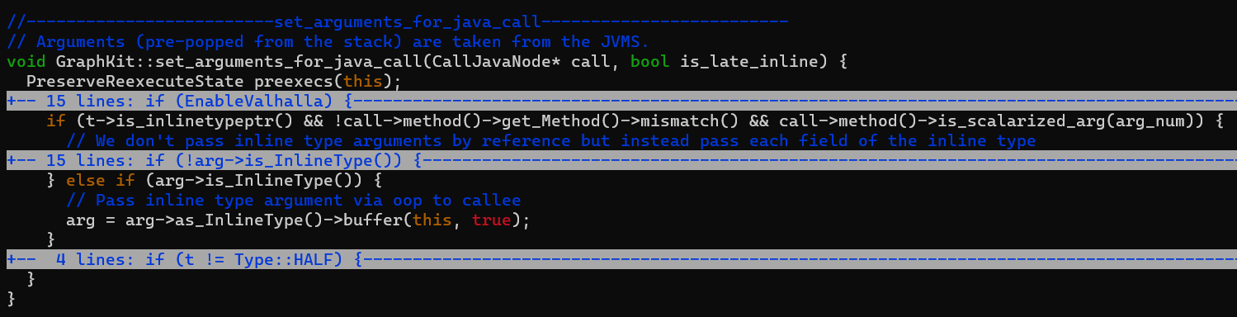

**New cloned Buffered IR node updates the local variable array entry (SafePoint->JVMState) if marked safe for replacement.**

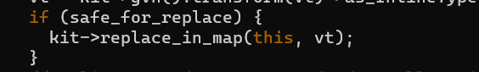

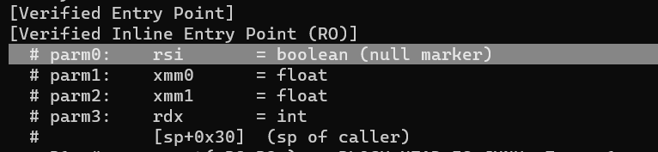

**Q. What is the relation between reduction and associativity, in other words why reduction mandates that operator should be associative ?**

**A. For parallel reduction we can split the lanes into buckets and operate on buckets independently, and then assemble the results in any order.**

**For an associative operator OP, (A OP B) OP C == A OP (B OP C), this fundamental property can be used to perform parallel reduction using divide and conquer**

**approach.**

**public static final Associative ADD = assoc("ADD", "+", VectorSupport.VECTOR_OP_ADD, VO_ALL+VO_ASSOC);**

**public static final Associative MUL = assoc("MUL", "*", VectorSupport.VECTOR_OP_MUL, VO_ALL+VO_ASSOC);**

**public static final Associative MIN = assoc("MIN", "min", VectorSupport.VECTOR_OP_MIN, VO_ALL+VO_ASSOC);**

**public static final Associative MAX = assoc("MAX", "max", VectorSupport.VECTOR_OP_MAX, VO_ALL+VO_ASSOC);**

**public static final Associative FIRST_NONZERO = assoc("FIRST_NONZERO", "a!=0?a:b", -1 /*VectorSupport.VECTOR_OP_FIRST_NONZERO*/, VO_ALL+VO_ASSOC);**

**public static final Associative AND = assoc("AND", "&", VectorSupport.VECTOR_OP_AND, VO_NOFP+VO_ASSOC);**

**public static final /*bitwise*/ Associative OR = assoc("OR", "|", VectorSupport.VECTOR_OP_OR, VO_NOFP+VO_ASSOC);**

**static final Associative OR_UNCHECKED = assoc("OR_UNCHECKED", "|", VectorSupport.VECTOR_OP_OR, VO_ASSOC+VO_PRIVATE);**

**public static final /*bitwise*/ Associative XOR = assoc("XOR", "^", VectorSupport.VECTOR_OP_XOR, VO_NOFP+VO_ASSOC);**

**public static final Associative SUADD = assoc("SUADD", "+", VectorSupport.VECTOR_OP_SUADD, VO_NOFP+VO_ASSOC);**

**public static final Associative UMIN = assoc("UMIN", "umin", VectorSupport.VECTOR_OP_UMIN, VO_NOFP+VO_ASSOC);**

**public static final Associative UMAX = assoc("UMAX", "umax", VectorSupport.VECTOR_OP_UMAX, VO_NOFP+VO_ASSOC);**

**For floating point addition reduction is strictly ordered due to precision constraints.**

**(((A + B) + C) + D)**

**26/08/2025**

**Partial escape analysis: -**

* **Context sensitive allocation elimination, each new allocation has its corresponding Virtual Object and Virtual Object State to keep the track field values modifications through control flow and state of object like locked / unlocked. An allocation which remains in Virtual State on all control paths is non-escaping and can be eliminated.**
* **While Valhalla gives the control of value instance creation to user, PEA/EA opportunistically eliminates allocations if an allocation is non-escaping through inter and intra procedural analysis.**
* **Following analogies can be drawn b/w JVM components** 
  + **Auto-vectorization - Vector API**
  + **EA/PEA – Valhalla**

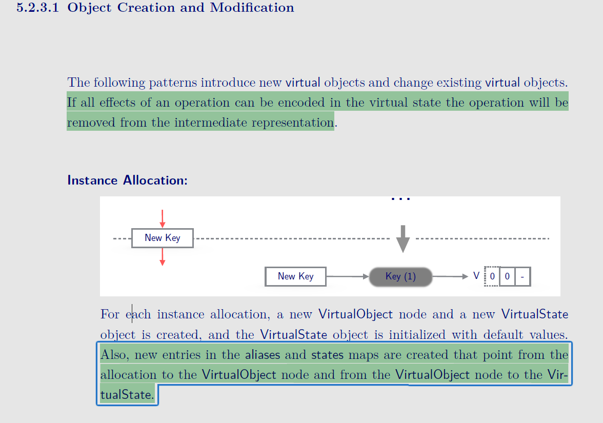

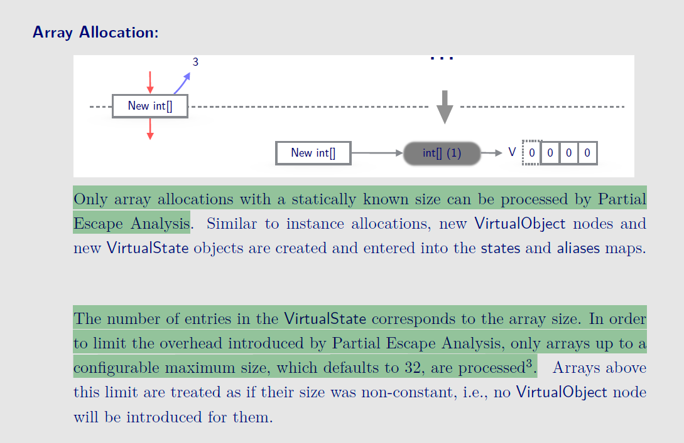

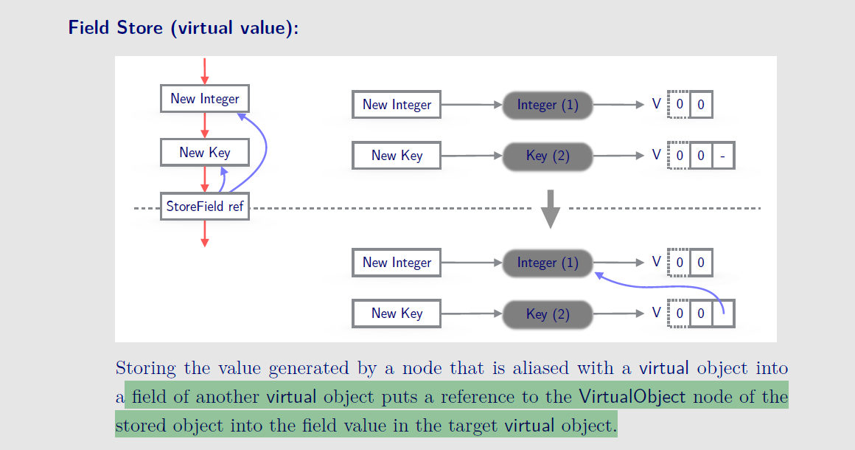

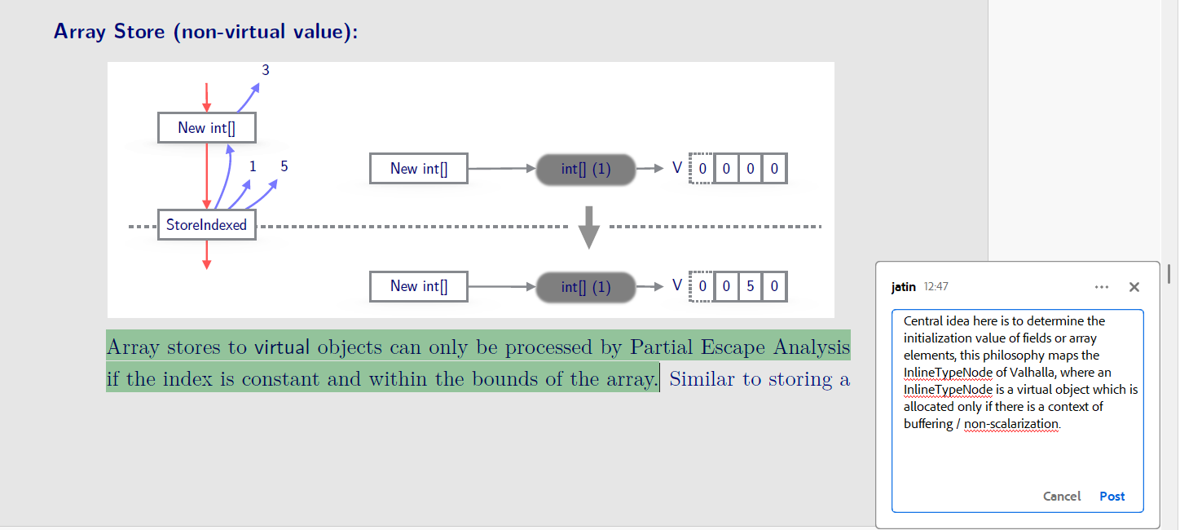

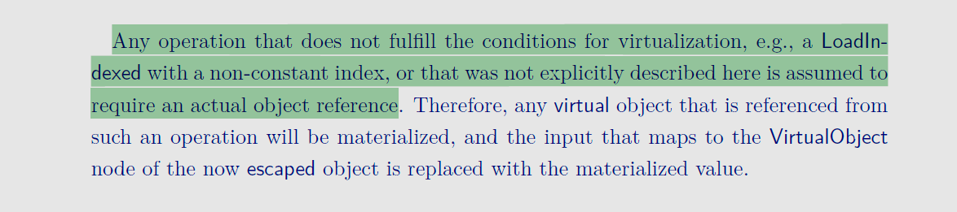

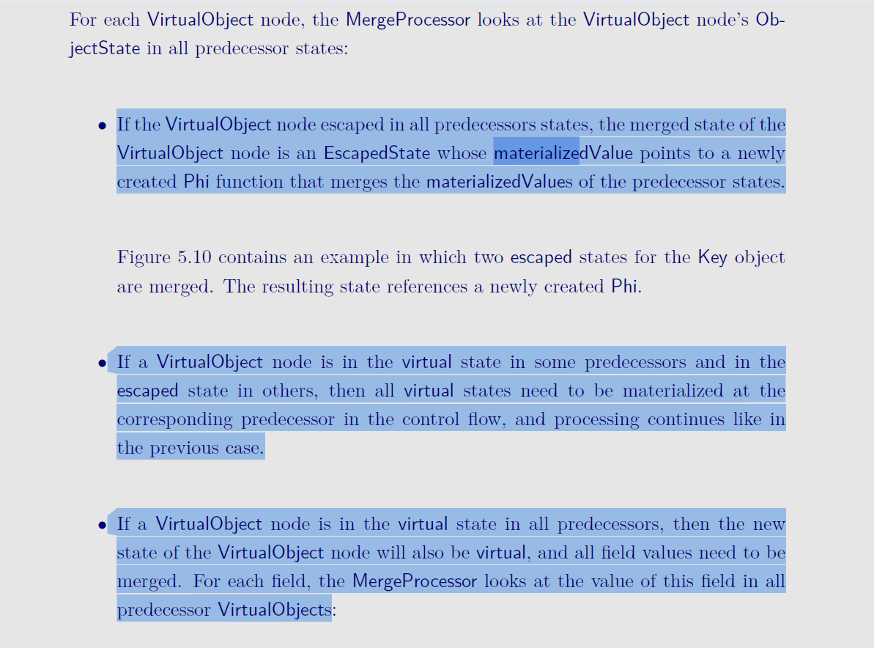

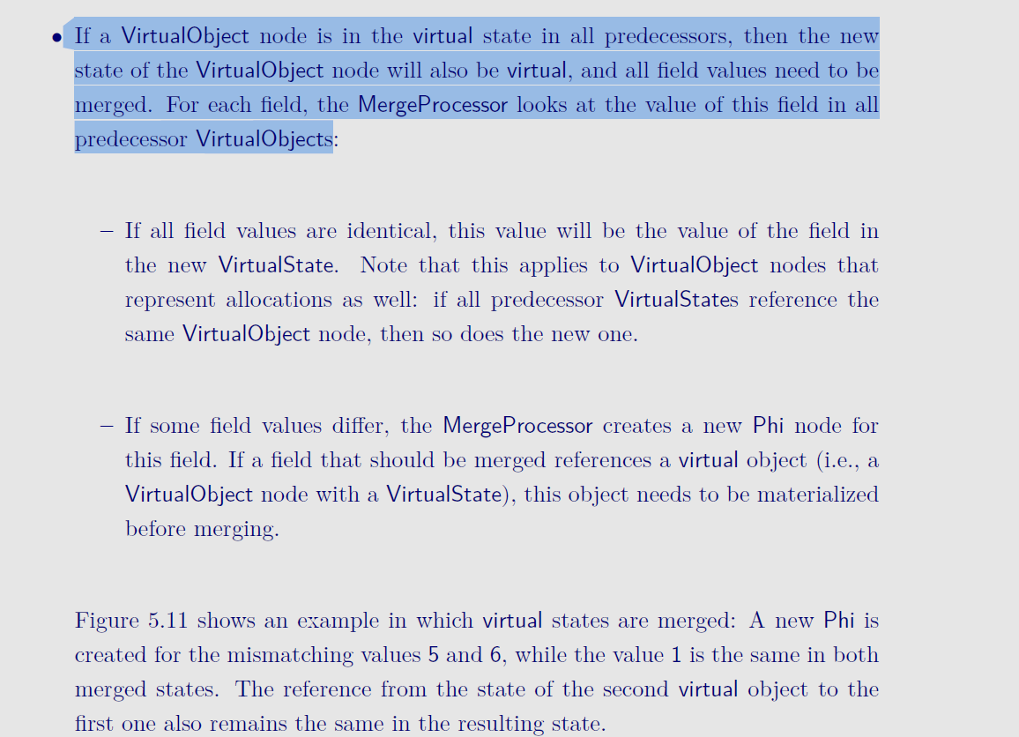

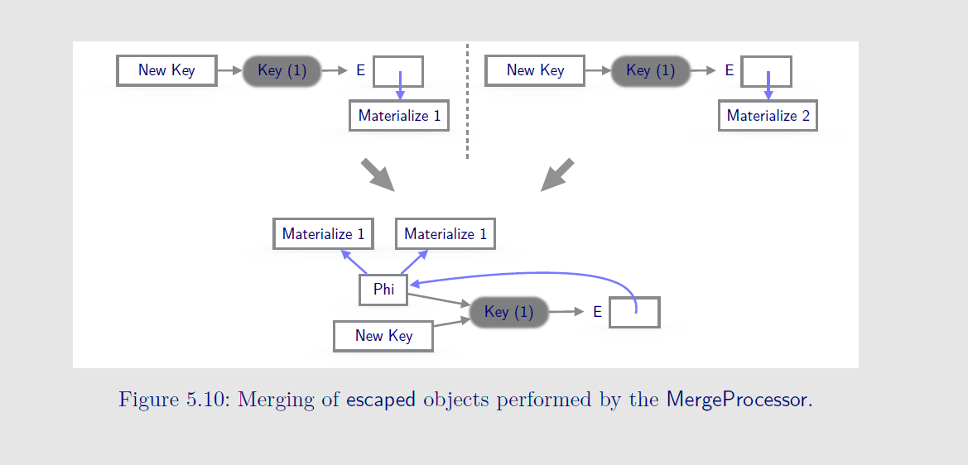

**26/9/2025**

**Q. Why do we need @multifield annotated field in VectorPayloads and not just retain the array-backed backing storage?**

**A. Even currently, Vector instances are immutable, with each modification or application of an operation, a new vector is generated.**

**Each new vector has a distinct backing storage in the form of an array; thus, no two vector ever share their backing storage, which makes vectors an immutable quantity.**

**Vector<Float> newVector = Vec1.lanewise(VectorOperators.ADD, Vec2);**

**Since arrays are always allocated over the heap, they carry an identity, which is the distinctive heap address for each new backing storage array.**

**This contradicts the philosophy of value type instances, which are identity-free; the compiler treats two values with the same contents as equivalent entities and is free to substitute one with another.**

**By replacing existing array-backed storage with a @multifield annotated storage, we ensure that payload adheres to true value semantics, a @multifiled is seen as a bundle of fields, encapsulating payload is a value class, unlike an array, a multifield is never allocated an explicit heap storage.**

**Here is an example code**

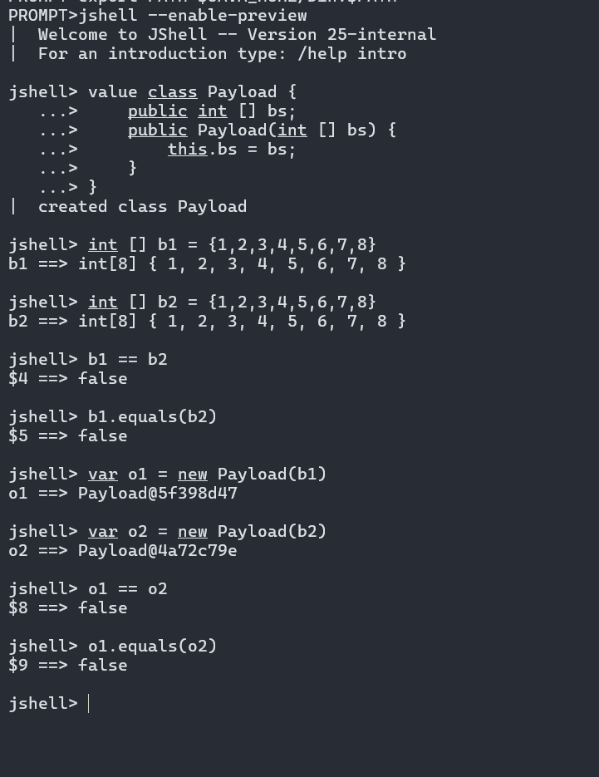

**Even though Payload is a value class, its two instances with the same backing storage are not equal, because arrays have identity.**

**By treating vectors as value objects, we expect that two vectors with the same contents should be equal.**

**Q. Is there any alternative to @multifield?**

**A. All we need to ensure is that the backing storage has no identity. Thus, we could have multiple primitive type fields in the payload, one for each lane of the vector.**

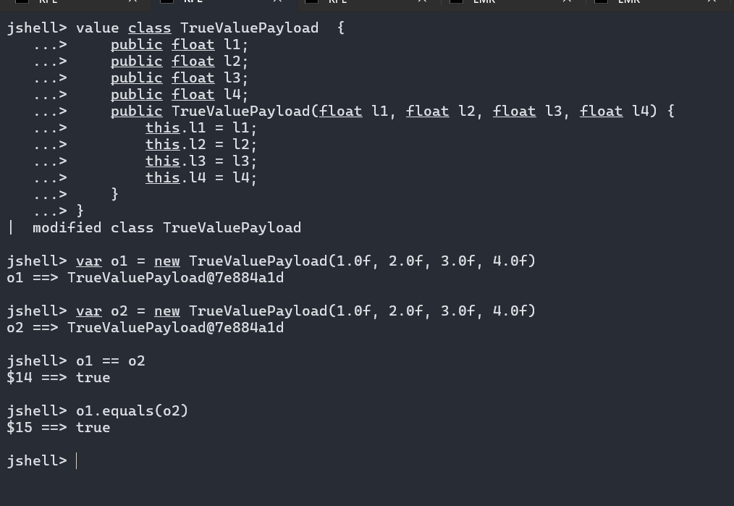

**Consider the above modified payload class ‘TrueValuePayload’, here we create a separate primitive type field for each lane of the vector, thus two vector values with the same contents are treated as equivalent entities.**

**With @multifield we intend to create identity-free backing storage.**

**Q. What are the complications with explicit fields for each lane in the container payload?**

**A. First, at load time, build_layout randomizes the fields' layout, but that is not a major concern since fields can always be updated using their effective offsets.**

**A bigger concern is that the C2 compiler will see scalar fields as different inputs to InlineTypeNode. The compiler creates an InlineTypeNode for each instance of a value class and scalarizes the fields, with different scalar field we may observe multiple inputs to IR, one for each lane. Each scalar field will be of primitive Type, while the type of Type of InlineTypeNode will be PayloadType, since an inline type node corresponds to a value object. We expect to deal in vector-type field, i.e., the one that carry an ideal type TypeVect.**

**Vector IR is forwarded to its user every time we perform a vector_unbox operation over VectorPayload, this way, vector IR inputs are directly forwarded to the vector operation nodes.**

**Keeping multiple scalar fields, one for each lane type in the VectorPayload class, while creating a vector IR for a bundle of lanes, will result in adding kludges in the code. Consider the following case**

**var v1 = FloatVector.fromArray(SP, arr1, index)**

**var v2 = FloatVector.fromArray(SP, arr2, index)**

**res = v1.lanewise(VectorOperators.ADD, v2)**

**v1 and v2 are concrete vector class instances, where is the vector class is a valuetype, with stock Valhalla, IR corresponding to fromArray API will look like following**

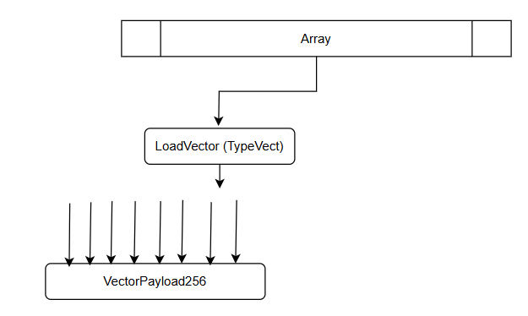

**While expected IR pallet should look like following**

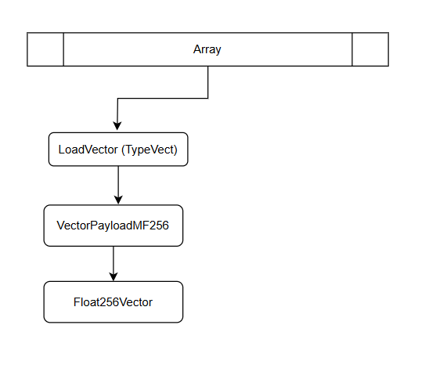

**Q. How can we initialize a value object using MethodHandle?**

**A. In terms of construction, value class instances follow identity instance allocation semantics, where allocation is decoupled from the initialization, while new simple allocates the instance <init> receives the uninitializedThis and runs this through the constructor, thereby initializing its fields. During this phase, the object is in a larval state.**

**MethodHandle invokeSpecial can be used for the invocation of a constructor after allocation.**

**import jdk.internal.misc.Unsafe;**

**import java.lang.invoke.MethodHandle;**

**import java.lang.invoke.MethodHandles;**

**import java.lang.invoke.MethodType;**

**import java.lang.reflect.Field;**

**value class MyClass {**

**private float f1;**

**private float f2;**

**public MyClass(float f1, float f2) {**

**System.out.println("Running <init>(" + f1 + "," + f2 + ")");**

**this.f1 = f1;**

**this.f2 = f2;**

**}**

**@Override**

**public String toString() {**

**return "MyClass{f1=" + f1 + ", f2=" + f2 + "}";**

**}**

**}**

**public class UnsafeCtorInitValueTest {**

**public static void main(String[] args) throws Throwable {**

**// Get Unsafe instance reflectively**

**Unsafe unsafe = Unsafe.getUnsafe();**

**// Allocate object without running constructor**

**MyClass raw = (MyClass) unsafe.allocateInstance(MyClass.class);**

**System.out.println("After allocateInstance: " + raw);**

**// Get constructor handle**

**MethodHandles.Lookup lookup = MethodHandles.lookup();**

**MethodType mt = MethodType.methodType(void.class, float.class, float.class);**

**MethodHandle ctor = lookup.findConstructor(MyClass.class, mt);**

**// Call constructor, returns the initialized instance**

**MyClass inited = (MyClass) ctor.invoke(1.23f, 4.56f);**

**System.out.println("Initialized object: " + inited);**

**}**

**}**

**Q. What minimal set of Unsafe APIs are needed to implement a fallback implementation?**

**A. Given that values are immutable entities, the existing solution transitions the values to an explicit mutable/larval state, runs the evaluation and update loop, and then transitions the value to an immutable state. The benefit of transitioning to a mutable state is that we save the creation of a new value with each iteration.**

**27/9/2025**

**--------------**

**Re-capitulating field’s runtime structures**

* **FieldInfo:-** 
  + **Driven by JLS**
  + **Separate FieldInfo for each real, synthetic and injected fields during field parsing. For multifield we create a distinct FieldInfo both both multifield base and multifield.** 
    - **JavaFieldStream iterates sequentially over FieldInfo structures. Thus, layout builder allocates a separate LayoutRawBlock for FieldInfo.**
    - **ci however, creates a hierarchical structure of ciMultiField which holds bundle of ciField corresponding to each synthetic multifield.**
  + **Layout Builder creates a MultiFieldGoup for base multifield, which then bookkeeps LayoutRawBlock for each synthetic multifield.**

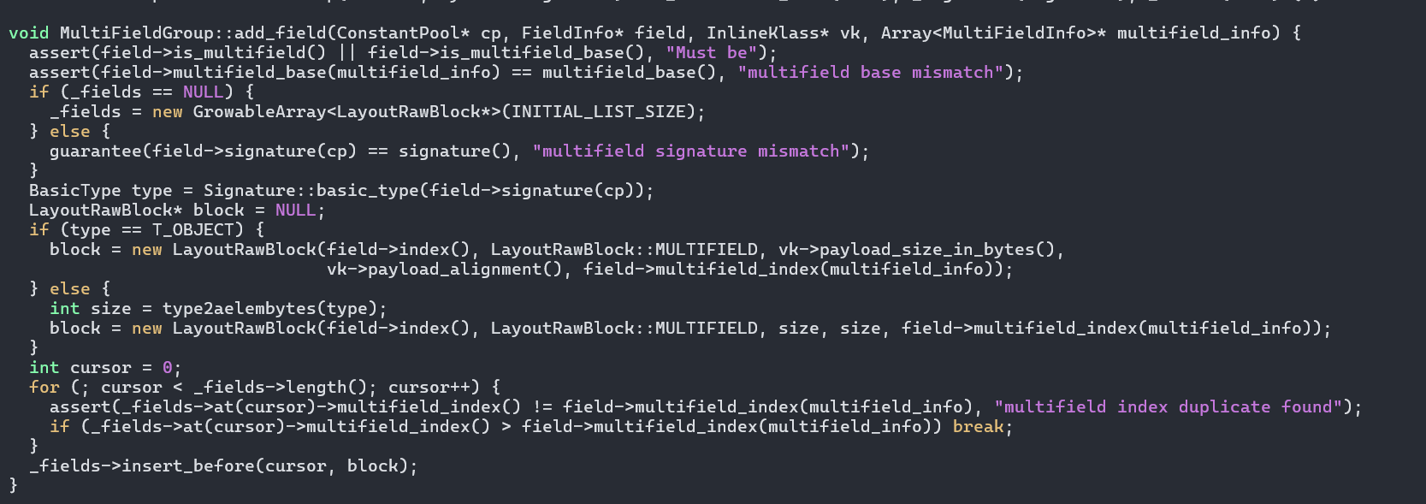

* + **Layout computation is flexible to handle existence of value type multifields, it computes the size of a LayoutRawBlock using InlineKlass::payload_size_in_bytes. For VectorAPI use case, lanes are primarily of primitive types, with HalffloatVector lanes are of Float16 value type.**
  + **Existing support of layout builder is fully equipped to handle Float16 value type lanes.**

**Consider the following @MultiField annotated value type field.**

**---------------------------------------------------------------------------------------**

**// JAVAC : javac --enable-preview --add-exports=java.base/jdk.internal.vm.annotation=ALL-UNNAMED field_offset.java**

**// JAVA : java --enable-preview -Xbootclasspath/a:. --add-exports=java.base/jdk.internal.vm.annotation=ALL-UNNAMED -XX:+PrintFieldLayout -cp . field_offset_recursive_ms**

**import jdk.internal.vm.annotation.MultiField;**

**value class Point {**

**public float x;**

**public float y;**

**public float z;**

**public Point(float x, float y, float z) {**

**this.x = x;**

**this.y = y;**

**this.z = z;**

**}**

**}**

**public class field_offset_recursive_ms {**

**@MultiField(value=8)**

**public float Point;**

**public static void main(String [] args) {**

**Point obj = new Point(10.0f, 20.0f, 30.0f);**

**System.out.println(obj.hashCode());**

**}**

**}**

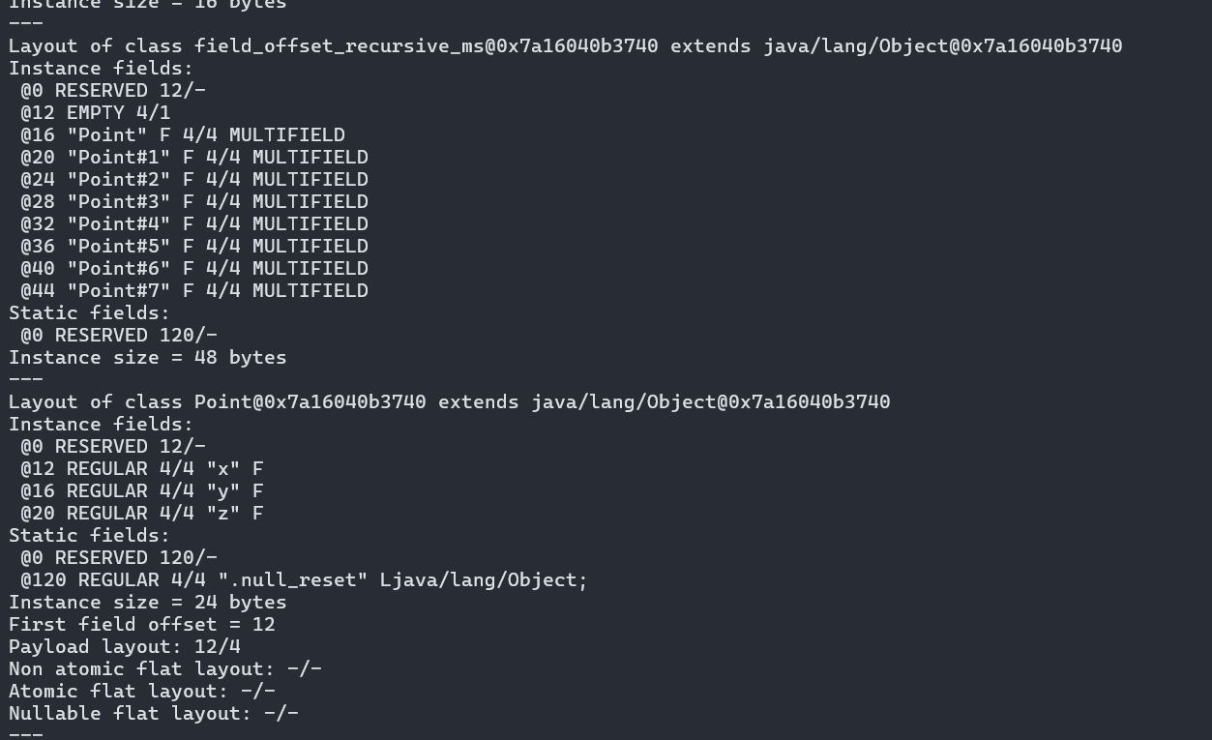

* + **Offsets are assigned during layout computation (build_layout)**
  + **Ordering of field layout is : multifield, big primitive, small primitive and oop_field_layout.**

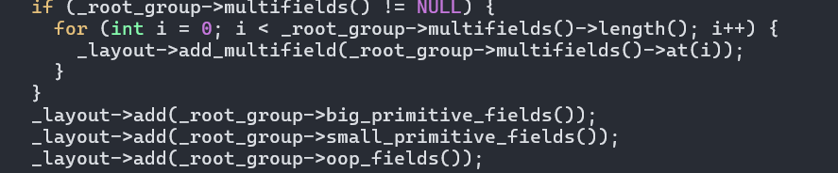

* **fieldDescriptor**
  + **Wrapper of constant_pool and uses field index to fetch the information.**

**An orthogonal but important annotation @Contended, leaves sufficient space b/w field or bundle of fields in a same contention group to prevent contentious memory accesses due to false sharing.**

